University of Management and Technology
Department of Computer Science & IT
RESOURCE ACQUISITION REPORT — GROUP 3 (CAMPUS NETWORK)
1. Purpose:
This document formally verifies that all emulation platforms, operating system images, server environments, and core client frameworks required to successfully implement the Campus Network Project (Problem Scenario 3) have been safely downloaded, initialized, and validated by the team members.
2. Inventory of Acquired Systems:
- Network Core Emulator: GNS3 Standalone Workspace integrated with GNS3 VM backend running natively on local hypervisors.
- Router Operating System Image: Cisco IOS c7200 Enterprise Architecture image built for core routing execution environments.
- Switch Operating System Image: Cisco IOU/IOL Layer 2 multi-layer switching platform for robust VLAN trunking encapsulation.
- Server Environment: Ubuntu Server 22.04 LTS Desktop/Server Virtual Machine deployed on VMware Workstation for Captive Portal engine execution.
- Client Emulators: Virtual PC Simulator (VPCS) nodes alongside minimalist Linux deployment terminals for end-user simulation.
3. Workspace Verification Checkpoints:
Verification Checkpoint 1: Clean GNS3 Virtual Workspace Initialized
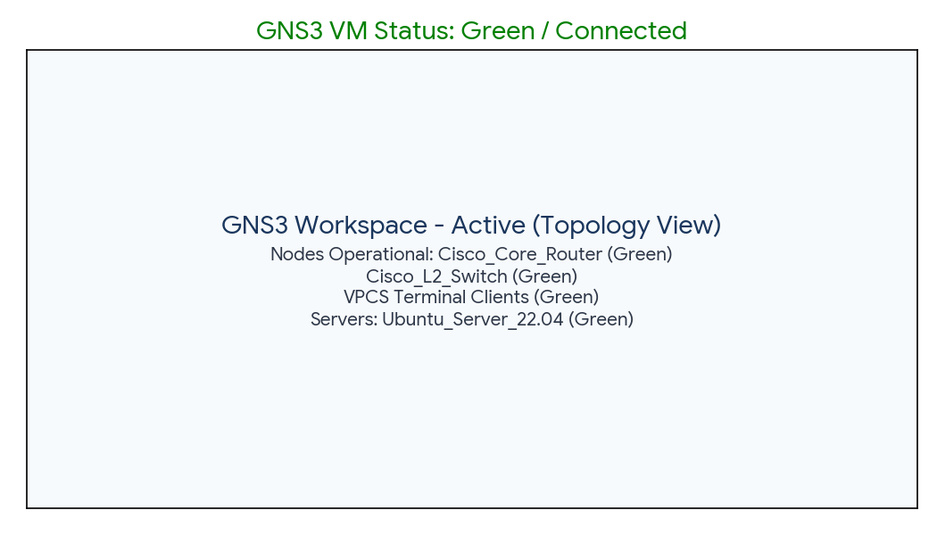
Verification Checkpoint 2: Cisco Routers and L2 Switch Images Successfully Indexed inside GNS3 Preferences
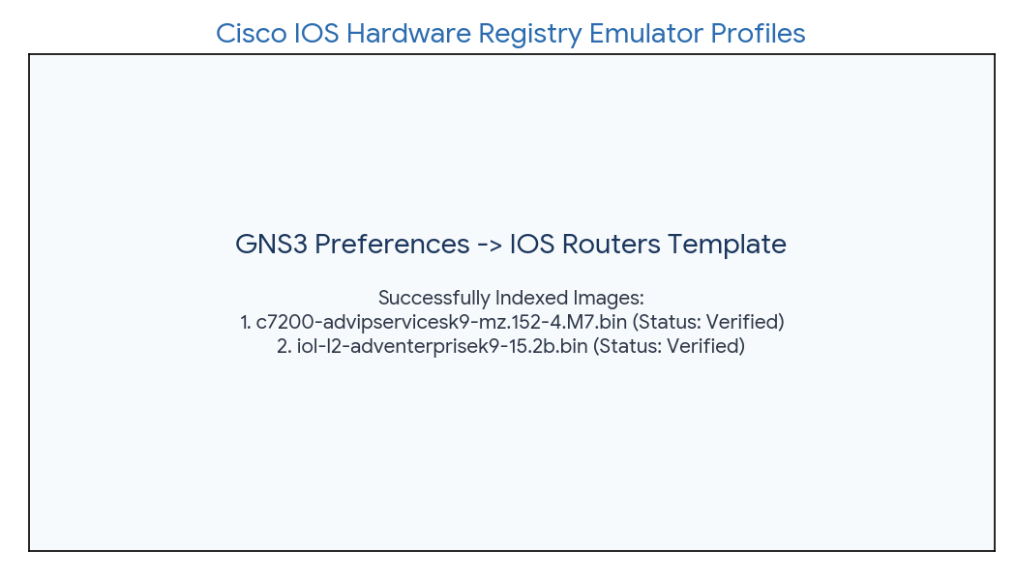
Verification Checkpoint 3: Local Ubuntu Server VM Deployment Verified
