Human when connectomes are filtered with relation to common atlas:

Sum of the three correlations is 1.78

[1,] -0.22646824

[2,] -0.01033296

[3,] 0.11643479

[4,] 0.96697896

For Geno, weight, age, sex

Mouse when connectomes are filtered :

Sum of the three correlations is 2.261323

[1,] 0.96111845

[2,] 0.19619960

[3,] -0.19047254

[4,] -0.03843511

For Geno, weight, sex , age.

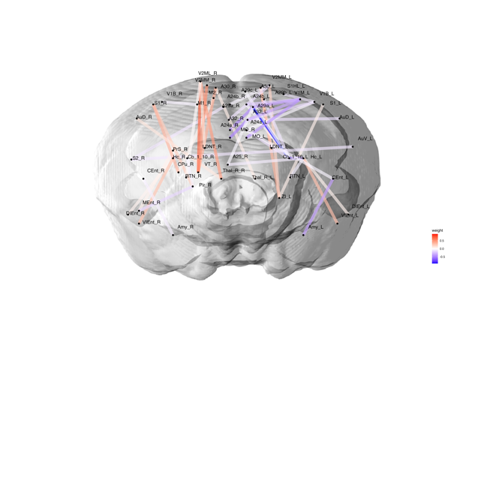

Common results :

|  |  |  |  |  |
| --- | --- | --- | --- | --- |
| 1 | ctx-lh-caudalanteriorcingulate--Left-Cerebellum-Cortex | 18--1 | Cingulate_Cortex_Area_24a--Left Cerebellar_Cortex | 1--91 |
| 2 | Left-Cerebellum-Cortex--ctx-lh-caudalanteriorcingulate | 1--18 | Cerebellar_Cortex--Left Cingulate_Cortex_Area_24a | 91--1 |
| 3 | ctx-lh-rostralanteriorcingulate--ctx-lh-fusiform | 41--22 | Cingulate_Cortex_Area_32--Left Primary_Visual_Cortex_Binocular_Area | 9--36 |
| 4 | ctx-lh-fusiform--ctx-lh-rostralanteriorcingulate | 22--41 | Primary_Visual_Cortex_Binocular_Area--Left Cingulate_Cortex_Area_32 | 36--9 |