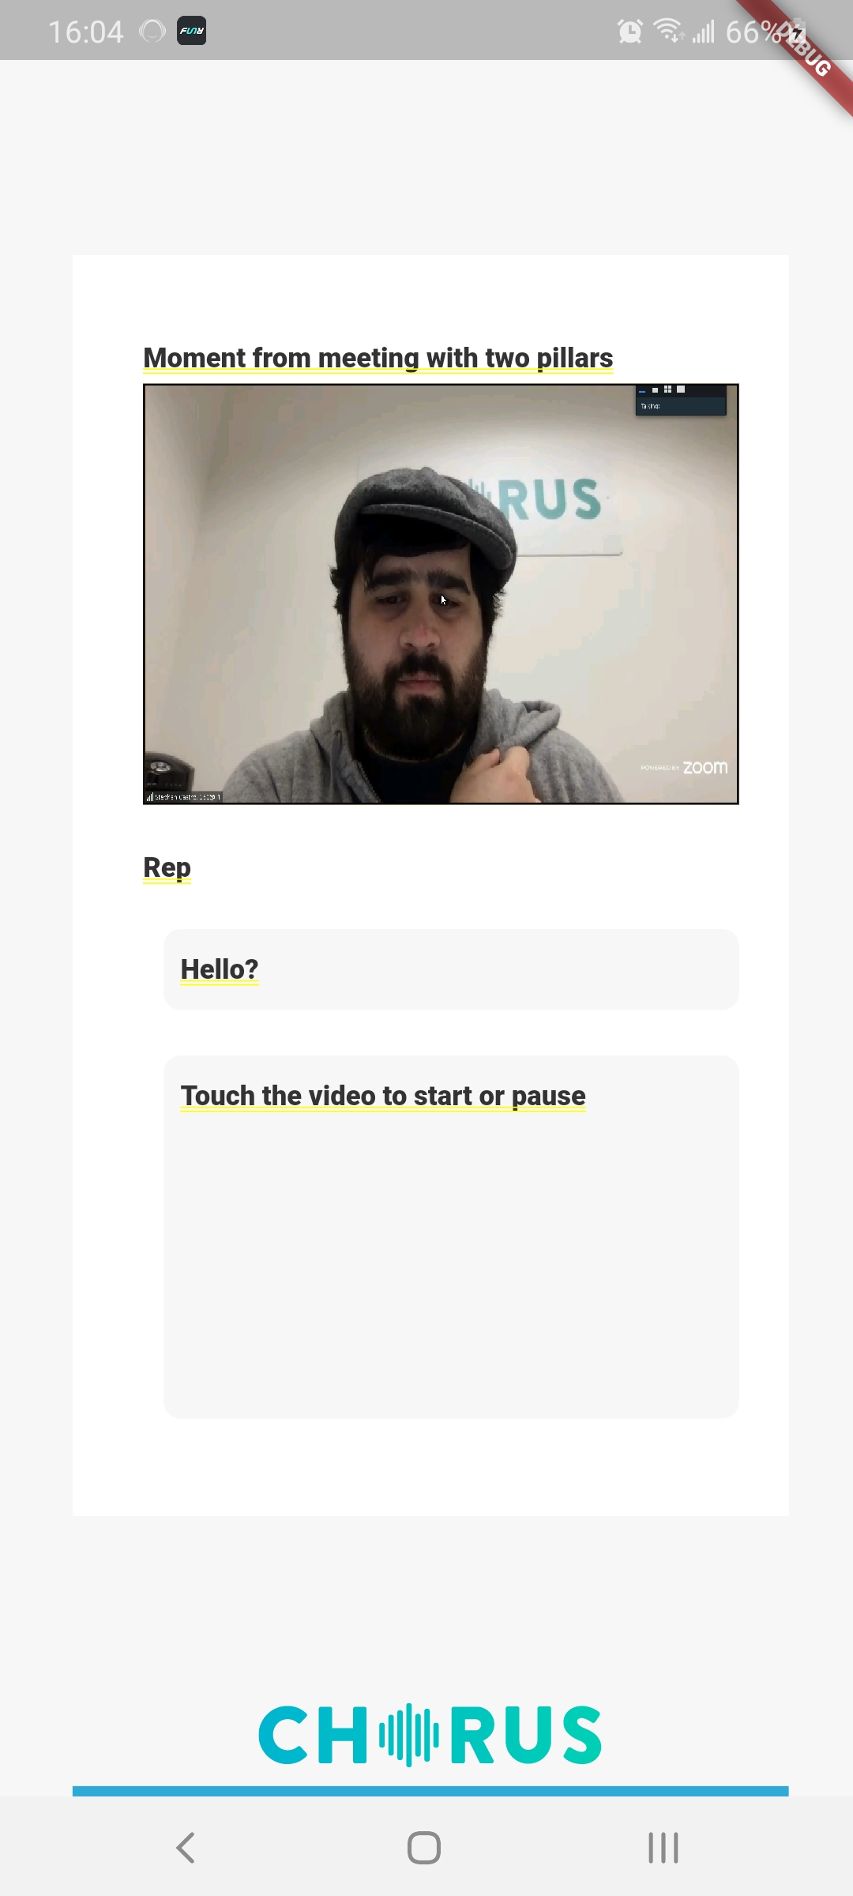 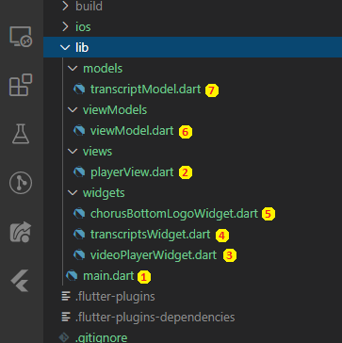

1. main.dart:

main.dart is the entry point of the application

1. playerView.dart: the assignment view

The playerView is a container/view to keep all necessary widget

1. videoPlayerWidget.dart:

The videoPlayer widget is to provide with top part of the UI (the tile and the video player)

1. transcriptsWidget.dart:

The transcripts widget is to provide with the middle part of the UI

1. chorusBottomLogoWidget.dart:

The bottom part of design, containing the Chorus logo and its bottom line

1. viewModel.dart:

The viewModel module is used as a view model for whole design

1. transcriptModel.dart:

Just a Model