

**Mehran University of Engineering and Technology, Jamshoro.**

**Department of Computer Systems Engineering**

**Computer Communication and Networks (CCN)**

Submitted by:

**Ali Murtaza (18CS30)**

Submitted to:

**Engr. Syed Shameeluddin**

|  |  |  |  |  |  |
| --- | --- | --- | --- | --- | --- |
| **Department of:** |  | **Subject of:** | | | |
| **Computer Systems Engineering** | **Computer Communication and Networks** | | | |
| **Mehran University of Engineering &Technology** | **Year** | **4th** | **Semester** | **7TH** |
| **Batch** | **18CS** | **Duration** | **03**  **Hours** |
| **Jamshoro** |

# **Lab-10**

**To Perform Implementation of STP**

## Exercise

### Topology

## Instructions:

Deploy STP on the three switches and eliminate layer 2 loop on the network.

Configure SW1 as root switch by setting its priority to 0.

Configure priority of SW2 to 4096+x. Replace “x” with your roll number. If roll number is 18CS01 then “x” is “01”.

Labels in topology and Device Names should follow the standards defined previously.

* SW1 should be 18CSxx_SW1
* SW2 should be 18CSxx_SW2
* SW3 should be 18CSxx_SW3

## Deliverables:

Please save the configuration of the three routers. Save the topology. Compress it into ZIP/RAR file.

Create a document for the steps that you have followed.

### Attach the document along with ZIP/RAR file in the assignment section.

### **TOPOLOGY**

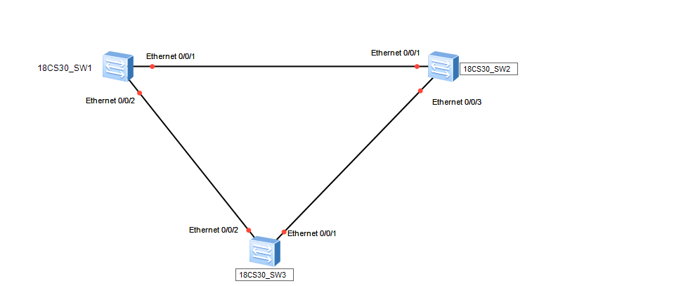

**Basic STP Configure and display**

**Switch 1:**

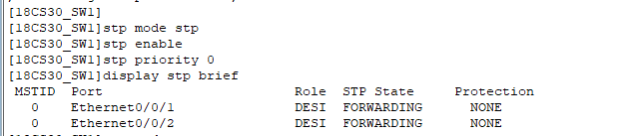

**Switch 2:**

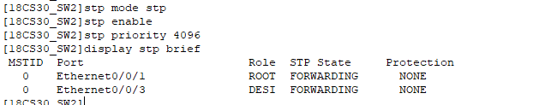

**Switch 3:**

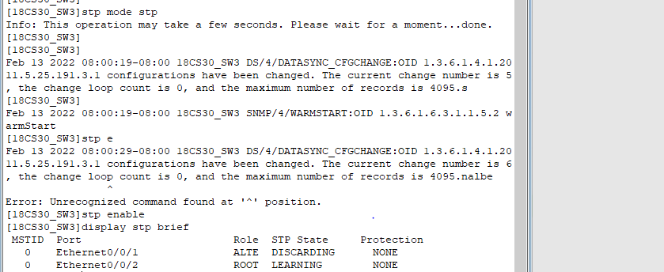

|  |  |  |
| --- | --- | --- |
| **Rubrics** | **Marks Obtained** | |
|  |  |
| **Completeness & Accuracy** |  |  |
| **Timelines** |  |  |

|  |  |
| --- | --- |
| **Student ID:** |  |
| **Subject Teacher:** |  |
| **Date:** |  |