Artificial Intelligence lab
Lab Manual 08

BS Cyber Security – 3rd Semester Fall 2025
Department of Computer Science
HITEC University Taxila Cantt
Due Date: December 14, 2025
Instructor: Mr. Mubashir Iqbal

Ali Abbas Qazi
24-CyS-050
Task 01
Apply Alpha-Beta Pruning to the graph.
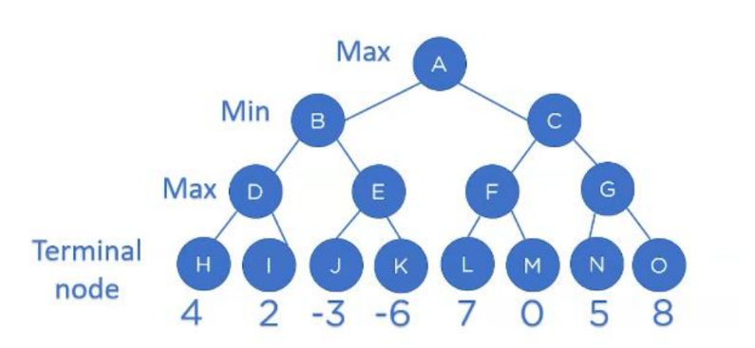
Code:
# Lab 08 - Task 01
# Alpha-Beta Pruning Algorithm

print("==== Alpha-Beta Pruning ====\n")

import math

def alpha_beta(depth, node_index, is_max, scores, alpha, beta, max_depth):
# Base case
if depth == max_depth:
return scores[node_index]

if is_max:
best = -math.inf
for i in range(2):
value = alpha_beta(depth + 1, node_index * 2 + i,
False, scores, alpha, beta, max_depth)
best = max(best, value)
alpha = max(alpha, best)

if beta <= alpha:
break # pruning
return best

else:
best = math.inf
for i in range(2):
value = alpha_beta(depth + 1, node_index * 2 + i,
True, scores, alpha, beta, max_depth)
best = min(best, value)
beta = min(beta, best)

if beta <= alpha:
break # pruning
return best

# Leaf node values (H, I, J, K, L, M, N, O)
scores = [4, 2, -3, -6, 7, 0, 5, 8]

depth = int(math.log2(len(scores)))

result = alpha_beta(0, 0, True, scores, -math.inf, math.inf, depth)

print("Optimal value using Alpha-Beta Pruning:", result)

Output:
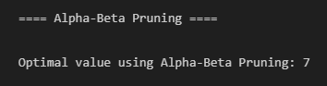

Task 02
Apply the minimax algorithm in the Tic-Tac-Toe game.
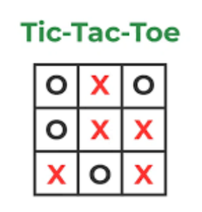

Code:
# Lab 08 - Task 02
# Minimax Algorithm for Tic-Tac-Toe

print("\n==== Tic-Tac-Toe using Minimax ====\n")

# Function to check winner
def check_winner(board):
win_states = [
[0,1,2], [3,4,5], [6,7,8], # rows
[0,3,6], [1,4,7], [2,5,8], # columns
[0,4,8], [2,4,6] # diagonals
]

for state in win_states:
if board[state[0]] == board[state[1]] == board[state[2]] != ' ':
return board[state[0]]
return None

# Minimax function
def minimax(board, is_max):
winner = check_winner(board)

if winner == 'X':
return 1
elif winner == 'O':
return -1
elif ' ' not in board:
return 0

if is_max:
best = -100
for i in range(9):
if board[i] == ' ':
board[i] = 'X'
best = max(best, minimax(board, False))
board[i] = ' '
return best
else:
best = 100
for i in range(9):
if board[i] == ' ':
board[i] = 'O'
best = min(best, minimax(board, True))
board[i] = ' '
return best

# Example board state
board = ['X', 'O', 'X',
' ', 'O', ' ',
' ', ' ', 'X']

print("Board State:")
print(board)

value = minimax(board, True)

print("\nOptimal value for X:", value)

Output:
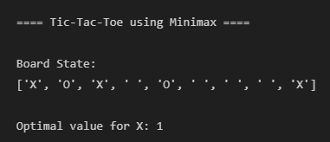

Conclusion
In this lab, we implemented game-playing algorithms, including Minimax and Alpha-Beta Pruning. These tasks helped us understand how decision-making works in adversarial environments, how Minimax evaluates possible moves for optimal outcomes, and how Alpha-Beta Pruning improves efficiency by eliminating unnecessary branches.
References
Github: https://github.com/Ali-Qazi-1966/HITEC-AI-Course/blob/main/Lab08_AI.ipynb

