

COMSATS UNIVERSITY ISLAMABAD

Vehari Campus

DEPARTMENT OF COMPUTER SCIENCE

Cab App

*Undertaken By:*

**Ali Shan**

Reg. No. CIIT/FA18-bSE-007/Vhr

**Hassan Shakeel**

Reg. No. CIIT/FA18-BSE-061/Vhr

*Supervised By:*

**Sir Nashit Ali**



DEPARTMENT OF COMPUTER SCIENCES

COMSATS UNIVESITY ISLAMABAD, VEHARI CAMPUS VEHARI – PAKISTAN

SESSION 2018-2022

**SCOPE DOCUMENT REVSION HISTORY**

|  |  |  |
| --- | --- | --- |
| **No.** | **Comment** | **Action** |
|  |  |  |
|  |  |  |
|  |  |  |
|  |  |  |
|  |  |  |
|  |  |  |

**Supervisor Signature**

**Date:**

## Table of Contents

1. ABSTRACT vi

2. INTRODUCTION vii

3. PROBLEM STATEMENT vii

4. PROPOSED SOLUTION vii

5. RELATED SYSTEM ANALYSIS viii

6. ADVANTAGES/BENEFITS OF PROPOSED SYSTEM viii

7. APPLICATION .............................................................................................................. viii

8. SCOPE ix

9. MODULES ix

10. HARDWARE REQUIRMENTS ix

11. SOFTWARE PROCESS METHODOLOGY x

12. MOCK-UP x

13. TOOLS AND TECHNOLOGY xi

14. TEAM MEMBER INDIVIDUAL TASK xi

15. CONCLUSION xi

16. REFRENCES xii

**Category: (**Select all the major domains of proposed project**)**

|  |
| --- |
| **A-** Web Application. **B-** Mobile Application (Android and ISO).  **C-** Desktop Application.  **D-** Problem Solving and Artificial Intelligence.  **E-** Simulation and Modeling.  **F-** Networks.  **G-** Smartphone Game.  **H-** Image Processing Other(specify category) __________________________________________. |

## Abstract

This app lets users with vehicles help other users who have the closest current location and destination by giving them a lift. A user who has a vehicle and is about to start a journey first marks its status as “I can share a ride” and then enters its destination in the app before starting the journey. A person who wants to travel but is not having conveyance requests the app for a lift by providing his/her destination. The app calculates three things:

1. Requesting user’s current distance from the current distances of all the users who have marked their status as “I can share a ride”.
2. The distance of destination of the requesting user from the destinations of all the users who have marked their status as “I can share a ride”.
3. Finally, the app adds up the current location distance and destination distance for each user

whose status is “I can share a ride” from the requesting user.

The user with the smallest sum is the selected user. A message appears on the selected user’s smartphone that someone wants a ride. The location of the requesting user is also shared with the selected user on the map so that the selected user may pick the requesting user from its current location. After the journey ends, a user who has set its status to “I can share a ride” will mark its status as “I cannot share a ride” so that the app knows that he/she is no longer offering a ride.

## Introduction

Cab App will be an android application which will works like Careem, Uber and Dida (App in China). This application will provide services to passengers and drivers. Cab App connects passengers and drivers using GPS (Google Map API (Application Program Interface)) system. Everyone who has any type of vehicle can register on this application. This app will support all type of vehicles. This application enables passengers to order any kind of vehicle with their Smartphone. The main objective of this application is that drivers online register their vehicles by providing their essential information and then check their nearest pick and drop. The project has two parts, the first one is an application run on android device and the second one is server on SQL database. Android section will have two applications. One is master refers to driver and other one is client refers to passengers. If the driver accepts booking, then the server will send order confirmation to the passenger application. This application is managing passengers’ booking in quick and easy way with shortest time possible. With one click on the button you can order a vehicle if you are a passenger. With another click you accept or decline requests if you are a driver. No party to be added to control this work. Some types of vehicles still don’t have any online ride service. But with this application, any type of vehicle can register. This app will support all type of vehicles. This app will run in all cities. All vehicle drivers can register and earn money using this app without any limitation. This service will not have any central office.

1. **Problem Statement**

Now a days it’s difficult for all to have their own Vehicle due higher rates of vehicle and the petroleum’s. The rates of rents are also touching the sky. Passengers have to wait for taxi in the pathway or hurrying on stairs when taxi reaches their location or on the taxis stands and bus stations. Today’s online ride services are not accessible by every driver due to some restrictions. Due to central office management, current ride services cannot be established in small developing cities and areas surroundings. Almost many types of vehicles still do not have any online ride service. For that reason, we thought of new way to handle the registration of taxies avoiding these problems. On the every stop many drivers are waiting for the customer if a customer come and watch there are many taxis available than you should ask from them is he come with you or not. Some drivers wait a full day but not get any customer.

# **Problem Solution for Proposed System**

This App will provide the facility to everyone who has any type of vehicle can register on this and earn money using this app without any limitation. All type of vehicle can register. This app will support all type of vehicles. This app will run in all cities. Using this application, the customers can also share the cab or taxi during the ride the rent of the customers is become less if they decided the rideshare option. It’s also for villages and colonies or towns which are outside from the cities. Rent price bargaining.

# **Related System Analysis/Literature Review**

**Table 1: Related System Analysis with proposed project solution**

|  |  |  |
| --- | --- | --- |
| **Application Name** | **Weakness** | **Proposed Project Solution** |
| **Careem and Uber** | No shearing allowed and the  Local driver cannot do the registration there. Prices are fixed | Pick the more than one customer for the same destination.  Local Drivers also get facilitate by that App. |

# **Advantages/Benefits of Proposed System**

* Every local driver can register and get the advantages.
* Low-cost rents because of sharing.
* Using this system, we can get the Vehicles so quickly.
* Gender Based Preference and Emergency Alert.
* Stopover the trip (additional charges applied).
* Call masking.

# **Application**:

This project is for the local drivers and in that project, we provide security to the data of customers. The drivers can add more than one vehicle and also fix his rent with the customers.

You can order food or things you want at your doorsteps and delivery of any things you order in your daily life.

# **Scope**

# This project can be implemented in the form of mobile application to reduce the cost of hardware. (Uber and Careem is an example of it).

# This app is basically open-source online ride service so this app provides opportunity to drivers to register their vehicles online.

# With this app, drivers can register any type of vehicle and then start finding the nearest pick and drop.

# This app will support all type of vehicles. With this app, drivers who have loss in their business resolve their issues.

# This app has no central management office so this app will run in all cities. This application also provides the text to speech service for driver when it delivers a notification that there exists a request from passenger. Advancement to introduce open-source app will increase its market value.

# **Modules**

* Register your account and book the ride and select the payment method.
* Driver took the selected vehicle go to the location and go to desired location.
* Data is automatically saved into Database.

# **Hardware Requirements**

* Mobile Phone (Internet/ Wi-Fi connected).
* PC (Internet/ Wi-Fi connected).

# **Software Process Methodology**

We use Agile methodology for or this project by using this methodology it minimizes the risk when we are adding new functionality. In all Agile methods team develops the software in iterations that contain mini-increments of the new functionality.

**Figure 1:**

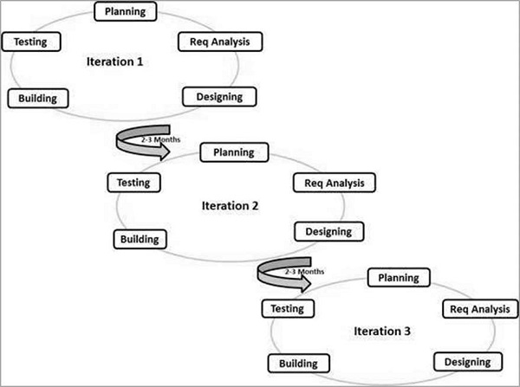

# **Mock-up**

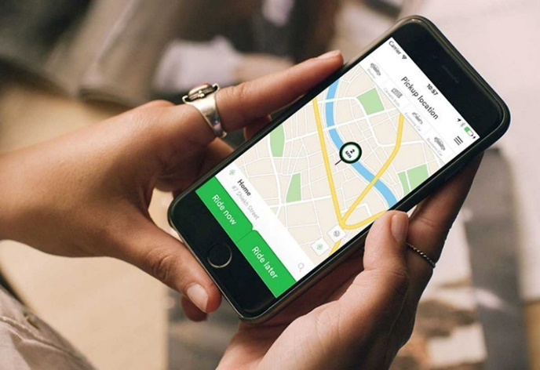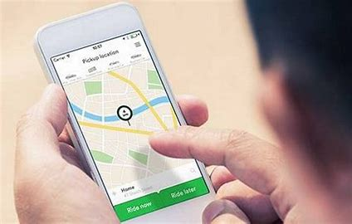

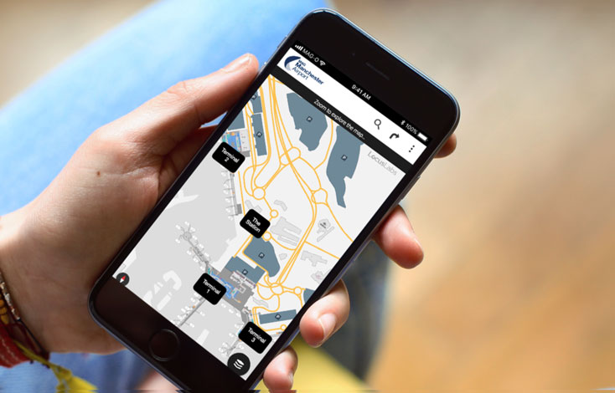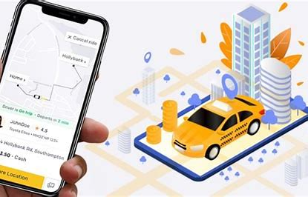

# **Tools and Technologies**

**Table 2: Tools and Technologies for Proposed Project**

|  |  |  |  |
| --- | --- | --- | --- |
| **Tools**  **And**  **Technologies** | **Tools** | **Version** | **Rationale** |
| Flutter | 2021 | IDE |
| MS SQL Server | 2018 | DBMS |
| Adobe Photoshop | CSC 6 | Design Work |
| MS Word | 2015 | Documentation |
| MS Power Point | 2015 | Presentation |
| Pencil | 2.0.5 | Mockups Creation |
| **Technology** | **Version** | **Rationale** |
| Dart/Flutter | 0.0 | Programming language |
| SQL | 2013 | Query Language |
| Html | 5 | Web Development |

# **Project Stakeholders and Roles**

**Table 3:**

|  |  |
| --- | --- |
| **Project Sponsor** | **COMSATS University, Islamabad Vehari** |
| **Stakeholder** | * Students’ names: **Ali Shan & Hassan Shakeel** * Project Supervisor Name: **Sir Nashit Ali** |

**15. Conclusion**

The use of this rideshare application is on the rise and is unlikely to see a decline in near future. There is need to maintain healthy competition between companies providing their services, which ought to be non-price feature such as customer services, security etc. and which should create an environment which allows the new arrival in market.

**16. References**

# 

* https://www.t4tutorials.com
* https://www.w3school.com