Non-Preemptive Priority Scheduling with a Combined Monitor and Semaphore: Flowchart, Pseudocode, Gantt Charts and Comparison with RM and EDF
Alinaviani
Department of Computer Engineering, Eshragh Institute of Higher Education, Bojnord, Iran
Corresponding author: alitnaviani0001384@gmail.com

Abstract
This report implements non-preemptive priority scheduling with a combined use of a monitor and a binary semaphore and compares it with the preemptive Rate Monotonic (RM) and Earliest Deadline First (EDF) algorithms. Two shared resources are modelled: shared data guarded by a Mesa-style monitor and a device guarded by a binary semaphore. The critical section of every job is split into a monitor part followed by a semaphore part, and the two locks are never nested. The report contains the flowchart, the pseudocode, the Gantt charts, the complete Python source code, the measured timing metrics and a comparison with the semaphore-only and monitor-only models. The results are valid only for the stated model.
Keywords: priority scheduling; non-preemptive scheduling; monitor; binary semaphore; Rate Monotonic; Earliest Deadline First; Gantt chart

1. Introduction
Real-time and general-purpose operating systems must decide which ready job receives the processor and, at the same time, how jobs share data and devices safely. This exercise combines both questions. A non-preemptive priority scheduler is implemented together with a monitor and binary semaphore and is compared with two classical preemptive policies, Rate Monotonic (RM) and Earliest Deadline First (EDF), under exactly the same workload and the same locking rules.
Non-preemptive priority scheduling gives every task a static priority (a smaller number means a higher priority). Whenever the processor becomes free it dispatches the ready job of highest priority (ties by arrival order) and never takes the processor away from a running job, even if a more important job arrives. RM assigns fixed priorities by period (shorter period, higher priority). EDF assigns dynamic priorities by absolute deadline (earlier deadline, higher priority). The comparison therefore shows what is gained or lost when preemption and deadline information are added to a simple static-priority scheduler while jobs compete for a shared resource.
The deliverables of this report are: the flowchart of the simulator (Section 4.1), the pseudocode (Section 4.2), the Gantt charts of both task sets (Section 6), the measured metrics, and the complete source code (Appendix A). Section 5 explains which inputs the program accepts and which outputs it writes.

2. Background

2.1 Priority scheduling (non-preemptive)
In the simulation every task has a static priority P (smaller number = higher priority; the built-in cases use P = 1, 2, 3 in the order in which the tasks are listed). When the processor is free, the ready job with the smallest P is dispatched (ties are broken by the arrival number in the ready queue) and it keeps the processor until it finishes or blocks on a lock. The method is simple and has very low overhead, but a running low-priority job can delay a high-priority job that arrives meanwhile (non-preemptive blocking, bounded by the length of the longest job), and low-priority jobs can starve if higher-priority work keeps arriving.

2.2 Rate Monotonic and Earliest Deadline First
RM is a fixed-priority preemptive policy: a newly released job preempts the running job if its task has a shorter period. Liu and Layland showed that RM is optimal among fixed-priority policies for independent periodic tasks, with a sufficient utilization bound that approaches 69 percent for many tasks. EDF always selects the ready job with the earliest absolute deadline and can schedule any independent preemptible task set with utilization not above 1. Both guarantees assume independent jobs; once jobs share locks, blocking times must be added to the analysis.

2.3 Synchronization primitive used here
A binary semaphore (Dijkstra) offers the atomic operations P and V on a counter that is either 1 or 0; a monitor (Hoare) bundles shared data with an implicit lock and condition variables. In real operating systems the two are often combined: a monitor is built on top of semaphores or mutexes, and a program may use a monitor for in-memory data structures and a semaphore for a device or a bounded pool.
This report models that combination with two independent resources. MON is a Mesa-style monitor (flag busy, condition free; a signalled job only becomes ready and must re-check busy). SEM is a binary semaphore with a FIFO wait queue and direct hand-over of ownership on V(). Both blocking mechanisms use the same rule for the CPU: a blocked job leaves the processor and another ready job is dispatched.

2.4 Priority inversion
When a low-priority job holds a lock that a high-priority job needs, the high-priority job is blocked. If medium-priority work can still run, or if the lock holder is preempted, the blocking time grows; this is priority inversion. Protocols such as priority inheritance (Sha, Rajkumar and Lehoczky) limit it. The simulator deliberately implements no such protocol, so that the raw interaction between the scheduling policy and the lock becomes visible.

3. Model and Assumptions
The system has one processor and integer time (one tick equals one time unit). Task i is a tuple (C, T, D, P): execution time, period, relative deadline and static priority. All tasks are released synchronously at time 0 and then every T time units; the absolute deadline of a job released at r is r + D. The simulation covers one hyperperiod H = LCM of the periods and then lets the already released jobs finish (drain mode) so that no job is cut off and all averages are computed over complete jobs.
Case | Tasks (C, T, D, P) | Hyperperiod | Utilization | Comment
A | A=(1,4,4,1), B=(2,5,5,2), C=(3,10,10,3) | 20 | 0.95 | Three tasks, 11 jobs
B | X=(2,5,5,1), Y=(4,7,7,2) | 35 | 0.9714 | Two tasks, 12 jobs
Table 1. Built-in task sets (P = static priority, smaller number = higher priority).
Two shared resources exist: MON (monitor) and SEM (binary semaphore). Let L = min(cs_len, C). The last L execution units of every job are its critical sections: the first ceil(L/2) units are executed inside the monitor MON and the remaining floor(L/2) units hold the semaphore SEM. With the default cs_len = 2 each job uses one unit of MON followed by one unit of SEM; a job with C = 1 uses only MON. The monitor is released before the semaphore is requested, so no job ever holds both locks and deadlock is impossible. A job that is preempted inside a section keeps the corresponding lock.
A job that cannot obtain its lock is BLOCKED: it is removed from the processor and from the ready queue, and the scheduler immediately dispatches another ready job in the same tick, so the processor is never idle while a ready job exists (this is checked by the self-test in Section 8). No priority inheritance, priority ceiling, context-switch cost, I/O or multiple processors are modelled.

3.1 Metrics
- Turnaround time = completion time - release time.
- Waiting time = turnaround time - execution time C (time spent not executing).
- Response time = first dispatch time - release time.
- Resource waiting time = time from the first lock request until the lock is actually obtained.
- Block time = number of ticks the job spends in the BLOCKED state (waiting in the semaphore or condition queue).
- Deadline miss = job finishing after its absolute deadline.
- Idle time = ticks in which no job runs; preemptions and lock-holder preemptions are also counted.

For the semaphore part the two quantities are equal; for the monitor part resource waiting time can exceed block time because a signalled job must be dispatched and re-check the condition (Mesa semantics).

4. Algorithm Design

4.1 Flowchart
Figure 1 shows the flowchart of the simulator for one run of one policy. Every tick consists of: release, dispatch (with lock request), state recording, execution of one time unit and, if applicable, release of the lock.

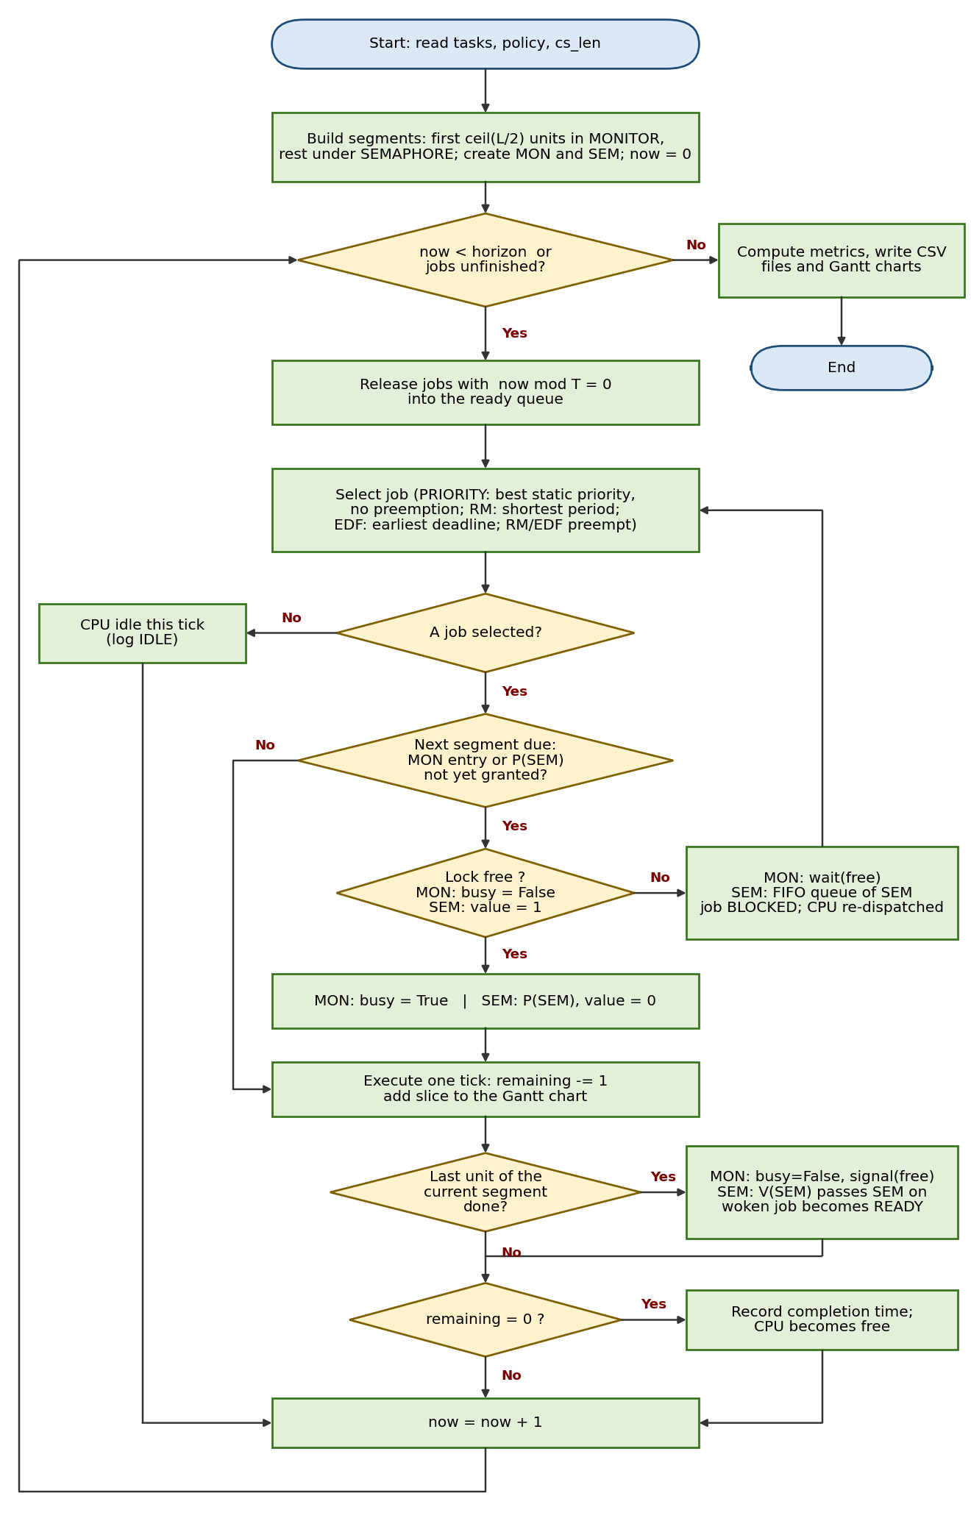
Figure 1. Flowchart of the non-preemptive priority / RM / EDF simulator with the monitor and binary semaphore.

4.2 Pseudocode
ALGORITHM Simulate(tasks, policy, cs_len, horizon)
1 H <- LCM(T1, ..., Tn); horizon <- H if not given; now <- 0
2 MON <- Monitor(busy = FALSE, condition free); SEM <- BinarySemaphore(value = 1)
3 FOR EACH job: L <- min(cs_len, C); m <- ceil(L / 2)
segments <- [ (MON, start = C - L, length = m), (SEM, start = C - L + m, length = L - m) ]
4 WHILE now < horizon OR some released job is unfinished DO
5 release periodic jobs (now MOD T = 0) into the ready queue
6 LOOP // dispatch phase
7 job <- SELECT(policy) // PRIORITY / RM / EDF as before
8 IF job = NIL THEN BREAK
9 seg <- the segment whose request is due (executed = seg.start, not granted)
10 IF seg = NIL THEN BREAK
11 IF seg.resource = MON THEN ok <- MON.acquire(job) // while busy: wait(free)
12 ELSE ok <- SEM.P(job) // FIFO queue, direct hand-over
13 IF ok THEN BREAK
14 job.state <- BLOCKED; running <- NIL // another job is dispatched
15 record job states; IF running = NIL THEN log IDLE ELSE execute one unit
16 IF the last unit of segment seg was executed THEN
17 IF seg.resource = MON THEN MON.release() // busy <- FALSE; signal(free) -> waiter READY
18 ELSE SEM.V() // hand SEM to first waiter or value <- 1
19 IF running.remaining = 0 THEN completion <- now + 1; running <- NIL
20 now <- now + 1
21 compute metrics; write CSV and Gantt

NOTE: MON follows Mesa semantics (woken job re-checks busy); SEM hands ownership to the woken job.
Lock order is MON then SEM and the monitor is released first, so a circular wait cannot occur.
Pseudocode 1. Simulator, scheduling policies and synchronization operations.

4.3 Event order inside one tick
- Release: jobs whose period divides the current time are created and appended to the ready queue.
- Dispatch: the policy chooses a job. PRIORITY keeps the running job; RM and EDF compare the running job with the ready jobs and may preempt it. If the chosen job must request a lock now, the request is made; on failure the job becomes BLOCKED and the choice is repeated.
- Recording: the state of every unfinished job is written to its timeline and block ticks are counted.
- Execution: the running job executes one unit; at the end of a critical section the lock is released and a waiter (if any) is woken.
- Completion: a job with no remaining work gets its completion time now + 1.

4.4 Program structure
The Python file contains: the data classes Task, Segment and Job; the synchronization objects; the function that builds the critical sections; the Simulator class (release_jobs, pick, dispatch, record_states, execute, run, summary); the reporting helpers (text Gantt, PNG Gantt, CSV writer); the input parsers; and main(). The three scheduling policies share one engine; only pick() differs.

5. Inputs and Outputs of the Program
Requirements: Python 3.9 or newer. matplotlib is optional and only used for PNG Gantt charts. Run the program from the folder that contains it: python "priority-scheduling_Non-Preemptive_semaphor&monitor-compretion.py"
Input option | Meaning | Example
(none) | Run the two built-in cases A and B with PRIORITY, RM, EDF | python "priority-scheduling_Non-Preemptive_semaphor&monitor-compretion.py"
--tasks | Task set name,C,T[,D[,P]] separated by semicolons; D defaults to T, P (priority, smaller = higher) defaults to 1,2,3... by position | --tasks "A,1,4,4,1;B,2,5,5,2;C,3,10,10,3"
--case-name | Label of the task set given with --tasks | --case-name MyCase
--tasks-file | JSON or CSV file with one or more task sets | --tasks-file mytasks.json
--interactive | Type the tasks, policies and cs_len on the keyboard | --interactive
--policies | Subset of PRIORITY,RM,EDF | --policies PRIORITY,EDF
--cs-len | Critical-section length in time units (default 2) | --cs-len 1
--horizon | Release jobs until this time (default hyperperiod) | --horizon 40
--no-drain | Stop exactly at the horizon | --no-drain
--outdir | Output directory (default results) | --outdir out
--no-plots / --quiet | Skip PNG charts / skip text Gantt charts | --no-plots --quiet
Table 2. Command-line inputs.
JSON file format: {"MyCase": [{"name": "A", "C": 1, "T": 4, "D": 4, "P": 1}, {"name": "B", "C": 2, "T": 5, "P": 2}]}. A CSV file needs the header name,C,T,D,P (optionally a case column first). Task names must be unique; C, T, D must be positive integers and P an integer.
Outputs: the console shows, for every case and policy, a text Gantt chart (# running, C running inside a critical section, b blocked, . ready, _ idle) and a final CSV-style summary table. The output directory receives the following files:
- semaphore_monitor_summary.csv - one row per case and policy with all average metrics, misses, idle time, preemptions and lock statistics;
- semaphore_monitor_job_details.csv - one row per job (release, deadline, first start, completion, waiting, turnaround, response, resource wait, block time, miss flag);
- semaphore_monitor_gantt.csv - merged time intervals of the Gantt chart with the resource held in each slice;
- gantt_<case>.png - Gantt charts of all policies of a case (one row per job; hatching = lock held, pink = blocked, grey = idle, v = deadline).

6. Results
Table 3 lists the measured averages for the two built-in task sets. All values are in time units and are taken directly from the CSV file produced by the included program.
Case | Policy | Avg wait | Avg turnaround | Avg response | Avg res. wait | Avg block | Misses | Idle | Preempt. | Lock-holder preempt.
A | PRIORITY | 1.273 | 3.000 | 1.273 | 0.000 | 0.000 | 0 | 1 | 0 | 0
A | RM | 1.364 | 3.091 | 0.636 | 0.000 | 0.000 | 0 | 1 | 4 | 0
A | EDF | 1.273 | 3.000 | 1.182 | 0.000 | 0.000 | 0 | 1 | 1 | 0
B | PRIORITY | 1.083 | 3.917 | 1.083 | 0.000 | 0.000 | 0 | 1 | 0 | 0
B | RM | 1.167 | 4.000 | 0.333 | 0.000 | 0.000 | 1 | 1 | 5 | 0
B | EDF | 1.000 | 3.833 | 0.833 | 0.000 | 0.000 | 0 | 1 | 1 | 0
Table 3. Summary metrics (averages over completed jobs).
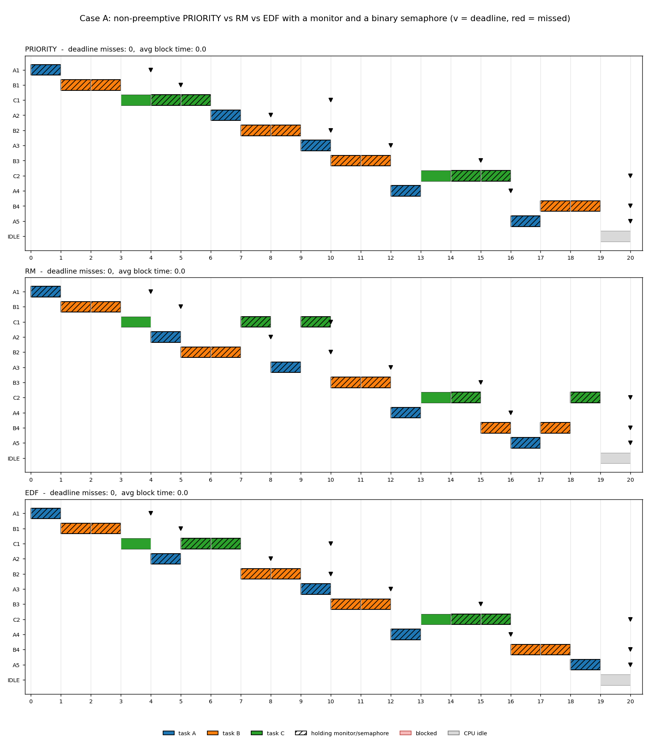
Figure 2. Gantt charts of Case A (PRIORITY, RM, EDF).
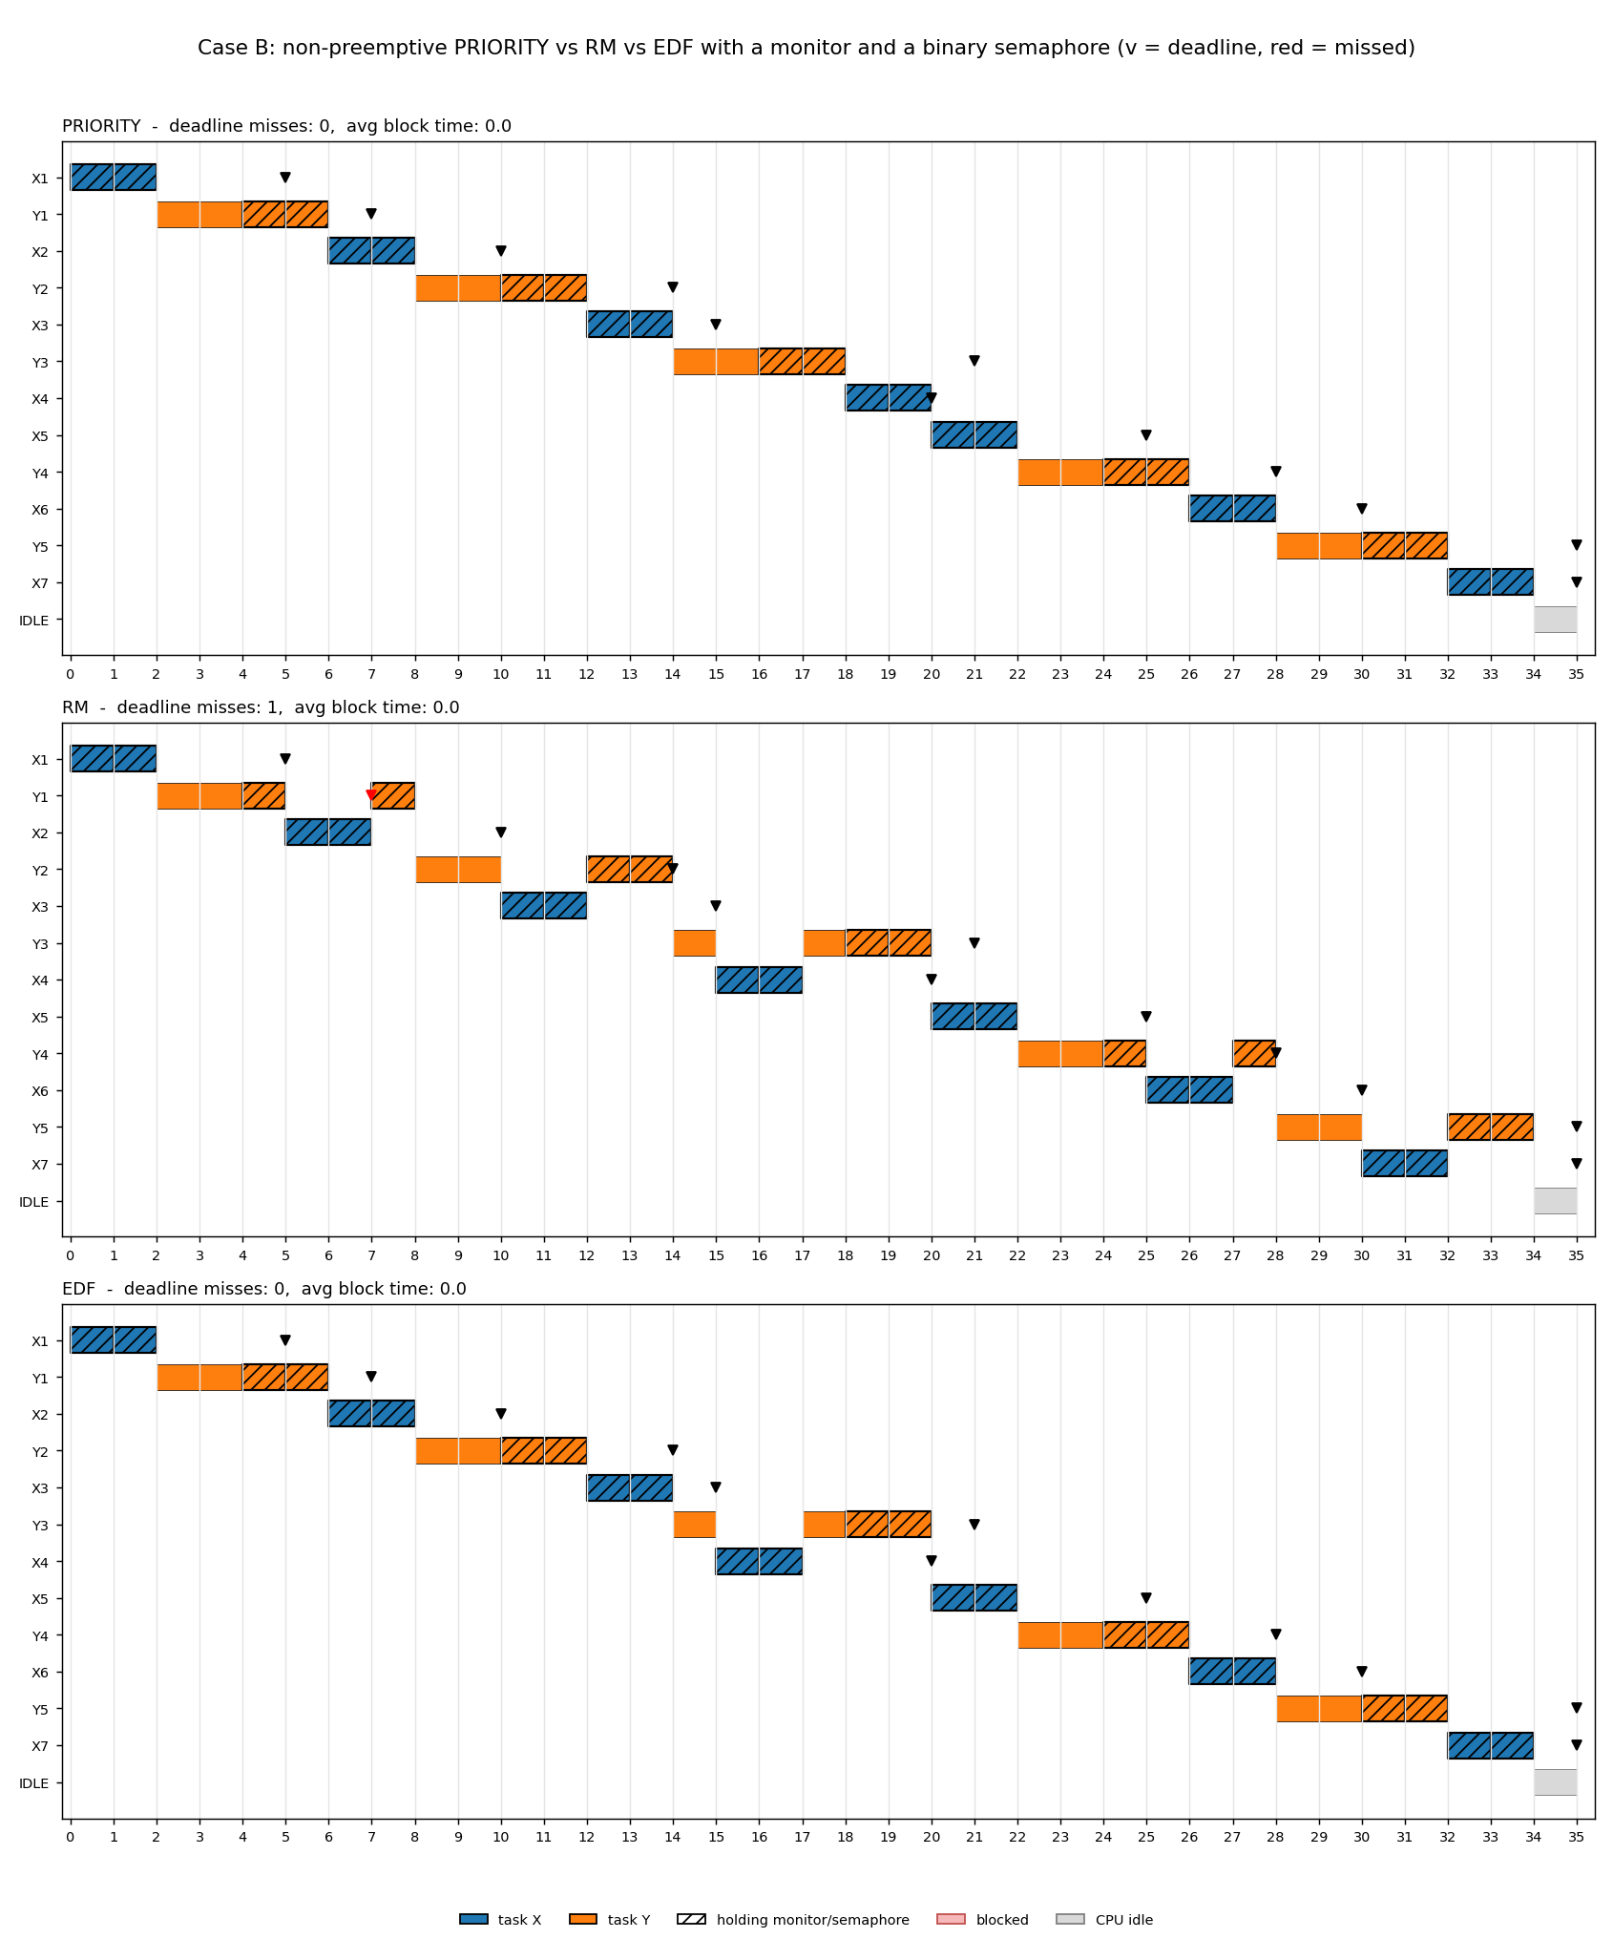
Figure 3. Gantt charts of Case B (PRIORITY, RM, EDF).
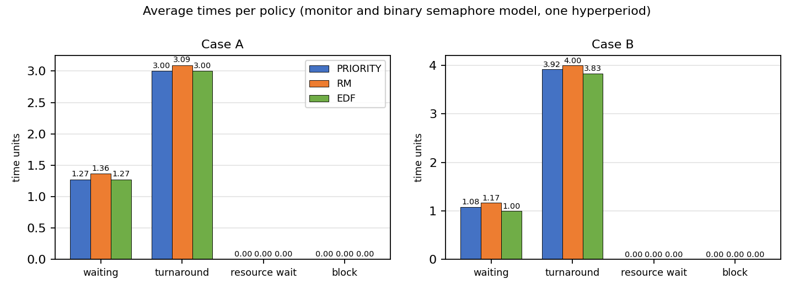
Figure 4. Comparison of the average times of the three policies.
Case | Policy | MON enter calls | MON cond waits | MON signals | MON spurious wakeups | MON max queue | SEM P calls | SEM P blocked | SEM max queue
A | PRIORITY | 11 | 0 | 0 | 0 | 0 | 6 | 0 | 0
A | RM | 11 | 0 | 0 | 0 | 0 | 6 | 0 | 0
A | EDF | 11 | 0 | 0 | 0 | 0 | 6 | 0 | 0
B | PRIORITY | 12 | 0 | 0 | 0 | 0 | 12 | 0 | 0
B | RM | 12 | 0 | 0 | 0 | 0 | 12 | 0 | 0
B | EDF | 12 | 0 | 0 | 0 | 0 | 12 | 0 | 0
Table 4. Statistics of the synchronization objects.

6.1 Observations
- Average waiting time (PRIORITY / RM / EDF): Case A 1.273 / 1.364 / 1.273; Case B 1.083 / 1.167 / 1.000. The differences are small because the total work and the single idle tick per hyperperiod are the same for all policies; the average turnaround time differs by the same amount.
- Average response time (PRIORITY / RM / EDF): Case A 1.273 / 0.636 / 1.182; Case B 1.083 / 0.333 / 0.833. Preemptive policies start urgent jobs earlier, whereas the non-preemptive PRIORITY scheduler must wait until the running job has finished.
- PRIORITY never preempts, so a lock holder always finishes its critical section before any other job can request the lock: block time is 0 in both cases and no job ever waits for a lock.
- RM preempts 4 times in Case A and 5 times in Case B, but none of these preempts a job that holds a lock (lock-holder preemptions: 0 and 0), because each protected section is only one tick long. Average block time is therefore 0 in both cases.
- EDF preempts 1 time in each case and never while a job holds the lock, so EDF shows no blocking here (block time 0).
- Deadline misses occur only for Y1 under RM in Case B (completion 8 > deadline 7).
- All policies have the same idle time (1 tick per hyperperiod) because the total work is identical and the processor is work-conserving.

7. Discussion
Splitting the critical section into a one-unit monitor part and a one-unit semaphore part has a strong effect: a job holds a lock only during the single tick in which it executes the protected unit, and preemption takes place only at tick boundaries after the lock has been released. No lock-holder preemption occurs, no job is ever blocked (block time 0 for all policies and cases) and the schedules of RM and EDF are the same as in a system without any locking.
Table 5 compares the three synchronization models for RM, the policy that is most sensitive to the critical-section structure.
Case | Model | Avg block | Avg res. wait | Avg turnaround | Misses | Lock-holder preempt.
A | semaphore only | 0.364 | 0.364 | 3.000 | 0 | 2
A | monitor only | 0.182 | 0.273 | 2.909 | 0 | 2
A | monitor + semaphore | 0.000 | 0.000 | 3.091 | 0 | 0
B | semaphore only | 0.167 | 0.167 | 3.833 | 0 | 2
B | monitor only | 0.167 | 0.167 | 3.833 | 0 | 2
B | monitor + semaphore | 0.000 | 0.000 | 4.000 | 1 | 0
Table 5. RM results under the three synchronization models (values from the three programs of this exercise).
In Case B the RM schedule misses the deadline of job Y1 (completion 8, deadline 7) when no blocking occurs. In the semaphore-only and monitor-only models RM meets all deadlines in Case B because a two-unit critical section lets the lock holder delay the higher-priority job X2: the blocked X2 leaves the processor and Y1 finishes earlier. This shows that blocking can change which job runs first and, in this particular schedule, even avoid a miss; it must not be read as a general benefit of locking.
Combining two primitives therefore does not automatically increase contention. What matters is the length of the protected sections, the order in which locks are taken and whether a holder can be preempted while it holds a lock.

8. Verification
The program was checked in three ways. First, selected schedules (RM in both built-in cases) were traced by hand and compared with the Gantt charts, in particular the blocked intervals and the lock hand-over times. Second, a randomized self-test generated 300 random task sets for each of the three programs and ran every policy with critical-section lengths 0 to 3 (10,800 simulations in total). For every tick it asserted mutual exclusion (at most one owner per resource), that a blocked job never runs or owns a lock, that the processor is never idle while a job is ready, that every job executes exactly C units and completes, that PRIORITY has no preemptions and no blocking, and (semaphore model) that resource waiting time equals block time. All assertions held. Third, the same workload was run with all three programs so that the PRIORITY results can be compared: PRIORITY gives identical numbers in all three models, as expected.
The self-test is a sanity check of the model's invariants; it does not prove that the model is a faithful representation of any particular operating system.

9. Limitations
- Only two small task sets are used; the numbers are examples, not a universal ranking of PRIORITY, RM and EDF.
- Critical sections are placed at the end of each job and have fixed length; real programs have other lock patterns.
- No priority inheritance or ceiling protocol, no context-switch overhead, one processor only, integer time, deterministic execution times.
- Ties are broken by the position of the task in the input list, which defines the default priorities and the dispatch order of equal-priority jobs.
- Averages are taken over completed jobs; with drain mode (default) all released jobs complete, with --no-drain unfinished jobs are excluded from averages but counted as misses if their deadline has passed.

10. Conclusion
Non-preemptive priority scheduling was implemented with a monitor and binary semaphore and compared with preemptive RM and EDF. The non-preemptive scheduler is the simplest and avoids any lock contention because a lock holder is never preempted, but it has the longest average response times because an important job may have to wait for a running job. RM and EDF start urgent jobs earlier; preemption of lock holders under RM can create blocking that PRIORITY and EDF do not show in these task sets. The conclusions apply to the stated model and workloads only. The complete code, flowchart, pseudocode and charts are included in this report.

References
E. W. Dijkstra, "Cooperating sequential processes," Technical Report EWD-123, 1965.
C. A. R. Hoare, "Monitors: an operating system structuring concept," Communications of the ACM, 17(10), 549-557, 1974.
C. L. Liu and J. W. Layland, "Scheduling algorithms for multiprogramming in a hard-real-time environment," Journal of the ACM, 20(1), 46-61, 1973.
B. W. Lampson and D. D. Redell, "Experience with processes and monitors in Mesa," Communications of the ACM, 23(2), 105-117, 1980.
L. Sha, R. Rajkumar and J. P. Lehoczky, "Priority inheritance protocols: an approach to real-time synchronization," IEEE Transactions on Computers, 39(9), 1175-1185, 1990.
G. C. Buttazzo, Hard Real-Time Computing Systems: Predictable Scheduling Algorithms and Applications, 3rd ed., Springer, 2011.
A. Silberschatz, P. B. Galvin and G. Gagne, Operating System Concepts, 10th ed., Wiley, 2018.

Appendix A. Complete Source Code
File: priority-scheduling_Non-Preemptive_semaphor&monitor-compretion.py (626 lines). Run with: python "priority-scheduling_Non-Preemptive_semaphor&monitor-compretion.py"
#!/usr/bin/env python3
# -*- coding: utf-8 -*-
"""
Non-preemptive priority scheduling with a combined monitor + semaphore, compared with preemptive RM and EDF
Author : Erfan Barati (student ID 1403176012) - Exercise 5

Model
-----
* One CPU, integer time, periodic tasks Ti = (C, T, D) released synchronously at t = 0.
* PRIORITY is NON-preemptive static-priority scheduling (smaller P = higher priority, ties by arrival); RM (shortest period first) and
EDF (earliest absolute deadline first) are preemptive at tick boundaries.
* TWO shared resources protected by DIFFERENT primitives:
- MON: shared data guarded by a Mesa-style monitor (condition variable `free`);
- SEM: a device guarded by a binary semaphore with a FIFO wait queue.
* The final L = min(cs_len, C) units of every job are its critical sections: the first
ceil(L/2) units run inside the monitor, the remaining floor(L/2) units hold the semaphore
(default cs_len = 2: one unit each). The monitor is released BEFORE the semaphore is requested,
so locks are never nested and deadlock is impossible.
* A job that cannot get a lock leaves the CPU (BLOCKED) and another ready job is dispatched.
* Lock holders keep their lock when preempted. No priority inheritance / ceiling is implemented.

Outputs: results/semaphore_monitor_summary.csv, semaphore_monitor_job_details.csv,
semaphore_monitor_gantt.csv, gantt_<case>.png

Run examples (Python 3.9+; matplotlib is optional and only needed for PNG Gantt charts):

python "priority-scheduling_Non-Preemptive_semaphor&monitor-compretion.py"
python "priority-scheduling_Non-Preemptive_semaphor&monitor-compretion.py" --tasks "A,1,4,4;B,2,5,5;C,3,10,10" --case-name MyCase
python "priority-scheduling_Non-Preemptive_semaphor&monitor-compretion.py" --tasks-file mytasks.json --policies PRIORITY,EDF --cs-len 1
python "priority-scheduling_Non-Preemptive_semaphor&monitor-compretion.py" --interactive
"""
from __future__ import annotations

import argparse
import csv
import json
import os
import sys
from collections import deque
from dataclasses import dataclass, field
from math import lcm
from typing import Dict, List, Optional

POLICIES = ("PRIORITY", "RM", "EDF")
FILE_PREFIX = "semaphore_monitor"

# Built-in task sets (name, C, T, D, P). P = static priority, a SMALLER number means a HIGHER priority.
DEFAULT_CASES = {
"A": [("A", 1, 4, 4, 1), ("B", 2, 5, 5, 2), ("C", 3, 10, 10, 3)],
"B": [("X", 2, 5, 5, 1), ("Y", 4, 7, 7, 2)],
}

# ---------------------------------------------------------------- data model
@dataclass
class Task:
name: str
C: int # execution time
T: int # period
D: int # relative deadline
P: int = 0 # static priority used by the PRIORITY policy (smaller number = higher priority)

@dataclass
class Segment:
"""A critical section: `length` CPU units on `resource`, starting after `start` executed units."""
resource: str
start: int
length: int

@dataclass
class Job:
task: Task
jid: int
order: int # task position in the input list (tie-breaker)
release: int
deadline: int
remaining: int
segments: List[Segment]
executed: int = 0
seg_idx: int = 0 # index of the current/next critical section
granted: bool = False # True while the job owns the resource of its current segment
state: str = "READY" # READY / RUNNING / BLOCKED / DONE
seq: int = 0 # ready-queue arrival number (tie-breaker)
req_time: Optional[int] = None # time of the first request for the current segment
woken: bool = False # monitor: signalled but has not re-checked its condition yet
first_start: Optional[int] = None
completion: Optional[int] = None
resource_wait: int = 0
block_ticks: int = 0
timeline: List[str] = field(default_factory=list)

@property
def label(self) -> str:
return f"{self.task.name}{self.jid}"

def pending_request(self) -> Optional[Segment]:
"""Segment whose lock must be requested right now (None if no request is due)."""
if self.seg_idx < len(self.segments):
seg = self.segments[self.seg_idx]
if self.executed == seg.start and not self.granted:
return seg
return None

def held_segment(self) -> Optional[Segment]:
return self.segments[self.seg_idx] if self.granted else None

# ----------------------------------------------------- synchronization objects
class BinarySemaphore:
"""Binary semaphore S with a FIFO wait queue (classic P/V semantics, ownership is handed over)."""
HANDOFF = True

def __init__(self, name: str):
self.name, self.value, self.owner = name, 1, None
self.queue: deque = deque()
self.p_calls = self.blocked_p = self.max_queue = 0

def acquire(self, job: Job) -> bool:
"""P(S): take the semaphore if free, otherwise join the FIFO wait queue."""
self.p_calls += 1
if self.value > 0:
self.value, self.owner = 0, job
return True
self.blocked_p += 1
self.queue.append(job)
self.max_queue = max(self.max_queue, len(self.queue))
return False

def release(self, job: Job) -> Optional[Job]:
"""V(S): wake the first waiter and give it the semaphore directly (value stays 0)."""
if self.queue:
self.owner = self.queue.popleft()
return self.owner
self.value, self.owner = 1, None
return None

def stats(self) -> dict:
return {"P_calls": self.p_calls, "P_blocked": self.blocked_p, "max_queue": self.max_queue}

class Monitor:
"""Monitor with one condition variable `free` and Mesa signalling semantics.

monitor SharedResource:
busy = False; condition free
procedure acquire(): while busy: wait(free); busy = True
procedure release(): busy = False; signal(free)

signal() only moves the first waiter to the ready queue. The woken job must re-check `busy`
when the CPU is given to it again, so a running job may "barge in" first (spurious wake-up)."""
HANDOFF = False

def __init__(self, name: str):
self.name, self.busy, self.owner = name, False, None
self.cond: deque = deque()
self.enter_calls = self.waits = self.signals = self.spurious = self.max_queue = 0

def acquire(self, job: Job) -> bool:
self.enter_calls += 1
if not self.busy:
self.busy, self.owner = True, job
return True
if job.woken: # was signalled, but the monitor is busy again
self.spurious += 1
job.woken = False
self.waits += 1
self.cond.append(job) # wait(free): join the condition queue
self.max_queue = max(self.max_queue, len(self.cond))
return False

def release(self, job: Job) -> Optional[Job]:
self.busy, self.owner = False, None
if self.cond: # signal(free)
self.signals += 1
woken = self.cond.popleft()
woken.woken = True
return woken
return None

def stats(self) -> dict:
return {"enter_calls": self.enter_calls, "cond_waits": self.waits, "signals": self.signals,
"spurious_wakeups": self.spurious, "max_queue": self.max_queue}

# -------------------------------------------------------------- critical sections
RESOURCE_TITLE = "monitor + binary semaphore"

def make_resources() -> dict:
return {"MON": Monitor("MON"), "SEM": BinarySemaphore("SEM")}

def build_segments(task: Task, cs_len: int) -> List[Segment]:
"""Final L = min(cs_len, C) units: first ceil(L/2) inside the monitor, the rest under the semaphore."""
length = min(cs_len, task.C)
in_monitor = (length + 1) // 2
in_semaphore = length - in_monitor
first = task.C - length
segs = []
if in_monitor:
segs.append(Segment("MON", first, in_monitor))
if in_semaphore:
segs.append(Segment("SEM", first + in_monitor, in_semaphore))
return segs

# ----------------------------------------------------------------- simulator
class Simulator:
"""Discrete-time (1 tick = 1 time unit) single-CPU simulator for non-preemptive PRIORITY, RM and EDF."""

def __init__(self, tasks: List[Task], policy: str, cs_len: int = 2,
horizon: Optional[int] = None, drain: bool = True):
if policy not in POLICIES:
raise ValueError(f"unknown policy {policy!r}; choose from {POLICIES}")
self.tasks, self.policy, self.cs_len, self.drain = tasks, policy, cs_len, drain
self.hyperperiod = lcm(*(t.T for t in tasks))
self.horizon = horizon or self.hyperperiod
self.resources = make_resources()
self.jobs: List[Job] = []
self.ready: List[Job] = []
self.blocked: List[Job] = []
self.running: Optional[Job] = None
self.slices = [] # (start, end, label, resource held)
self.counters = {"idle": 0, "preemptions": 0, "lock_holder_preemptions": 0}
self.jid_count = {t.name: 0 for t in tasks}
self.seq = 0
self.end_time = 0

# -- helpers ----------------------------------------------------------
def enqueue_ready(self, job: Job) -> None:
self.seq += 1
job.seq, job.state = self.seq, "READY"
self.ready.append(job)

def priority(self, job: Job):
if self.policy == "RM": # shorter period = higher priority
return (job.task.T, job.release, job.order, job.jid)
return (job.deadline, job.release, job.order, job.jid) # EDF

# -- one tick, phase 1: periodic releases ------------------------------
def release_jobs(self, now: int) -> None:
for order, t in enumerate(self.tasks):
if now % t.T == 0:
self.jid_count[t.name] += 1
job = Job(t, self.jid_count[t.name], order, now, now + t.D, t.C,
build_segments(t, self.cs_len))
self.jobs.append(job)
self.enqueue_ready(job)

# -- one tick, phase 2: scheduler decision + lock requests -------------
def pick(self) -> Optional[Job]:
if self.policy == "PRIORITY": # non-preemptive static priority
if self.running is None and self.ready:
self.running = min(self.ready, key=lambda j: (j.task.P, j.seq))
self.ready.remove(self.running)
return self.running
candidates = self.ready + ([self.running] if self.running else []) # RM / EDF: preemptive
if not candidates:
return None
best = min(candidates, key=self.priority)
if best is not self.running:
if self.running is not None: # preemption
self.counters["preemptions"] += 1
if self.running.granted:
self.counters["lock_holder_preemptions"] += 1
self.enqueue_ready(self.running)
self.ready.remove(best)
self.running = best
return self.running

def dispatch(self, now: int) -> None:
while True:
job = self.pick()
if job is None:
return
job.state = "RUNNING"
seg = job.pending_request()
if seg is None: # no lock needed in this tick
return
res = self.resources[seg.resource]
if job.req_time is None:
job.req_time = now
if res.acquire(job): # P(S) / monitor entry succeeded
job.granted, job.woken = True, False
job.resource_wait += now - job.req_time
job.req_time = None
return
job.state = "BLOCKED" # lock busy: leave the CPU, pick another job
self.blocked.append(job)
self.running = None

# -- one tick, phase 3: bookkeeping ------------------------------------
def record_states(self, now: int) -> None:
for job in self.jobs:
if job.completion is not None:
continue
if job is self.running:
job.timeline.append("C" if job.granted else "#")
elif job.state == "BLOCKED":
job.timeline.append("b")
job.block_ticks += 1
else:
job.timeline.append(".")

# -- one tick, phase 4: execute one time unit --------------------------
def execute(self, now: int) -> None:
job = self.running
if job is None:
self.slices.append((now, now + 1, "IDLE", ""))
self.counters["idle"] += 1
return
if job.first_start is None:
job.first_start = now
seg = job.held_segment()
self.slices.append((now, now + 1, job.label, seg.resource if seg else ""))
job.remaining -= 1
job.executed += 1
if seg and job.executed == seg.start + seg.length: # leave the critical section
woken = self.resources[seg.resource].release(job) # V(S) / release + signal
job.granted = False
job.seg_idx += 1
if woken is not None:
self.blocked.remove(woken)
self.enqueue_ready(woken)
if self.resources[seg.resource].HANDOFF: # semaphore: ownership passed on
woken.granted = True
woken.resource_wait += now + 1 - woken.req_time
woken.req_time = None
if job.remaining == 0:
job.completion, job.state = now + 1, "DONE"
self.running = None

def run(self) -> "Simulator":
now = 0
limit = self.horizon * 10 + max(t.D for t in self.tasks)
while now < limit:
all_done = all(j.completion is not None for j in self.jobs)
if now >= self.horizon and (not self.drain or all_done):
break
if now < self.horizon:
self.release_jobs(now)
self.dispatch(now)
self.record_states(now)
self.execute(now)
now += 1
self.end_time = now
return self

# -- results -------------------------------------------------------------
def job_rows(self) -> List[dict]:
rows = []
for j in self.jobs:
done = j.completion is not None
turnaround = j.completion - j.release if done else None
missed = (j.completion > j.deadline) if done else (self.end_time >= j.deadline)
rows.append({
"policy": self.policy, "job": j.label, "task": j.task.name,
"release": j.release, "deadline": j.deadline, "C": j.task.C,
"first_start": j.first_start, "completion": j.completion,
"waiting_time": turnaround - j.task.C if done else None,
"turnaround_time": turnaround,
"response_time": j.first_start - j.release if j.first_start is not None else None,
"resource_waiting_time": j.resource_wait, "block_time": j.block_ticks,
"deadline_missed": missed})
return rows

def summary(self) -> dict:
def avg(xs):
return round(sum(xs) / len(xs), 3) if xs else None
done = [j for j in self.jobs if j.completion is not None]
rows = self.job_rows()
s = {"policy": self.policy, "hyperperiod": self.hyperperiod, "end_time": self.end_time,
"jobs_released": len(self.jobs), "jobs_completed": len(done),
"avg_waiting_time": avg([j.completion - j.release - j.task.C for j in done]),
"avg_turnaround_time": avg([j.completion - j.release for j in done]),
"avg_response_time": avg([j.first_start - j.release for j in done]),
"avg_resource_waiting_time": avg([j.resource_wait for j in done]),
"avg_block_time": avg([j.block_ticks for j in done]),
"deadline_misses": sum(1 for r in rows if r["deadline_missed"]),
"idle_time": self.counters["idle"],
"preemptions": self.counters["preemptions"],
"lock_holder_preemptions": self.counters["lock_holder_preemptions"]}
for rname, res in self.resources.items():
for k, v in res.stats().items():
s[f"{rname}_{k}"] = v
return s

def gantt(self) -> List[tuple]:
merged = []
for a, b, label, res in self.slices:
if merged and merged[-1][2] == label and merged[-1][3] == res and merged[-1][1] == a:
merged[-1] = (merged[-1][0], b, label, res)
else:
merged.append((a, b, label, res))
return merged

# ------------------------------------------------------------------ reporting
def ascii_gantt(sim: Simulator) -> str:
"""One line per job: # running, C running inside a critical section, b blocked, . ready, _ idle CPU."""
end = sim.end_time
lines = [f" {sim.policy} (# run, C run in critical section, b blocked, . ready, _ idle)",
" " + "time " + "".join(str(t % 10) for t in range(end))]
for j in sim.jobs:
row = [" "] * end
for i, ch in enumerate(j.timeline):
row[j.release + i] = ch
lines.append(f" {j.label:<6}" + "".join(row))
idle = [" "] * end
for a, b, label, _ in sim.slices:
if label == "IDLE":
for t in range(a, b):
idle[t] = "_"
lines.append(f" {'CPU':<6}" + "".join(idle))
return "\n".join(lines)

def plot_case(case: str, sims: List[Simulator], outdir: str) -> Optional[str]:
try:
import matplotlib
matplotlib.use("Agg")
import matplotlib.pyplot as plt
from matplotlib.patches import Patch
except ImportError:
print(" (matplotlib not installed - PNG Gantt chart skipped; text Gantt is shown instead)")
return None
tasks = sims[0].tasks
palette = plt.get_cmap("tab10")
color = {t.name: palette(i % 10) for i, t in enumerate(tasks)}
rows_per = [len(s.jobs) + 1 for s in sims]
fig, axes = plt.subplots(len(sims), 1, figsize=(13, 0.27 * sum(rows_per) + 1.7 * len(sims)),
gridspec_kw={"height_ratios": rows_per}, squeeze=False)
for ax, sim in zip(axes[:, 0], sims):
order = [j.label for j in sim.jobs]
ypos = {lab: len(order) - i for i, lab in enumerate(order)}
ypos["IDLE"] = 0
for j in sim.jobs:
y = ypos[j.label]
for i, ch in enumerate(j.timeline):
if ch == "b":
ax.broken_barh([(j.release + i, 1)], (y - 0.35, 0.7), facecolors="#f6b8b8",
edgecolor="#c0504d", linewidth=0.5)
ax.plot([j.deadline], [y], marker="v", color="red" if j.completion is None or
j.completion > j.deadline else "black", markersize=5)
for a, b, label, res in sim.slices:
y = ypos[label]
if label == "IDLE":
ax.broken_barh([(a, b - a)], (y - 0.35, 0.7), facecolors="#d9d9d9", edgecolor="grey",
linewidth=0.5)
continue
tname = label.rstrip("0123456789")
ax.broken_barh([(a, b - a)], (y - 0.35, 0.7), facecolors=color[tname],
edgecolor="black", linewidth=1.2 if res else 0.4, hatch="///" if res else None)
ax.set_yticks(list(ypos.values()))
ax.set_yticklabels(list(ypos.keys()), fontsize=8)
ax.set_xlim(-0.2, sim.end_time + 0.4)
ax.set_xticks(range(0, sim.end_time + 1, 1 if sim.end_time <= 40 else 5))
ax.tick_params(axis="x", labelsize=8)
ax.grid(axis="x", color="#e5e5e5")
s = sim.summary()
ax.set_title(f"{sim.policy} - deadline misses: {s['deadline_misses']}, "
f"avg block time: {s['avg_block_time']}", loc="left", fontsize=10)
handles = [Patch(facecolor=color[t.name], edgecolor="black", label=f"task {t.name}") for t in tasks]
handles += [Patch(facecolor="white", edgecolor="black", hatch="///", label="holding monitor/semaphore"),
Patch(facecolor="#f6b8b8", edgecolor="#c0504d", label="blocked"),
Patch(facecolor="#d9d9d9", edgecolor="grey", label="CPU idle")]
fig.legend(handles=handles, loc="lower center", ncol=len(handles), fontsize=8, frameon=False)
fig.suptitle(f"Case {case}: non-preemptive PRIORITY vs RM vs EDF with a monitor and a binary semaphore (v = deadline, red = missed)",
fontsize=12)
fig.tight_layout(rect=(0, 0.04, 1, 0.97))
path = os.path.join(outdir, f"gantt_{case}.png")
fig.savefig(path, dpi=130)
plt.close(fig)
return path

def write_csv(path: str, rows: List[dict]) -> None:
if not rows:
return
fields = list(rows[0].keys())
for r in rows: # make sure every column that appears is declared
for k in r:
if k not in fields:
fields.append(k)
with open(path, "w", newline="", encoding="utf-8") as f:
w = csv.DictWriter(f, fieldnames=fields)
w.writeheader()
w.writerows(rows)

# ---------------------------------------------------------------- input parsing
def make_task_list(raw) -> List[Task]:
tasks = []
for item in raw:
name, C, T = str(item[0]).strip(), int(item[1]), int(item[2])
D = int(item[3]) if len(item) > 3 and item[3] not in (None, "") else T
P = int(item[4]) if len(item) > 4 and item[4] not in (None, "") else len(tasks) + 1
if C <= 0 or T <= 0 or D <= 0:
raise ValueError(f"task {name}: C, T and D must be positive integers")
if C > D:
print(f"warning: task {name} has C > D and can never meet its deadline")
tasks.append(Task(name, C, T, D, P))
if not tasks:
raise ValueError("at least one task is required")
if len({t.name for t in tasks}) != len(tasks):
raise ValueError("task names must be unique")
return tasks

def parse_task_string(text: str) -> List[Task]:
"""'A,1,4,4,1;B,2,5,5,2' -> tasks (name,C,T[,D[,P]]). D defaults to T, P defaults to the task position (1,2,3...)."""
return make_task_list([[p.strip() for p in chunk.split(",")] for chunk in text.split(";") if chunk.strip()])

def load_task_file(path: str, default_case: str) -> Dict[str, List[Task]]:
cases: Dict[str, List[Task]] = {}
if path.lower().endswith(".json"):
with open(path, encoding="utf-8") as f:
data = json.load(f)
if isinstance(data, list):
data = {default_case: data}
for case, items in data.items():
cases[case] = make_task_list([[i["name"], i["C"], i["T"], i.get("D"), i.get("P")] for i in items])
else: # CSV with header: [case,]name,C,T[,D]
grouped: Dict[str, list] = {}
with open(path, newline="", encoding="utf-8") as f:
for r in csv.DictReader(f):
grouped.setdefault(r.get("case") or default_case, []).append(
[r["name"], r["C"], r["T"], r.get("D"), r.get("P")])
cases = {c: make_task_list(v) for c, v in grouped.items()}
return cases

def interactive_input():
print("Interactive mode - enter one task per line as: name C T [D [P]] (P: smaller = higher priority) (empty line to finish)")
raw = []
while True:
line = input(f"task {len(raw) + 1}> ").strip()
if not line:
break
raw.append(line.replace(",", " ").split())
case = input("case name [custom]> ").strip() or "custom"
pol = input("policies [PRIORITY,RM,EDF]> ").strip() or "PRIORITY,RM,EDF"
cs = input("critical-section length [2]> ").strip() or "2"
return {case: make_task_list(raw)}, [p.strip().upper() for p in pol.split(",")], int(cs)

# ----------------------------------------------------------------------- main
def main(argv=None) -> int:
ap = argparse.ArgumentParser(description=__doc__.split("\n")[1], formatter_class=argparse.RawTextHelpFormatter)
ap.add_argument("--tasks", help='task set "name,C,T[,D[,P]];..." (P: priority, smaller number = higher priority)')
ap.add_argument("--case-name", default="custom", help="label for the task set given with --tasks")
ap.add_argument("--tasks-file", help="JSON or CSV file with one or more task sets")
ap.add_argument("--interactive", action="store_true", help="type the task set on the keyboard")
ap.add_argument("--policies", default="PRIORITY,RM,EDF", help="comma list from PRIORITY,RM,EDF (default: all)")
ap.add_argument("--cs-len", type=int, default=2, help="critical-section length in time units (default 2)")
ap.add_argument("--horizon", type=int, help="release jobs until this time (default: hyperperiod)")
ap.add_argument("--no-drain", action="store_true", help="stop exactly at the horizon (unfinished jobs stay unfinished)")
ap.add_argument("--outdir", default="results", help="output directory (default: results)")
ap.add_argument("--no-plots", action="store_true", help="do not draw PNG Gantt charts")
ap.add_argument("--quiet", action="store_true", help="do not print the text Gantt charts")
args = ap.parse_args(argv)

try:
policies = [p.strip().upper() for p in args.policies.split(",") if p.strip()]
cs_len = args.cs_len
if args.interactive:
cases, policies, cs_len = interactive_input()
elif args.tasks:
cases = {args.case_name: parse_task_string(args.tasks)}
elif args.tasks_file:
cases = load_task_file(args.tasks_file, args.case_name)
else:
cases = {c: make_task_list(v) for c, v in DEFAULT_CASES.items()}
if cs_len < 0:
raise ValueError("--cs-len must be >= 0")
for p in policies:
if p not in POLICIES:
raise ValueError(f"unknown policy {p!r}; choose from {POLICIES}")
except (ValueError, KeyError, OSError) as exc:
print(f"input error: {exc}", file=sys.stderr)
return 2

os.makedirs(args.outdir, exist_ok=True)
summaries, details, gantts = [], [], []
for case, tasks in cases.items():
util = sum(t.C / t.T for t in tasks)
print(f"\n=== Case {case}: " + ", ".join(f"{t.name}(C={t.C},T={t.T},D={t.D},P={t.P})" for t in tasks)
+ f" | utilization = {util:.4f}")
sims = []
for policy in policies:
sim = Simulator(tasks, policy, cs_len, args.horizon, drain=not args.no_drain).run()
sims.append(sim)
s = sim.summary()
s["case"] = case
summaries.append(s)
for r in sim.job_rows():
r["case"] = case
details.append(r)
for a, b, label, res in sim.gantt():
gantts.append({"case": case, "policy": policy, "start": a, "end": b, "slot": label,
"resource_held": res})
if not args.quiet:
print(ascii_gantt(sim))
if not args.no_plots:
path = plot_case(case, sims, args.outdir)
if path:
print(f" Gantt chart saved: {path}")

write_csv(os.path.join(args.outdir, f"{FILE_PREFIX}_summary.csv"), summaries)
write_csv(os.path.join(args.outdir, f"{FILE_PREFIX}_job_details.csv"), details)
write_csv(os.path.join(args.outdir, f"{FILE_PREFIX}_gantt.csv"), gantts)

print("\ncase,policy,avg_wait,avg_turnaround,avg_response,avg_resource_wait,avg_block,misses,idle,preempt,lock_preempt")
for s in summaries:
print(",".join(str(x) for x in (s["case"], s["policy"], s["avg_waiting_time"], s["avg_turnaround_time"],
s["avg_response_time"], s["avg_resource_waiting_time"], s["avg_block_time"], s["deadline_misses"],
s["idle_time"], s["preemptions"], s["lock_holder_preemptions"])))
print(f"\nCSV files written to: {os.path.abspath(args.outdir)}")
return 0

if __name__ == "__main__":
sys.exit(main())

