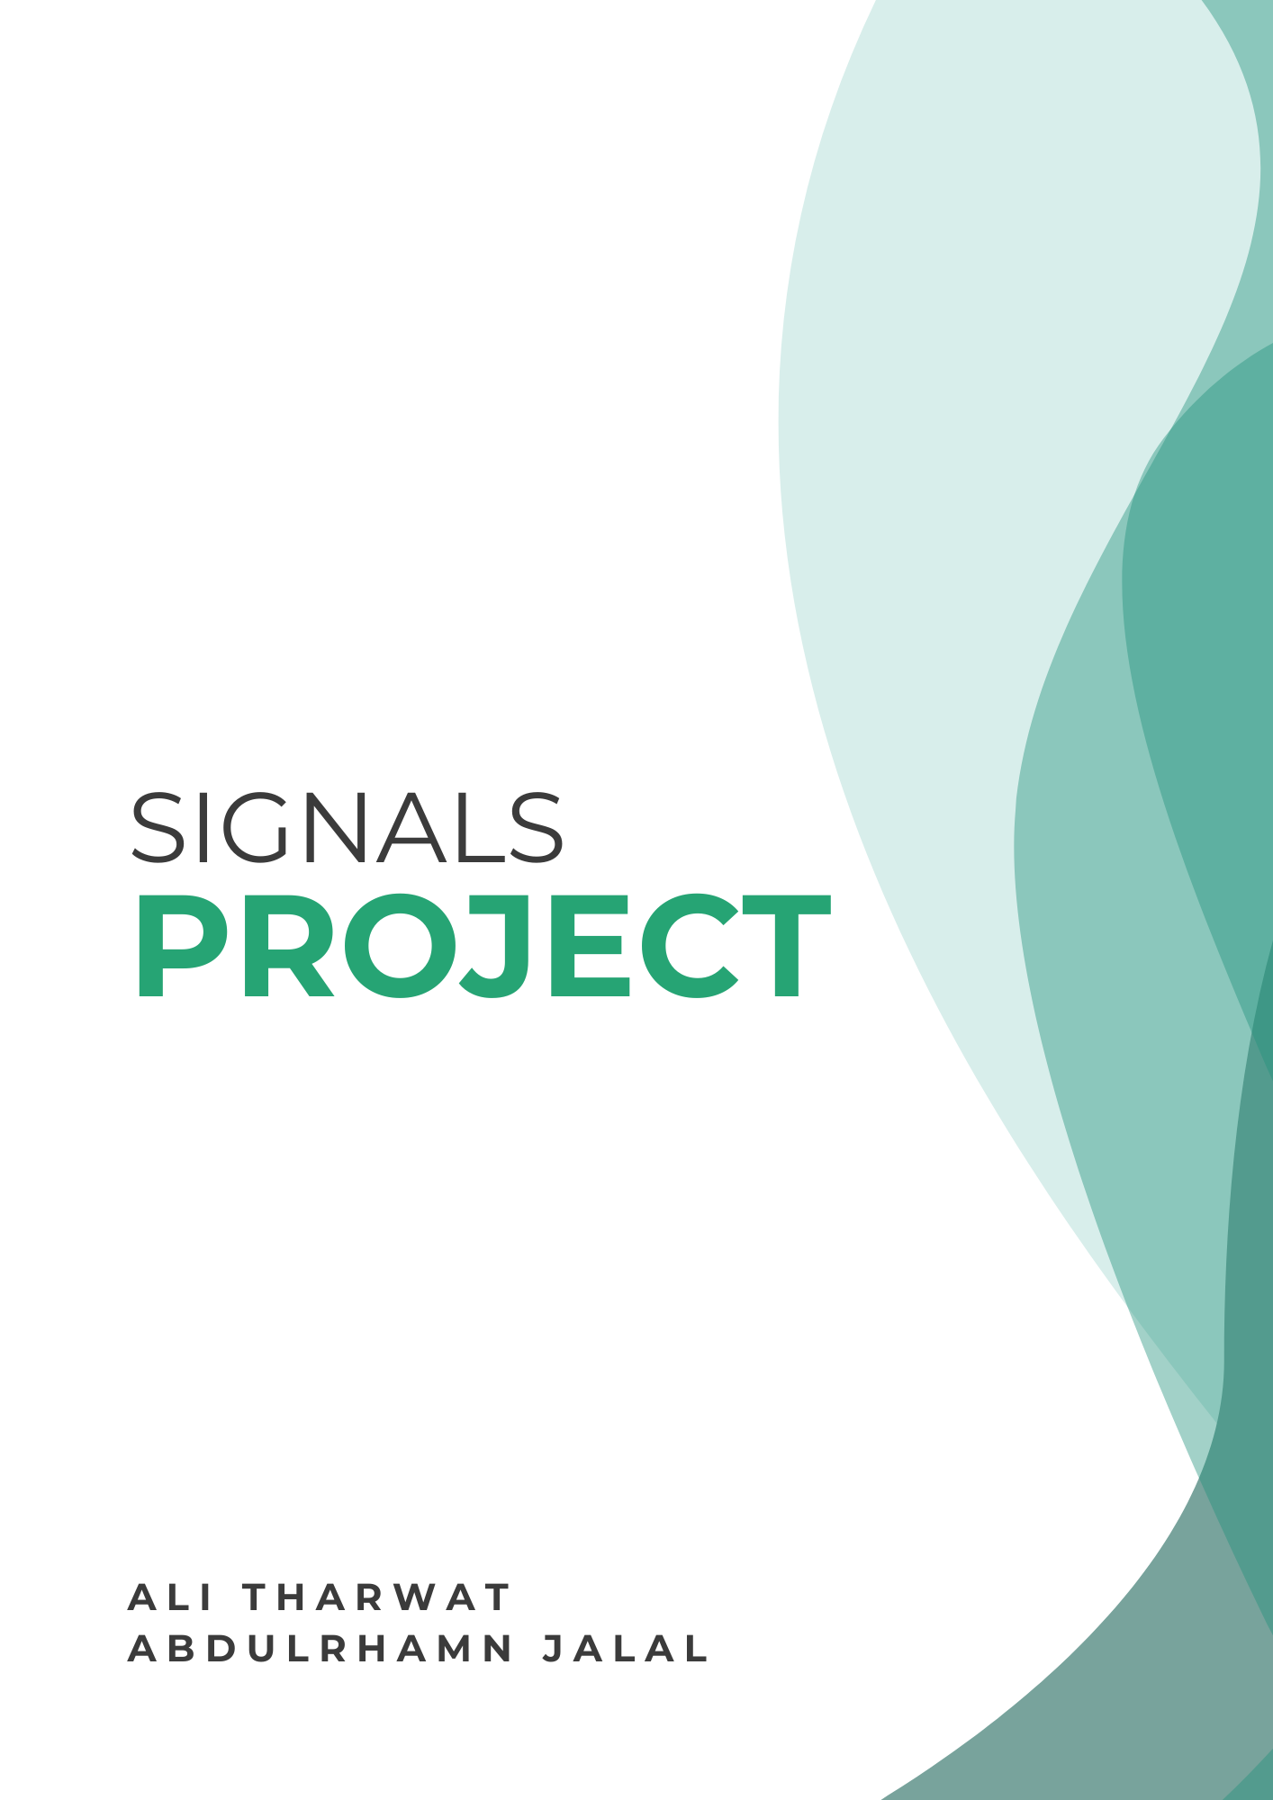

A) Radar System Design and Signal Generation
Used Parameters:
Parameter | Value
Carrier Frequency ($F_{c}$) | 77 GHz
PRI | $$2 μs$$
Pulse Width ($T_{p}$) | 4.5 ns
Sampling Points ($N$) | 1000000
SNR | -5 dB
Parameter | Formula | Result | Project Requirement
Max Unambiguous Range | $$R_{max}=\frac{C*PRI}{2}$$ | $$299.8 m$$ | Must be > 250m
Max Unambiguous Velocity | $$v_{max}=\frac{C*PRF}{4*F_{c}}$$ | $$486.7 m/s$$ | Realistic (-100 to 100)
Number of pulses | $$N=\frac{λ}{2*V_{res}*PRI}$$ | 2048 | Target velocity resolution < 0.5m/s
Pulse Width ($T_{p}$) | $$T_{p}=\frac{2* ∆R}{C}$$ | $$4.5*10^{-9}$$ | Target range resolution < 0.75m
Reported Quantities:

Chosen Scenario:
Parameter | Target 1 | Target 2
Range | 50m | 135m
Velocity | $$-20m/s$$ | $$35 m/s$$

Transmitted and received signals plots:
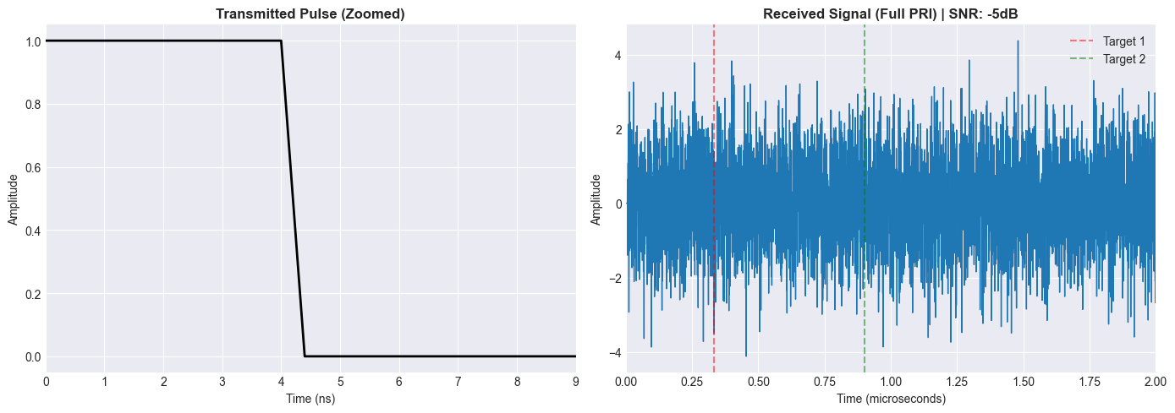
Figure 1 Transmitted/Received signals plots
The left plot represents the transmitted pulse we zoomed in a lot to show that it in fact is a rectangular pulse as from far away it appears as if it’s a line. An important note for the second plot no attention was considered we picked a small value to simulate the effect as it caused a lot of issues when we tried to realistically model it when doing the next couple of tasks.
Range Time Plot:
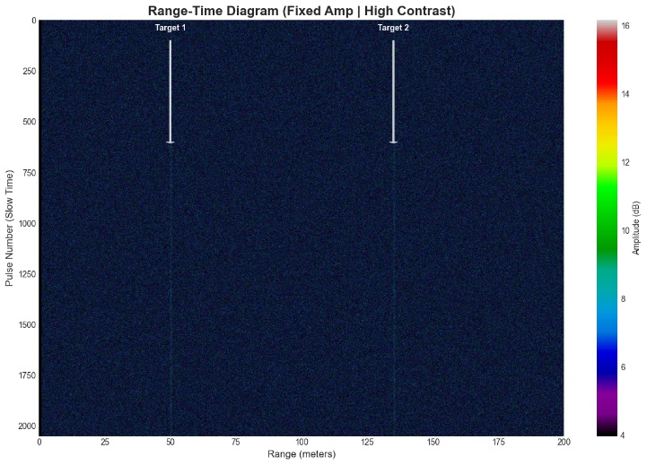
Figure 2 Range Time Plot

B) Radar System Design and Signal Generation
Received signal before any matched filter:
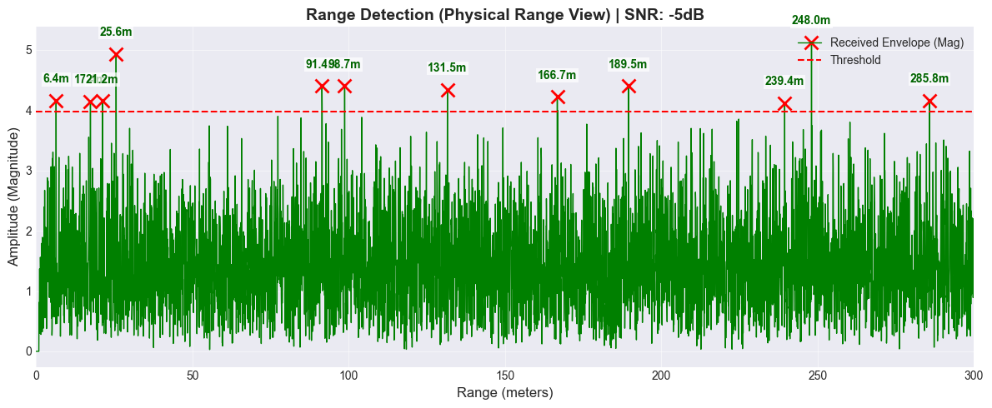
Figure 3 Noisy received signal plot

C) Velocity Estimation using Doppler Analysis

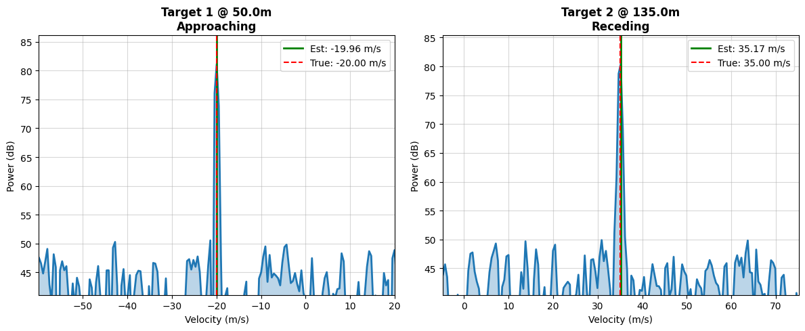 Figure 4 Doppler Spectrum

Target | Detected Range | True Range | Detected Velocities | True Velocities | Direction Classification
Target 1 | $$50.01m$$ | $$50m$$ | $$-19.96 m /s$$ | $$20.00 m /s$$ | Approaching
Target 2 | $$135.03m$$ | $$135m$$ | $$35 .17 m/s$$ | $$35 m /s$$ | Receding

D) Radar System Design and Signal Generation
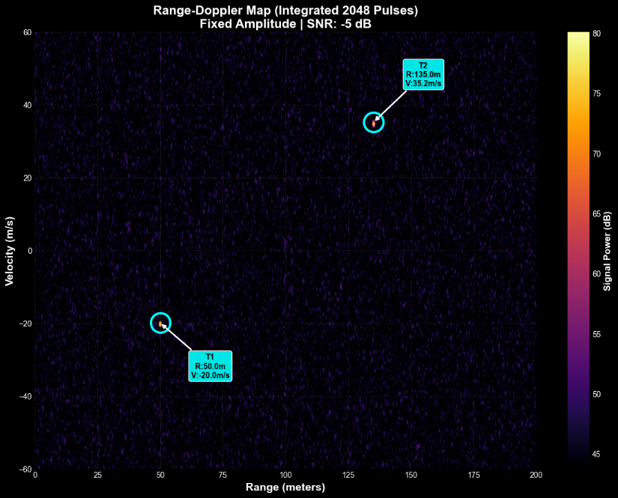
Figure 5 Range Doppler Map

