

**Assignment # 2**

**Mobile App Development**

**Name:**

M-Ali-Irtza

**Reg # no:**

L1F22BSCS0860

**Section:**

E2

**Submitted to:**

Prof. Muneeb Ali Muzaffar

**Faculty of Information Technology**

## Calculator Design

**Shapes Used:**

**Filename: line.xml** (used it as a line above my buttons)

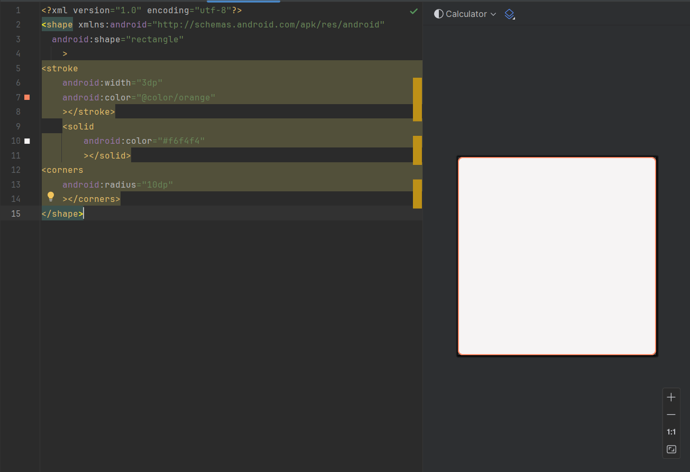

**Filename: Rectangle.xml (Used it as border for textview)**

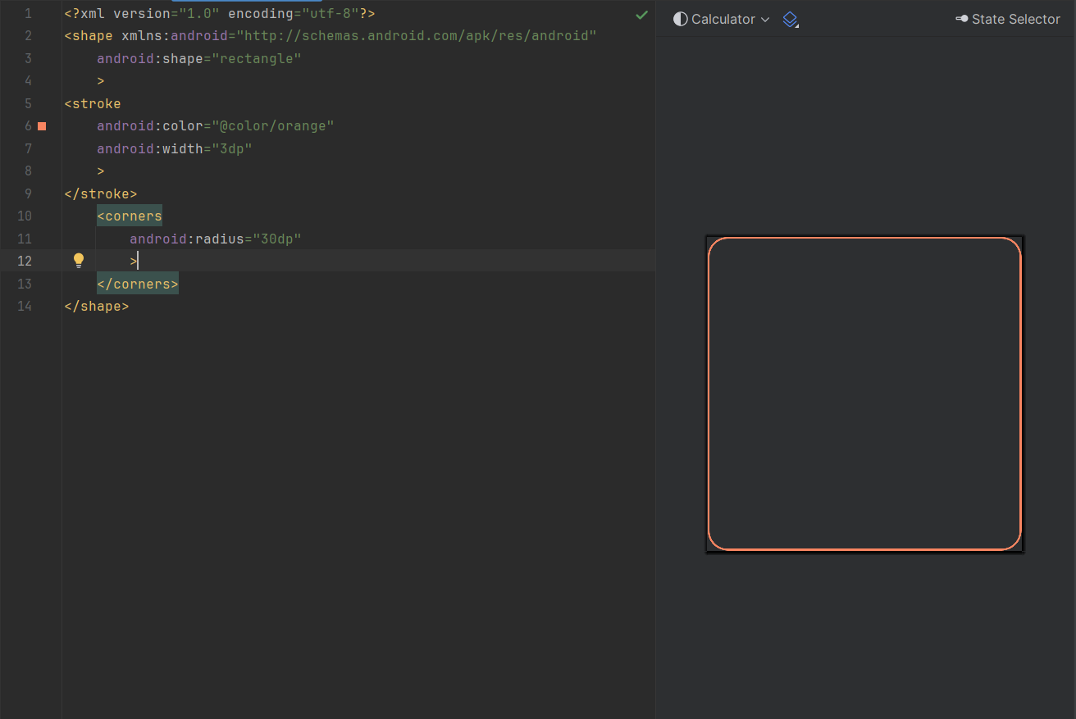

**Filename: Circle.xml** (Used it as border for buttons Layout)

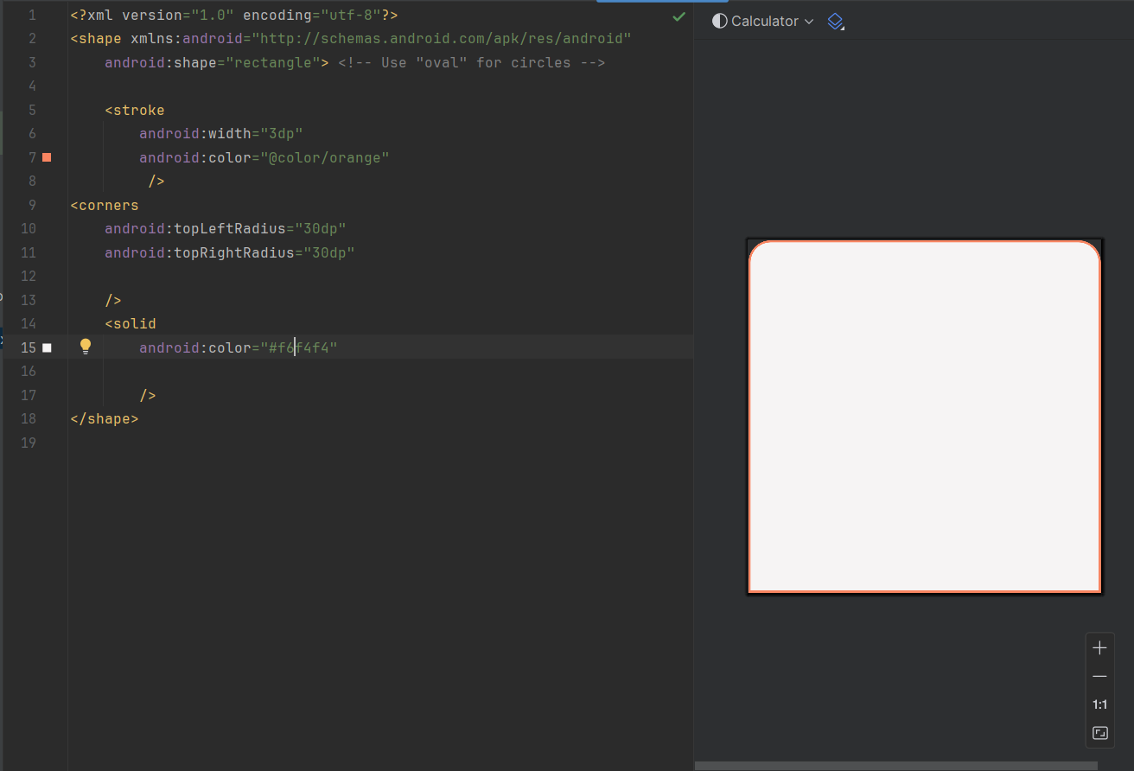

**Colors Used:**

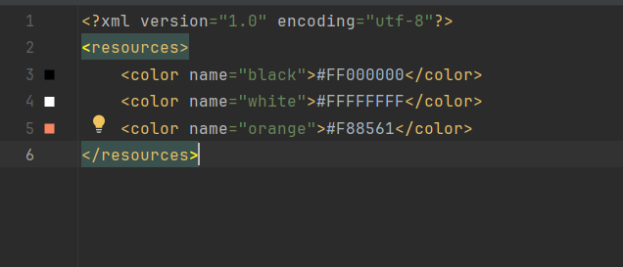

I also use a light gray color

**Color code: #F6F4F4**

**XML Code:**

**I** use a Linear layout as a main layout after that I added a relative layout and in that I use a Text view for my app’s Heading.

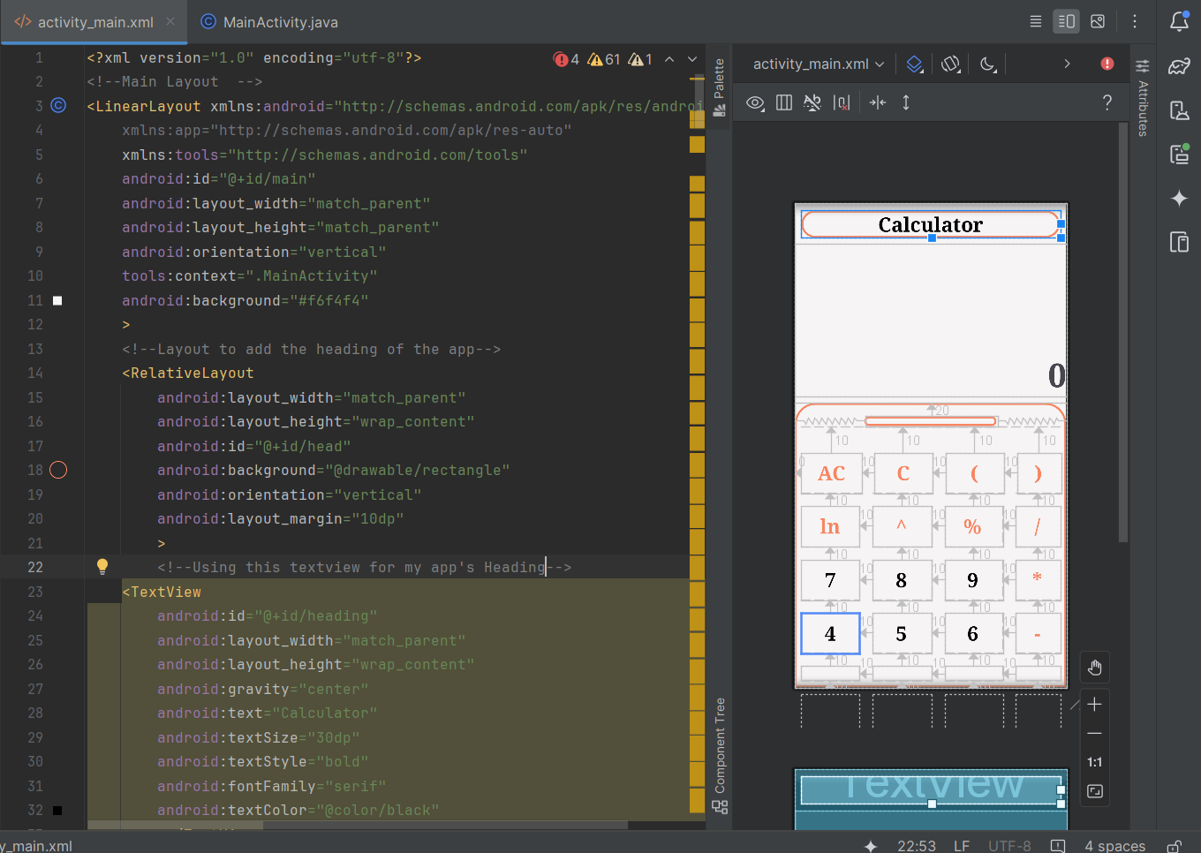

After that I made a Text view in my main linear layout for displaying the calculations then I again made a relative layout for my buttons in the start I made a line so user can swap up and down the button menu.

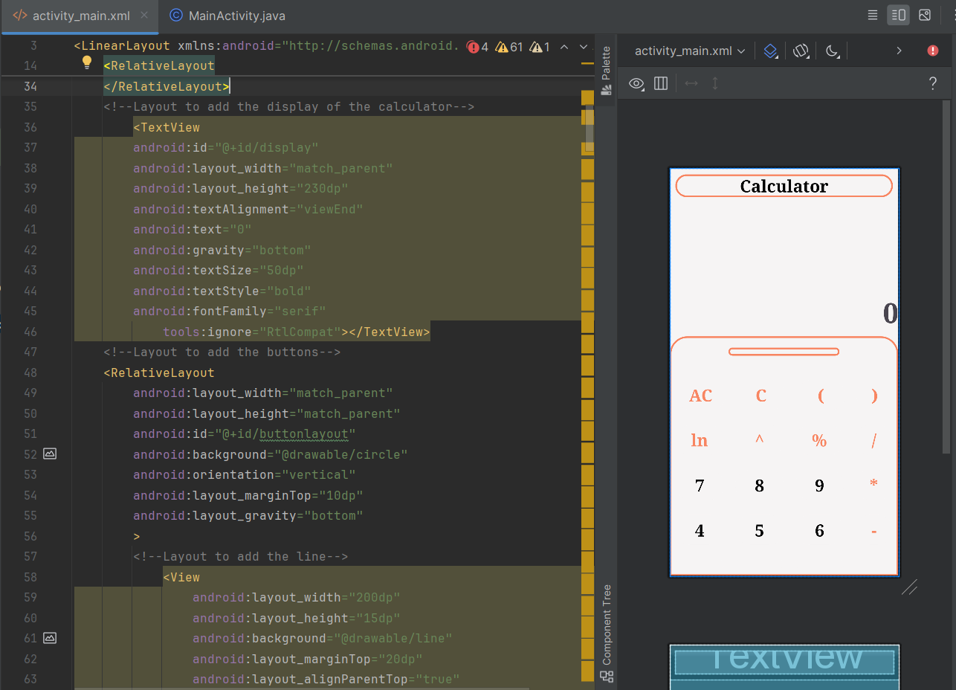

Then I start adding the buttons in my relative layout.

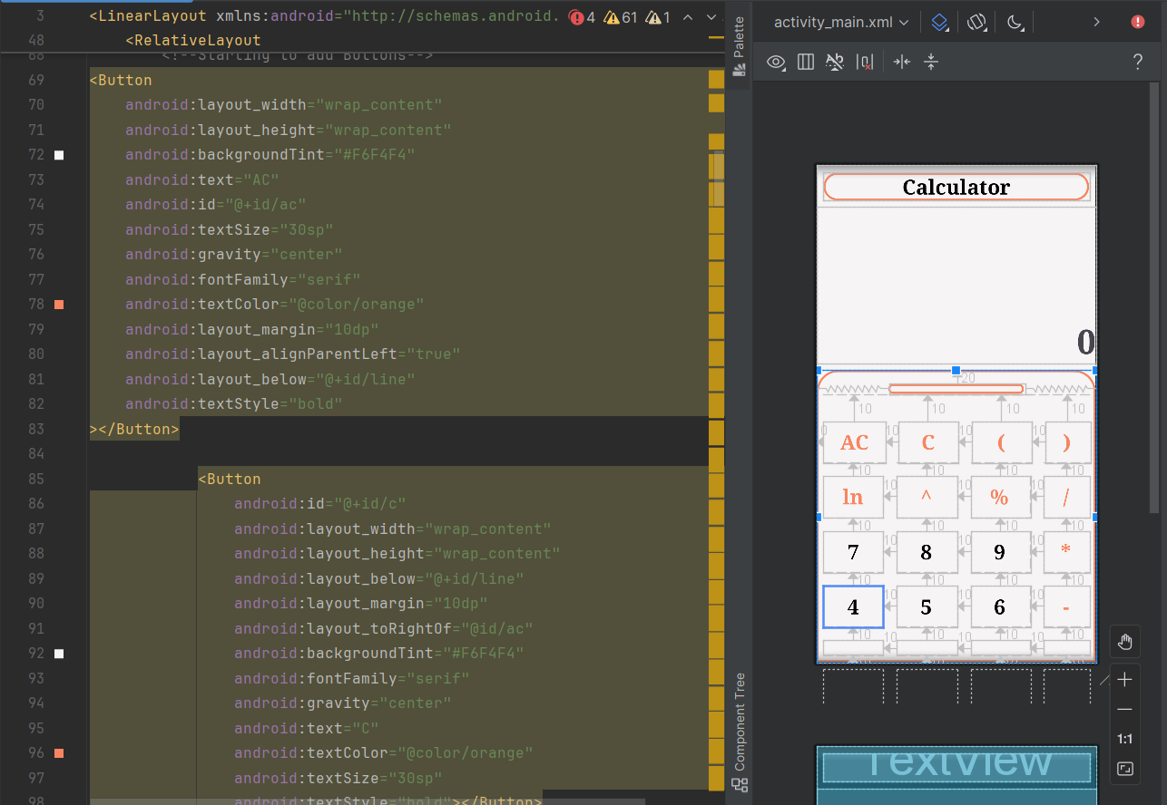

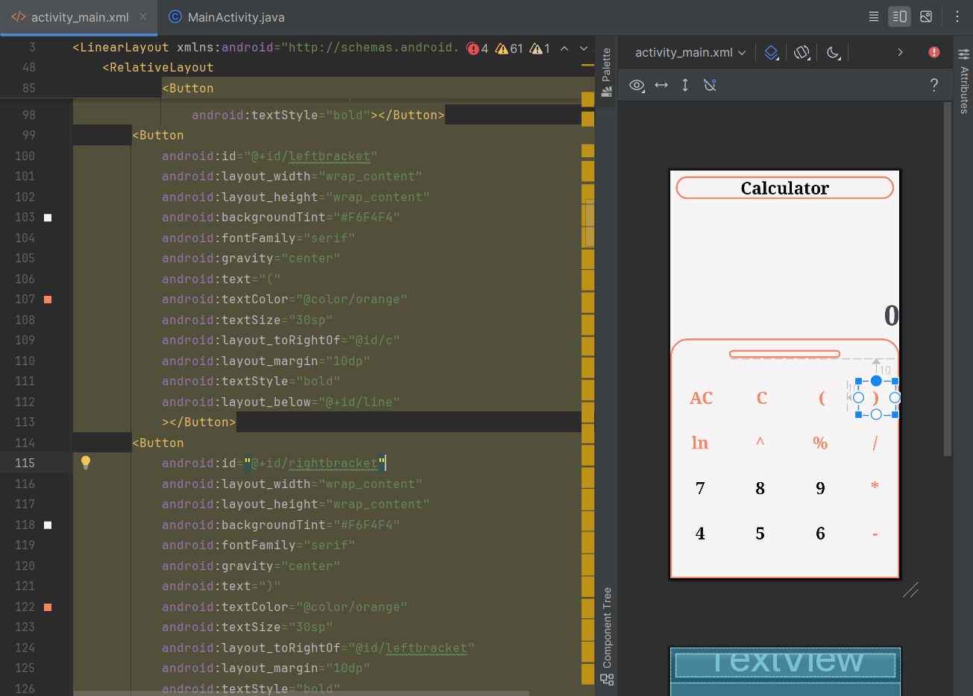

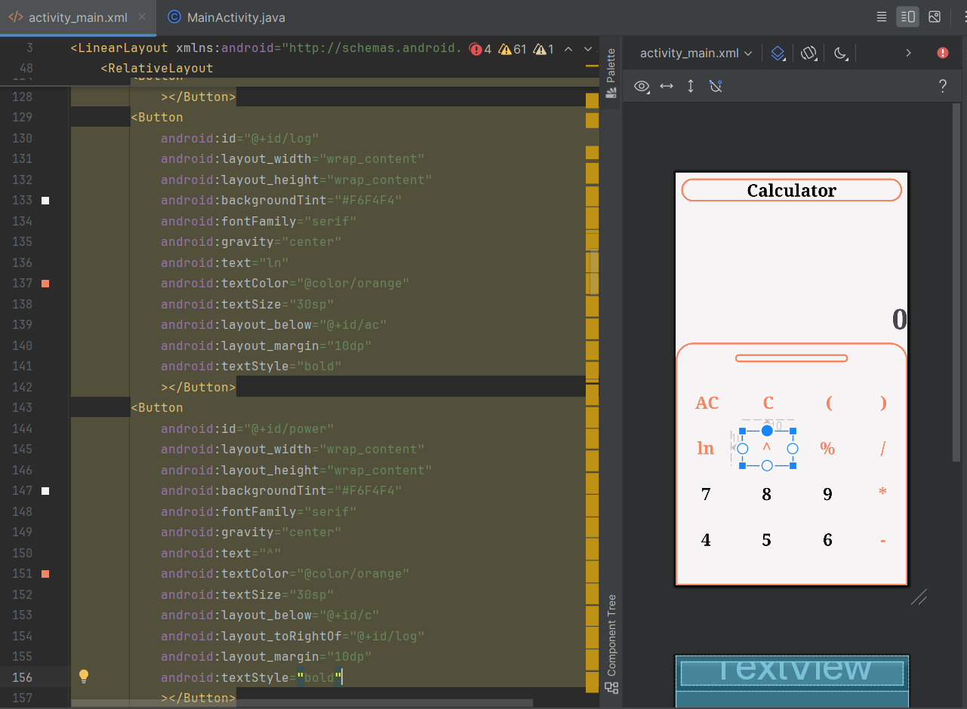

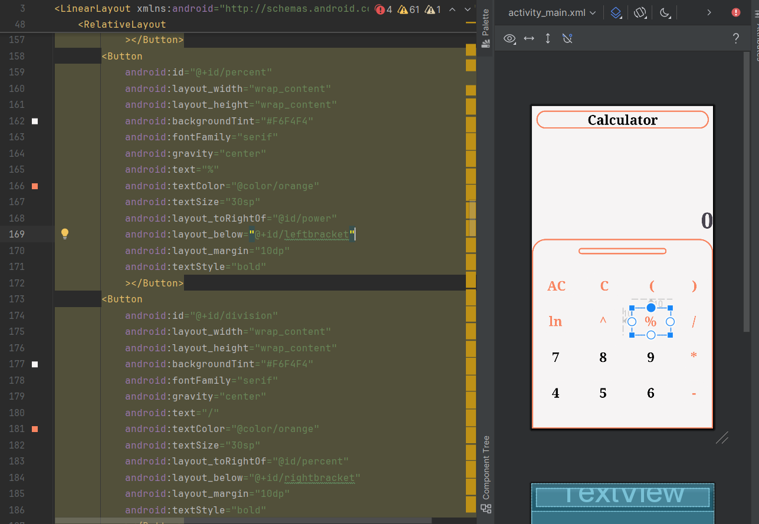

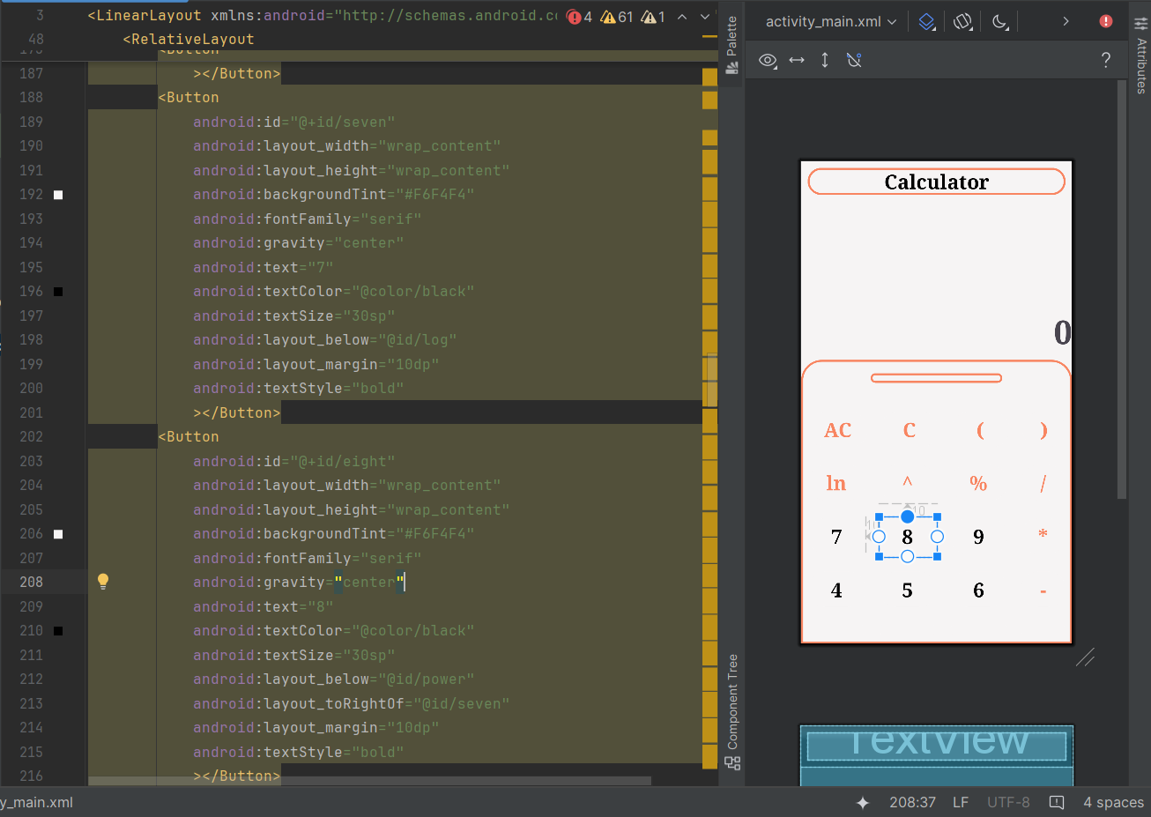

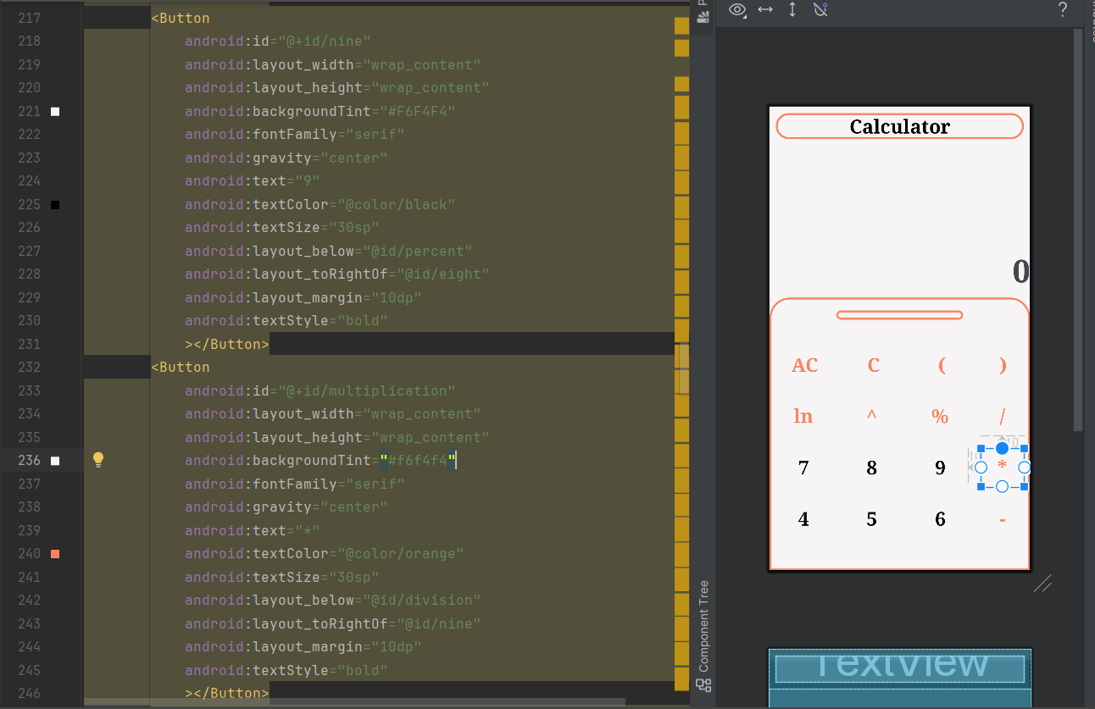

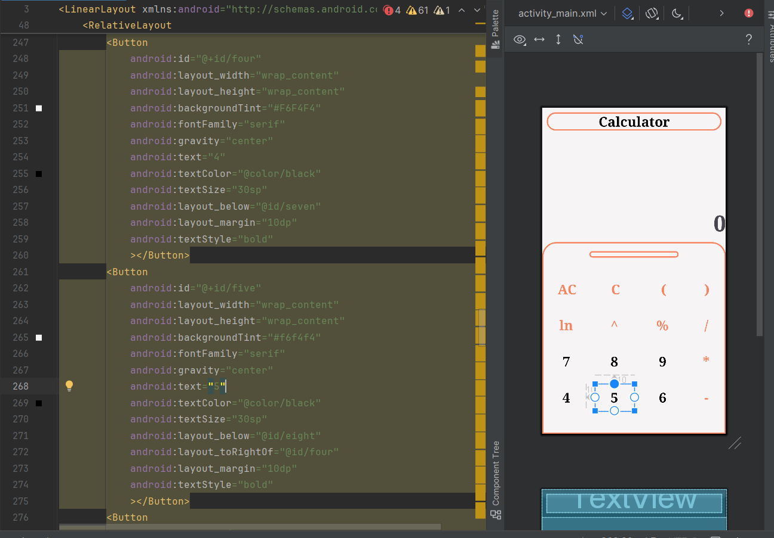

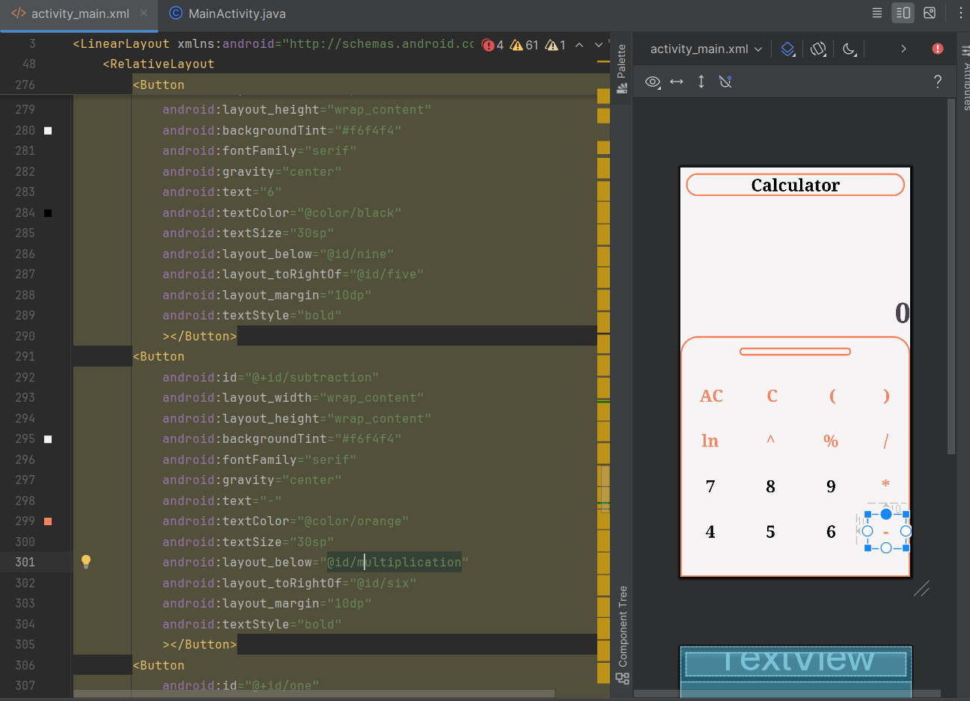

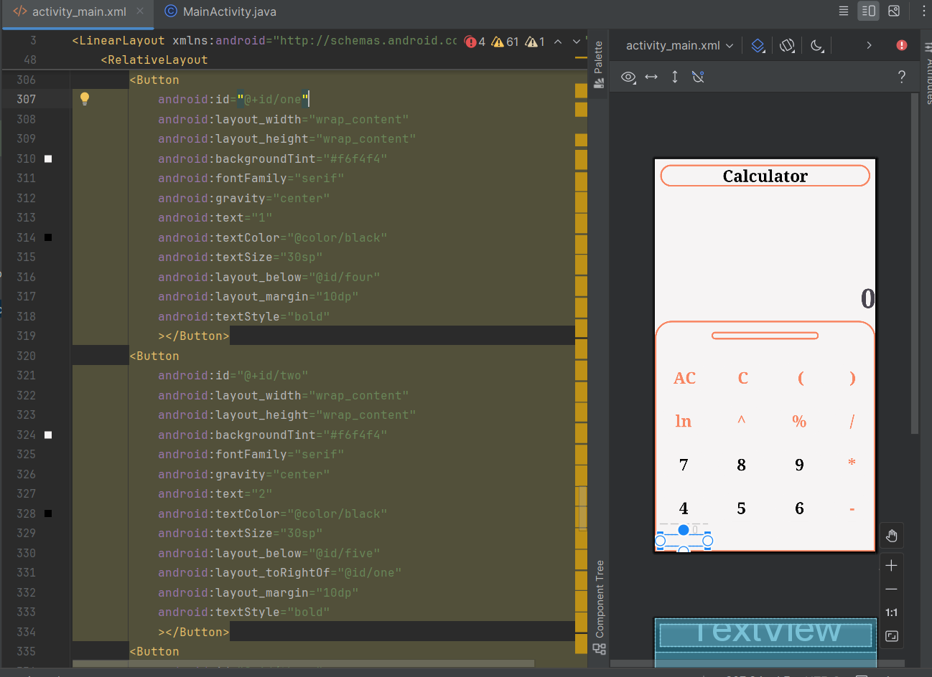

### Some buttons might not show on this screen because of the screen size difference I am designing this for Pixel 7 so these are perfect in the emulator Screen.

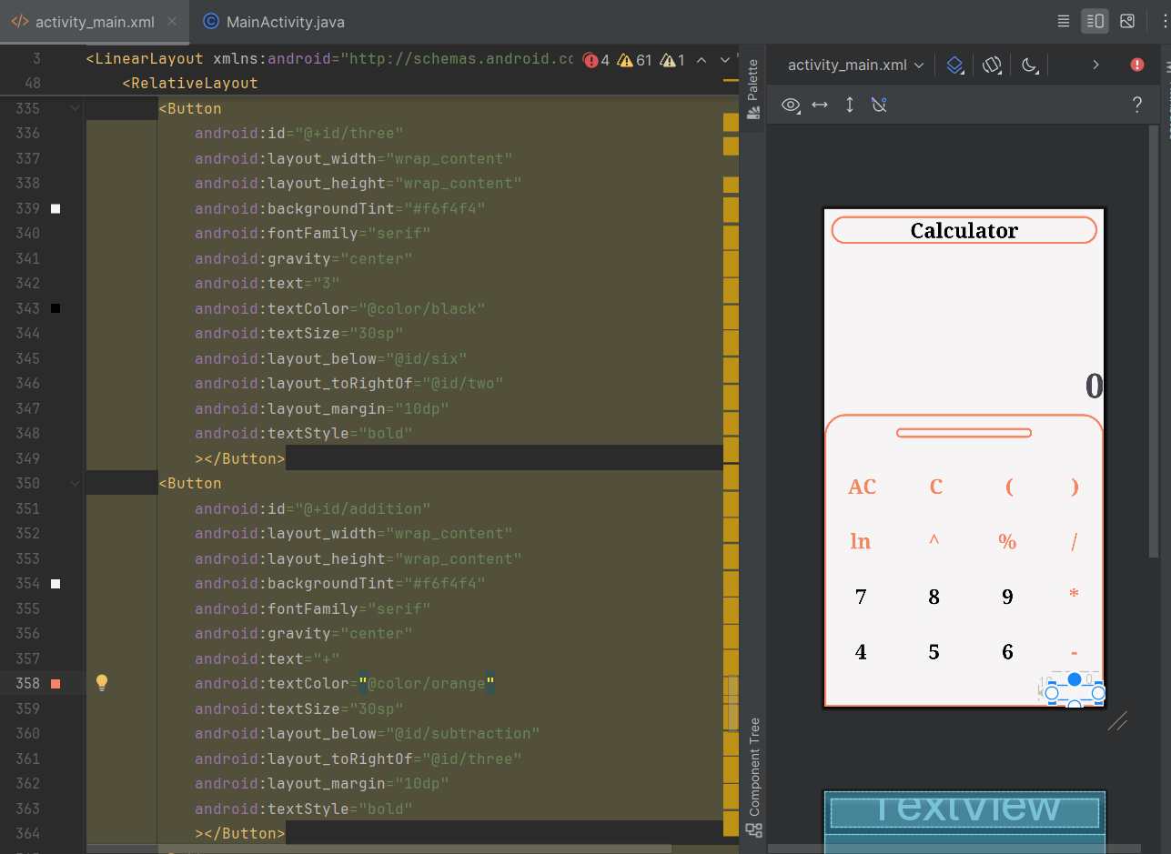.

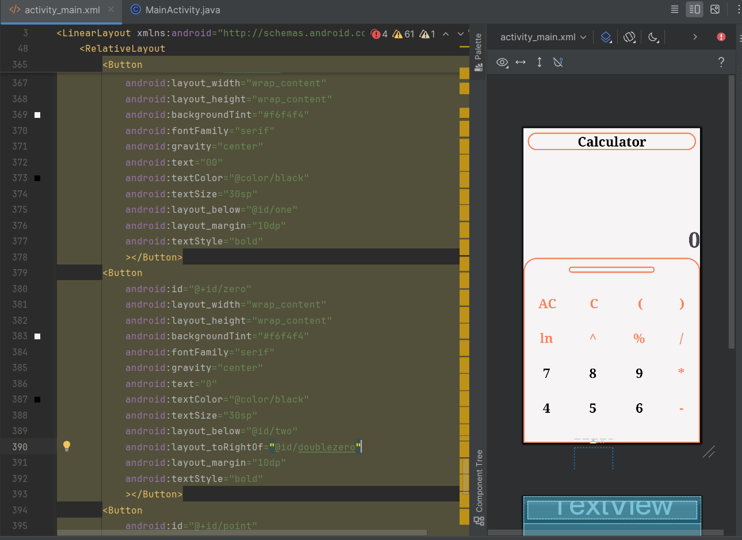

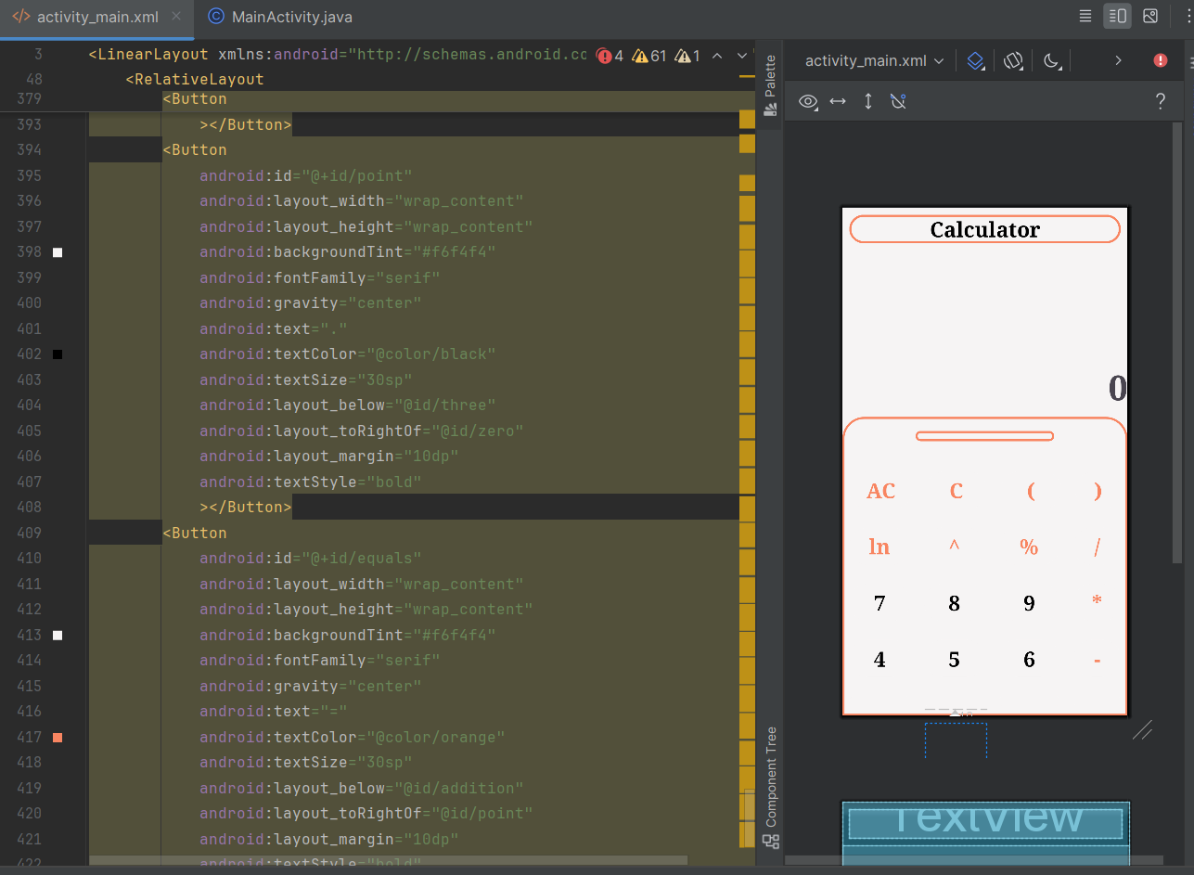

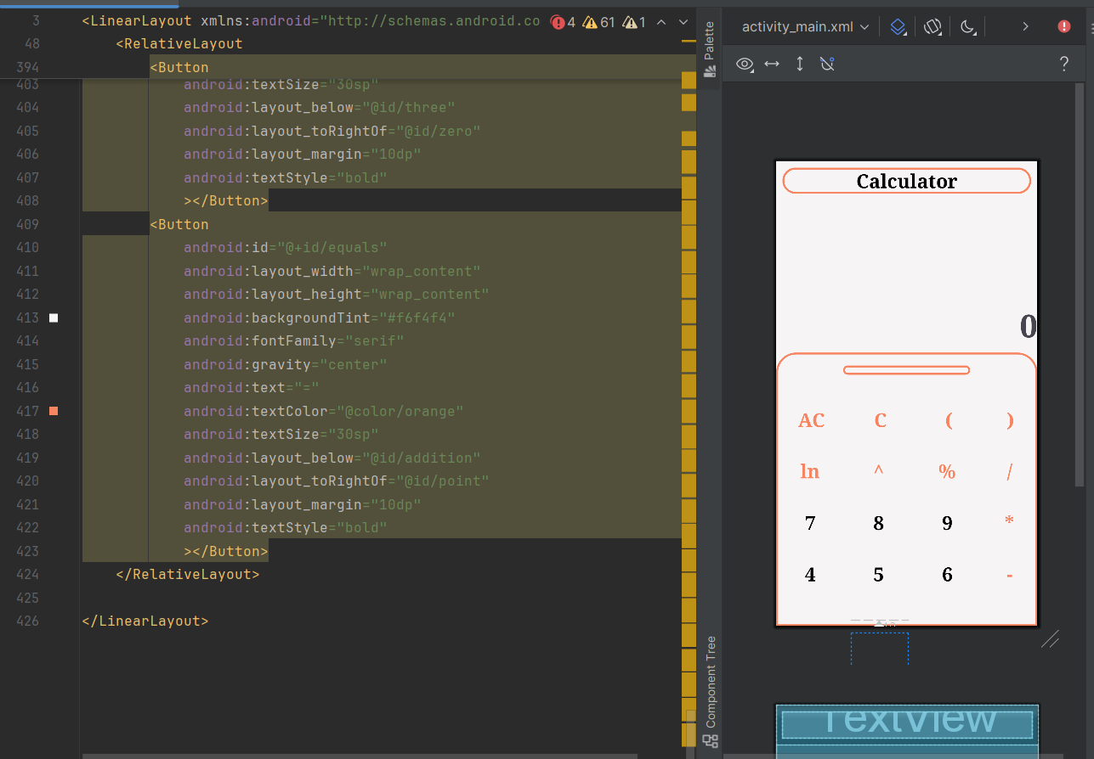

The Xml Code ends here…

**Design and Blue Print:**

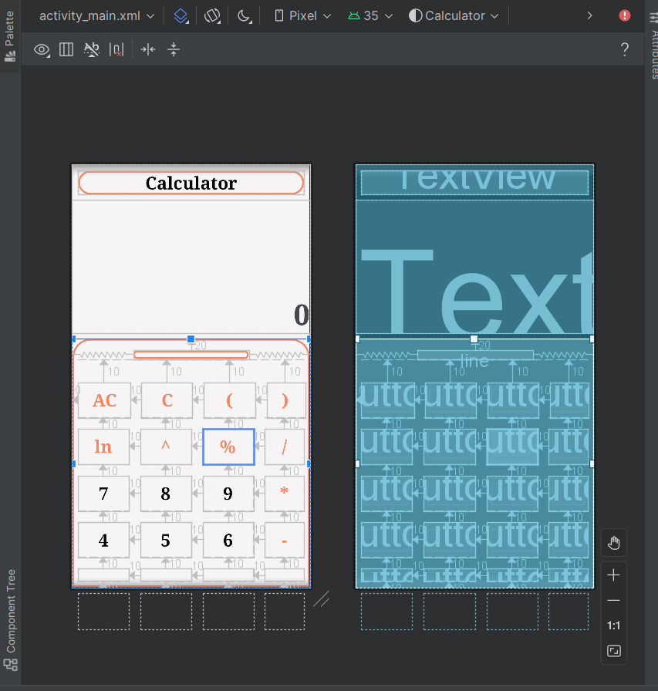

**Final Design:**

