Report
Project Title | DBMS Used
Healthcare Clinic Chronic Disease Monitoring and Health Analytics Database System | MySQL (Workbench)

Executive Summary
Executive Summary
Chronic diseases such as diabetes, hypertension, and high cholesterol require continuous monitoring, regular follow-up visits, and accurate tracking of patient health data. Healthcare clinics often face challenges in organizing patient records, tracking clinical measurements, and generating insights for decision-making. This project addresses these challenges by designing and implementing a relational database system to support chronic disease monitoring in a healthcare clinic setting.
The database was designed using an Entity-Relationship (ER) model and normalized to Third Normal Form (3NF) to ensure data integrity and reduce redundancy. The system includes eight core entities: Patients, Doctors, Departments, Visits, Vitals, Diagnoses, Medications, and FollowUps. The Visits table serves as the central transactional entity, connecting patient encounters with clinical data such as vital signs, diagnoses, and prescribed medications.
The database was implemented in MySQL using primary keys, foreign keys, and integrity constraints to enforce relationships between tables. Sample data was inserted to simulate real-world healthcare scenarios. Role-based access control was implemented with Admin, Doctor, and Receptionist roles, and views were created to restrict sensitive data access. Several SQL queries were developed to generate meaningful reports, such as identifying patients with high glucose levels, tracking doctor workloads, and analyzing common diagnoses.
This project demonstrates how a well-designed relational database can improve healthcare data management, support clinical decision-making, and enhance operational efficiency. Future improvements could include integration with a web-based application and advanced analytics dashboards.

Business Rules & Assumptions

System Overview / Scenario Description
This database models a healthcare clinic system that manages patients with chronic diseases. It supports patient visits, health monitoring, diagnosis tracking, medication management, and follow-up scheduling

Business Rules
- Rule 1: Each patient can have multiple visits, but each visit belongs to one patient.
- Rule 2: Each doctor can manage multiple visits, but each visit is assigned to one doctor.
- Rule 3: Each visit must have one diagnosis.
- Rule 4: Each visit records one set of vitals.
- Rule 5: Each doctor belongs to one department.
- Rule 6: Each visit may prescribe multiple medications.
- Rule 7: Each patient may have multiple follow-up appointments.
- Rule 8: Each follow-up is linked to a previous visit.

Assumptions
The system models outpatient clinic operations only.
Each visit records one primary diagnosis for simplicity.
Vital measurements (e.g., glucose, blood pressure) are recorded during visits.
The system does not include a separate laboratory testing module.

Entity-Relationship Diagram
ER Diagram
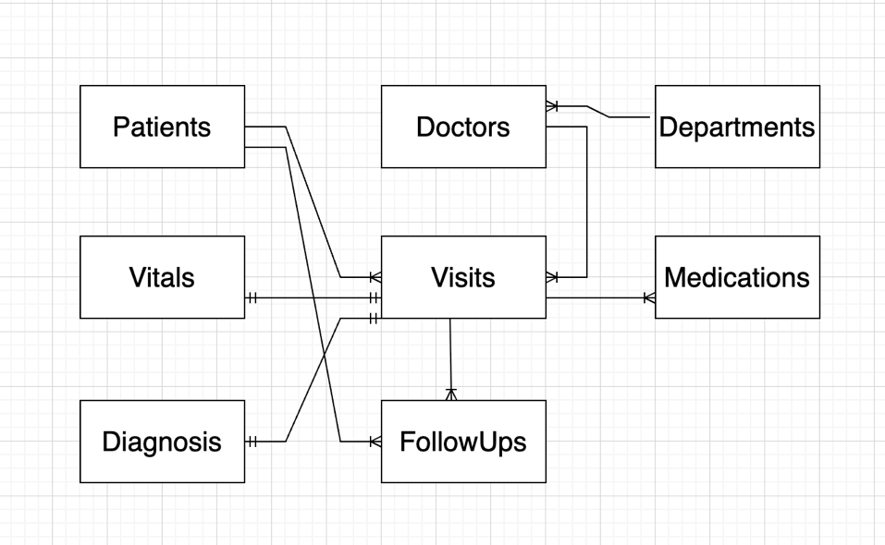

Entity Summary
Entity Name | Primary Key | Description / Purpose
Patients | PatientID | Stores patient demographic information
Doctors | DoctorID | Stores doctor details and specialties
Departments | DepartmentID | Stores clinic departments
Visits | VisitID | Represents patient visits (central entity)
Vitals | VitalID | Stores health measurements per visit
Diagnoses | DiagnosisID | Stores diagnosis per visit
Medications | MedicationID | Stores medications prescribed
FollowUps | FollowUpID | Stores follow-up appointments

Normalization to 3NF
3NF Quick Reference
1NF: All attributes are atomic (no repeating groups, no multi-valued attributes). Each row is unique.
2NF: In 1NF AND every non-key attribute is fully functionally dependent on the entire primary key (no partial dependencies).
3NF: In 2NF AND no non-key attribute is transitively dependent on the primary key.

Normalization Walkthrough
Relation 1 — Clinic Visit Data
Unnormalized Form
A single table contained patient, doctor, diagnosis, medications, and vitals.
1NF
Removed repeating medication fields and stored medications separately.
2NF
Separated patient and doctor information into independent tables.
3NF
Removed transitive dependency by separating Departments from Doctors.

Relation 2 — Doctor Department Dependency
Before
Doctor table included DepartmentName.
Issue
DepartmentName depended on DepartmentID (transitive dependency).
After
Doctors (DoctorID, DoctorName, DepartmentID)
Departments (DepartmentID, DepartmentName)

MySQL Implementation

5.1 — CREATE TABLE Statements

CREATE TABLE Visits (
VisitID INT PRIMARY KEY AUTO_INCREMENT,
PatientID INT,
DoctorID INT,
VisitDate DATE NOT NULL,
ReasonForVisit VARCHAR(100),
FOREIGN KEY (PatientID) REFERENCES Patients(PatientID),
FOREIGN KEY (DoctorID) REFERENCES Doctors(DoctorID)
);

5.2 — Sample INSERT Statements
INSERT INTO Visits (PatientID, DoctorID, VisitDate, ReasonForVisit)
VALUES (1, 2, '2026-04-01', 'Diabetes Checkup');

Notes on Constraints & Integrity
Primary keys ensure uniqueness
Foreign keys enforce relationships
NOT NULL ensures required fields
Referential integrity prevents invalid deletions

User Roles, Privileges & Views

6.1 — User Roles and GRANT / REVOKE
CREATE USER 'admin1'@'localhost' IDENTIFIED BY 'admin123';
CREATE USER 'doctor1'@'localhost' IDENTIFIED BY 'doctor123';
CREATE USER 'reception1'@'localhost' IDENTIFIED BY 'recep123';
GRANT ALL PRIVILEGES ON clinic_db.* TO 'admin1'@'localhost';

GRANT SELECT, INSERT, UPDATE ON clinic_db.Patients TO 'doctor1'@'localhost';
GRANT SELECT, INSERT, UPDATE ON clinic_db.Visits TO 'doctor1'@'localhost';
GRANT SELECT, INSERT, UPDATE ON clinic_db.Vitals TO 'doctor1'@'localhost';
GRANT SELECT, INSERT, UPDATE ON clinic_db.Diagnoses TO 'doctor1'@'localhost';
GRANT SELECT, INSERT, UPDATE ON clinic_db.Medications TO 'doctor1'@'localhost';

GRANT SELECT, INSERT, UPDATE ON clinic_db.Patients TO 'reception1'@'localhost';
GRANT SELECT, INSERT, UPDATE ON clinic_db.Visits TO 'reception1'@'localhost';
GRANT SELECT, INSERT, UPDATE ON clinic_db.FollowUps TO 'reception1'@'localhost';

FLUSH PRIVILEGES;

Username / Role | Privileges Granted | Reason / Use Case
Admin | Full access | System management
Doctor | Clinical data access | Patient treatment
Receptionist | Limited access | Scheduling & registration

6.2 — Views for Access Restriction

- CREATE VIEW Reception_View AS
- SELECT PatientID, FirstName, LastName, Phone
- FROM Patients;

- CREATE VIEW Doctor_View AS
- SELECT p.PatientID, p.FirstName, p.LastName,
- v.VisitDate,
- d.DiagnosisName
- FROM Patients p
- JOIN Visits v ON p.PatientID = v.PatientID
- JOIN Diagnoses d ON v.VisitID = d.VisitID;

Reports & Queries

Report Requirements
-- Query 2: Patients with high glucose level
SELECT p.PatientID, p.FirstName, p.LastName, v.GlucoseLevel
FROM Patients p
JOIN Visits vt ON p.PatientID = vt.PatientID
JOIN Vitals v ON vt.VisitID = v.VisitID
WHERE v.GlucoseLevel > 140;
-- Query 6: Average cholesterol level
SELECT AVG(CholesterolLevel) AS AverageCholesterol
FROM Vitals;
-- Query 7: Missed follow-up appointments
SELECT p.FirstName, p.LastName, f.FollowUpDate, f.Status
FROM Patients p
JOIN FollowUps f ON p.PatientID = f.PatientID
WHERE f.Status = 'Missed';
-- Query 5: Doctor with most visits
SELECT d.DoctorName, COUNT(v.VisitID) AS TotalVisits
FROM Doctors d
JOIN Visits v ON d.DoctorID = v.DoctorID
GROUP BY d.DoctorName
ORDER BY TotalVisits DESC;
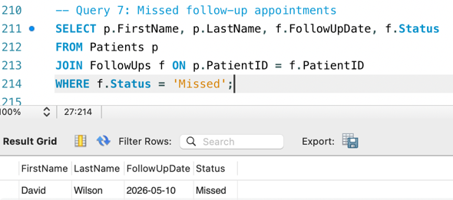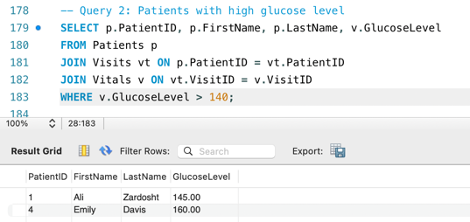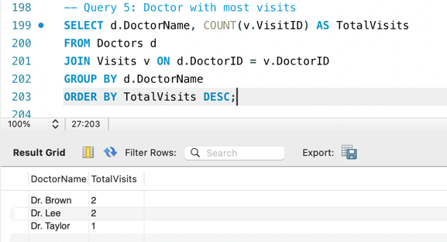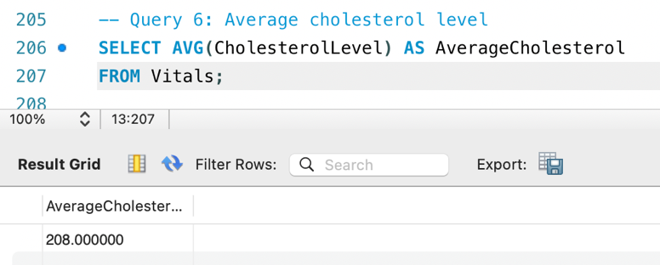

Report 1
Report 1 — Business Purpose
-- Query: Patients with high glucose level

- SELECT p.PatientID, p.FirstName, p.LastName, v.GlucoseLevel
FROM Patients p
JOIN Visits vt ON p.PatientID = vt.PatientID
JOIN Vitals v ON vt.VisitID = v.VisitID
WHERE v.GlucoseLevel > 140;

Report 1 — Sample Output / Screenshot


Report 2
Report 2 — Business Purpose
-- Query: Average cholesterol level

- SELECT AVG(CholesterolLevel) AS AverageCholesterol
FROM Vitals;

Report 2 — Sample Output / Screenshot


Report 3
Report 3 — Business Purpose
-- Query: Missed follow-up appointments

- SELECT p.FirstName, p.LastName, f.FollowUpDate, f.Status
FROM Patients p
JOIN FollowUps f ON p.PatientID = f.PatientID
WHERE f.Status = 'Missed';

Report 3 — Sample Output / Screenshot


Report 4
Report 4 — Business Purpose
-- Query: Doctor with most visits

- SELECT d.DoctorName, COUNT(v.VisitID) AS TotalVisits
FROM Doctors d
JOIN Visits v ON d.DoctorID = v.DoctorID
GROUP BY d.DoctorName
ORDER BY TotalVisits DESC;

Report 4 — Sample Output / Screenshot
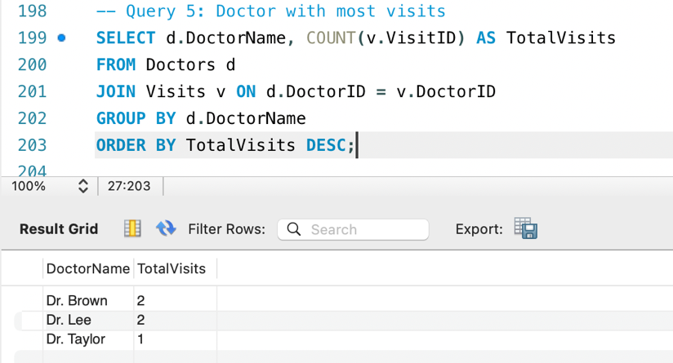

Section 9: Conclusion

Conclusion (1–2 paragraphs)
This project successfully designed and implemented a healthcare clinic database system for chronic disease monitoring. The system met the original project goals by providing a normalized relational structure, enforcing data integrity through constraints, and supporting meaningful data analysis through SQL queries.
Key challenges included designing relationships between multiple entities and ensuring normalization. These were addressed through careful schema design and adherence to database principles. Future improvements could include web integration, advanced analytics, and scalability enhancements.
Overall, this project demonstrates how database systems can improve healthcare efficiency and support data-driven decision-making.

