Taxonomy Agent
User Guide

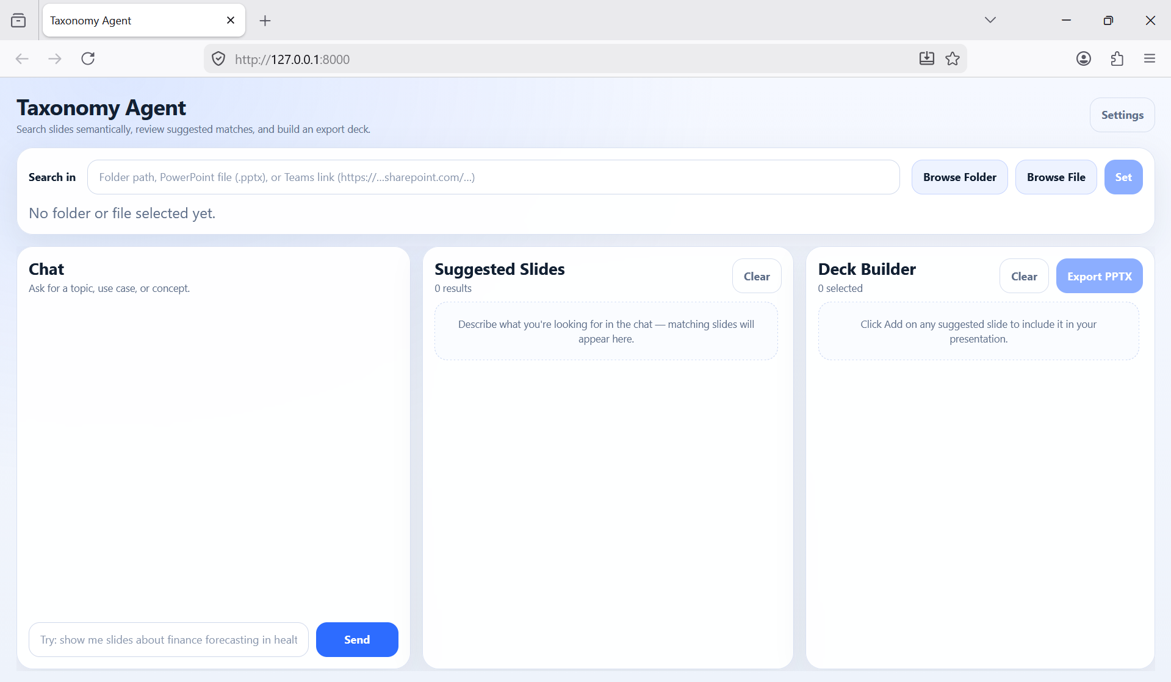
This guide walks you through every feature of the application.
No technical knowledge required.

Contents
- 1. What Does This App Do?
- 2. The Screen at a Glance
- 3. Step 1 – Choose Where to Search
- 4. Step 2 – Sign In to Microsoft (Teams folders only)
- 5. Step 3 – Wait for Indexing to Finish
- 6. Step 4 – Search for Slides
- 7. Reading the Suggested Slides
- 8. Step 5 – Build Your Deck
- 9. Step 6 – Export Your Presentation
- 10. Settings – All Options Explained
- 11. Complete Step-by-Step Workflows
- 12. Common Problems & How to Fix Them
- 13. Quick Reference – Every Button

1. What Does This App Do?
Taxonomy agent helps you quickly find specific slides across many PowerPoint presentations — without opening each file manually. You describe what you are looking for in plain English, and the app shows you the most relevant slides from your files. You can then pick the slides you want, arrange them in order, and export them as a brand-new PowerPoint presentation in seconds.
The app can search across three types of sources:
- Local folder: A folder on your computer containing multiple .pptx files
- Single file: A single .pptx file on your computer
- Teams / SharePoint folder: A folder shared via Microsoft Teams or SharePoint (Does not work for now. Still needs permission)

TIP The search is 'semantic' — it understands the meaning of your words, not just exact matches. Searching for 'patient outcomes' may also find slides about 'clinical results' or 'treatment effectiveness'.

2. The Screen at a Glance
When you open the app, you see four main areas. Here is a quick overview before we walk through each one in detail.

Area | Where it is | What it does
Search in | Top of the page | Choose which folder, file, or Teams link to search
Chat panel | Left column | Type what you are looking for in plain English
Suggested Slides | Middle column | Shows the slides that match your search
Deck Builder | Right column | Holds the slides you have chosen to export
Settings | Top-right corner | Configure how the app saves and indexes files

3. Step 1 – Choose Where to Search
Before you can search, you must tell the app where your PowerPoint files are. The 'Search in' bar is at the very top of the page.

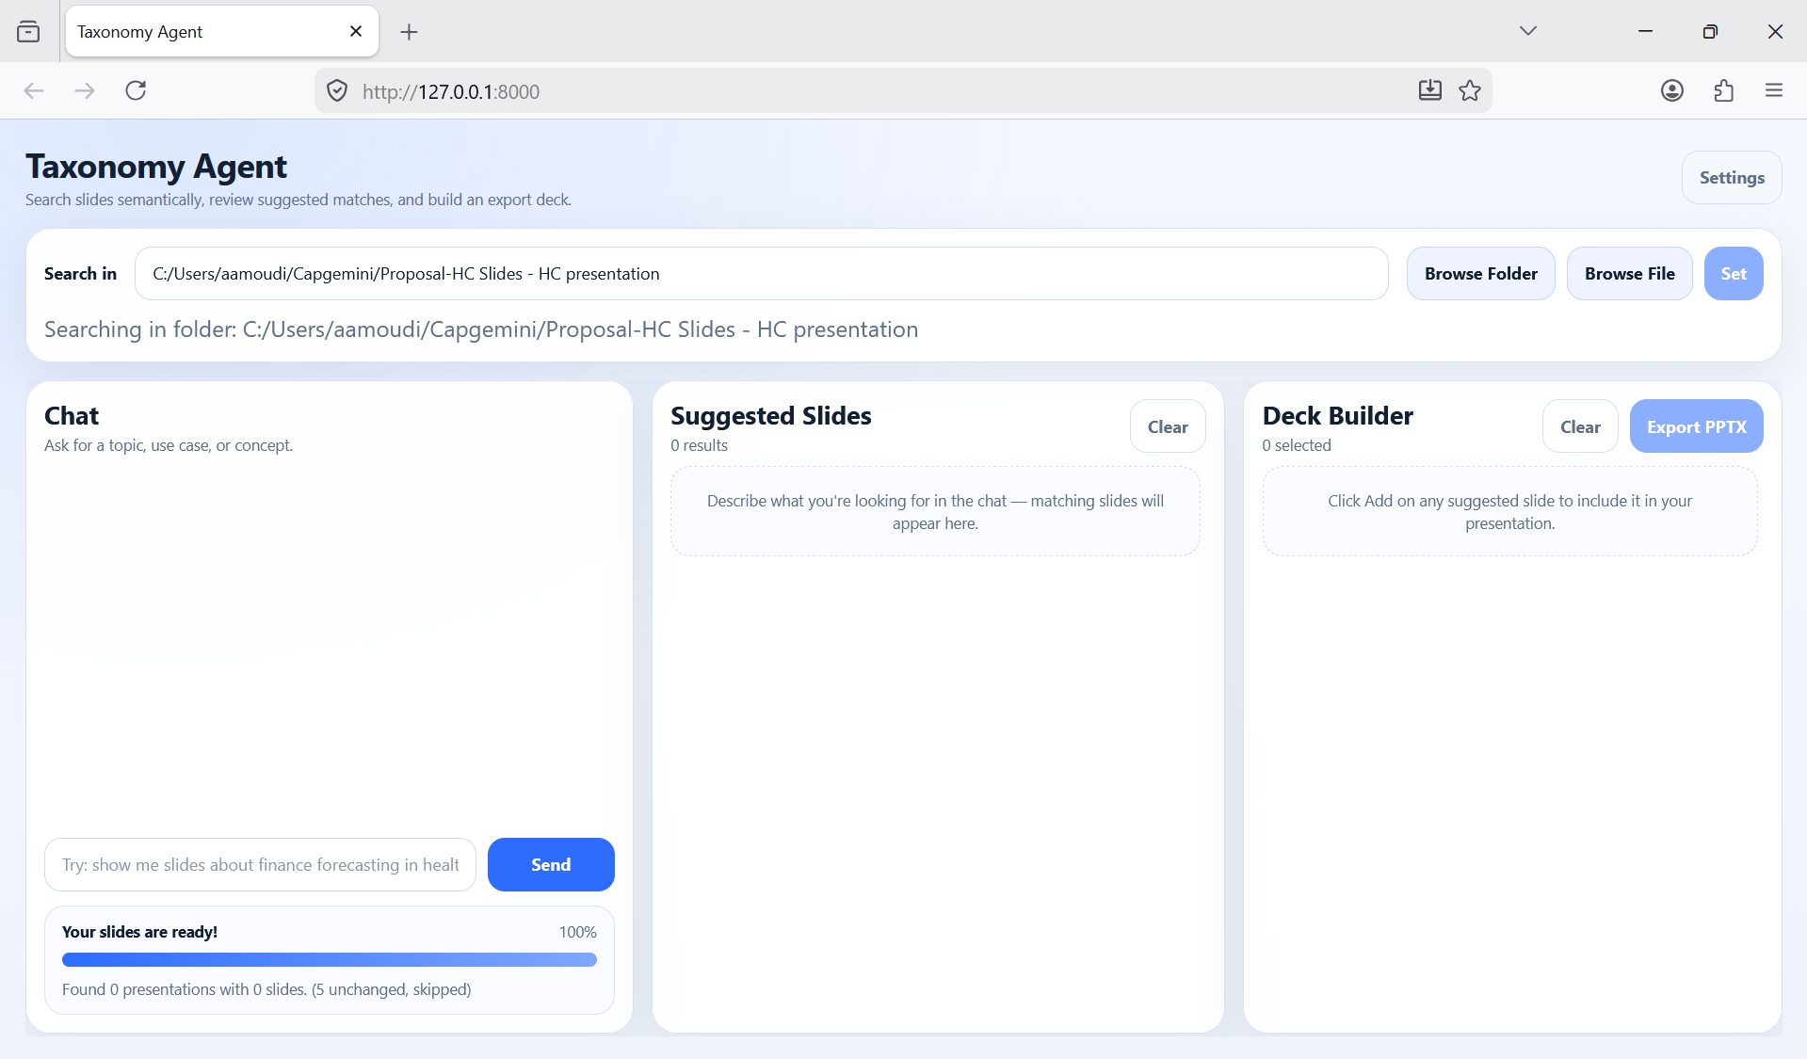3a. Searching a Local Folder
Use this when you have a folder on your computer (or a shared network drive) that contains one or more PowerPoint files.
How to do it:
- Click the Browse Folder button.
- A window opens — navigate to your folder and click OK / Select Folder.
- The folder path appears in the text box and indexing starts automatically.
TIP You can also type or paste a folder path directly into the text box and then click Set.

3b. Searching a Single PowerPoint File
Use this when you only want to search within one specific presentation — for example, to find a slide you remember seeing in a particular deck.
How to do it:
- Click the Browse File button.
- A file picker opens — find and select your .pptx file, then click Open.
- The file path appears in the text box and indexing starts.

3c. Searching a Teams / SharePoint Folder (Does not work now. Still needs permission)
Use this when your presentations are stored in Microsoft Teams or SharePoint. You will need to sign in to your work Microsoft account.
How to find the link:
- In Microsoft Teams, open the Files tab of any channel.
- Navigate to the folder you want to search.
- Click the three-dot (…) menu next to the folder name and choose 'Copy link'.
- Paste that link into the 'Search in' text box.
- Click the Set button.
NOTE If you are not already signed in, a Microsoft sign-in window will open automatically. See Section 4 for sign-in instructions.

3d. Understanding the Status Message
Below the 'Search in' bar a status line shows what is currently selected:
Status message | What it means
No folder or file selected yet. | Nothing has been selected — choose a source to begin.
Searching in folder: C:\…\Slides | A local folder is active.
Searching in file: C:\…\deck.pptx | A single file is active.
Teams folder: My Team – Project Files | A Teams/SharePoint folder is active.

4. Step 2 – Sign In to Microsoft (Teams folders only)
If you set a Teams or SharePoint link and you are not yet signed in, the app will open a sign-in window automatically. This is a one-time step — once signed in, you can switch between different Teams folders without signing in again.

Follow these three steps inside the sign-in window:
- Click the blue link that says 'microsoft.com/devicelogin'. This opens your web browser.
- Enter the code shown in the window (click Copy to copy it automatically, then paste it in the browser).
- Sign in with your work Microsoft 365 account.
Once complete, the window closes automatically, and the top-right corner of the app shows 'Microsoft: Connected'. The app will then begin reading your Teams folder.
NOTE Your sign-in is remembered until you click Sign out. If your session expires, you will be prompted to sign in again.

Signing Out
Click the Sign out button (top-right) at any time to disconnect from Microsoft. This clears your credentials. You will need to sign in again to access any Teams folders.
(More on this once the feature is working)

5. Step 3 – Wait for Indexing to Finish
'Indexing' means the app is reading all the slides in your files so it can search them later. You only need to wait for this once per folder — after that the app remembers your slides and searches instantly.


What you will see during indexing
A progress bar appears at the bottom of the Chat panel:
- Reading your presentations… — the app is actively reading files.
- A percentage (e.g. 45%) and a bar that fills from left to right.
- A details line such as 'Reading file 3 of 12: Sales_Deck.pptx'.
The Send button (in the chat) is greyed out while indexing is running — you cannot search yet.

When indexing is complete
The progress bar area changes to a success summary, for example:
- Your slides are ready!
- Found 8 presentation(s) with 142 slide(s).
- (14 unchanged, skipped) — files that were already indexed are re-used to save time.
The Send button becomes active and you can start searching.

If something goes wrong
The label changes to 'Something went wrong' and shows a short error message. Common causes:
- The folder path no longer exists or has been moved.
- You do not have permission to read those files.
- A Teams sign-in error occurred (try signing out and back in).
WARNING Try selecting the folder again — if the problem persists, try Reset database in Settings and start fresh.

6. Step 4 – Search for Slides
Once indexing is done, type what you are looking for into the chat box at the bottom of the Chat panel and press Enter or click Send.
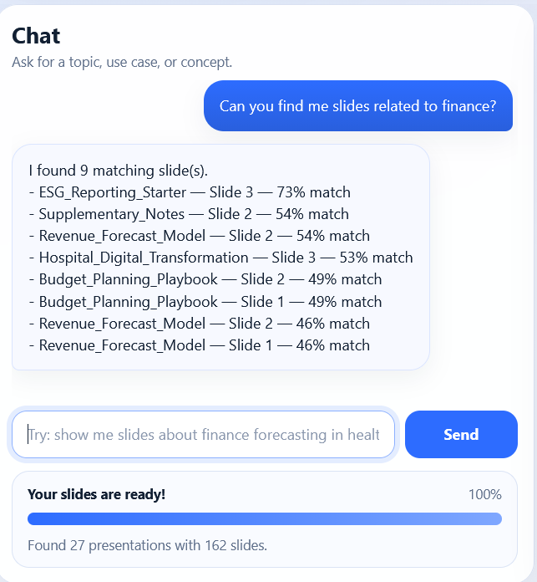

What to type
Write your request in plain English — there are no special commands. Examples:
- slides about quarterly revenue growth
- anything on patient safety and hospital procedures
- competitive landscape in the retail sector
- project timeline and milestones
- team structure and organisational chart
TIP Be descriptive rather than keyword-only. 'Show me slides about digital transformation strategy for financial services' will give better results than just 'digital'.

What happens next
- Your message appears as a blue bubble in the chat.
- Three bouncing dots show the app is thinking.
- Matching slides appear in the Suggested Slides panel (middle column).
- The assistant replies with a short summary, e.g. 'I found 7 matching slide(s)'.

Searching again
You can search as many times as you like. Each new search adds more results to the Suggested Slides panel (it does not replace the previous ones, unless you click Clear in that panel). This lets you run multiple searches and gather slides from different topics into one deck.

7. Reading the Suggested Slides
Every matching slide is shown as a card in the Suggested Slides panel. Here is what each part of a card means:
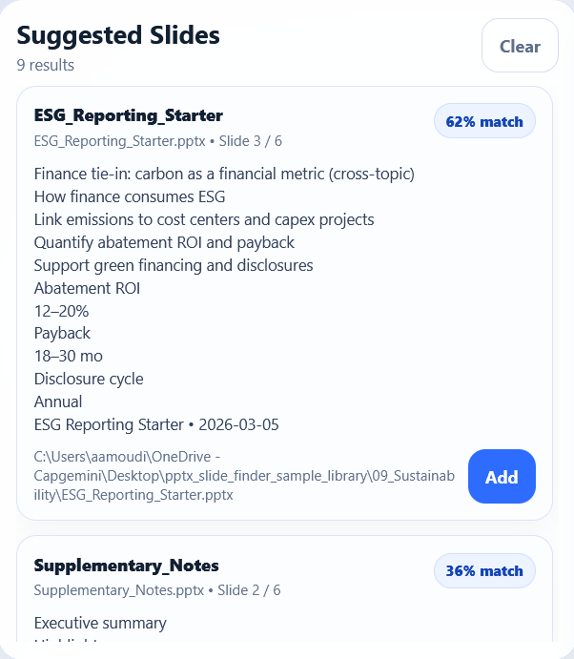
Part of the card | What it tells you
Deck title (bold, top) | The name of the presentation this slide comes from.
Slide reference | File name and slide number, e.g. 'ESG_Reporting_Starter.pptx • Slide 3 / 6'.
Match % badge | How relevant the slide is to your query — higher is more relevant. Ranges from 1% to 99%.
Content snippet | A short preview of the text on the slide.
File path | The full location of the file on disk or in Teams.
Add button | Click to add this slide to your Deck Builder.

Understanding the Match Percentage
The match percentage tells you how closely the slide's content relates to what you searched for. It is not a perfect score — think of it as a guide:
- 80%–99% — Very strong match. Likely exactly what you need.
- 50%–79% — Good match. Worth reviewing.
- Below 50% — Weaker match. May still be useful but check the content.
TIP Results are sorted from highest to lowest match. If the first few results look right, the rest are likely to be less relevant.

Adding and Removing Slides from Results
- Click Add to move a slide into your Deck Builder.
- The button changes to Added (greyed out) and the card gets a blue highlight.
- To remove a slide from the deck, go to the Deck Builder panel and click Remove next to it.
- Clicking Clear at the top of the Suggested Slides panel removes all results from view — but does NOT remove slides already added to your deck.

8. Step 5 – Build Your Deck
The Deck Builder (right column) is where you assemble the slides for your new presentation. Think of it as a shopping basket — you add the slides you want, arrange them in order, and then export when ready.
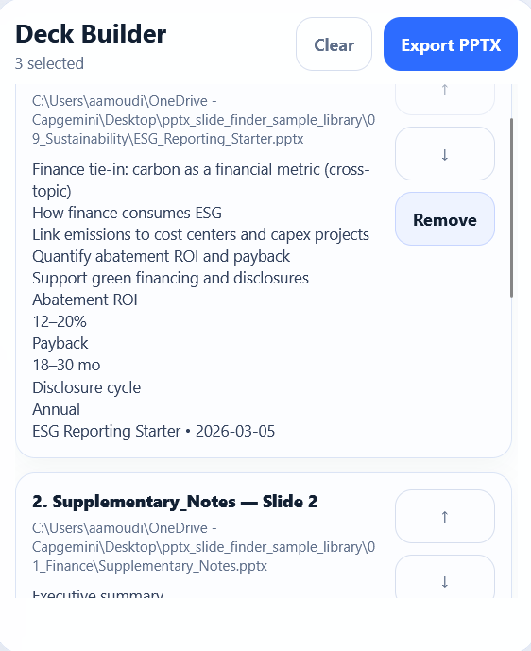

Each selected slide shows:
Element | Purpose
Number (1, 2, 3…) | The order this slide will appear in your exported presentation.
Presentation name | Which file this slide comes from.
Slide number | Which slide it is within its original file.
Content snippet | A preview of the slide's text.
↑ (Up arrow) | Move this slide one position earlier in the deck.
↓ (Down arrow) | Move this slide one position later in the deck.
Remove | Remove this slide from the deck (it stays in Suggested Slides).

Reordering Slides
The order of slides in the Deck Builder is exactly the order they will appear in your exported file. Use the ↑ and ↓ buttons to rearrange them until you are happy.
NOTE The Up arrow is greyed out for the first slide; the Down arrow is greyed out for the last.

Clearing the Deck
Click Clear at the top of the Deck Builder to remove all selected slides at once and start fresh. This does not affect your search results or indexed files.

9. Step 6 – Export Your Presentation
When you are happy with your slide selection and order, click the blue Export PPTX button at the top of the Deck Builder. The app will create a new PowerPoint file containing exactly the slides you chose.
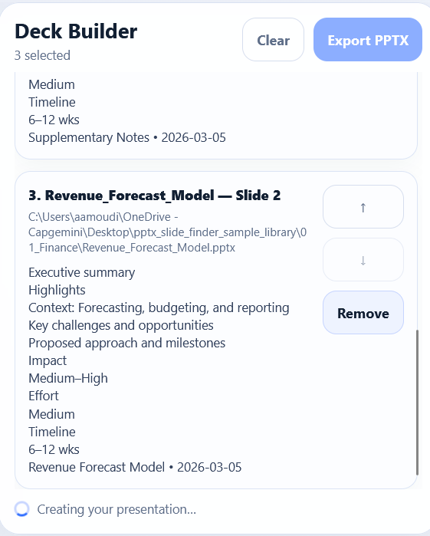

What happens during export
- The Export PPTX button is disabled (to prevent double-clicks).
- A spinning icon and the text 'Creating your presentation…' appear at the bottom of the Deck Builder.
- A file-save dialog may appear (depending on your Settings — see Section 10).
- The app copies each selected slide from its original file into a new presentation.
- A success message appears, e.g. 'Saved to: C:\Users\…\my_deck.pptx'.

Where is the file saved?
This depends on the Export setting you have chosen (see Section 10):
- Always ask: A file-save dialog opens each time — you choose the folder and filename.
- Fixed directory: The file is saved automatically to the folder you configured, with a name like 'taxonomy_deck_20260425_143200.pptx'.

WARNING Be aware of an error that might happen when exporting your slides. It looks like this:

This means that one or more of your slides are coming from one or more presentations that has not been labeled yet. Auto labeling is not supported yet, so you will have to set the labels for those presentations in order to use them.

After exporting — the 'New Deck' prompt
After a successful export, the app may ask whether you want to switch your search to the newly created file (if you have set 'Ask me each time' in Settings):
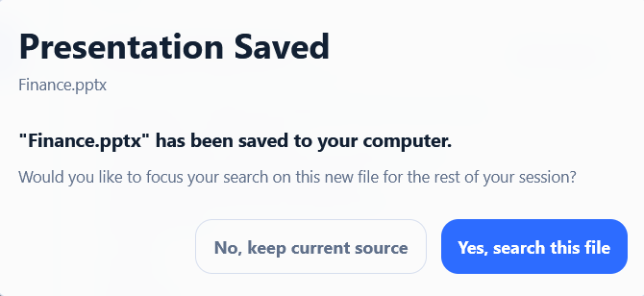
- Yes, search this file: Useful if you want to further refine or continue building from your new file.
- No, keep current source: Keeps searching in your original folder or presentation.
TIP You can change when this prompt appears — or make it switch automatically — in Settings under 'After Exporting a New Presentation' (see Section 10).

10. Settings – All Options Explained
Click the Settings button (top-right corner) to open the Settings panel. Changes only take effect after you click Save preferences at the bottom.
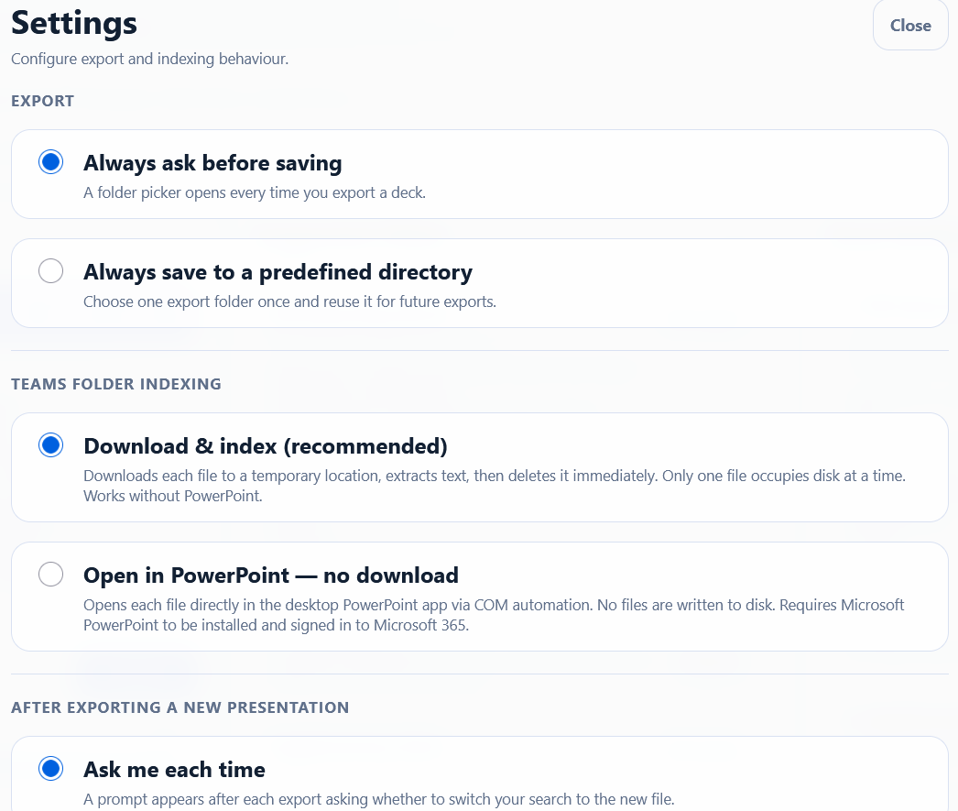

Export
Controls where exported presentations are saved.
Option | Behaviour | Best for
Always ask before saving (default) | A 'Save As' dialog opens every time you export. | Users who export to different folders for different projects.
Always save to a predefined directory | Files are saved automatically to a fixed folder. A Browse button appears to let you choose the folder. | Users who always export to the same location, e.g. a shared drive.

WARNING If you choose 'fixed directory' but have not set a folder yet, the export will fail with an error. Make sure to click Browse and choose a folder first.

Teams Folder Indexing (Does not work now. Still needs permission)
Controls how the app reads files from Teams / SharePoint. This setting only affects Teams folders — local files are unaffected.
Option | How it works | Pros | Cons
Download & index (Recommended) | Downloads each file to a temporary location, reads its text, then deletes it immediately. Only one file is on disk at a time. | Works without PowerPoint installed. Faster for most users. | Each file is briefly downloaded (a few seconds per file).
Open in PowerPoint — no download | Opens each file directly in the desktop PowerPoint app using Windows automation. | No files are written to disk at all. | Requires Microsoft PowerPoint to be installed and you must be signed in to Microsoft 365 in PowerPoint.

TIP If you are unsure, leave this on 'Download & index' — it is the most reliable option for most users.

After Exporting a New Presentation
Controls what happens to your search focus after you export a deck.
Option | What happens | Best for
Ask me each time (default) | A dialog appears after export asking whether to switch search to the new file. | Most users — lets you decide case by case.
Switch automatically | Your search focus instantly moves to the newly exported file — no prompt. | Users who always want to continue refining the new deck.
Stay on current source | The search focus never changes after export. | Users who are building many decks from the same large library.

Database – Reset
The Reset database button permanently deletes all indexed data for every folder and every Teams source. After resetting:
- The search source is cleared.
- Any slides in the Deck Builder are removed.
- You will need to re-index before searching again.
WARNING Only use Reset database if you are experiencing errors or want a completely fresh start. Normal use never requires this.

11. Complete Step-by-Step Workflows

Workflow A – Search a Local Folder and Build a Deck
- Click Browse Folder and select the folder containing your presentations.
- Wait for 'Your slides are ready!' to appear.
- Type a search query in the chat input, e.g. 'slides about cost reduction strategies', and press Enter.
- Review the slides that appear in the Suggested Slides panel.
- Click Add on each slide you want to keep.
- In the Deck Builder, use ↑ / ↓ to arrange the slides in the order you want.
- Click Export PPTX.
- Choose where to save the file (if prompted) and click Save.
- Your new presentation is ready.

Workflow B – Search a Teams / SharePoint Folder (Does not work now. Still needs permission)
- In Microsoft Teams, navigate to the folder you want to search.
- Copy the folder link (three-dot menu → Copy link).
- Paste the link into the 'Search in' text box and click Set.
- The sign-in window opens. Click the link, copy the code, open it in your browser, enter the code, and sign in with your work account.
- After sign-in the window closes and Teams indexing begins. Wait for it to finish.
- Search and build your deck as in Workflow A (steps 3–9 above).

Workflow C – Refine an Exported Deck
If you want to keep adding slides to a presentation you already exported:
- After exporting, click 'Yes, search this file' in the prompt (or set 'Switch automatically' in Settings).
- The app now searches your newly created presentation.
- Run new searches and select the slides you want.
- Export again when ready. A new file is created each time (the original is not overwritten).

Workflow D – Multiple Searches, One Deck
You can run several different searches and combine results into one deck:
- Search for 'financial performance' → add relevant slides.
- Search for 'operational risk' → add more slides.
- Search for 'market trends' → add even more slides.
- Reorder everything in the Deck Builder.
- Export the combined deck as one presentation.
NOTE The Suggested Slides panel resets results every searches. Make sure you add the wanted slides from each search before starting a new search.

12. Common Problems and How to Fix Them
Problem | Likely cause | What to do
The Send button is greyed out | Indexing is still running. | Wait for 'Your slides are ready!' before typing a search.
No results found | Your query didn't match anything in the indexed files. | Try rephrasing your query with different words, or check that the correct folder is selected.
Very low match percentages (below 5%) | The content you are looking for may not be in the indexed files. | Try a broader or differently worded query.
Only 1 or 2 results when you expected more | The query may be too specific. | Use a broader description, e.g. 'healthcare' instead of 'NHS patient pathway Q3 2025'.
Indexing never finishes / appears stuck | A very large folder, slow network, or a corrupted file. | Let it run. If it errors out, try resetting the database and re-indexing.
'Sign in again' message for Teams folders | Your Microsoft session has expired. | Click the link and sign in again — it only takes a minute.
Export fails with 'PowerPoint is not installed' | The app needs PowerPoint to copy slides. | Install Microsoft PowerPoint
Export fails with 'access denied' | You do not have write permission for the save location. | Choose a different folder to save to, e.g. your Desktop.
Export fails with 'Presentation cannot be modified' | Some of the presentations are not labeled yet. | Set a label for each presentation you choose a slide from.
Export directory error in Settings | 'Fixed directory' mode is on but no folder has been set. | Open Settings, click Browse next to the export directory field, and choose a folder.
Results are from the wrong folder | The search source was changed (e.g. after auto-switching to a new deck). | Check the 'Search in' bar to see what is currently selected, and change it if needed.

13. Quick Reference – Every Button
A complete list of every clickable element in the application.
Button / Control | Location | What it does
Browse Folder | 'Search in' bar | Opens a folder picker to select a local folder of presentations.
Browse File | 'Search in' bar | Opens a file picker to select a single .pptx file.
Set | 'Search in' bar | Applies the path or Teams link typed in the text box.
Settings | Top-right corner | Opens the Settings panel.
Sign out | Top-right corner | Disconnects from Microsoft (Teams folders only).
Send | Chat panel | Sends your typed query and starts the search.
Clear | Suggested Slides header | Removes all search results from the panel. Does not affect the Deck Builder.
Add | Each result card | Adds this slide to the Deck Builder.
↑ | Each Deck Builder slide | Moves this slide one position up in the export order.
↓ | Each Deck Builder slide | Moves this slide one position down in the export order.
Remove | Each Deck Builder slide | Removes this slide from the Deck Builder.
Clear | Deck Builder header | Removes all slides from the Deck Builder.
Export PPTX | Deck Builder header | Creates and saves your new presentation.
Browse | Settings – Export dir. | Opens a folder picker to choose the fixed export directory.
Save preferences | Settings footer | Saves all settings and closes the panel.
Reset database | Settings – Database | Permanently deletes all indexed data. Requires confirmation.
Close / Cancel | Any open modal | Closes the modal without saving.
Copy | Sign-in modal | Copies the device code to the clipboard.
Yes, search this file | New Deck modal | Switches the search source to the newly exported presentation.
No, keep current source | New Deck modal | Keeps the current search source unchanged after export.

Notes:
- So far, we can't access Teams folders using the agent, the feature is available but needs permissions that we do not have. To use the agent for finding the slides in a certain Teams folder you will have to follow these steps:
  - Go to the folder that contains the presentations on Teams and find the three dots symbol (...).
  - Click on the three dots and press on "Sync". It might ask you to give it permission to use OneDrive and start synchronization. Accept it and wait until it does the synchronization.
  - On your device, go to "File Explorer" and go to the left bar that shows different directories.
  - If you go to bottom of this bar, you should find three options:
    - Capgemini
    - This PC
    - Network
  - Go to Capgemini and check if the Teams folder is synchronized on your device. If it is there, then you can just use this directory with the agent. If it's not, then just wait until synchronization is finished then try again.

