Artificial Intelligence
Lab Final Project

Dataset: Mental health tech survey OSMI

Prepared by
Muhammad Ali Irfan (24F-0517)
Eshal Hussain (24F-0597)



Department of Computer Science
FAST – National University of Computer & Emerging Sciences Chiniot-Faisalabad Campus

Phase 1: Reflection:

- How many rows and columns does your dataset have? What does each row represent?
The dataset has 1,259 rows and 27 columns. Each row represents a single survey response from a tech industry worker, capturing their demographic information, workplace conditions, and mental health attitudes and history.
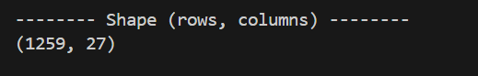

- Are there missing values? If yes, which columns have them and how might this affect your analysis?
Yes, three columns have missing values: state (515 missing), work_interfere (264 missing), and comments (1,095 missing). The comments column is mostly empty and can be dropped entirely, while work_interfere is a meaningful feature, its missing values may need to be filled or handled carefully, as ignoring them could reduce the accuracy of our predictions.
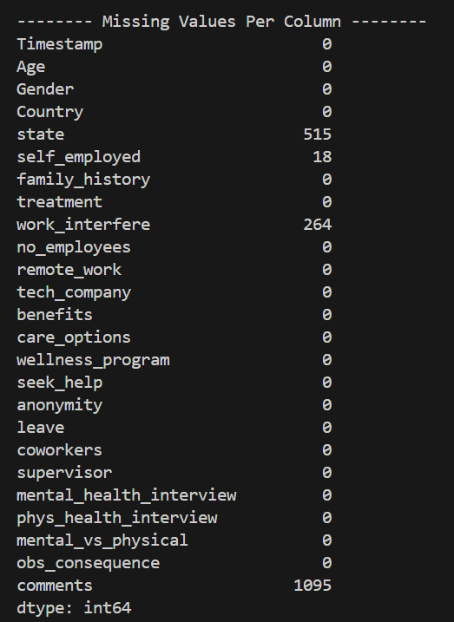

- What is the target variable and how many unique classes does it have?
The target variable is treatment, which indicates whether a tech worker sought mental health treatment. It has 2 unique classes. Yes (637 responses) and No (622 responses) and the classes are nearly balanced, which is ideal for training a classifier without bias toward one class.
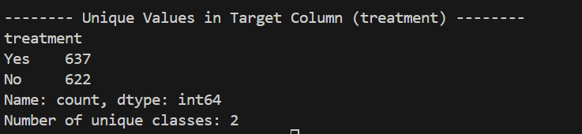

- Describe the graph you built. What do the nodes and edges represent in the context of your domain?
The graph was built using the "work_interfere" and "treatment" columns. The nodes represent unique values from both columns: Often, Sometimes, Rarely, Never, Yes, and No. An edge connects two nodes if they appear together in the same row. For example, "Often" is connected to "Yes" because some respondents who said work often interferes also sought treatment. The graph has 6 nodes and 8 edges, showing that every level of work interference is linked to both treatment outcomes.

