Artificial Intelligence
Lab Final Project

Dataset: Mental health tech survey OSMI

Prepared by
Muhammad Ali Irfan (24F-0517)
Eshal Hussain (24F-0597)



Department of Computer Science
FAST – National University of Computer & Emerging Sciences Chiniot-Faisalabad Campus

Phase 1

Reflection:

- How many rows and columns does your dataset have? What does each row represent?
The dataset has 1,259 rows and 27 columns. Each row represents a single survey response from a tech industry worker, capturing their demographic information, workplace conditions, and mental health attitudes and history.
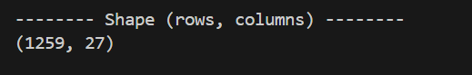

- Are there missing values? If yes, which columns have them and how might this affect your analysis?
Yes, three columns have missing values: state (515 missing), work_interfere (264 missing), and comments (1,095 missing). The comments column is mostly empty and can be dropped entirely, while work_interfere is a meaningful feature, its missing values may need to be filled or handled carefully, as ignoring them could reduce the accuracy of our predictions.
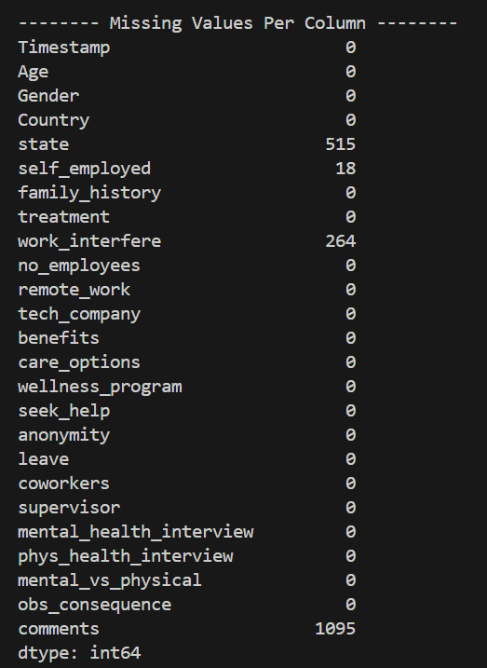

- What is the target variable and how many unique classes does it have?
The target variable is treatment, which indicates whether a tech worker sought mental health treatment. It has 2 unique classes. Yes (637 responses) and No (622 responses) and the classes are nearly balanced, which is ideal for training a classifier without bias toward one class.
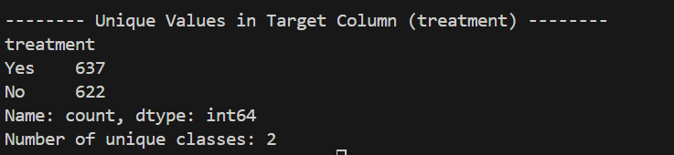

- Describe the graph you built. What do the nodes and edges represent in the context of your domain?

Phase 2

Analysis Table:
Algorithm | Path Found | Path Length | Nodes Explored | Optimal?
BFS | Yes | 2 | 2 | Yes
DFS | Yes | 4 | 4 | No
Depth Limited (limit=3) | Yes | 2 | 2 | No
Depth Limited (limit=5) | Yes | 2 | 2 | No
Iterative Deepening | Yes | 2 | 3 | Yes
Uniform Cost Search | Yes | 2 | 3 | Yes

Reflection:
- Which uninformed search algorithm explored the fewest nodes? Why?
BFS and Depth Limited Search explored the fewest nodes (2) because the goal was only one edge away from the start node, and both algorithms check immediate neighbours before exploring deeper paths.

- Did your heuristic improve the search in A* compared to UCS? How do you measure improvement?
A* and UCS both explored 3 nodes. In this specific graph where the goal is 1 step away and highly connected, the heuristic didn't drastically reduce the node count because UCS already found it quickly. Improvement is measured by the reduction in 'Nodes Explored', which in this edge-case was identical.
- How often did Hill Climbing get stuck in a local optimum? Did Simulated Annealing help?
Hill climbing reached the global optimum 10 out of 10 times. Because our objective function creates a smooth gradient toward the goal ('Yes'=100, 'Often'=80, etc.), there were no local optima to get stuck in. Simulated Annealing also succeeded but took a longer path (around 14-22 steps) due to its randomized acceptance of worse moves.
- How many nodes did Alpha-Beta Pruning eliminate compared to plain Minimax?
Alpha-Beta Pruning eliminated 24 nodes (Minimax evaluated 31 nodes, while Alpha-Beta evaluated only 7), significantly speeding up the adversarial search.

Phase 3

Reflection:

- How much did AC-3 reduce your domain sizes? Give exact numbers.
AC-3 did not reduce domain sizes at all (0 reductions). The domain sizes before and after running AC-3 remained exactly the same: work_interfere (4), benefits (3), care_options (3), seek_help (3), and family_history (2). This occurred because the specific constraints we defined were already arc-consistent with the initial full domains.
- Which backtracking variant had the fewest backtracks? Why?
All three backtracking variants (Plain Backtracking, Forward Checking, and MRV) had exactly 0 backtracks. Because our constraints were relatively loose and there were many valid combinations, the very first assignment path chosen by the algorithms happened to satisfy all constraints, eliminating the need to backtrack in all three cases.
- Did Min-Conflicts find a solution within 100 iterations? If not, how many violations remained?
Yes, Min-Conflicts found a solution well within 100 iterations. In fact, it found a solution at step 0. The initial random assignment chosen by the algorithm happened to be a valid state without violating any constraints, so no conflict-minimization steps were required.

