2025
Atari Breakout
Computer Organization & Assembly Language – Lab Project

Presented by:
Ali Irfan [24F-0517]
Eshal Hussain [24F-0597]

Contents
Introduction 2
Problem Statement 2
Project Objectives 2
Tools & Technologies 2
Game Overview 3
Gameplay Mechanics 3
Player Controls 3
Game Rules 3
Brick Score Values 3
Features 4
System Requirements 4
Software 4
Hardware 4
Game Architecture 4
Main Components 4
Memory Usage 5
Flowchart 6
Implementation Details 8
Graphics 8
Ball Physics 9
Collision Behavior 9
Leveling 9
Sound 9
Interrupt Usage 9
Results 10
Future Improvements 11
Conclusion 12

Introduction
This project is a classic Atari Breakout arcade game recreated using NASM assembly language, running inside DOSBox.
The goal was to develop a complete playable game using low-level programming, memory manipulation, interrupts, and graphics using text-mode video memory (0xB800).

Problem Statement
Games today are made using modern languages, but the challenge of this project was:
- Can we build a real, playable game using pure Assembly language?
- Can we draw graphics manually using text-mode memory?
- Can we implement physics (ball movement, collision, paddle control) without high-level libraries?
This project answers these problems by building a full Atari Breakout clone in Assembly.

Project Objectives
- Understand low-level graphics writing in text memory
- Learn keyboard interrupt handling
- Implement real-time movement & collision detection
- Understand loops, conditions, and arithmetic in Assembly
- Learn sound generation using the Programmable Interval Timer
- Build a complete working game with 3 difficulty levels

Tools & Technologies
- NASM (Netwide Assembler)
- DOSBox
- 8086 Assembly
- BIOS Keyboard Interrupt 16h
- Video Memory 0xB800 for graphics
- PC Speaker (Port 61h) for sound

Game Overview
Atari Breakout is a single-player arcade game where:
- The player controls a paddle
- A ball moves around the screen
- The player destroys bricks by hitting them
- Each hit gives points
- At the bottom, missing the ball decreases lives
- Game has 3 levels with increasing ball speed
When the player clears all bricks → WIN
If lives = 0 → GAME OVER

Gameplay Mechanics

Player Controls
- Left Arrow (←) : Move Paddle Left
- Right Arrow (→) : Move Paddle Right

Game Rules
- Ball bounces from walls, paddle, and bricks
- Hitting coloured bricks increases score based on colour
- If ball touches bottom → life decreases
- Score > 350 → Level increases
- Maximum levels = 3

Brick Score Values
Brick Colour | Points
Red (40h) | 15
Green (20h) | 10
Blue (10h) | 5
Yellow(60h) | 2

Features
- 3 fully playable levels
- Randomized wall widths
- Random brick colours
- Paddle collision physics
- Ball angles (45° and vertical)
- Steeper ball speed when hitting paddle edges
- Score & Lives HUD
- Welcome Screen
- Instruction Screen
- Game Over / Win Screen
- Sound effects using PC speaker
- Real-time keyboard input
- Smooth animation using custom delay system

System Requirements

Software
- DOSBox
- NASM Assembler

Hardware
- Any modern PC (DOSBox emulates everything)

Game Architecture

Main Components
- HomeScreen – Welcome screen
- InstructionScreen – Controls + rules
- printMap – Draws bricks, boundaries, paddle
- Gameloop – Core loop controlling gameplay
- Ball_update – Ball movement logic
- Detect_collision – Wall, brick, paddle collisions
- printnum – Print score/lives
- Randomizer_Walls / Randomizer_colors – Random generation
- beep – PC speaker sound generation

Memory Usage
- 0xB800: Text mode video memory
- Score stored: [score]
- Lives stored: [lives_1]
- Ball Position: [Ball_location]
- Paddle Position: [paddle_location_left] / [paddle_location_right]

Flowchart
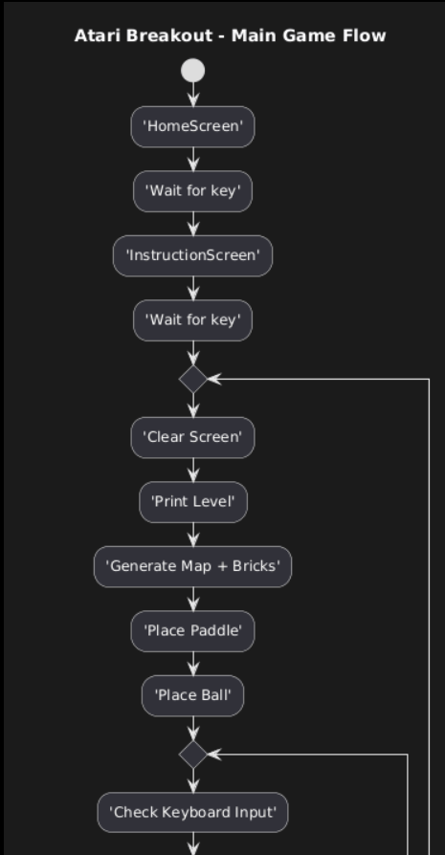
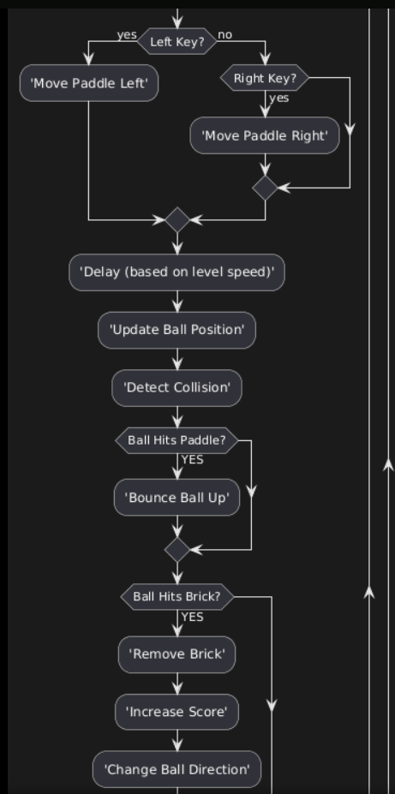
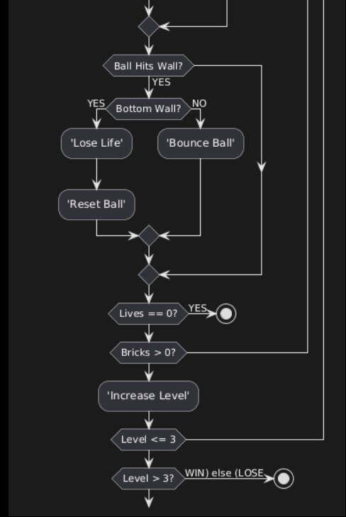

Implementation Details

Graphics
- Game uses text mode graphics
- Each cell = 2 bytes (char + color attribute)
- All drawing is done using:
- mov ax, 0xB800
- mov es, ax
- mov [es:di], value

Ball Physics
- Ball has two angle variables:
  - Horizontal angle (left/right)
  - Vertical angle (up/down)
- Ball moves based on ±160 and ±2 offsets

Collision Behavior
- Hits top → reverse vertical
- Hits side walls → reverse horizontal
- Hits paddle center → straight
- Hits paddle edges → steeper angle
- Hits brick → remove brick + increase score

Leveling
- Score exceeds 350 → next level
- Delay reduces = ball moves faster

Sound
Each event plays a PC Speaker beep using PIT channel 2.

Interrupt Usage
Interrupt / Port | Use | Why We Used It
INT 16h | Keyboard input | Move paddle left/right
INT 21h (4Ch) | Exit program | End the game safely
0xB800 Video Memory | Screen drawing | Show bricks, ball, paddle, score
Port 43h | Set sound mode | Prepare PC speaker beep
Port 42h | Send frequency | Control beep pitch
Port 61h | Turn speaker on/off | Play game sound effects

Results
The game successfully runs in DOSBox and includes:
- Fully interactive gameplay
- Sounds
- Three levels
- Working physics
- Stability
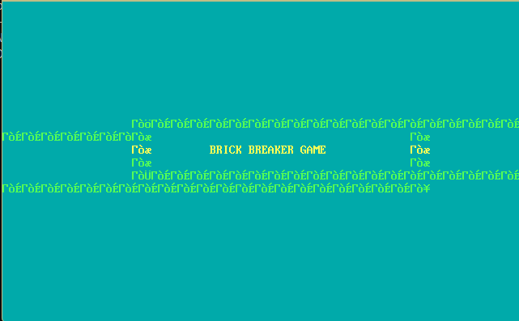

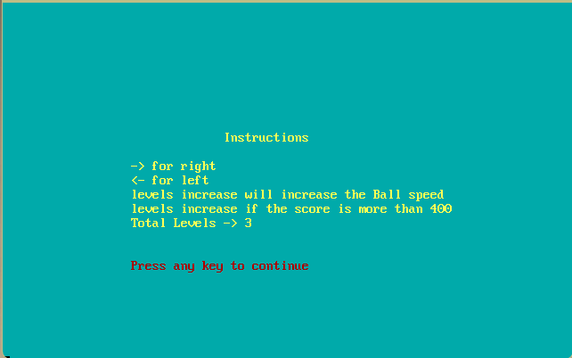

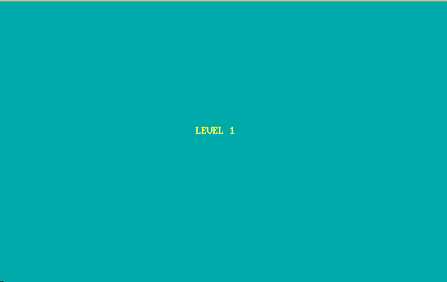

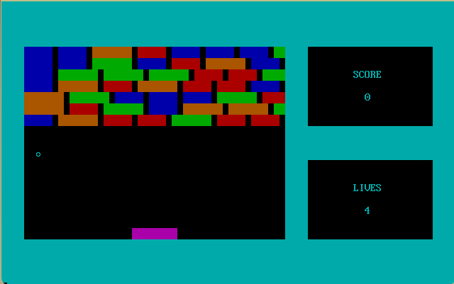

Future Improvements
- Add more levels
- High score saving
- Better graphics using VGA mode
- Power-ups
- Brick patterns
- Multiplayer paddle mode
- Mouse input

Conclusion
This project demonstrates that even with pure Assembly language, we can develop a complete arcade-style game.
It required understanding of low-level memory, keyboard interrupts, video memory, timers, and real-time logic.
The project successfully achieves all objectives and recreates the classic Atari Breakout in a fully functional way.

