**OBSTACLE AVOIDING ROBOT CAR**

**Introduction:**

This project focused on creating a self-driving car that can independently navigate its environment while avoiding collisions with obstacles. The development process involved utilizing Arduino microcontrollers, sensors, and programming techniques to achieve effective obstacle detection and avoidance. This report provides a comprehensive overview of the project's goals, methodology, components used, implementation process, achieved outcomes, and the challenges encountered throughout the project.

**Project overview:**

My project centered on constructing a chassis for a robotic car and incorporating components such as motors, wheels, an Arduino board, and sensors for detecting obstacles. I programmed the car to analyze its surroundings using the sensors and promptly make decisions to evade obstacles. My main goal was to develop a car that could identify and maneuver around obstacles within a designated setting.

**Components:**

**1-Arduino UNO:**

It acts as the brain of the system, receiving input from sensors and controlling the motors. With Arduino UNO, you can build projects such as LED blinking, temperature monitoring, motor control, sensor integration, and more. It offers a wide range of digital and analog input/output pins that allow you to connect and control different devices and sensors.

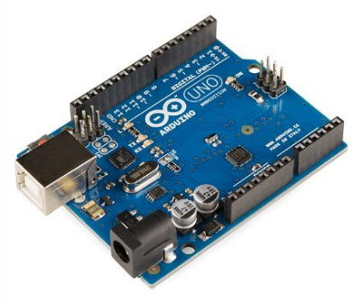

**Arduino UNO’s pin configuration:**

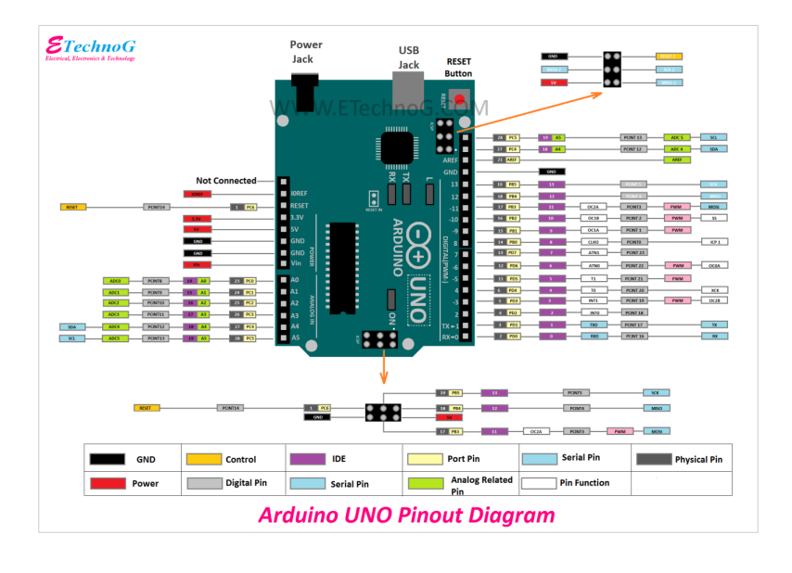

**2-Motor driver:**

A motor driver is an electronic device that controls the speed, direction, and torque of an electric motor. It receives signals from a microcontroller and amplifies them to provide the necessary power to the motor. Motor drivers are commonly used in robotics, automation, and industrial applications.

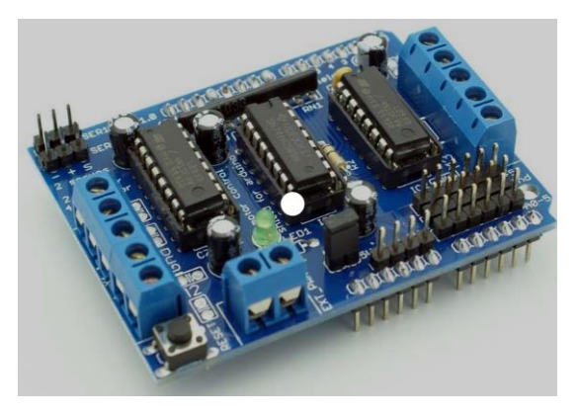

**3-Servo motor:**

A servo motor is a type of motor that is designed to provide precise control over angular or linear movement. They are known for their ability to maintain a specific position and respond to commands quickly and accurately. It is used to control the steering mechanism of the robot.

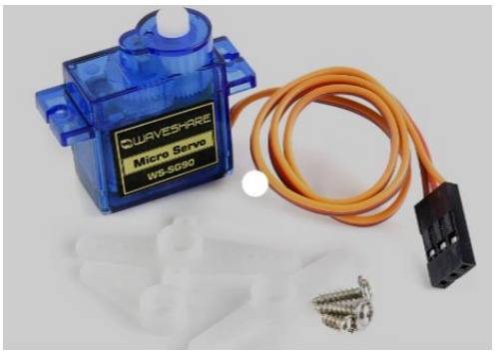

**4-Ultrasonic sensor:**

An ultrasonic sensor is a device that uses sound waves with frequencies higher than the audible range of humans (typically above 20 kHz) to measure distances and detect objects. Ultrasonic sensors are commonly used in robotics, industrial automation, and security systems. It helps in detecting the obstacles that are in the way of robot.

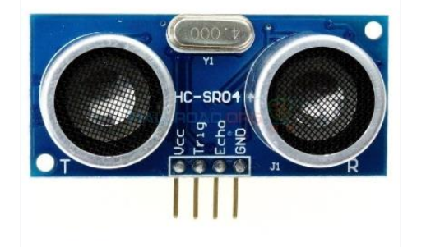

**Physics components:**

**Robotic Wheels:**

Robotic wheels are mechanical devices designed to provide motion and mobility to robots. They typically consist of a circular structure with a tire or tread for traction and a motor for rotation**.**

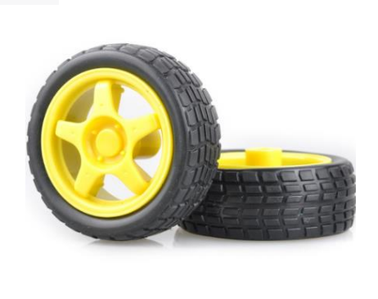

**Gear motors:**

Gear motors are electromechanical devices that combine an electric motor with a gearbox. They provide high torque and low-speed output, making them suitable for applications that require precise control and power transmission.

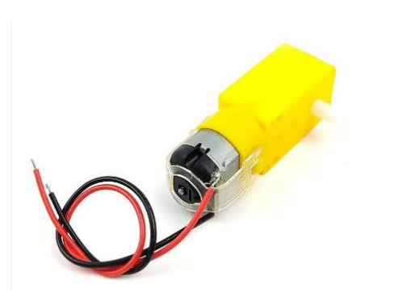

**Battery:**

A battery is an electrochemical device that stores and provides electrical energy. It consists of one or more electrochemical cells that convert chemical energy into electrical energy through a chemical reaction.

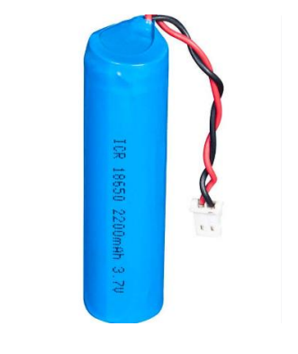

**Procedure:**

• Use the jumper wires to connect the ultrasonic sensor to the motor shield.

• First, attach the four gear motors to the dot board. For that, I used a glue gun. You can use any method.

• Then, connect the motor drive shield to the Arduino board and attach it to the center of the dot board.

• Next, connect these four motors to the motor driver shield. For that, use the circuit diagram below.

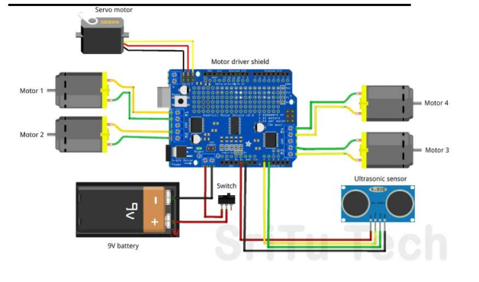

• Attach the servo motor to the dot board and connect it to the motor shield. Then, attach the ultrasonic sensor to the top of the servo motor and connect it to the driver shield using the jumper wire. • Finally, attach the power source to this robot car. For that, I used two li-ion batteries. You can use any type of battery. But you have to keep in mind that its voltage ranges from 7 to 12 VDC.

**Objectives:**

• Build a robotic car using Arduino microcontrollers.

• Integrate obstacle detection sensors for environment perception.

• Develop algorithms for obstacle detection and avoidance.

• Program the car to autonomously navigate and avoid obstacles.

• Test the car's functionality and observe its performance.

**Code regarding project:**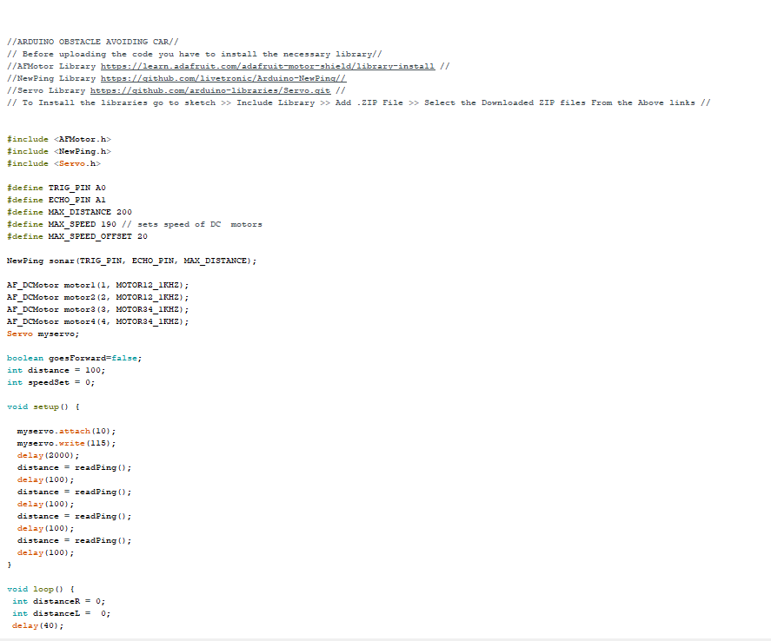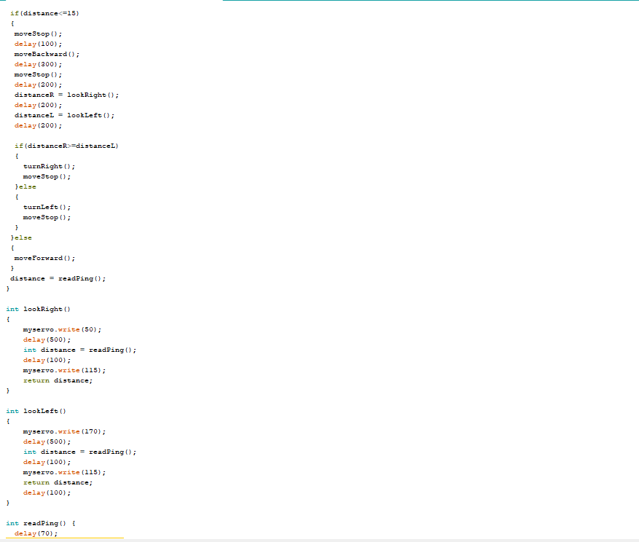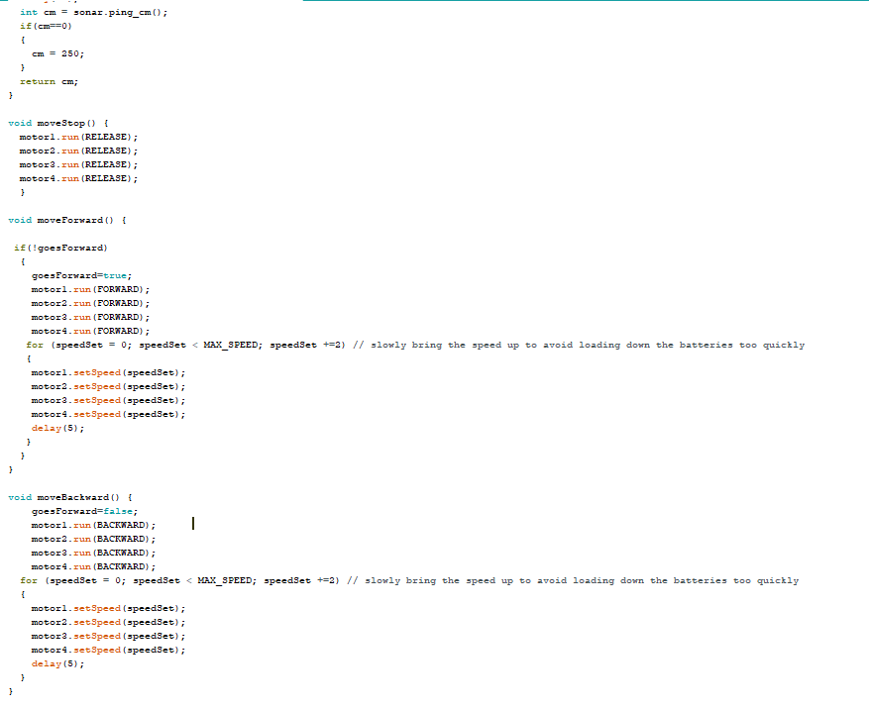

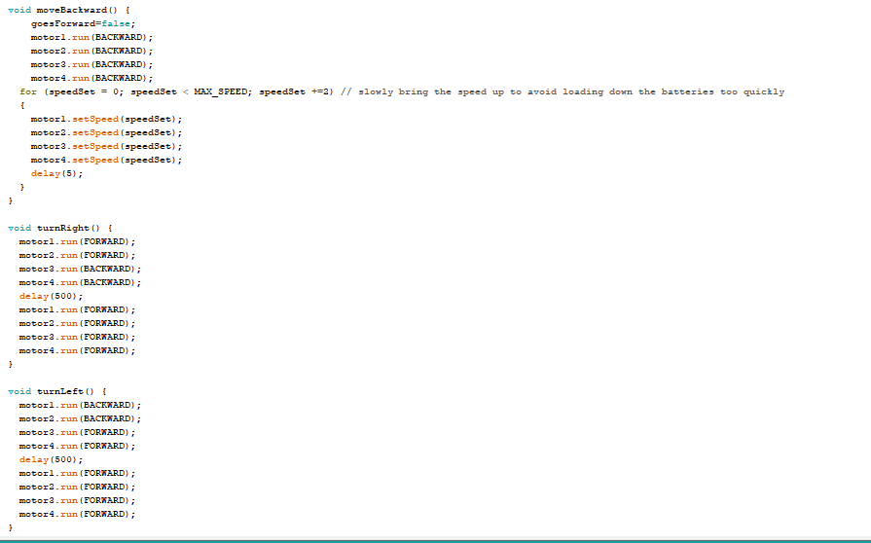

**Results and Observations:**

The project successfully demonstrated obstacle detection and avoidance capabilities. It effectively detected obstacles within its range and navigated around them. It showcased consistent performance in a controlled environment, avoiding collisions and maneuvering smoothly