**Assignment 1 & 2**

**Software Engineering (W4)**

**Submitted By**

**Ali Raza**

**(F2023065352)**

**Submitted to**

**Kinza Sardar**



**Department of Software Engineering**

**University of Management and Technology Lahore**

**Proposal: Mobile Health Monitoring App for Chronic Patients**

* **Introduction**

With the rise of chronic illnesses like diabetes, hypertension, and cardiovascular diseases, the demand for effective and accessible health monitoring solutions has grown exponentially. Traditional healthcare systems often fail to provide real-time and personalized care, leading to a gap in chronic disease management. This project proposes the development of a mobile health monitoring app aimed at empowering chronic patients to track, manage, and improve their health conveniently.

* **Project Overview**

The Mobile Health Monitoring App will act as a bridge between patients and healthcare providers. It will feature real-time health monitoring, medication reminders, personalized insights, and the ability to connect with doctors for virtual consultations. Equipped with wearable integration and AI-driven analytics, the app aims to provide actionable insights, thereby enhancing patients' quality of life.

* **Problem Statement**

Chronic patients often face challenges such as:

* Irregular monitoring of health parameters.
* Forgetting to take medications or missing appointments.
* Limited access to personalized healthcare. This lack of continuous and comprehensive care can lead to complications, hospitalizations, and a decline in quality of life.
* **Objectives**

The primary objectives of the Mobile Health Monitoring App are:

1. To provide real-time monitoring of vital health parameters such as blood pressure, glucose levels, and heart rate.
2. To ensure medication adherence through reminders and notifications.
3. To facilitate seamless communication between patients and healthcare providers.
4. To empower patients with personalized insights and recommendations for better disease management.
5. To integrate wearable devices and IoT sensors for advanced health tracking.

* **Domain Analysis**

1. **Customer**

The app targets individuals with chronic illnesses who need regular health monitoring and management. Key characteristics include:

* Patients aged 25-70 with chronic conditions like diabetes, hypertension, or heart disease.
* Tech-savvy individuals and caregivers seeking better disease management tools.
* Patients in urban and semi-urban areas with access to smartphones and wearables.

1. **Stakeholders**
2. **Primary Stakeholders**:
   * Chronic patients: End-users of the app.
   * Caregivers: Family members or healthcare aides.
3. **Secondary Stakeholders**:
   * Healthcare providers: Doctors, nurses, and specialists who will interact with patient data.
   * App developers and designers: Responsible for building and maintaining the app.
   * Sponsors or investors: Organizations funding the app development.
   * Regulatory authorities: Ensuring compliance with healthcare data standards (e.g., HIPAA, GDPR).

* **Prototypes**

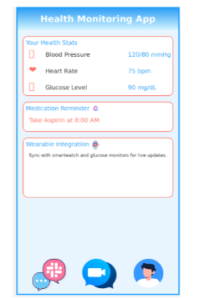

* **Gantt Chart**

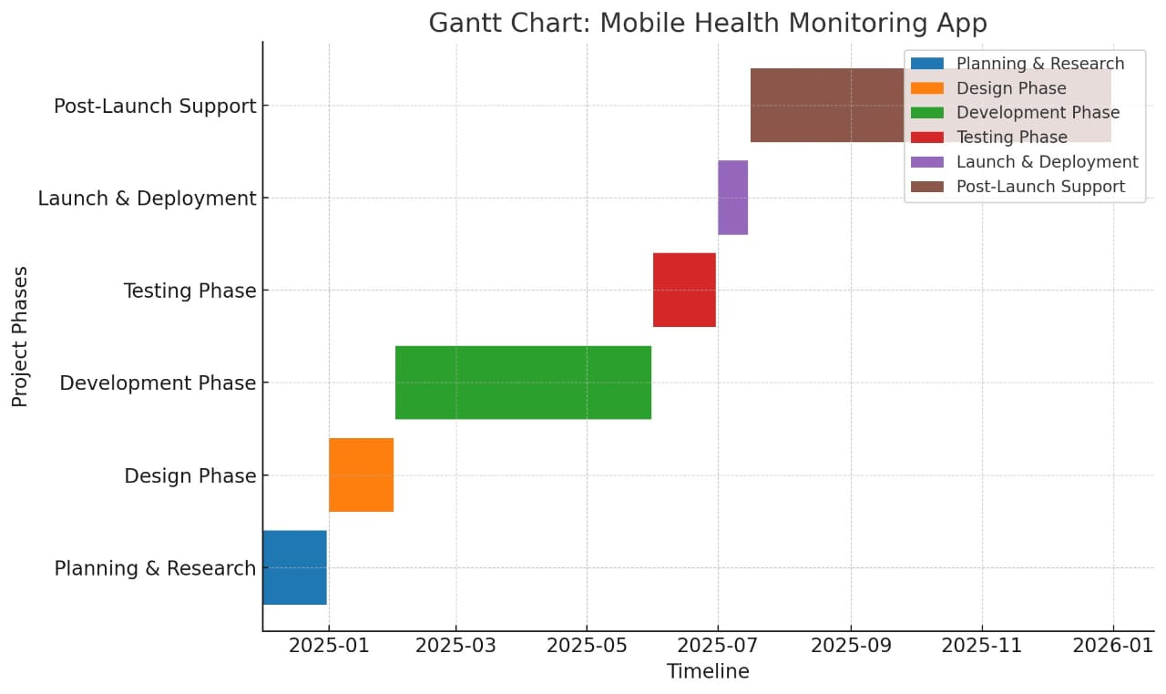

**Requirements Analysis**

* **Requirements**

**Functional Requirements:**

1. **User Registration & Authentication**:
   * Users can create accounts, log in, and reset passwords.
2. **Health Monitoring**:
   * Record and display vital signs like blood pressure, glucose levels, and heart rate.
   * Sync with wearable devices for real-time data collection.
3. **Medication Management**:
   * Set reminders for medications and dosage tracking.
4. **Teleconsultation**:
   * Schedule and conduct virtual consultations with healthcare providers.
5. **Data Visualization**:
   * Generate reports and graphs for users to track their health trends over time.
6. **Emergency Alerts**:
   * Send alerts to healthcare providers or emergency contacts when critical thresholds are reached.

**Non-Functional Requirements:**

1. **Usability**:
   * Intuitive UI/UX for patients of all ages, especially older adults.
2. **Scalability**:
   * Support for a growing user base without performance degradation.
3. **Security**:
   * Compliance with HIPAA and GDPR for data protection.
4. **Performance**:
   * Near real-time synchronization with wearable devices.
5. **Availability**:
   * 99.9% uptime with reliable cloud infrastructure.

* **List of Actors**

1. **Primary Actors**:
   * **Patient**: Monitors health, receives notifications, and consults with doctors.
   * **Caregiver**: Assists patients in managing their health data and medication.
2. **Secondary Actors**:
   * **Doctor/Healthcare Provider**: Reviews patient data and provides consultations.
   * **Admin**: Manages the app's backend, ensuring smooth operations.
   * **Wearable Device**: Collects real-time health data (indirect actor).

* **List of Use Cases**

1. **User Registration and Login**:
   * Patients and caregivers can create accounts and log in.
2. **Monitor Health Metrics**:
   * View and track vitals (e.g., glucose levels, blood pressure).
3. **Set Medication Reminders**:
   * Patients can set custom reminders for medications.
4. **Teleconsultation**:
   * Schedule appointments and communicate with doctors.
5. **Generate Reports**:
   * Download and share health reports with healthcare providers.
6. **Emergency Alerts**:
   * Notify emergency contacts when health parameters exceed critical thresholds.

* **System Use Case Diagram**

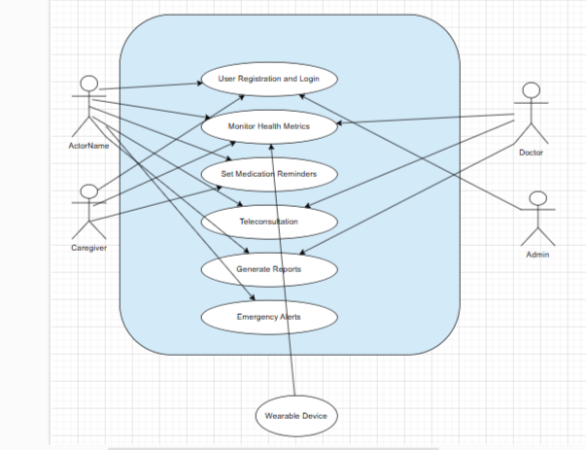

* **Class Diagram:**

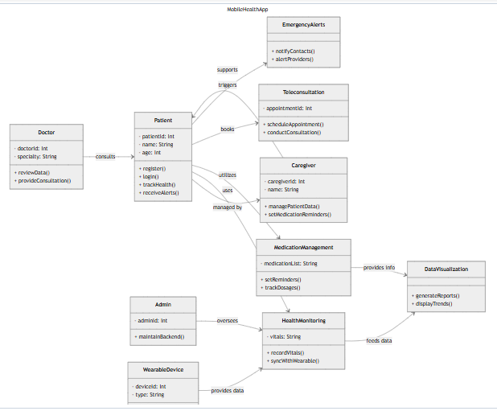

* **Sequence Diagram:**

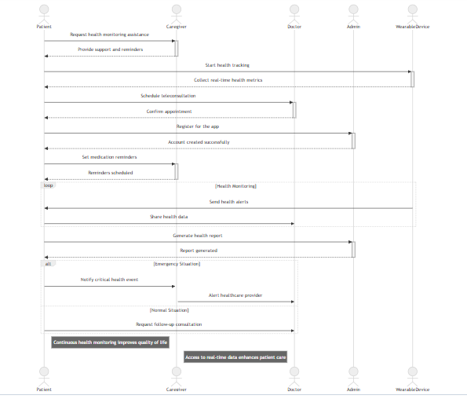

* **Architecture Diagram:**

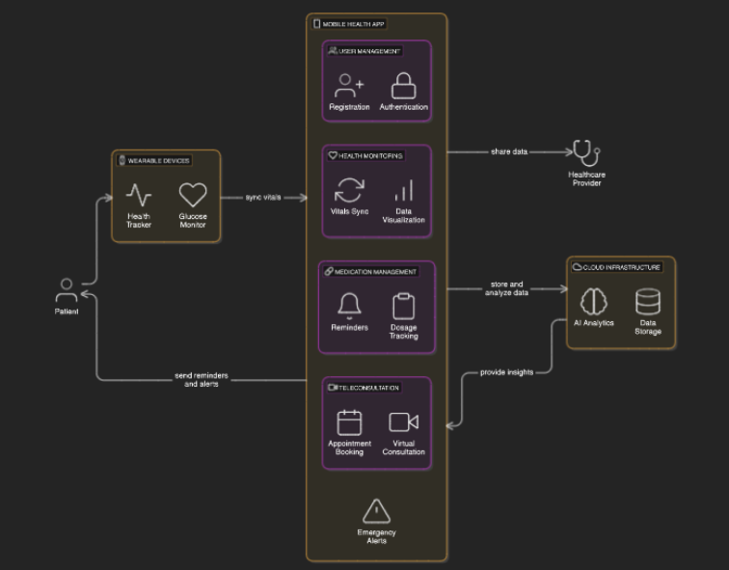

* **DFD:**

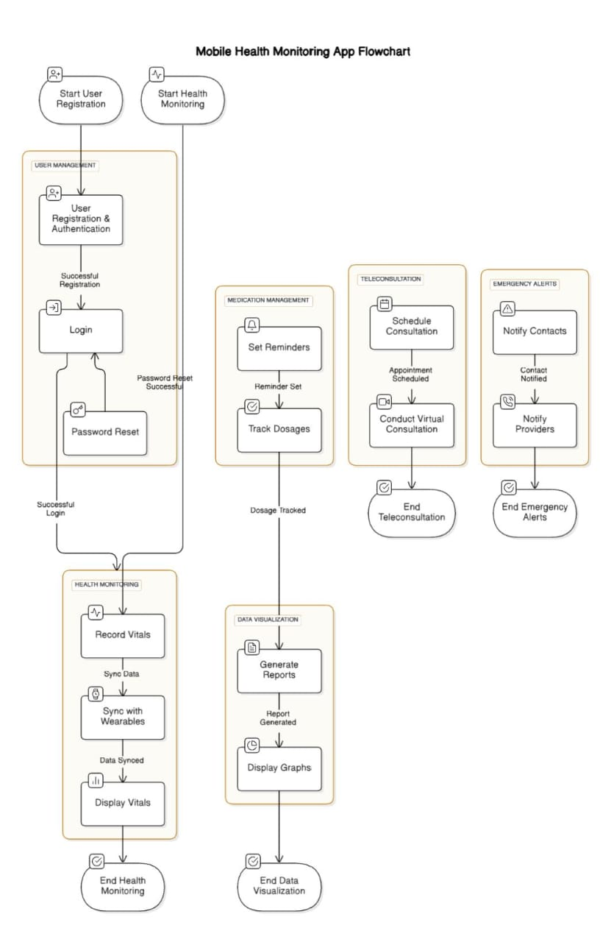

* **ERD:**

