TRANSISTORS
Types of transistors
1.Bipolar junction transistor (BJT)
2.field effect transistor (FETS)
Bipolar junction transistor
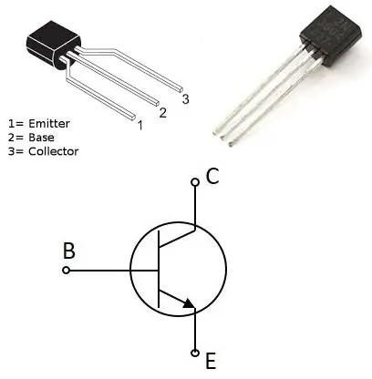
A bipolar junction transistor is a three-terminal semiconductor device that consists of two p-n junctions which are able to amplify or magnify a signal. It is a current controlled device. BJT terminals
Gate
Emitter
Collector.

Types of bipolar junction transistor
NPN
PNP 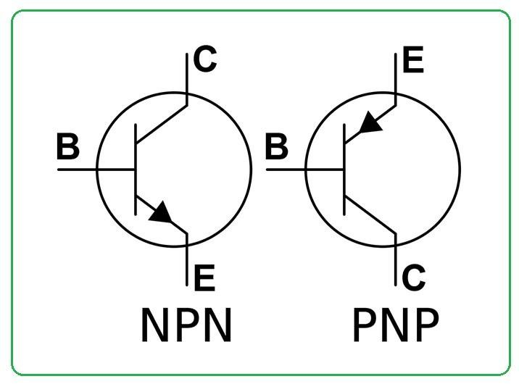
P-N-P Transistor:
In P-N-P configuration the Holes are the majority charge carrier. When emitter injects holes into the transistor when the emitter-base junction is forward biased. These flow into base region which controls the current passing from emitter to the collector. The base control this flow and the collector collects the holes. By reverse biasing the collector base junction the flow is controlled which enables modulation of the collector current by the base current.

NPN transistors
In N-P-N configuration electrons are the majority charge carriers. Electrons flow from emitter to collector when the emitter-base junction is forward biased. The base controls this flow and the collector collects the electrons. By reverse biasing the collector-base junction the flow is controlled by regulating the collector current.

FUNCTIONAL MODEL OF AN NPN TRANSISTOR
The base-emitter junction behaves like a diode.
A base current IB flows only when the voltage VBE across the base-emitter junction is 0.7V or more.
The small base current IB controls the large collector current Ic by varying the resistance RCE.
Ic = hFE × IB (unless the transistor is full on and saturated). hFE is the current gain (strictly the DC current gain), a typical value for hFE is 100 (it is a ratio so it has no units).
The collector-emitter resistance RCE is controlled by the base current IB:
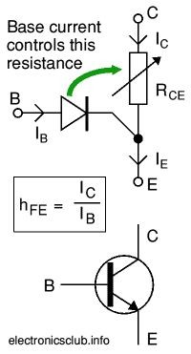
IB = 0, RCE = infinity, transistor off
IB small, RCE reduced, transistor partly on
IB increased, RCE = 0, transistor full on ('saturated') Functional model of NPN transistor.

TRANSISTOR CURRENT
The small base current controls the larger collector current.
When the switch is closed a small current flows into the base (B) of the transistor. It is just enough to make LED B glow dimly. The transistor amplifies this small current to allow a larger current to flow through from its collector (C) to its emitter (E). This collector current is large enough to make lED c light brightly.
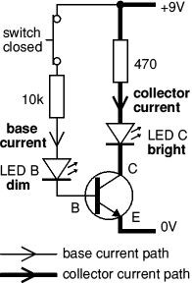
When the switch is open no base current flows, so the transistor switches off the collector current. Both LEDs are off.

FIELD EFFECT TRANSISTOR
A field-effect transistor (FET) is a type of transistor device that uses an electric field to control the electrical current through a semiconductor.
Terminals of a FET
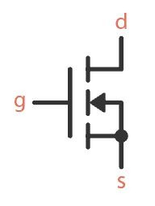
Gate
Drain
Source

How FETS work
FETs have three terminals: the source (S), the drain (D) and the gate (G). When we apply a voltage to the gate, it creates an electric field that either attracts or repels the charge carriers (electrons or holes) in the channel region. Whether the charge carriers are attracted or repelled depends on the voltage’s polarity. The process of applying a voltage to the gate of the FET controls the channel’s conductivity and the current flow between the source and drain terminals.
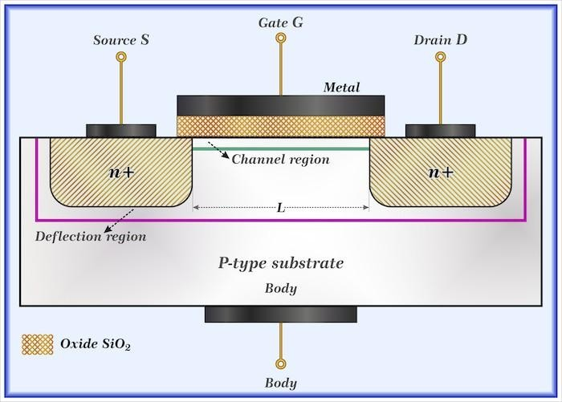

Main types of FETS
Metal oxide semiconductor field effect transistor (MOSFET)
Junction field effect transistor (JFET) MOSFET
is a field-effect transistor (FET with an insulated gate) where the voltage determines the conductivity of the device.
Symbol
Drain
Source
Gate

Types of MOSFET
Depletion type. MOSFET
Enhancement type MOSFET
Depletion type
The transistor requires a Gate-Source voltage (VGS) to switch the device “ON”. The enhancement mode MOSFET is equivalent to a “Normally Open” switch
Types
N channel MOSFET
P channel mosfet

Symbols of N channel MOSFET
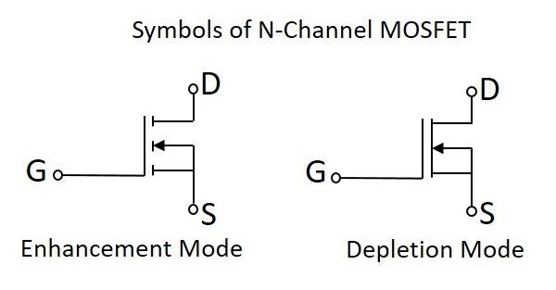

Working of N channel depletion MOSFET
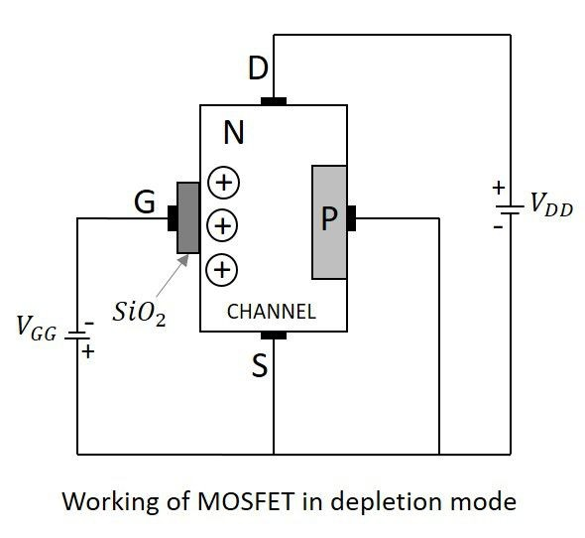
When no voltage is applied between gate and source, some current flows due to the voltage between drain and source. Let some negative voltage is applied at VGG. Then the minority carriers i.e. holes, get attracted and settle near SiO2 layer. But the majority carriers, i.e., electrons get repelle
With some amount of negative potential at VGG a certain amount of drain current ID flows through source to drain. When this negative potential is further increased, the electrons get depleted and the current ID decreases. Hence the more negative the applied VGG, the lesser the value of drain current ID will be.

Working of N-Channel MOSFET EnhancementMode
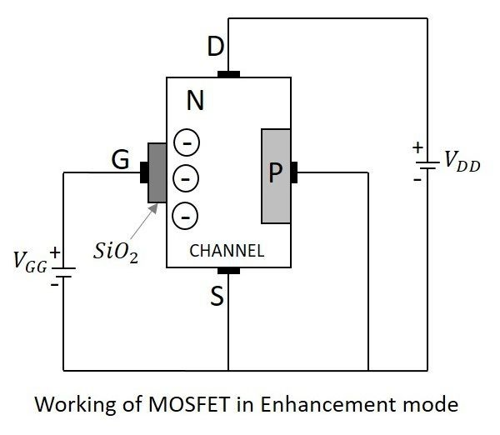
When no voltage is applied between gate and source, some current flows due to the voltage between drain and source. Let some positive voltage is applied at VGG. Then the minority carriers i.e. holes, get repelled and the majority carriers i.e. electrons gets attracted towards the SiO2 layer.
With some amount of positive potential at VGG a certain amount of drain current ID flows through source to drain. When this positive potential is further increased, the current ID increases due to the flow of electrons from source and these are pushed further due to the voltage applied at VGG. Hence the more positive the applied VGG, the more the value of drain current ID will be

Working of a PMOS in enhancement mode
When the gate terminal is given a negative potential at VGG than the drain source voltage VDD, then due to the P+ regions present, the hole current is increased through the diffused P channel and the PMOS works in Enhancement Mode.

Working of a PMOS in depletion mode
When the gate terminal is given a positive potential at VGG than the drain source voltage VDD, then due to the repulsion, the depletion occurs due to which the flow of current reduces. Thus PMOS works in Depletion Mode

Junction field effect transistor (JFET)
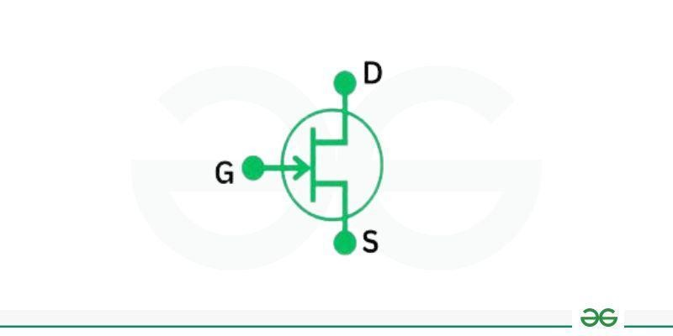
JFET is a three terminal unidirectional electrical circuit. Symbol diagram types of JFET
N- channel JFET
P- channel JFET

Working of a junction field effect transistor
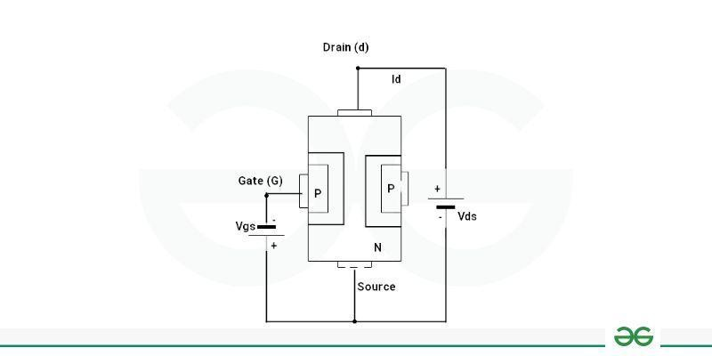
The junction field effect transistor is operated on the current flow through a semiconductor channel. When you apply voltage to a gate, it creates an electrical field but when no voltage is applied then the path becomes the open path for the carriers to flow in that. In the figure, in case of an application of a voltage Vds, two PN junctions are formed on either side by depletion layers to control flow of electrons from source to outflow when gate terminal voltage is zero. The width of these depletion layers can determine the current conduction.
Whenever a reverse voltage Vgs is applied through the gate, the width of the depletion layers increases and raises the resistance of the conduction channel. If voltage Vgs are reduced, the width of layers will decrease. The flow of electrons from the source to the drain will decrease as the depletion layer increases. The flow of electrons will decrease when the width is decreased.
The JFET device is capable of controlling the voltage during that process. So in the reverse bias the JFET comes in the cut off region and when the voltage of gate is negative - the width of channel decreases with no current flow through that , which is called pinched off region and the voltage at which this region is obtained is called pinch off voltage.
Other types of transistors
IGBT (Insulated-Gate Bipolar Transistor): Combines features of both MOSFET and bipolar junction transistor (BJT) which is used in high-power applications.
Thin-Film Transistor (TFT): It is used in flat-panel displays and sensors.
HEMT (High Electron Mobility Transistor):It is used for high-speed operation and low noise performance. ITFET (Inverted-T Field-Effect Transistor):It uses inverted-T-shaped gate structure for improved performance.
FREDFET (Fast-Reverse Epitaxial Diode Field-Effect Transistor): It is used for high-speed switching applications with low reverse recovery time.
Schottky Transistor: It uses Schottky barrier at the base-collector junction to improve switching speed.
Tunnel Field-Effect Transistor (TFET):It is used for low-power operation.
OFET (Organic Field-Effect Transistor):It is used for flexible electronics and displays.
Diffusion Transistor: It uses diffused semiconductor junction for amplification.

