**Software Requirements Specification**

**for**

**Online Examination System**

**Prepared by**

**Ali Ahmad khan(fa18-bsse-0082)**

**Muhmmad Osama (fa18-bsse-0005)**

**Syed Arslan Ahmed (fa18-bsse-0012)**

# 1. Introduction

## 1.1 Purpose

This Web Application provides facility to online examination worldwide. It saves time as it allows number of students/candidates to give the exam at same time and display the results at the end of the test, so there is no need to wait for the result. It is evaluated and generated by the server. Administrator has privileges to create, modify and delete the test papers and its particular questions. User can register, login and give the test with his specific id, and can see the results as well. Others can view sample papers to learn the structure of online exams. It eliminates the use of items like pen, paper, etc.

## 1.2 Intended Audience and Reading Suggestions

The different types of reader that this document is intended for are developers, project managers, marketing staff, users, testers, and documentation writers. The rest of this SRS contains Overall Description, External Interface Requirements, System Features, Non-Functional Requirements and Other Requirements. Suggested sequence for reading the document - begin with the overview sections and proceed through the sections that are most pertinent to each reader type.

## 1.3 Product Scope

Scope of this project is very broad compared to manually taken exams. They are: -

∑ This app can be used in educational institutions as well as in corporate world.

∑ Can be used anywhere any time as it is a web-based application (user location doesn’t matter).

∑ No restriction that examiner has to be present when the candidate takes the test.

∑ No manual work of preparing and storing the result information.

∑ Less time consumption, as the result is calculated immediately after the test and displayed to the student/candidate.

∑ For students/candidates, it saves time of going too far away centers to give exams.

## 1.4 References

This web application has been prepared on the basis of discussion with Team members and also taken information from following website – [www.google.com](http://www.google.com/) and the IEEE website.

# 2. Overall Description

## 2.1 Product Perspective

OES is an on-line examination system. It is accessible via the Internet, 24 hours a day, 7 days a week. The objective of this app is to reach and connect candidate and examiner in remote communities and conduct exams in a virtual environment online. This app will only allow the registered users to enter the test module. The various stages in the app are as follows: -

Login

System Overview

Test

Result

Login:

This window offers the user two choices for logging into the system according to the preset privileges - Candidate login and Administrator login.

The candidate login will take the user to the user profile.

The Administrator Login will take the user to the administrator profile.

System Overview:

This window can only be accessed by the administrator. It allows the administrator to add and edit exams.

Test:

This window contains all the exams candidate can give. All these exams are organized according to the categories they fall in. The test window will be different for students and corporate employees.

Result:

This window displays the result of exams the candidate has just appeared. This data will be saved and displayed in the user profile. If the score is in top 10, the result will also be displayed in the rankings area of result window.

## 2.2 Product Functions

The functions are divided according to the user types such as: -

Administrator: -

The function of the administrator is to add/edit exams in the test module.

Candidate: -

The function of the student is to update his/her profile and give various exams.

## 2.3 User Classes and Characteristics

The various users of this app are classified into two types: - Administrator

- Candidate o Student of Corporate Employees

This app requires the user to have characteristics such as the user should be able to communicate and write in English and should have previous experience of giving an online exam. If not, the candidate should be instructed about the basic’s usage of the app by authorized personnel.

## 2.4 Operating Environment

This app is internet based so it will run in any operating system with internet access through a web browser.

## 2.5 Design and Implementation Constraints

The candidate is allowed to give the exams any number of times, until specified otherwise by the administrator while building the test. While giving the exam the candidate is given only a set amount of time and the remaining time should be displayed, after which the exam should close and display the result.

## 2.6 User Documentation

The product will include a user manual. The user manual will include product overview, complete configuration of the required software and hardware, technical details and contact information which will include email address.

## 2.7 Assumptions and Dependencies

Proper working of this app is dependent on the internet connectivity of the users’ computer

Assumptions and dependencies:

* It is assumed that the user has basic knowledge of the system (i.e. he/she is not a first time user) as any action by the user is considered valid during an examination.
* It is assumed that the data entered by the user while registering is true.
* It is assumed that the candidate does not cheat during the exam as there are no supervisors around to monitor.

# 3. External Interface Requirements

## 3.1.1 User Interfaces

•Registration Screen:

Various fields available on this screen will be:

-Login Name

-Email Id

-Password

•Login Screen:

Fields available on this screen are:

-Login Name

-Password

•Entering Questions: Various Fields are:

-Questions

-Options (4)

-Correct Answer

•Exam Details Screen: Various Fields are:

-Exam Name

-No. Of Questions

-Time Limit

-Passing Marks

•Result Displaying Screen: Various Fields are:

-No. Of Correct Questions

-No. Of Incorrect Questions

-Total Marks

-Result(Pass/Fail)

## 3.1.2 Hardware Interfaces

Screen resolution of at least 800X600 is required for proper and complete viewing of screens. Higher resolution will be accepted.

## 3.1.3 Software Interfaces

-Any windows based operating system.

-MySql Server Database

-Php and javascript

**3.1.4 Communications Interfaces**

None

## 3.2 Functional Requirements

This section gives a functional requirement that applicable to the On-Line Examination system. There are three sub modules in this phase.

∑ Candidate module.

∑ Examiner module.

∑ Administrator module.

∑ Result rankings module

∑ Discussion Forum module

## 3.3 Behavior Requirement

### 3.3.1 Use Case Diagram

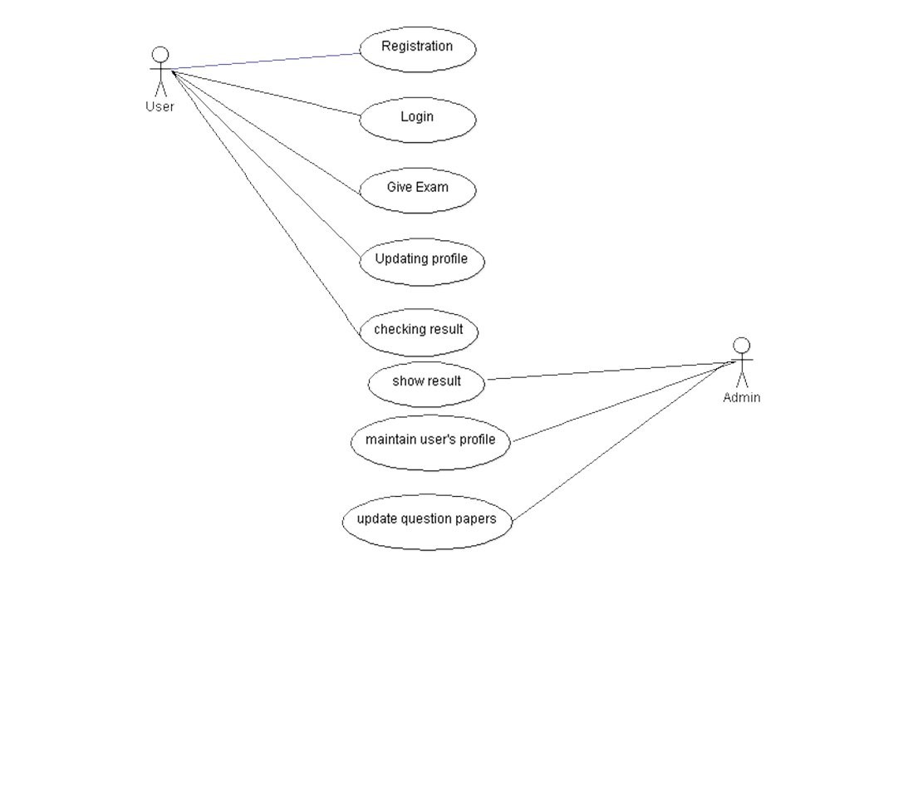

### 3.3.2 Entity Relationship Diagram

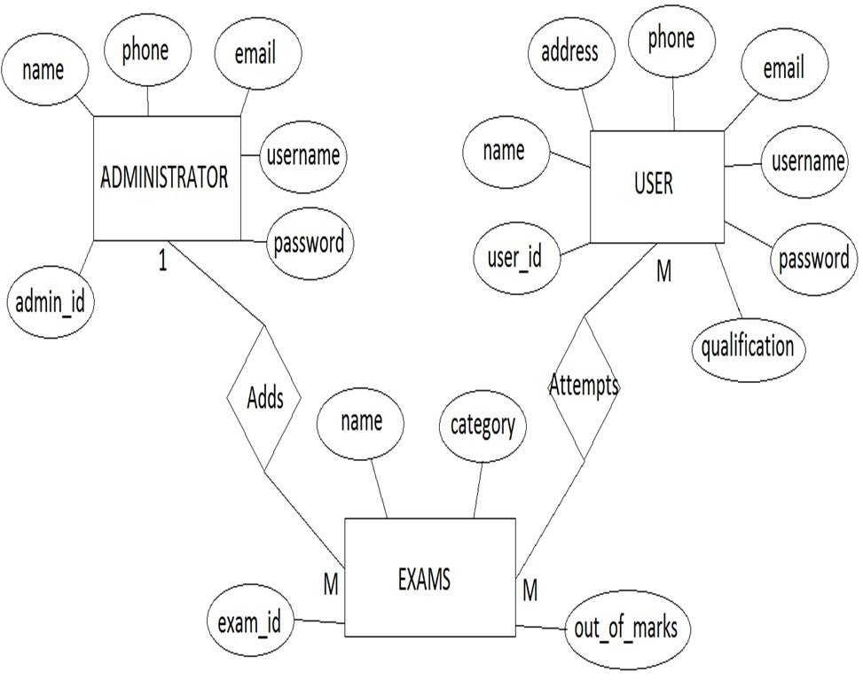

### 3.3.3 Data Flow Diagram

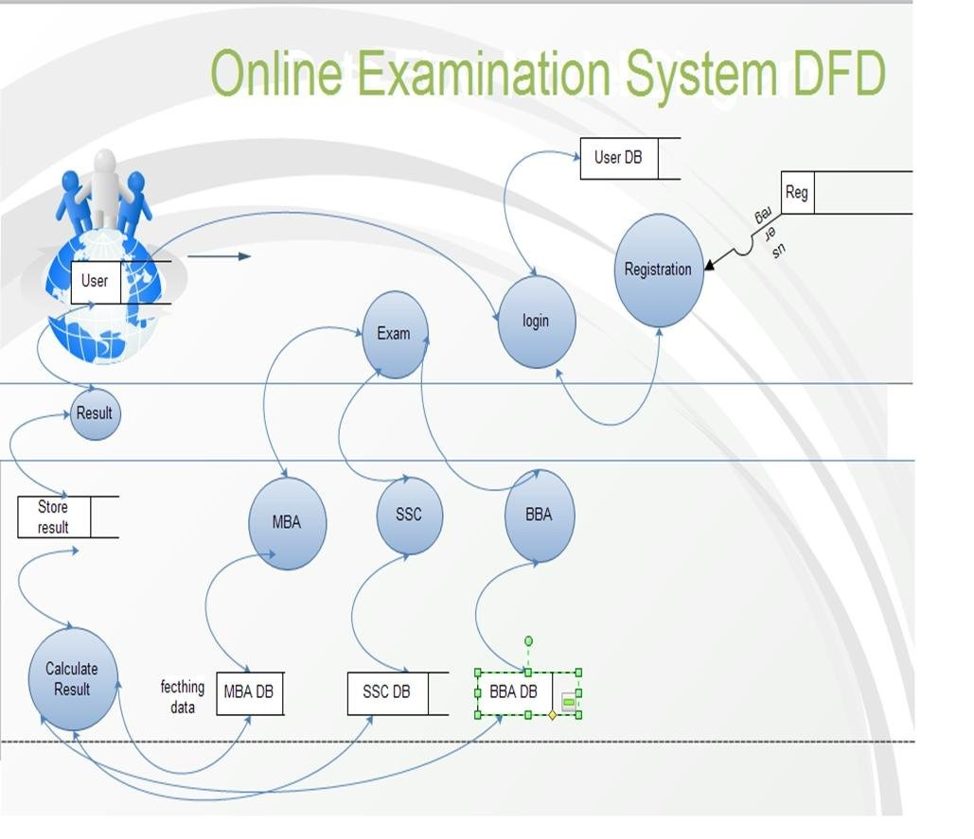

**3.3.4Database Name: ONLINE EXAMINATION SYSTEM**

### Admin

|  |  |  |  |  |  |
| --- | --- | --- | --- | --- | --- |
| **Admin_ID** | **Name** | **Phone** | **Email** | **Username** | **Password** |
|  |  |  |  |  |  |

### User

|  |  |  |  |  |  |  |  |
| --- | --- | --- | --- | --- | --- | --- | --- |
| **User_ID** | **Name** | **Phone** | **Address** | **Email** | **Qualificatin** | **UserName** | **Password** |
|  |  |  |  |  |  |  |  |

### Exam

|  |  |  |  |
| --- | --- | --- | --- |
| **Exam_ID** | **Name** | **Category** | **Out_Of_marks** |
|  |  |  |  |

### Result

|  |  |  |
| --- | --- | --- |
| **User_ID** | **Exam_ID** | **Total Marks** |
|  |  |  |

### Exam paper

|  |  |  |
| --- | --- | --- |
| **Exam_ID** | **Exam_name** | **hours** |
|  |  |  |

### Question for each Exam

|  |  |  |
| --- | --- | --- |
| **Question_ID** | **Exam_ID** | **Question** |
|  |  |  |

### Given Answer Of Question

|  |  |  |  |  |  |  |
| --- | --- | --- | --- | --- | --- | --- |
| **Opt_ID** | **Opt1** | **Opt2** | **Opt3** | **Opt4** | **Question_ID** | **Exam_ID** |
|  |  |  |  |  |  |  |

# 4. System Features

Some Performance requirements identified is listed below:

∑ The database shall be able to accommodate a minimum of 1,000 records of Users.

∑ The software shall support use of multiple users at a time.

∑ There are no other specific performance requirements that will affect development.

## 4.1 Safety and Security Requirements

### 4.1.2 Safety Requirements

The database may get crashed at any certain time due to virus or operating system failure. Therefore, it is required to take the database backup.

### 4.1.3 Security Requirements

Some of the factors that are identified to protect the software from accidental or malicious access, use, modification below. Keep specific log or history data sets

¸ Assign certain functions to different modules

### 4.2 Software Quality Attributes

The Quality of the System is maintained in such a way so that it can be very user friendly to all the users.

The software quality attributes are assumed as under: ¸ Accurate and hence reliable.

* Secured.
* Fast speed.
* Compatibility.