Report

**Dataset information:**

**Link:** https://www.kaggle.com/datasets/amalab182/property-salesmelbourne-city

**Information about columns:**

The data provided is a set of property sales in the suburb of Abbotsford, Victoria, Australia. It includes details such as the address, number of rooms, property type, price, method of sale, and seller information, as well as information on the property's location and characteristics, such as distance from the city centre, postcode, bedroom and bathroom count, car spaces, land size, building area, year built, council area, latitude and longitude, region name, and property count.

Suburb: Name of the suburb where the property is located

Address: Street address of the property

Rooms: Number of rooms in the property (excluding bathrooms and other non-living spaces)

Price: Sale price of the property in Australian dollars (AUD)

Method: Method of sale (e.g., S = property sold, SP = property sold prior, PI = property passed in, PN = sold prior not disclosed, SN = sold not disclosed, VB = vendor bid, W = withdrawn prior to auction, SA = sold after auction)

Type: Type of property (e.g., h = house, t = townhouse, u = unit/apartment)

SellerG: Real estate agency or agent handling the sale.

Date: Date of the sale

Distance: Distance from the property to Melbourne central business district (CBD) in kilometers

Region name: Name of the region where the property is located (e.g., Eastern Metropolitan, Northern Metropolitan, Southern Metropolitan, Western Metropolitan)

Property count: Number of properties that exist in the suburb.

Bedroom2: Number of bedrooms in the property (including any non-living spaces that could be used as bedrooms)

Bathroom: Number of bathrooms in the property

Car: Number of car spaces associated with the property

Land size: Land size of the property in square meters.

Building Area: Total building area of the property in square meters

Council Area: Name of the local government area where the property is located.

We added new columns during transformation and analysis. Those columns are discussed later.

**Data cleaning and transformation:**

**Refer to attached notebook for complete details.**

1. Dropped column with no column name.
2. There were few columns having many missing values, so columns that were numerical (except longitude and latitude) used median to handle null values and for categorical values, used mode. For Longitude and Latitude used geopy library to use addresses and suburb to get coordinates. Then there were approx. 4% values having still null values then those rows were dropped.
3. Changed spelling of longitude and latitude column names
4. Added columns: Year, Month, Building age, total rooms.
5. Modified values in type and method columns
6. Dropped postcode and yearbuilt columns.

We added these columns in powerBI using dax query:

Bathroom category, Building age category, Total rooms category, Car category, land size category, distance category.

**Insights:**

***Mostly insights are written in the powerBI. Screenshots will be including that. However, if clarification or more insights are needed for particular snap that will be done over here.***

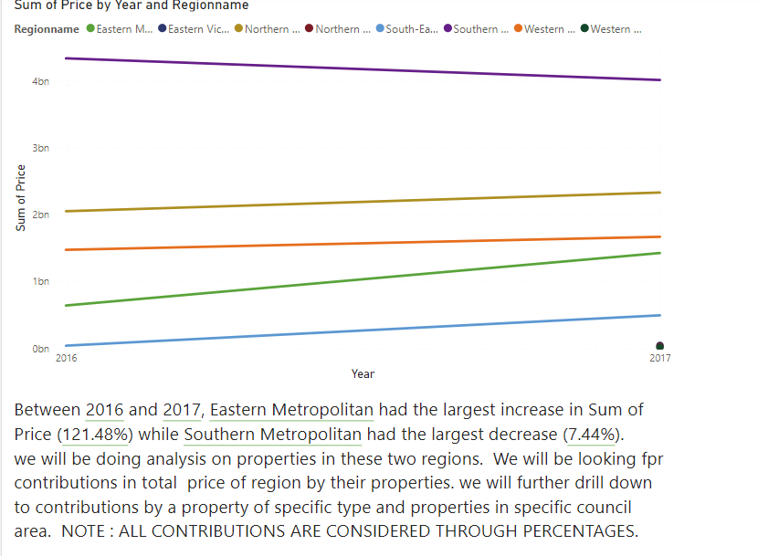

Figure 1

All contributions are considered through percentages i.e. if for type: house, there is increase in percentage (for example: 20% to 30%) of sum of price out of total price for region, from 2016 to 2017, then this change is considered to be increase in contribution, same for the case of decrease. On the contrary, if there is change in sum (for example: 1m to 2m) while change in percentage is decreased, then the contribution is considered to be decreased. If percentage is same in both years, then sum is considered.

Intuition1: contribution increase, count decrease => average price of property increased.

Formulae used for them:

**(sum** of price 2017 – sum of price 2016)/ (count in 2017 – count in 2016

Intuition2: contribution decrease, count increase => average price of property decreased.

We will refer to this intuition later.

**Southern Metropolitan:**

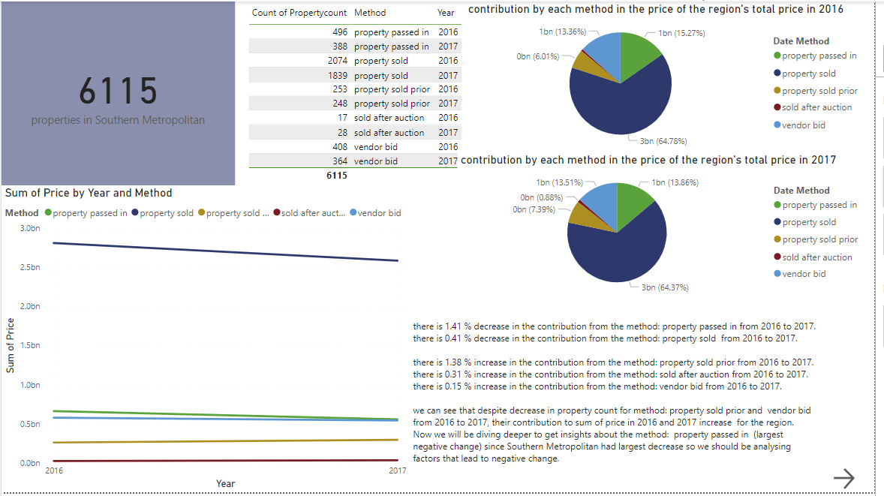

Figure 2

Idea is to get deeper for the cause of change. So, if Southern metropolitan has largest decrease, so we should look for a general factor for that region which should be having largest decrease amongst its respective category i.e. method: property passed in, in this case. **An insight is that contribution from methods: vendor bid, and property sold prior, increased and count decreased so average price of the property with either of those two methods is increased as per intuition1.**

**Southern Metropolitan, method: property passed in.**

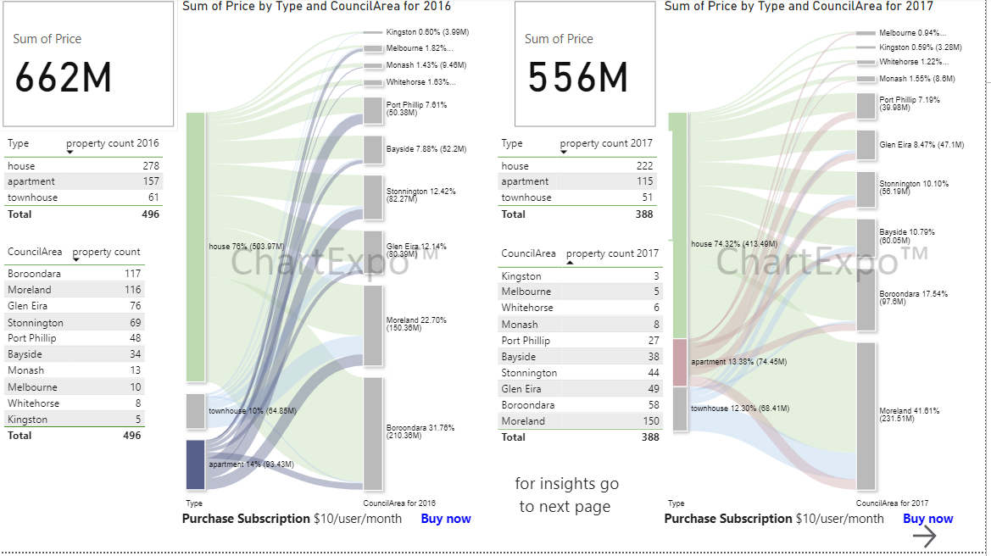

Figure 3

Figure 4

**Insight:**

As in this region and with this method we have to dive deeper for “largest decreasing factor”, we can see that property type: house has largest decrease: 1.68%, amongst house types. Notice that there is positive change in contribution from type: townhouse despite decrease in count; this means that average price of property with this type is increased as per intuition1. For type: apartment count and contribution both decreased. Council area: Boroondara has largest decrease: 14.22 amongst council areas (refer to figure 4).

From figure 3:

For council areas: Moreland, Monash, Bayside contributions increased and other than these 3 council areas had their contribution decreased. For council areas: Moreland, bayside count increased while other than these 2 council areas other had their count decreased. Monash has the average price of property increased (intuition1) (refer to figure3).

**Southern Metropolitan, method: property passed in, Council Area: Boroondara.**

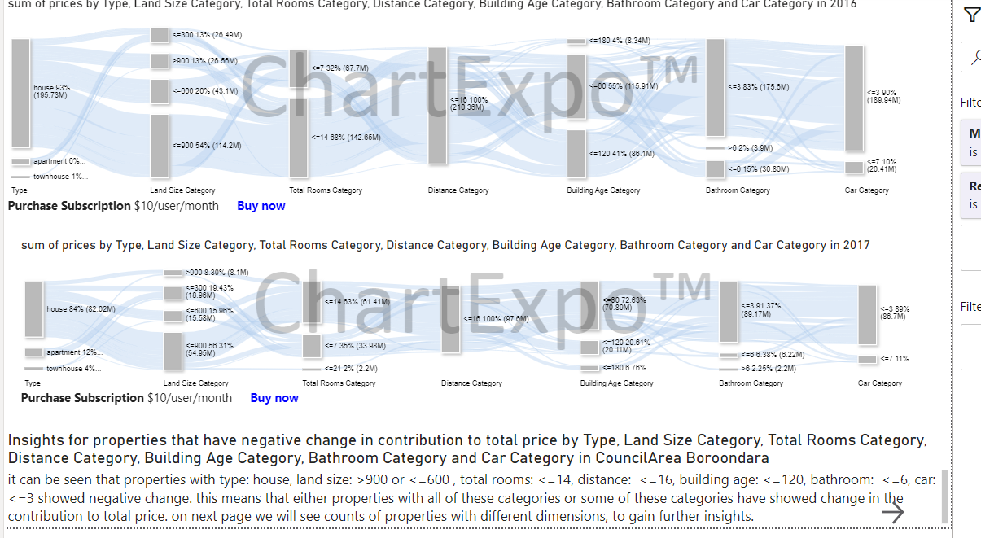

Figure 6

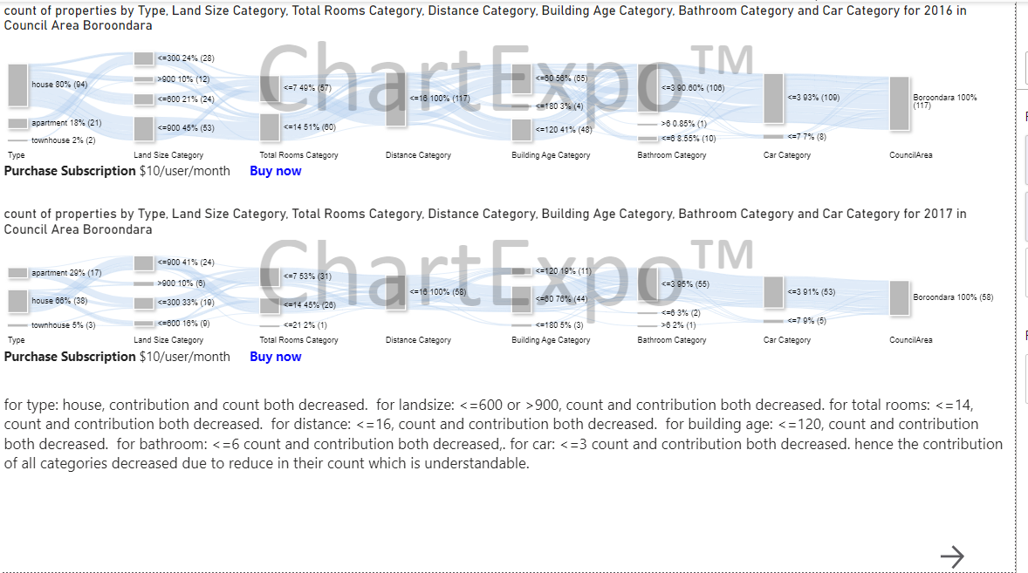

Figure 7

Insights (other than in snap) from figure6 and 7:

From property type: apartment and townhouse had their contribution and count increased. From land size: <=300, contribution and count both increased while from <=900, contribution increased but count decreased, so average price increased (intuition1). From total rooms: <=7, count and contribution increased. From distance: <=16, count and contribution decreased. From building age: <=180, <=60 count decreased contribution increased so intuition 1. From bathroom: <=3, >6 count, and contribution increased. From car: <=3, contribution and count decreased.

**Southern Metropolitan, method: property passed in, property type: House.**

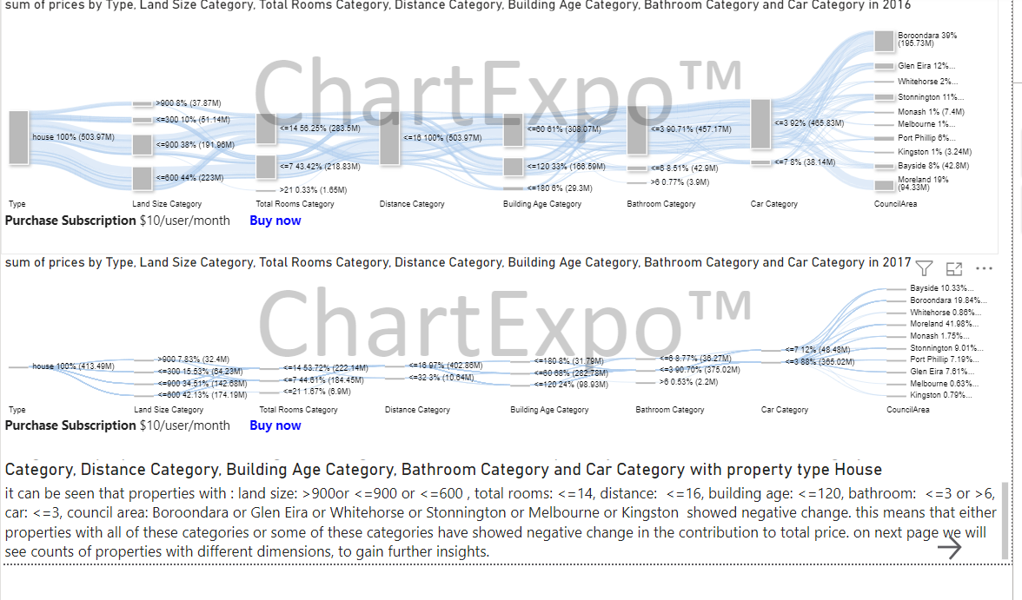

Figure 8

Figure 9

Insights (other than in snap) for figure 8 and 9:

From land size: <=300, contribution and count both increased. From total rooms: <=7 count decreased, contribution increased, hence average price increased (intuition1), for >21, count and contribution increased. From distance: <=32, count and contribution increased. From building age: <=180, <=60 count and contribution increased. From bathroom: <=6 count decreased, and contribution decreased hence average price increased (intuition1). From car: <=7, contribution and count increased. From council area: Monash contribution increased, count decreased hence average price decreased intuition 1, Port Philip, Bayside, Moreland count and contribution increased.

**Eastern Metropolitan:**

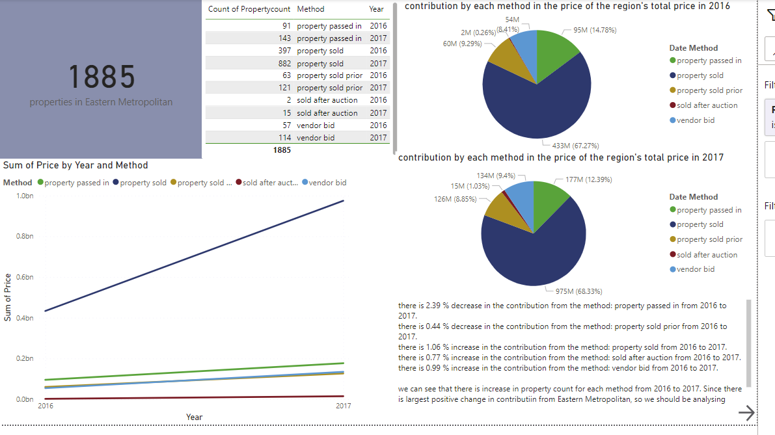

Figure 10

Insights (other than in snap) from figure 10:

Contribution from method: property passed in, and property sold prior, decreased, while count increased, so average price decreased (intuition2). Other than these two methods have their count and contribution increased.

**Eastern Metropolitan, method: property sold.**

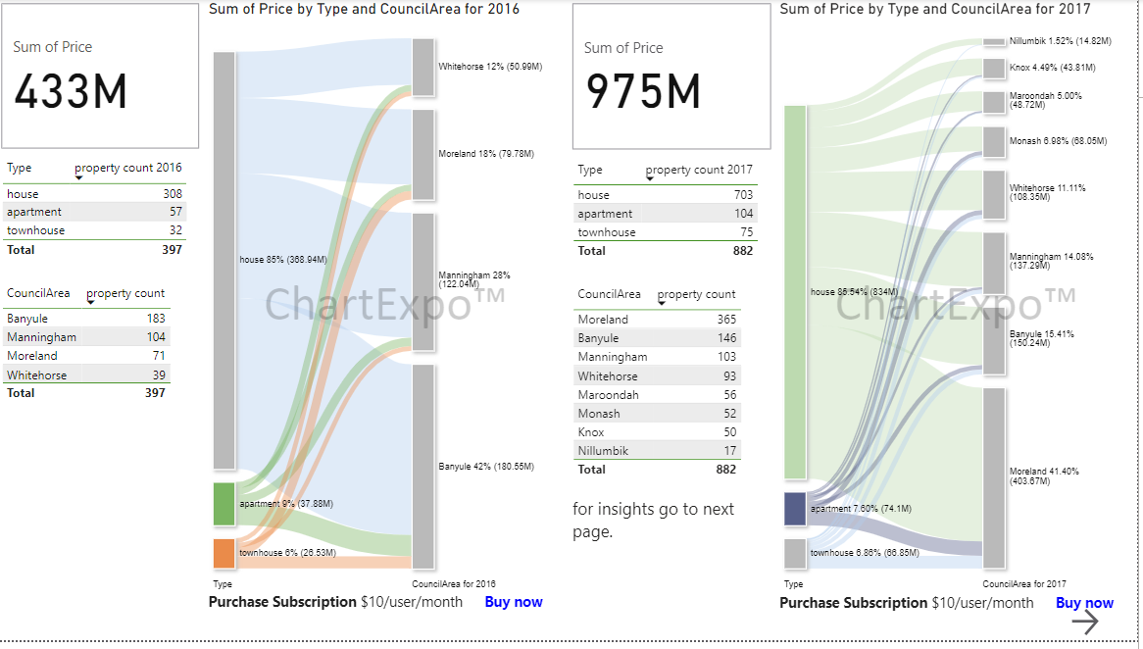

**Figure 11**

Insights:

All types have their count increased, only apartment had its contribution decreased so average price decreased (intuition 2). From council areas: Banyule and Manningham had their count and contribution decreased while Moreland had count and contribution increased, and Whitehorse had count increased, but contribution decreased hence average price decreased (intuition2).

**Eastern Metropolitan, method: property sold, council area: Moreland.**

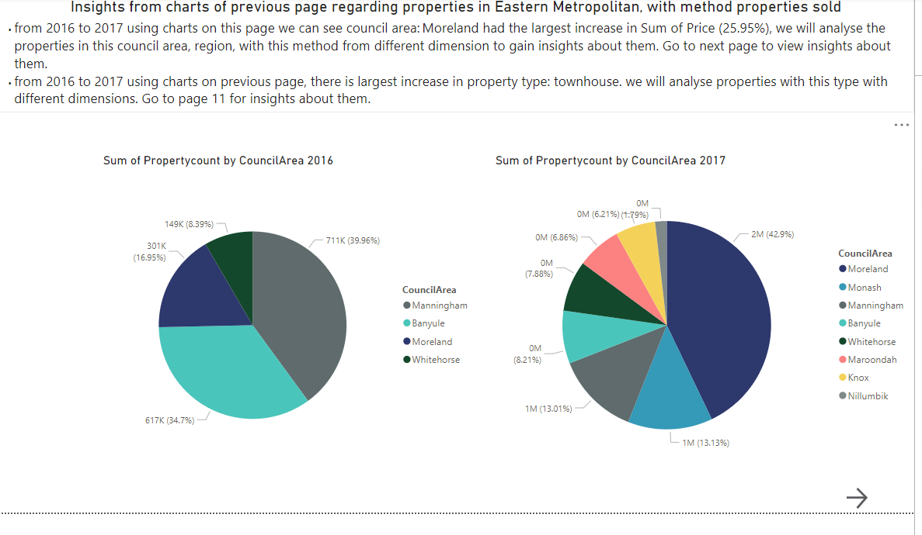

Figure 12

Figure 13

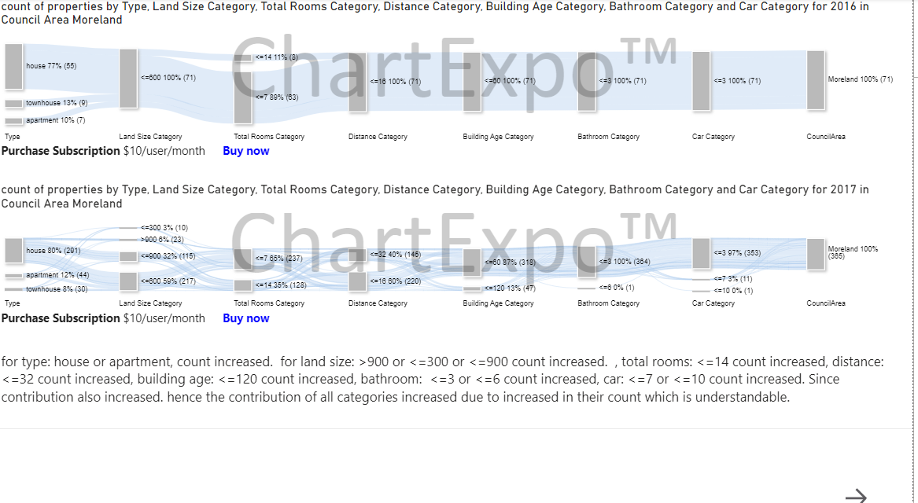

Figure 14

Insights (other than in snap) from figure 13 and 14:

From type: townhouse had their contribution and count decreased. From land size: <=600 count and contribution decreased. From total rooms: <=7 count, and contribution decreased. From distance: <=16, count and contribution decreased. From building age: <=60, count and contribution decreased. From bathroom: same as in snaps. From car: count and contribution decreased.

**Eastern Metropolitan, method: property sold, property type: townhouse.**

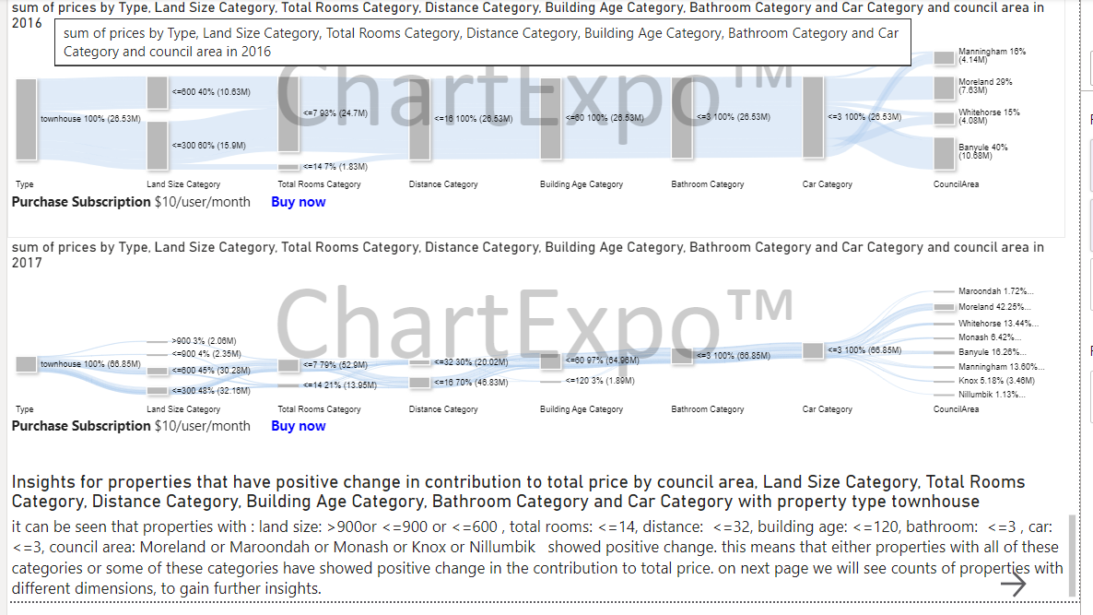

Figure 15

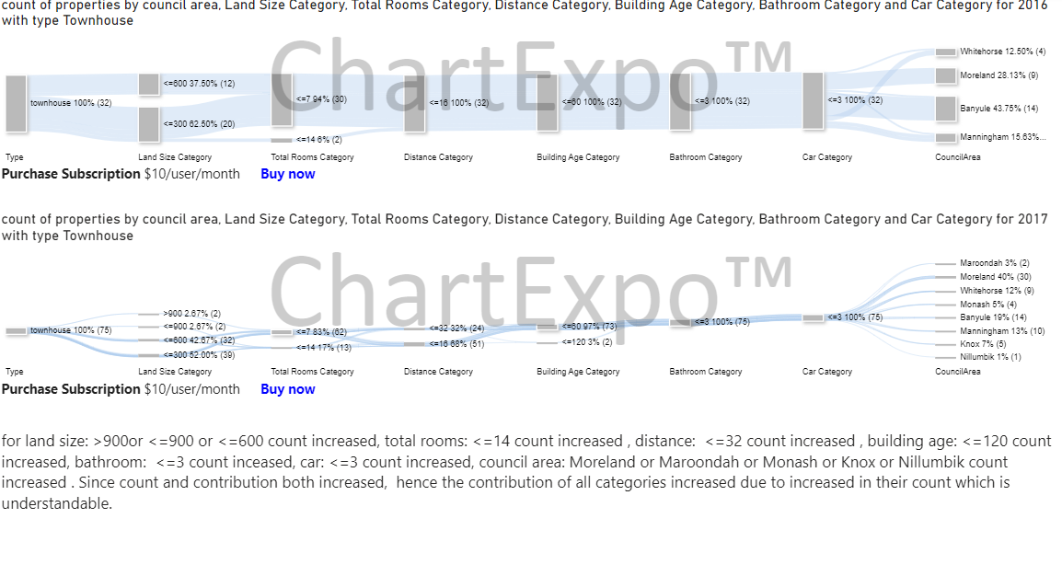

Figure 16

Insights (other than in snap) from figure 15 and 16:

From land size: <=300 count, and contribution decreased. From total rooms: <=7, count and contribution decreased. From distance: <=16, count and contribution decreased. From building age: <=60, count and contribution decreased. From bathroom: <=3, count and contribution increased. From Car: <=3, count and contribution increased. From council areas: Banyule, Manningham, white horse had their contribution and count decreased.

**Recommendations:**

using these insights, one should look for properties with catgeories that had their average price increased if investment is done for business purposes like for earning, and if house or any property is being bought, then one should look for properties that had their average price decreased.

Insights from the dimension of suburb and seller agent are not done but for more information those dimensions could be used.