Report

**Dataset link:**

<https://data.humdata.org/dataset/6a1e00b3-0ff2-42ba-ba8c-efc06b0bc930/resource/7cc2945a-2498-4180-b04b-089959691339>

NOTE: *We added a column: All total where each value is  
(Male Total + Female Total), to help in analysis, since there was inconsistency with values of “Total” column and its related column values.*

*For different insights interaction could be done with dashboard here is just summary.*

**Overview of asylum countries:**

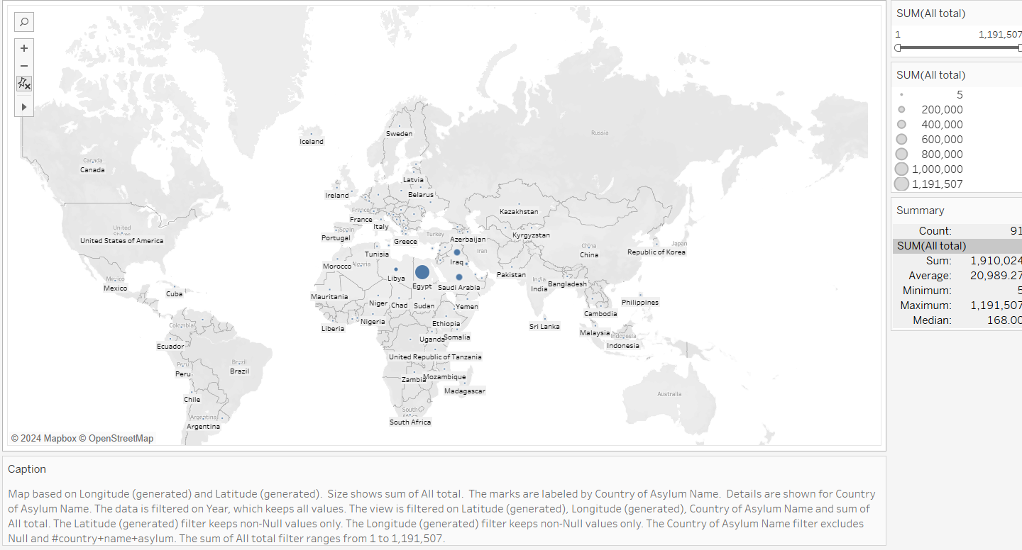

Here through summary box, we can see that 1191507 is the highest number of displaced people to a single country. Filtering out top 5 we can see that:

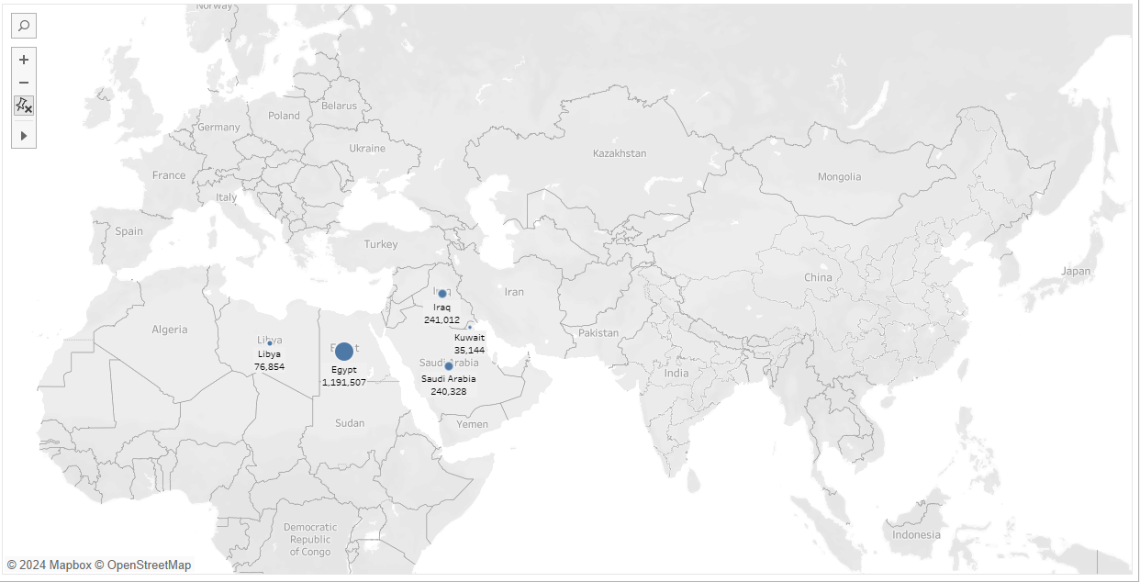

Egypt>Iraq>Saudi Arabia> Libya> Kuwait is the order of decreasing displaced people to each country, within top 5 countries.

**Trend of displacement to each country and type of displacement:**

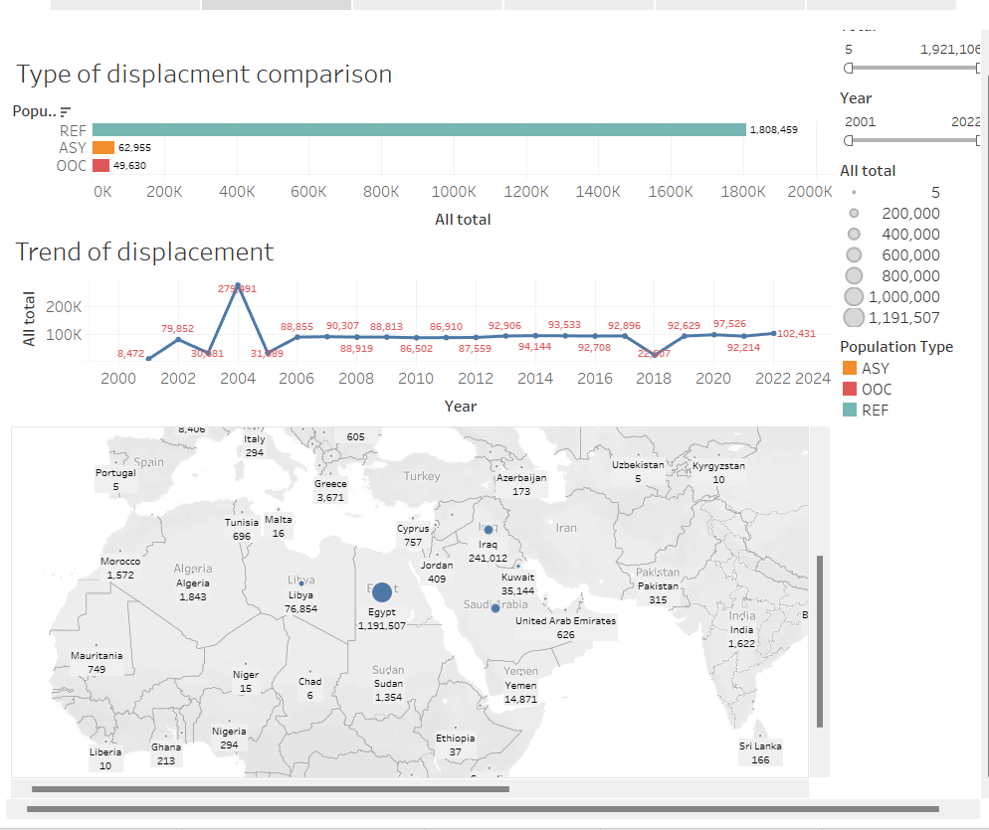

We can see that 2004 is the highest number of displacement while 2000 is for lowest.

Ref: refugee, Asy: asylum, Ooc: out of camp. Out of these three types, refugee type of displaced population is highest while OOC is lowest.

**For type refugee:**

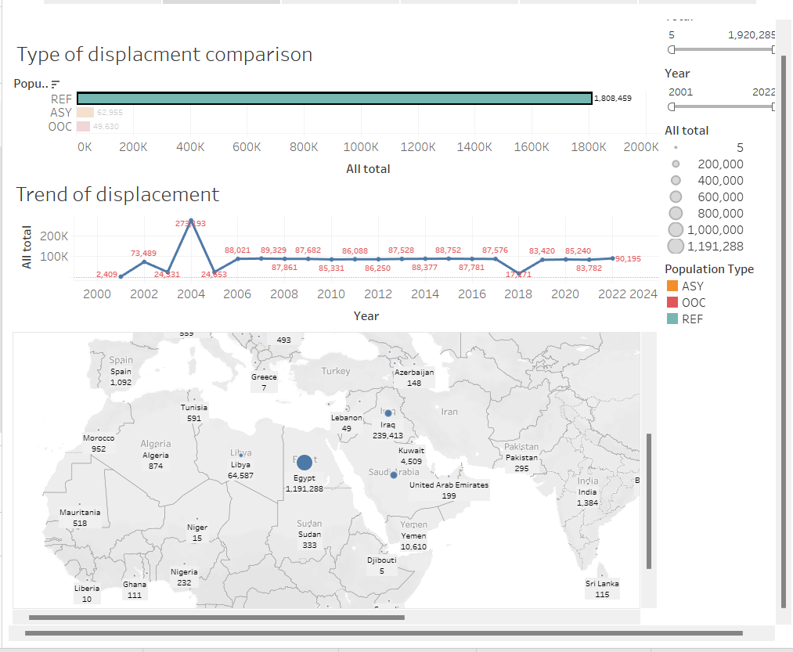

Egypt is the country with highest number, 2004 is the year with highest number and 2000 for lowest.

**For asylum:**

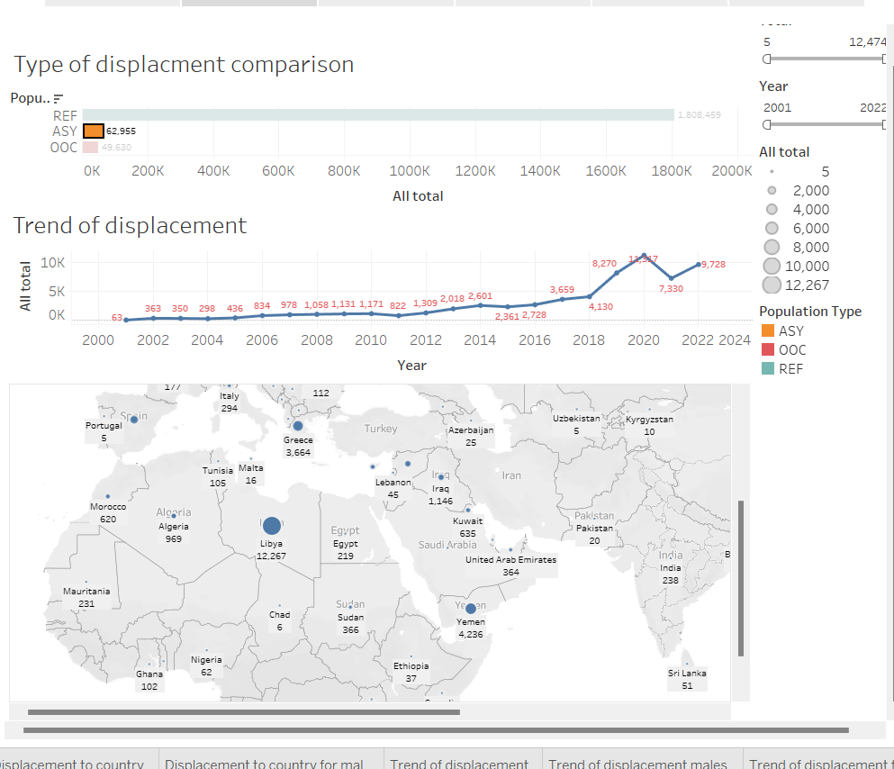

Libya is the country with highest number, 2020 is the year with highest and 2001 for lowest.

**For out of camp:**

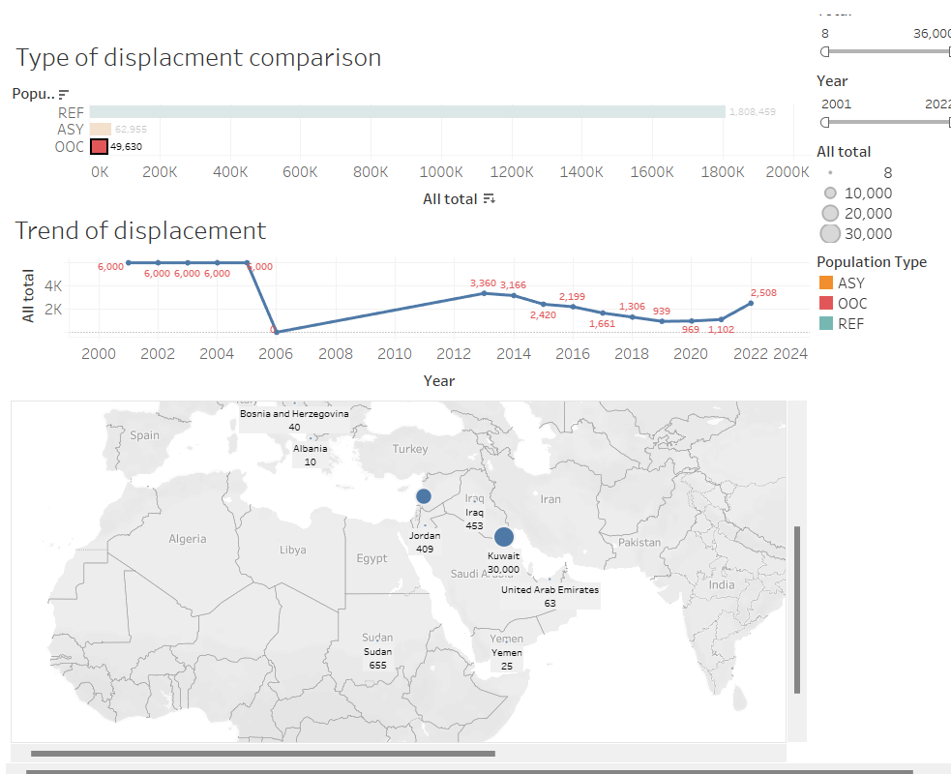

Kuwait is the country with highest, 2000-2005 are the years with same number and highest number amongst other years while 2006 is the year for lowest number (0).

**Comparison between displaced males and females along with their age groups:**

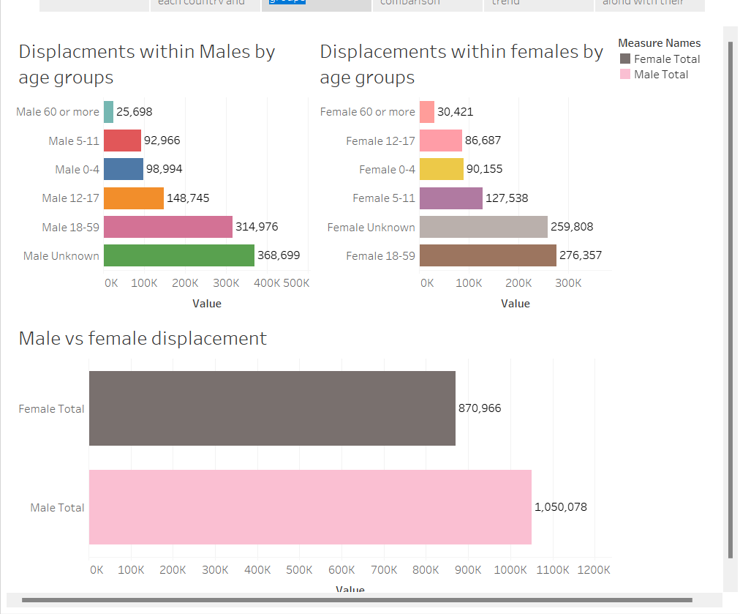

Total number of displaced males= 1050078, age group with highest proportion: Unknown, age group with lowest proportion: >=60.

Total number of displaced females: 870966, age group with highest proportion: 18-59, age group with lowest proportion: >=60.

**Male vs Female displacement comparison country wise:**

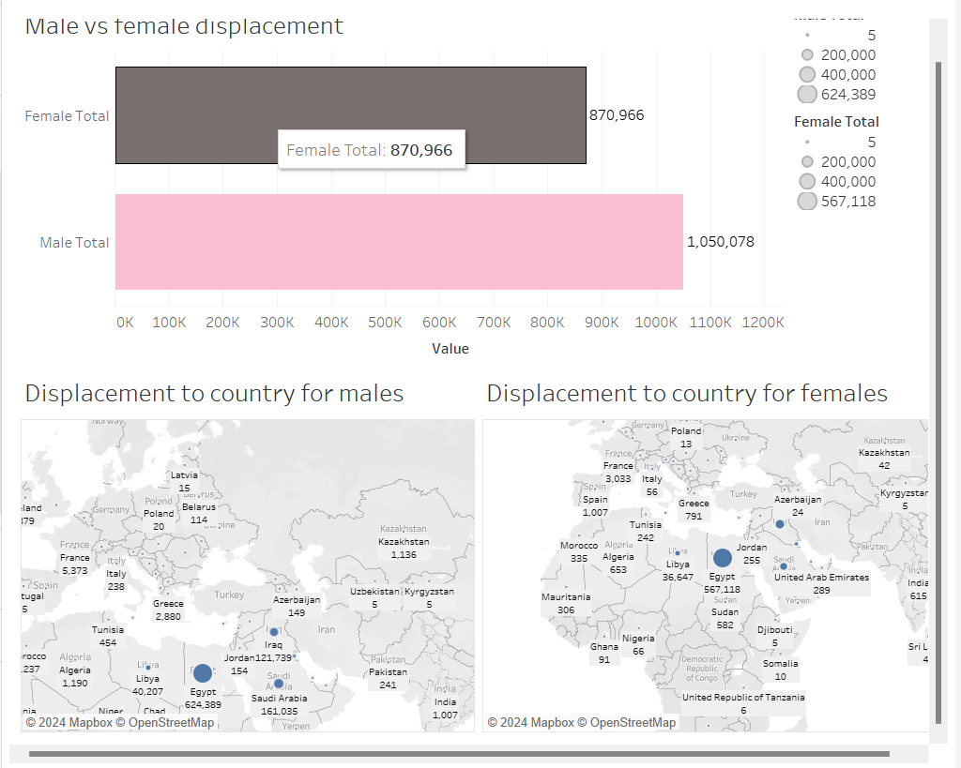

Egypt is the country with highest number of displaced people for all genders. We will filter out top 5 countries for both genders to have better visualization:

**For males:**

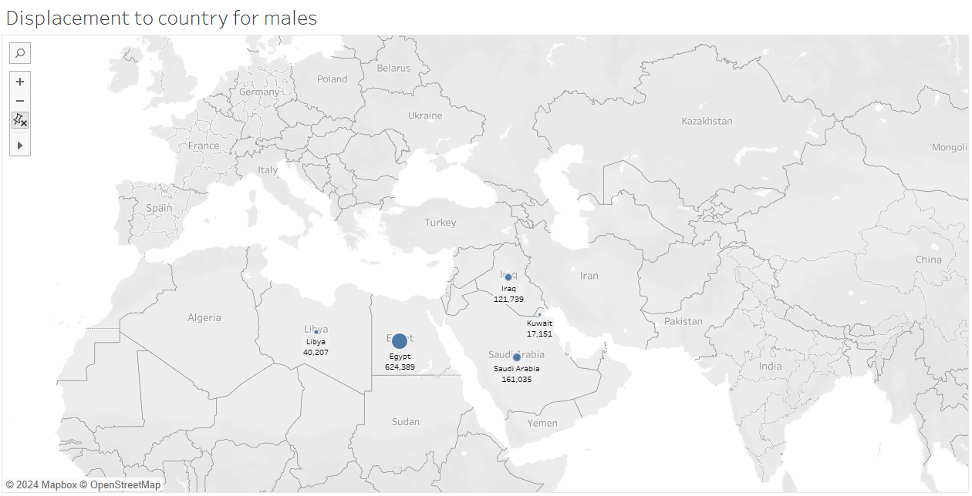

Egypt> Saudi Arabia> Iraq> Libya> Kuwait

**For females:**

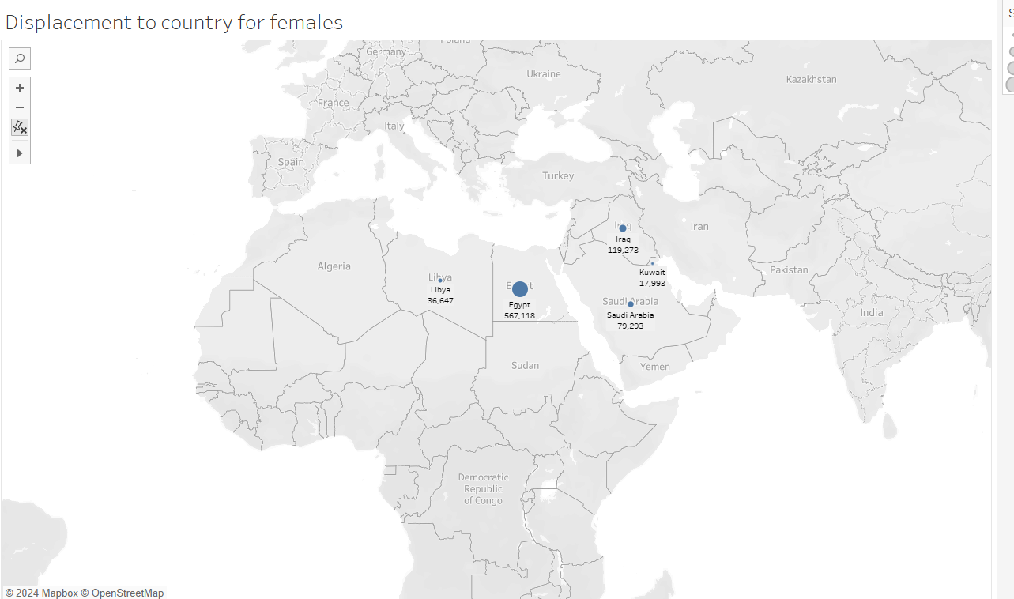

Egypt>Iraq>Saudi Arabia> Libya> Kuwait. Just position of Iraq and Saudia is changed from male to female.

**Male vs female displacement trend:**

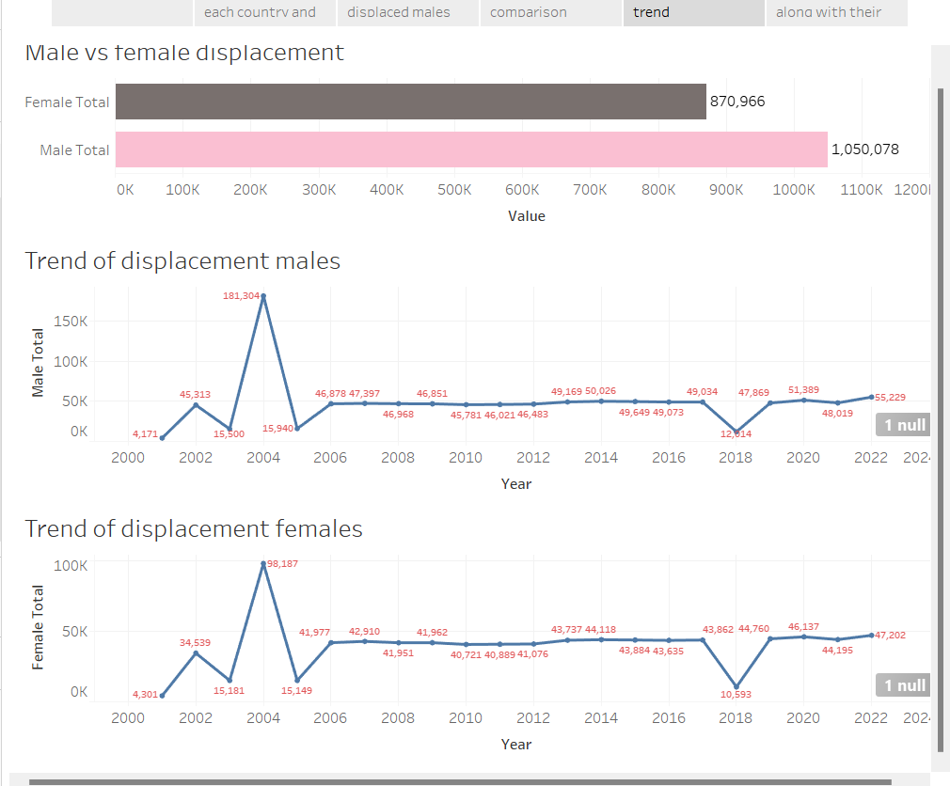

Trend of displacement for all genders is same, however, the values are different.

**Distribution of males and females along with their age groups, against displaced population types:**

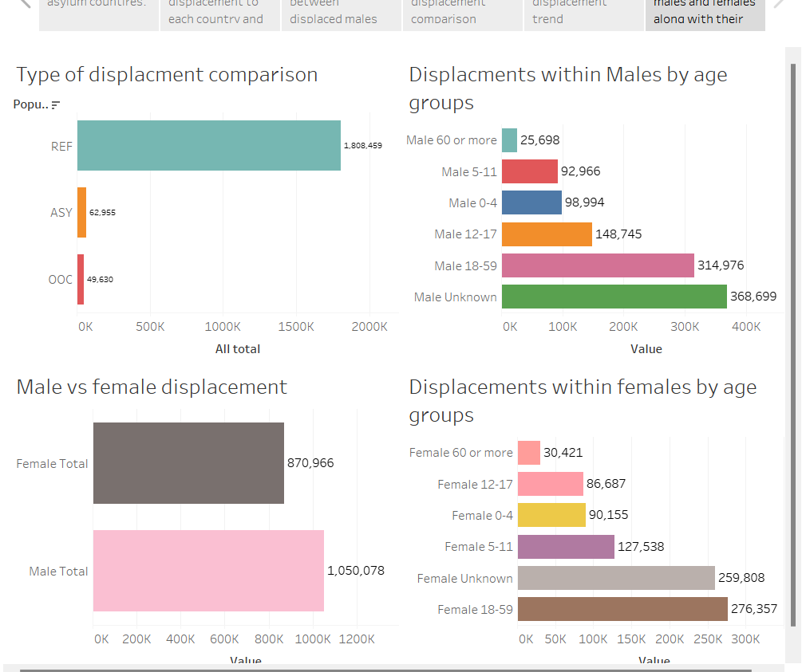

**Figure a**

We will play around with each type of population to check the distribution of gender and their age groups in that population type:

**For refugee:**

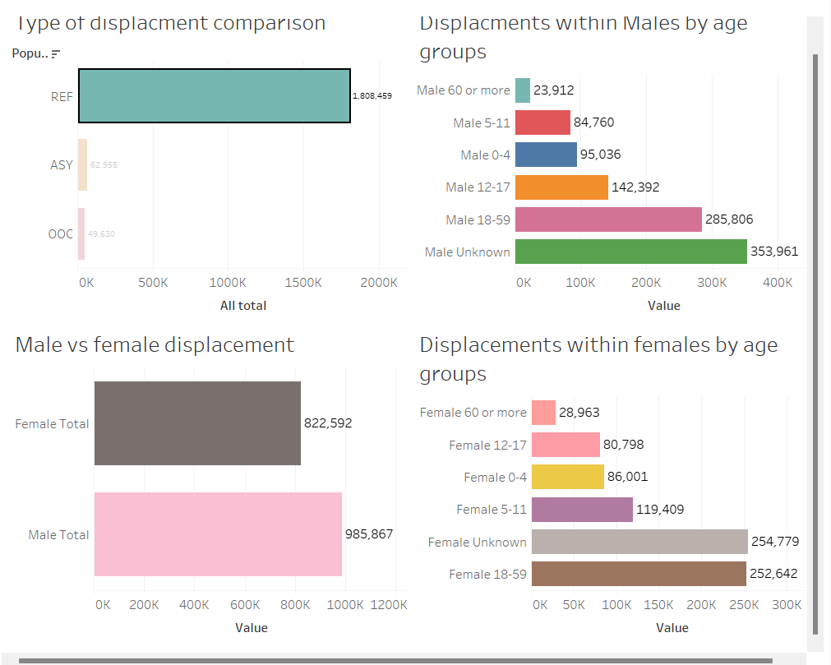

We can see in figure a that for females age group: 18-59, has highest number of displaced people but specifically in refugee type, age group: Unknown, dominates other groups for both genders. More males are displaced with this type than females.

**For asylum:**

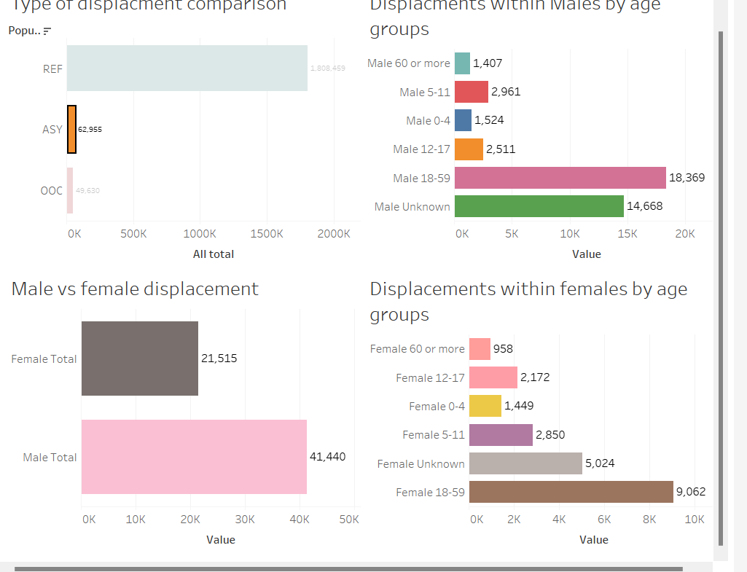

Age group: 18-59, dominates other groups for both genders. Referring to figure a, generally values for age group:

5-11, for both genders were greater than 60 or more and less than 0-4, but in this type, it is greater than both. More males are displaced with this type than females.

**For out of camp:**

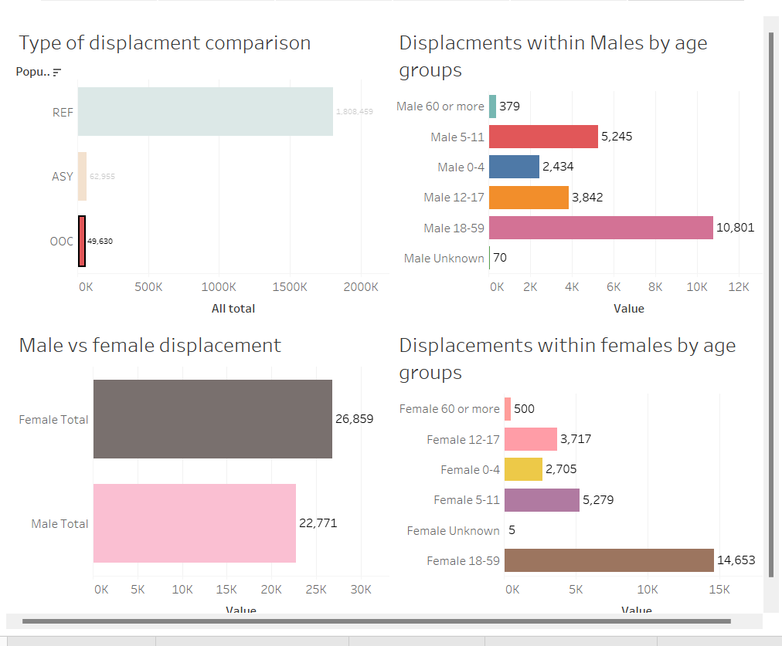

In this type, more females are displaced than males. Age group 18-59 dominates other groups for both genders while age group unknown is least for both genders which is quite contrary to the distribution for other types of population.