**Body Boost**

|  |
| --- |
| **Riphah** |

**By:**

**Anosh Junaid**

**11359**

**Muhammad Ali Hamza**

**12826**

**Hidayat Ullah**

**11939**

**Supervised by:**

**Mr. Muhammad Usman Karim**

**Faculty of Computing**

**Riphah International University, Islamabad**

**Spring/Fall 2023**

**A Dissertation Submitted To**

**Faculty of Computing,**

**Riphah International University, Islamabad**

**As a Partial Fulfillment of the Requirement for the Award of the Degree of**

**Bachelors of Science in Software Engineering**

**Faculty of Computing**

**Riphah International University, Islamabad**

Date: [date of final presentation]

**Final Approval**

This is to certify that we have read the report submitted by **Anosh Junaid (Sap Id #11359)**, **Muhammad Ali Hamza (Sap Id #12826), Hidayat Ullah (Sap Id #11939)** for the partial fulfillment of the requirements for the degree of the Bachelors of Science in Computer Science (BSCS). It is our judgment that this report is of sufficient standard to warrant its acceptance by Riphah International University, Islamabad for the degree of Bachelors of Science in Computer Science (BSCS).

**Committee:**

|  |  |
| --- | --- |
| **1** | [Name Supervisor]  (Mr. Muhammad Usman Karim) |
|  |  |
| **2** | [DR. Musharaf Ahmed]  (Head of Department/chairman) |

**Declaration**

We hereby declare that this document “**BodyBoost**” neither as a whole nor as a part has been copied out from any source. It is further declared that we have done this project with the accompanied report entirely on the basis of our personal efforts, under the proficient guidance of our teachers especially our supervisor **Mr. Muhammad Usman Karim**. If any part of the system is proved to be copied out from any source or found to be reproduction of any project from anywhere else, we shall stand by the consequences.

**___________________________**

**Anosh Junaid**

**11359**

**___________________________**

**Muhammad Ali Hamza**

**12826**

**___________________________**

**Hidayat Ullah**

**11939**

**Dedication**

To the kindest person, Mother, and especially the dearest person, Father who was always our support and whose prayers brought us up to this level and our supervisor; the kindest dedicated person that it would have been impossible for us to complete or accomplish our goals of the project if he wasn’t there for us.

**Acknowledgement**

First of all, we are obliged to Allah Almighty the Merciful, the Beneficent and the source of all Knowledge, for granting us the courage and knowledge to complete this Project. We want to express our sincere thanks to our project supervisor **Mr. Muhammad Usman Karim** for his guidance. We also take this opportunity to thank our parents for the unceasing encouragement, support, attention and reassuring our confidence. We also place our sense of gratitude on record to one and all who directly or indirectly have lent their hand in this venture. Lastly, we would like to thank each other (Project Team – Anosh Junaid, Muhammad Ali Hamza and Hidayat Ullah) for caring support under challenging situations.

**___________________________**

**Anosh Junaid**

**11359**

**___________________________**

**Muhammad Ali Hamza**

**12826**

**___________________________**

**Hidayat Ullah**

**11939**

**Abstract**

The global health and fitness industry is continuously growing, with an increasing number of people looking for convenient ways to stay fit and healthy. After COVID 19

People become app oriented, they don’t want to go in gym rather they want to do exercises in home on their free time. They want to have good diet plan and do proper exercise to keep themselves fit, Problem occur when some people who aren’t mentally stable or in stress when they start eating nutrients what aren’t good for their health. Our app can tap into this expanding market Provide users with personalized workout and diet plans tailored to their emotional states, contributing to holistic well-being. By integrating social media textual data, the system captures real-time sentiments, enabling personalized workout and diet plans aligned with users' emotional states expressed.

**Table of Contents**

Chapter 1 11

INTRODUCTION 11

1.1 Introduction 2

1.2 Opportunity and Stakeholder 2

1.2.1 Health and Fitness Industry Growth 3

1.2.2 Community Building 3

1.2.3 Data Analytics and Insights 3

1.2.4 Monetization Options 3

1.2.5 Stakeholders 3

1.3 Motives and Challenges 3

1.4 Goals and Objectives 4

1.5 Solution Overview 4

1.7 Report Outline 5

Chapter 2 6

2 LITERATURE/MARKET SURVEY 6

2.1 Introduction 6

2.2 Background and Problem Elaboration 6

2.3 Detailed Literature Reviewer 7

2.3.2 Existing Solutions for BodyBoost 7

2.3.3 Strengths: 7

2.3.4 Weaknesses: 7

2.3.5 Related research work 8

Chapter 3 11

3 REQUIREMENT ANALYSIS 11

3.1 Introduction 11

3.2 Problem Scenario 11

3.2.1 User registration and login: 11

3.2.2 Daily Exercise: 11

3.2.3 Suggesting Diet: 11

3.2.4 Sentiment: 11

3.2.5 Admin dashboard for user management and data analysis: 11

3.2.6 Blocking/unblocking users: 11

3.3 Functional Requirements 11

3.4 Non-Functional Requirements 12

3.5 SQA Activities: Defect Detection 13

3.5.1 Test case design: 13

3.5.2 Code review: 13

3.5.3 Unit testing: 13

3.5.4 Integration testing: 13

3.5.5 System testing: 13

3.5.6 Performance testing: 13

Chapter 4 14

4 SYSTEM DESIGN 14

4.1 Introduction 14

4.2 Architectural Design 15

4.3 Detailed Design 16

4.3.1 Test Case 17

Chapter 5 27

**5** **IMPLEMENTATION** 27

**5.1.2** **Team Members** 27

**5.1.3** **Work Breakdown Structure (WBS)** 27

**5.2.1** **Project Schedule** 28

**5.2.2** **Way of Working** 28

**5.2.3** **Risk Management** 28

**5.3** **Flow Control/Pseudo codes** 29

**5.3.1** **Sign up Page** 29

**5.3.2** **Login Page** 29

**5.4** **Components, Libraries, Web Services, and Stubs** 30

**5.4.1** **Components** 30

**5.4.2** **Libraries** 31

**5.4.3** **Web Services** 31

**5.4.3** **Stubs** 33

**5.5** **IDE, Tools and Technologies** 33

**5.6** **Best Practices and Coding Standards** 33

**5.7** **Deployment Environment for Body Boost** 34

**5.8** **Summary** 34

Bibliography 35

**List of Figures**

Figure ‎4.1 Architectural Design 18

Figure ‎4.2 Use Case Diagram 19

Figure ‎4.4:- Database Schema Diagram 29

Figure ‎5.1 Testing twitter API in Post Man 40

Figure ‎5.2 shows that we are unable to enter twitter URL 40

**List of Tables**

Table ‎2.1 Summary table of research paper 11

Table ‎4.1 Register 20

Table ‎4.2 login 21

Table ‎4.3 view profile 22

Table ‎4.4 Manage Profile 23

Table ‎4.5 Create workout plan 24

Table ‎4.6 Mange workout plan 25

Table ‎4.7 View workout schedule 26

Table ‎4.8 Create diet plan 26

Table ‎4.9 Track progress 27

Table ‎4.10 Notification 28

Chapter 1

INTRODUCTION

# Introduction

BodyBoost is an Application based on fitness specifically designed for a person who do exercises in home. The system aims to provide efficient, safe, and reliable health for people, our app can tap into this expanding market Provide users with personalized workout and diet plans tailored to their emotional states, contributing to holistic well-being. By integrating social media textual data, the system captures real-time sentiments, enabling personalized workout and diet plans aligned with users' emotional states expressed.

## Opportunity and Stakeholder

Physical activity can help people maintain a healthy weight and lower their chance of developing a variety of chronic conditions and many diseases. Despite this information, adults and children in many nations, countries do not engage in physical activity on a regular basis or any physical games. Researchers have never-before-seen chances to learn and adopt more about the health advantages of physical activity thanks to recent advancements in physical activity monitoring.

Research indicates that technology has played a role in the rise in sitting down and decline in physical activity. On the other hand, it has additionally inspired a number of creative physical activity-focused therapies. One such innovation is through the use of mobile fitness apps and the sharing of one’s workout through a social network. This paper will focus on the collection of self-reported fitness data through a mobile fitness app that is then shared with one’s social network via Twitter. The dataset of these tweets along with other connected datasets of demographic information allows for a number of analyses, including but not limited to the potential influence of such tweets and the sentiment of these tweets. By combining the digital traces as people interact through mobile phones and emerging technology may now provide novel methods to assess a range of factors objectively and with minimal expense and burden to participants. This paper will review both the potential online influence and the sentiment of the shared fitness tweets.

The way societies have been exposed to information has changed as a result of social media like Facebook, tweeter etc. Twitter has developed into a more beneficial tool for the general population to express their opinions, ideas, and thoughts. Twitter is one of the most used application worldwide. It is a free social networking site that is utilized by both people and companies to share their ideas and business.

The mission of Twitter is to “give everyone the power to create and share ideas and information instantly, without barriers”. With 328 million active monthly users, more than 1 billion unique visitors each month to sites with embedded tweets. Twitter users can rapidly and directly share with and respond to a massive audience, using messages of 140 characters or less. With the creation and introduction of newly developing technologies such as Twitter, new opportunities to obtain global health data that may circumvent the limitations of traditional data sources used in population health and physical activity research are now available.

1.2.1 Health and Fitness Industry Growth: The global health and fitness industry is continuously growing, with an increasing number of people looking for convenient ways to stay fit and healthy. Our app can tap into this expanding market.

* + 1. Community Building: Creating a supportive community within the app can foster engagement and retention. Users can motivate each other, share progress, and seek advice.
    2. Data Analytics and Insights: Providing users with detailed analytics on their progress, along with suggestions for improvement, can set your app apart from others.
    3. Monetization Options: Explore various monetization models, in-app or partnerships with fitness equipment or nutrition brands.

### Stakeholders

#### End Users**:** The individuals who will use the app to improve their fitness and overall health.

#### Fitness Trainers and Instructors: our app involves expert advice or personalized training plans, fitness professionals become stakeholders. They may provide content or expertise for the app

## Motives and Challenges

The main motive in our mind is to develop a fitness app so that it will facilitate user and nutritionist both. Our App will provide users with personalized workout and diet plans tailored to their emotional states, contributing to holistic well-being. To give good diet and exercise but looking at his mental state, the detection will be performed using Machine learning models.

In our fast-paced lives, we often struggle to stay healthy while dealing with different emotions like stress or happiness. The problem is current fitness apps don't really understand our feelings. They give us the same exercises and diet plans, no matter how we're feeling. This disconnect means we miss out on personalized advice that matches our emotions. The motivation for a new solution is clear. We need a smart system that understands our feelings in real-time. Using this system, we can create personalized workouts and diets that match our feelings, making it much easier to stay healthy and happy.

## Goals and Objectives

We want to create a smart system that understands how you're feeling, like if you're stressed or happy. Our fitness app's objectives include encouraging overall wellbeing through the integration of sentiment analysis and BMI calculations for an integrated strategy to health. Our goal is to customize fitness experiences by making nutrition and exercise suggestions based on individual body metrics and social media-derived emotional states. Our goals are to: apply precise BMI computations; incorporate a dependable sentiment analysis module; create an adaptive recommendation engine; guarantee user-friendly profile management; give app security and privacy first priority; create mechanisms for continuous improvement; and develop a pleasant and easy-to-use user experience. By implementing these aims and objectives, we hope to provide a motivating and encouraging fitness platform that takes into factors related to mental and physical health and fosters long-term user engagement.

## Solution Overview

Our app can tap into this expanding market Provide users with personalized workout and diet plans tailored to their emotional states, contributing to holistic well-being. By integrating social media textual data, the system captures real-time sentiments, enabling personalized workout and diet plans aligned with users' emotional states expressed.

* 1. **Conclusion**

We want to create a smart system that understands how you're feeling, like if you're stressed or happy. This system will use that info to give you personalized workout and diet plans. It's similar to having a fitness buddy fitness partner. It will be easy to use and understand, so you won't need to be a mobile application expert and genius. Our goal is to help you manage your physical and mental state, deal with your emotions, and find your path to health and fitness. We want to convert the way you manage your health by customizing your fitness journey to fit your specific needs and emotional state. The goal is to grow a happier, healthier version of yourself by making good food and training choices every step of the way.

## Report Outline

Our project involves the implementation of a fitness app through sentiment analysis algorithms. It will process user-input sentiments, extracting emotional cues such as stress or happiness, forming the foundation for personalized recommendations. The Data will be Collected gather from user-input data, which may include text-based input or responses to emotion-related prompts. This could be collected directly within the application or through integrated social media platforms.

# Chapter 2

# LITERATURE/MARKET SURVEY

## Introduction

In this chapter, we have discussed our background and problem elaboration in detail. In detailed literature review, we have mentioned that how previous studies showed that a variety of researchers from across the globe are working on sentimental analysis and health and fitness.

Our focus is around the intersection of emotional assessment, fitness, and nutrition. Through a comprehensive literature review, we find research has been conducted on sentiment analysis in health-related forums and social media platforms. Studies explore how sentiment analysis can be applied to understand user emotions and attitudes towards health issues, the literature on personalized fitness applications has focused on algorithms for tailoring workout plans based on user characteristics such as fitness level, preferences, and goals. [See table 2.1]

Existing fitness applications often provide generic workout and diet plans, lacking the finesse of tailoring recommendations based on users' emotional states. Our research seeks to bridge this gap by integrating sentiment analysis algorithms to discern users' emotional states and preferences, subsequently offering bespoke workout routines and dietary guidance. We have also explained existing apps that can facilitate user regarding their health issues and fitness goals i.e. (Nike training club, My Fitness Pal) and how they work.

## Background and Problem Elaboration

In today's world, lots of people want personalized fitness help from their phones. But the apps we have now mostly miss out on understanding how our feelings affect our health choices. Our project, it wants to create a new kind of app that listens to your emotions and gives you fitness and diet plans that really fit you. With everyone using smartphones, this is the perfect time to make an app that really understands how we feel about our health.

The problem is, the current fitness apps are a bit basic. They give everyone the same exercises and diets, ignoring that we all feel different. This one-size-fits-all method doesn’t work for everyone. Our research shows that there's no app that truly gets how person feelings, our ups and downs, affect our health choices. We want to make an app that not only knows the exercises and foods you need but also understands how you feel, making your health journey more personal and enjoyable. The app which uses social media post like tweets to detect mental state. Through our project, we aim to fill this gap and make a fitness and nutrition app that's as unique as you are.

## Detailed Literature Reviewer

Previous studies showed that a variety of researchers from across the globe are working on sentimental analysis, health and fitness but very little work has been done on fitness app which takes user mental health and suggest workout plan and diet.

### ****Existing Solutions for BodyBoost****

Several existing mobile applications and platforms address the needs of fitness . apps. Some notable examples include:

#### ****FitBit:**** Offers activity tracking and give exercise and calculate the mass of our body.

#### ****MyFitnessPall**:** Provides a similar service with comprehensive meal tracking and dedicated workout.

#### ****Nike Training Club**: Gives customized workout plans**.

#### ****7 Minute Workout**:** Gives a quick and focused workout.

### ****Strengths****:

* These application gives a wide ranges of trackers that monitors various activities.
* Some of the apps provides valuable insights into user and helping them make informed choices.
* App often include variety of workouts and catering to different fitness level.

### ****Weaknesses****:

* Users find this app difficult to use, especially new member.
* Some advance features behind a premium feature, which may deter budget conscious user.
* Lack of information of the user mental health lead it to the lack of wellbeing of the user.

### Related research work

Previous studies showed that a variety of researchers from across the globe are working on sentimental analysis, health and fitness but very little work has been done on fitness app which takes user mental health and suggest workout plan and diet.

[1] Facebook Al developed RoBERTa (short for “Robustly Optimized BERT Approach”) which is the variant of BERT (Bidirectional Encoder Representations from Transformers) model. it is transformer-based language model. In BERT, the system learns by predicting intentionally hidden parts of sentences in unannotated language examples. There was two key change in RoBERT. It removes BERT's next-sentence pretraining objective (NSP). And RoBERTa was trained on a much larger dataset.

The training data includes existing unannotated NLP datasets and a new set called CC-News, derived from public news articles. The model achieves an overall score of 88.5 on the GLUE benchmark, which stands for General Language Understanding Evaluation. This benchmark consists of multiple NLP tasks. The GLUE leaderboard refers to the ranking system for models participating in the General Language Understanding Evaluation (GLUE) benchmark. It is designed to evaluate the general language understanding capabilities of models. We also match state-of-the-art results on SQuAD. SQuAD stands for the "Stanford Question Answering Dataset." SQuAD is designed to evaluate the ability of computer systems to understand and answer questions posed by humans based on a given passage of text.

[2] Sunir Gohil, Sabine Vuik and Ara Darzi paper sets out with the primary objective of understanding the tools available for sentiment analysis in health care research on Twitter. [] The second objective was to determine which method would work best in the health care settings, by analyzing how the methods were used to answer specific health care questions, their production, and how their accuracy was analyzed. The study found that people use different methods to figure out the feelings in tweets, from simple ways to expensive tools. It says we need better tools that are trained specifically on health-related tweets. The study looked at 12 papers published between 2011 and 2016, and in about 46% of health tweets, people express either positive or negative feelings. The researchers suggest that it's crucial to have accurate tools that understand the unique way people talk about health on Twitter. 4500 Twitter records were used. Of the classification algorithms, the best performance has been obtained with SVM by 82.9% accuracy on the dataset using unigrams. In their sentiment analysis study, Huq et al (Huq et al, 2017) used the SVM and k-NN machine learning algorithms on the Twitter data, and obtained the normal tracking accuracy values between 58.39% and 79.99% on the datasets obtained after the feature extraction by the n-grams.

[3] Muhammet Sinan Başarslan, Fatih Kayaalp This study explores how social media, particularly Twitter, is a significant part of our daily lives. The research specifically investigates how different ways of representing text affect the accuracy of sentiment analysis. Two datasets were used—one with user reviews about movies from IMDB and another with Twitter tweets about health in English from 2019. The study implemented classification models using Naïve Bayes, Support Vector Machines, and Artificial Neural Networks in Python. The sentiment categorization used techniques like Term Frequency-Inverse Document Frequency (TF-IDF) and Word2Vec (W2V) modeling. The results showed that Artificial Neural Networks performed the best in terms of accuracy for both datasets with score of 0.85. The NB gave the worst performance among others in both datasets.

Table ‎2.1 Summary table of research paper

|  |  |  |  |  |  |  |
| --- | --- | --- | --- | --- | --- | --- |
| No. | Author Name | Language | Year | Machine Learning Methods | Data Description | Performance |
| 1. | Facebook AL | English | 2019 | RoBERTa and BERT | 160GB of text | SQuAD 94.6/89.4, 88.5 on the GLUE benchmark |
| 2. | Muhammet Sinan Başarslan, Fatih Kayaalp | English | 2020 | NB, SVM & ANN | English | 0.85 score |
| 3. | Sunir Gohil, Sabine Vuik and Ara Darzi | English | 2018 | SVM , SVM,NB & k-NN | 4500 Twitter records were used | 82% accuracy |

* 1. **Summary**

In this chapter we gathered various research paper related to sentimental analysis which uses machine learning and have a different accuracy rate. Roberto model have excellent accuracy and wide range of different feature like hate speech detection, irony detection which can be very helpful for sentimental analysis. We also discussed different apps which have different strength and weakness. Every app has different purpose like 7 Minute Workout have only quick work out and have no feature for diet plan or sentimental analysis. We have also discussed there is increase in demand of personalized fitness assistance since Covid. Existing apps does not have option for understanding the emotional aspect of health. This application aims to fill this gap by creating an app that considers user emotions by using textual data and provides custom work out and diet plans.

# Chapter 3

# REQUIREMENT ANALYSIS

## Introduction

In this chapter we have developed our functional requirements for our actors i.e. (user, admin and nutritionist). We have also developed functional requirements here we discuss those factors which may not be direct features of our designed system but are important to consider during our system’s development. We purposed our methodology in which we aim to develop a fitness app that will facilitate the user, main motive in our mind is to develop a fitness app so that it will facilitate user and nutritionist both. Our App will provide users with personalized workout and diet plans tailored to their emotional states, contributing to holistic well-being. To give good diet and exercise but looking at his mental state, the detection will be performed using Machine learning models.

## Problem Scenario

This section describes the various situations where both trainee and BodyBoost nutritionist will utilize the app and website. This includes:

### User registration and login:

  How users create accounts and access the system.

### Daily Exercise:

  How user do his daily workout and saw his record.

### Suggesting Diet:

How users find his daily diet and what nutrients should he take on what basis.

### Sentiment:

How the use is feeling, what is his mental health.

### Admin dashboard for user management and data analysis:

How admins manage user accounts, monitor activity, and analyze data for insights.

### Blocking/unblocking users:

How admins manage user access and prevent misuse.

## Functional Requirements

User Table 3.1

|  |  |
| --- | --- |
| **ID** | **Requirements** |
| FR 1.1 | User shall be able to register an account. |
| FR 1.2 | User shall be able to login to their account through authentication. |
| FR 1.3 | User shall be able to view his activity. |
| FR 1.4 | User shall be able to view his profile. |
| FR 1.5 | User shall be able to edit his profile. |
| FR 1.6 | User shall be able to forget password. |
| FR 1.7 | User shall be able to recover password. |

Admin Table 3.2

|  |  |
| --- | --- |
| **ID** | **Requirements** |
| FR 2.1 | Admin shall be able to login to their account. |
| FR 2.2 | Admin shall be able to view his profile. |
| FR 2.3 | Admin shall be able to update his profile. |
| FR 2.4 | Admin shall be able manage user. |
| FR 2.5 | Admin shall be able to create announcements. |
| FR 2.6 | Admin shall be able to edit announcements. |
| FR 2.7 | Admin shall be able to delete announcements. |
| FR 3.1 | A classification module shall be able to classify the mood of the user before giving exercise. |
| FR 3.2 | A classification module shall be able to classify the mood of the user before giving diet plan. |

### Non-Functional Requirements

Non-functional requirements are the capabilities, constraints and specifications which help enhance the system and its usage. Unlike functional requirements here we discuss those factors which may not be direct features of our designed system but are important to consider during our system’s development.

* + 1. User Privacy: The system should ensure the privacy of users and their data.
    2. Data Security: The system should protect sensitive user data from unauthorized access.
    3. Accuracy: The system should accurately the mood sentiments.
    4. Speed: The system should process data in real-time to quickly detect mood of the user.
    5. Language Support: The system will support the use of English and Roman Urdu to detect the mood of the user.
    6. Interoperability: The system should be compatible with web browsers.

## SQA Activities: Defect Detection

Software Quality Assurance (SQA) ensures the app and website meet defined requirements. This includes various defect detection activities:

### Test case design:

Write comprehensive test cases that cover all functionalities and identify potential defects in code and functionality.

### Code review:

Analyze the code for errors, adherence to coding standards, and potential security vulnerabilities.

### Unit testing:

Test individual modules of the code to ensure they function correctly in isolation.

### Integration testing:

Test how different components of the system work together and identify any integration issues.

### System testing:

Test the complete system to verify it meets all specified requirements and functions as intended.

### Performance testing:

  Evaluate the system's performance under load and identify potential bottlenecks.

# Chapter 4

# SYSTEM DESIGN

## Introduction

In this chapter, we aim to present a comprehensive collection of design diagrams, including architectural, use case and activity designs for our project "BodyBoost." Through these diagrams, our goal is to represent visually, both the system's workflow and its technical design.

## Architectural Design

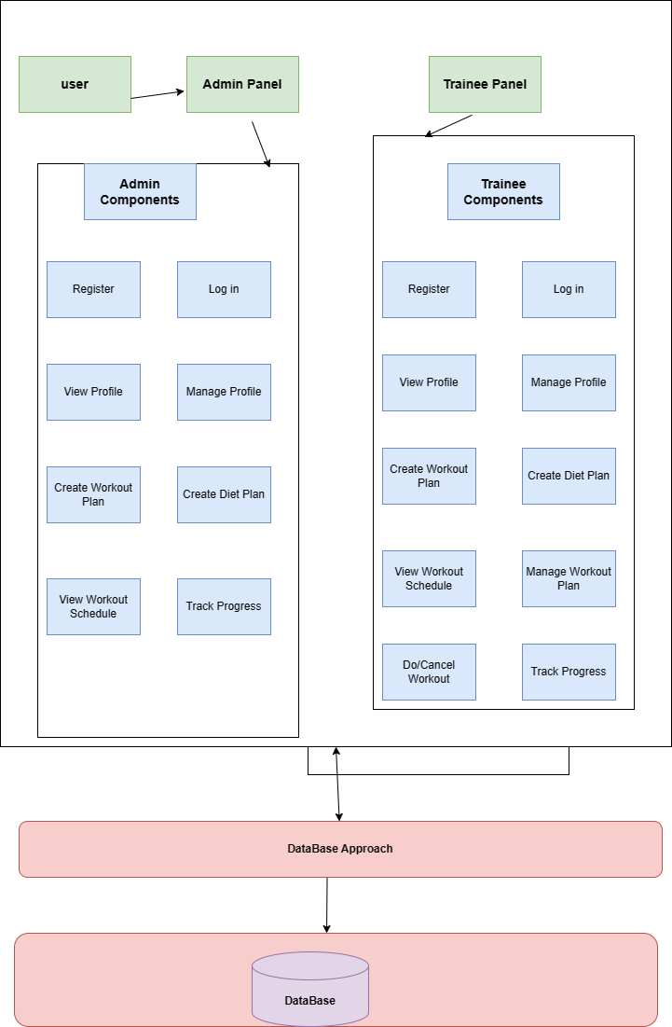

**Figure ‎4.1 Architectural Design**

## Detailed Design

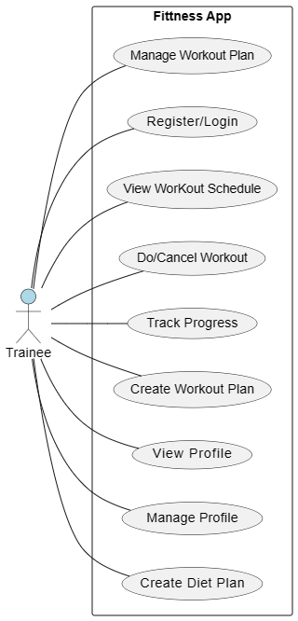

**Figure ‎4.2 Use Case Diagram**

Use Case Diagram of Admin 4.3

### Test Case

Table ‎4.1 Register

|  |  |  |  |  |
| --- | --- | --- | --- | --- |
| ID | | UC-001 | | |
| Name | | Register | | |
| Actors | | Admin, Trainee | | |
| Summary | | The visitor shall provide their email, password and gender on the registration form and after successful verification, redirect now the user to the login page. | | |
| Pre-Conditions | | Admin, Member must have access to register form | | |
| Post-Conditions | | User has successfully registered an account | | |
| Special Requirements | | None | | |
| Basic Flow | | | | |
| Actor Action | | | **System Response** | |
| 1 | User enters name, email, password, security question and gender information on registration form | | 3 | System displays success  Message if everything goes accordingly |
| 2 | User clicks on the submit  Button | | 4 | System saves signup information under a new Account Id |
| **Alternative Flow** | | | | |
| 6 | Email already exists. | | 7 | System displays an error message |
|  |  | | 8 | System restarts use case from step 1 |

Table ‎4.2 login

|  |  |  |  |  |
| --- | --- | --- | --- | --- |
| ID | | UC-002 | | |
| Name | | Login | | |
| Actors | | Admin, Trainee | | |
| Summary | | The actor shall provide their email and password on the login form and after successful verification, redirect the user to the home page. | | |
| Pre-Conditions | | Actor has already registered an account  Actor must have access to the login forum | | |
| Post-Conditions | | Actor has successfully logged into their account. | | |
| Special Requirements | | None | | |
| Basic Flow | | | | |
| Actor Action | | | **System Response** | |
| 1 | Actor enters email and  password | |  |  |
| 2 | Actor clicks on the submit  Button | | 3 | System verifies credentials |
|  |  | | 4 | System displays the home page |
|  |  | | 5 | System gives access to profile page to manage comments, posts, projects and tutorials |
|  |  | | 6 | System gives access to profile page if he/she is a user or give access to admin dashboard too if he/she is admin |
| **Alternative Flow** | | | | |
| 7 | Actor ends login session | | 8 | System displays an error message |
|  |  | | 9 | System restarts use case from step 1 |

Table ‎4.3 View profile

|  |  |  |  |  |
| --- | --- | --- | --- | --- |
| ID | | UC-003 | | |
| Name | | View Profile | | |
| Actors | | Admin, Trainee | | |
| Summary | | Actor select view profile, system displays view posts section  actor click on profile; system displays a profile | | |
| Pre-Conditions | | Actor must be logged in  Actor must select view profile section | | |
| Post-Conditions | | Actor has viewed profile | | |
| Special Requirements | | None | | |
| Basic Flow | | | | |
| Actor Action | | | **System Response** | |
| 1 | Actor selects view profile | | 2 | System displays view profile section |
| 3 | Actor click on the profile | | 4 | System displays profile |
| **Alternative Flow** | | | | |
| 5 | System displays an error | |  | Not displayed if network error |

Table ‎4.4 Manage Profile

|  |  |  |  |  |
| --- | --- | --- | --- | --- |
| ID | | UC-004 | | |
| Name | | Manage Profile | | |
| Actors | | Trainee, Admin | | |
| Summary | | The user updates their profile information. | | |
| Pre-Conditions | | The user is logged into the platform | | |
| Post-Conditions | | The user's profile information is updated with the changes. | | |
| Special Requirements | | None | | |
| Basic Flow | | | | |
| Actor Action | | | **System Response** | |
| 1 | The user clicks on the "Edit Profile" button. | | 2 | The system displays the editable profile form with the user's current information |
| 3 | The user modifies the desired information on the form | | 4 | The system validates the input and updates the user's profile with the changes. |
| **Alternative Flow** | | | | |
| 5 | System displays an error | |  | Not redirected if network error |

Table ‎4.5 Create workout plan

|  |  |  |  |  |
| --- | --- | --- | --- | --- |
| ID | | UC-005 | | |
| Name | | Create Workout plan | | |
| Actors | | Admin, Trainee | | |
| Summary | | The actor selects workout plans in home page, system displays workout plans.  Actor selects create workout plans; system displays “create workout plans here”.  Actor create a workout plans and clicks on submit button. If workout plan is valid according to model system saves it in DB and displays in specific section and shows a popup of “workout plan created successfully” | | |
| Pre-Conditions | | Actor must be logged in | | |
| Post-Conditions | | Actor has created workout plan | | |
| Special Requirements | | None | | |
| Basic Flow | | | | |
| Actor Action | | | **System Response** | |
| 1 | Actor selects workout plans and initiates the process of adding a workout plan. | | 2 | System displays the workout plans |
| 3 | Actor selects create workout plans | | 4 | System displays workout plans to choose a workout plans |
| 5 | Actor creates a workout plan | | 6 | The system will save th selected workout plan |
| 7 | Actor selects on submit button | | 8 | System will show a popup of  “workout plan created successfully” |
| **Alternative Flow** | | | | |
| 9 | Error will display while creating workout plan | | 10 | If workout plan is valid according to model system saves it in DB and displays in specific section and shows a popup of “workout plan created successfully” |
|  |  | | 11 | If the workout plan is not valid according to system:  System will show error |

Table ‎4.6 Mange workout plan

|  |  |  |  |  |
| --- | --- | --- | --- | --- |
| ID | | UC-006 | | |
| Name | | Manage workout plan | | |
| Actors | | Admin ,Trainee | | |
| Summary | | The actor selects workout plans in home page, system displays a workout plans section  Actor selects edit workout plan; system edit workout plan section.  Actor edit workout plan. If workout plan is valid according to model system saves it in DB and displays in specific section | | |
| Pre-Conditions | | Actor must be logged in | | |
| Post-Conditions | | Actor has edited workout plan | | |
| Special Requirements | | None | | |
| Basic Flow | | | | |
| Actor Action | | | **System Response** | |
| 1 | Actor selects workout plan | | 2 | System displays the workout plan |
| 3 | Actor selects edit workout plan | | 4 | System displays edit workout plan section |
| 5 | Actor edit the workout plan | |  | If workout plan is valid according to model system saves it in DB and displays in specific section |
| 6 | Actor clicks on submit button | |  |  |
| **Alternative Flow** | | | | |
| 7 | Error will display while editing workout plan | | 8 | If workout plan is not valid according to model system saves it in DB |

Table ‎4.7 View workout schedule

|  |  |  |  |  |
| --- | --- | --- | --- | --- |
| ID | | UC-007 | | |
| Name | | View workout schedule | | |
| Actors | | Admin, Trainee | | |
| Summary | | Actor select view workout schedule, system displays view workout schedule section  actor click on workout schedule; system displays a selected workout | | |
| Pre-Conditions | | Actor must be logged in  Actor must select view workout schedule section | | |
| Post-Conditions | | Actor has viewed workout schedule | | |
| Special Requirements | | None | | |
| Basic Flow | | | | |
| Actor Action | | | **System Response** | |
| 1 | Actor selects view workout schedule | | 2 | System displays view workout schedule section |
| 3 | Actor click on the workout schedule | | 4 | System displays workout schedule |
| **Alternative Flow** | | | | |
| 5 | System displays an error | |  | Not displayed if network error |

Table ‎4.8 Create diet plan

|  |  |  |  |  |
| --- | --- | --- | --- | --- |
| ID | | UC-008 | | |
| Name | | Create Diet Plan | | |
| Actors | | Admin, Trainee | | |
| Summary | | The User creates the diet plan within the platform. | | |
| Pre-Conditions | | User must be logged in  User must be in diet section | | |
| Post-Conditions | | User has added the diet plan | | |
| Special Requirements | | None | | |
| Basic Flow | | | | |
| Actor Action | | | **System Response** | |
| 1 | user selects Diet | | 2 | System displays the diet section |
| 3 | User select Add diet | | 4 | The system Add the diet plan accordingly.. |
| 5 | User clicks submit button | | 6 | System displays a popup of diet plan created successfully. |
| **Alternative Flow** | | | | |
| 7 | Error will display while Creating diet plan | |  | Not created if network error |

Table ‎4.9 Track progress

|  |  |  |  |  |
| --- | --- | --- | --- | --- |
| ID | | UC-009 | | |
| Name | | Track progress | | |
| Actors | | Admin, Trainee | | |
| Summary | | The user accesses and reviews track progress generated by the platform to gain insights into their fatness practices and Health. | | |
| Pre-Conditions | | User must be logged in  User must be in track progress section | | |
| Post-Conditions | | User has view the track progress | | |
| Special Requirements | | Reports should be generated regularly and updated with new data. | | |
| Basic Flow | | | | |
| Actor Action | | | **System Response** | |
| 1 | user selects track progress | | 2 | System displays the track progress section |
| 5 | User clicks submit button | | 6 | System displays a popup of track viewed successfully |
| **Alternative Flow** | | | | |
| 7 | Error will display while showing track progress. | |  | Not view if network error |

Table ‎4.10 Notification

|  |  |  |  |  |
| --- | --- | --- | --- | --- |
| ID | | UC-010 | | |
| Name | | Notification | | |
| Actors | | Admin | | |
| Summary | | The Admin creates and sends notification to users based on specific criteria. | | |
| Pre-Conditions | | User must be logged in  User must be in Notification section. | | |
| Post-Conditions | | Users receive timely and relevant notifications about potential threats or important information related to their workout. | | |
| Special Requirements | | None | | |
| Basic Flow | | | | |
| Actor Action | | | **System Response** | |
| 1 | user selects Notification | | 2 | System displays the Notification section |
| 3 | User select send Notification | | 4 | The system send the Notification accordingly.. |
| 5 | User clicks submit button | | 6 | System generate a popup of send notification successfully |

* 1. **Database Schema Diagram**

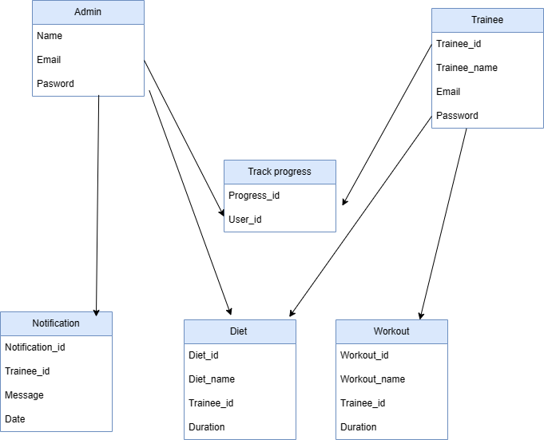

**Figure ‎4.4:- Database Schema Diagram**

# Chapter 5

* 1. **IMPLEMENTATION**
  2. **Endeavour (Team + Work + Way of Working)**
     1. **BodyBoost App**:

An app for workout and diet which uses sentimental analysis

* + 1. **Team Members**

Anosh Junaid (ID: 11359)

Muhammad Ali Hamza (ID: 12826)

Hidayat Ullah (ID: 11939)

* + 1. **Work Breakdown Structure (WBS)**
       1. **Phase 1:** Application Front-End Development

**Task 1:**  Log in & sign up page

**Subtask**: Storing user ID in Mongo Database

**Task 2:** Deployment of different pages of front-end

**Subtask**: Selecting an easy interface for user

**Subtask:** Storing Images in MongoDB Database

* + - 1. **Phase 2:** Back-end sentimental analysis

**Task 3:** Integration with Social media

**Subtask:** Applying Twitter API for user data

**Subtask:** Applying Facebook API for user data

**Task 4:** Model Training for sentimental analysis

**Subtask:** Training Model with data set

**Subtask:** Google Colab integration for model enhancement

**Task 5:** Applying Facebook AL Pre-Trained model

**Subtask: Collecting and analyzing data set**

* + 1. **Project Schedule**
       1. **Milestone 1:** Application Front-End Development

**Start Date:** [15 Nov 2023]

**End Date:** [25 Dec 2023]

* + - 1. **Milestone 2:** Deployment of different pages of front-end

**Start Date:** [20 Nov 2023]

**End Date:** [27 Dec 2023]

* + 1. **Way of Working**
       1. **Agile Methodology**
* Overview of Agile Principles Applied
* Iterative Development Cycles
* Regular Team Reviews and Adjustments
* Sprint Durations, Planning Meetings, and Retrospective Sessions
  + - 1. **Collaboration Tools**

**Used Tools:** GitHub for Document and Data Sharing, Google Drive for Collaborative Document Editing

* + 1. **Risk Management**
       1. **Risk 1:** Technical Challenges

**Mitigation Plan:** Regular Team Training Sessions

**Contingency Measures:** External Expertise Consultation’

* + - 1. **Risk 2:** Resource Constraints

**Mitigation Plan:** Cross-training Team Members

**Contingency Measures:** Resource Reallocation

* + 1. **Additional Features:**
       1. Offline Alerts: Implementing offline alerts for immediate notifications to Trainee.
       2. Stakeholders**:** The primary focus is our End user(trainee), ensuring user-friendly features and effective solutions.
  1. **Flow Control/Pseudo codes**
     1. **Sign up Page**

Initialize controllers: username, email, phone, password display Sign Up Page ():

Show Screen with Logo, Username, Email, Phone, Password fields, and Sign Up button on Sign up Button Press ():

If validate Inputs (username, email, phone, and password):

Execute Sign Up (username, email, phone, and password) else:

Display Error Message ("Invalid inputs")

validate Inputs (username, email, phone, password):

Return true if inputs are valid, else false

execute Signup(username, email, phone, password):

create New User locally

send SignUp Request To Server

navigate To Homepage

display Error Message(message):

Show Error Message

create New User (username, email, phone, password):

// Local user creation logic

send Sign Up Request To Server(username, email, phone, password):

// Send user details to the server

navigate To Home Page():

Show Home Page

* + 1. **Login Page**

# Initialize user input controllers

Initialize controllers: username, password

# Display the login page display Login Page(): show Screen with: - Logo - Username input field - Password input field (masked)

- Login button

# Handle Login button press on Login Button Press():

if validate Inputs (username, password):execute Login (username, password) else: display Error Message("Invalid credentials. Please check and try again.")

Validate user inputs validate Inputs(username, password):

if any input is empty or invalid: return false else: return true

# Execute login logic Execute Login (username, password):

if authenticate User(username, password): navigate To Homepage()

else: display Error Message("Authentication failed. Please try again.")

# Authenticate user

authenticate User(username, password):

# Logic to check username and password against stored credentials or server

# Display error message

display Error Message (message):

show Error Message on Screen

# Navigate to the home page after successful login

navigate To Homepage():

show Home Page

* 1. **Components, Libraries, Web Services, and Stubs**
     1. **Components**
        1. **Naive bayes**

**Description:** For sentimental analysis

**Functionality:** Implements Naïve bayes for Mood detection of the user.

**Implementation:** Python

* + - 1. **Fine-tuned Roberto Model**

**Description:** For sentimental analysis

**Functionality:** Implements Roberto model for Mood detection of the user.

**Implementation:** Python

* + - 1. **Google Colab**

**Description**: Model training for Naïve bayes, fine-tune Robert0 model & tweeter integration.

Functionality: Jupyter Notebook Service Implementation: Python.

* + - 1. **Flutter Application**

**Description:** Front & Back-End of the Mobile application.

**Functionality:** Easily interface for user

**Implementation**: Flutter SDK.

* + 1. **Libraries**
       1. **Tweepy**

**Description:** Library to access Twitter Api

**Integration**: integration with Roberto model

* + - 1. **Pandas**

**Description**: For data analyzing in Colab

**Integration:** Used for Model training in Naïve bye

* + - 1. **Sklearn**

**Description:** For features classification in Colab

**Integration:** Used for Model training in Naïve bye

* + - 1. **Flutter SDK**

**Description:** Cross-platform app development kit.

**Integration:** Utilized for Flutter app.

* + 1. **Web Services** 
       1. **Post man**

**Description:** It is an API platform for building and using APIs.

**Integration**: It is use to test different APIs.

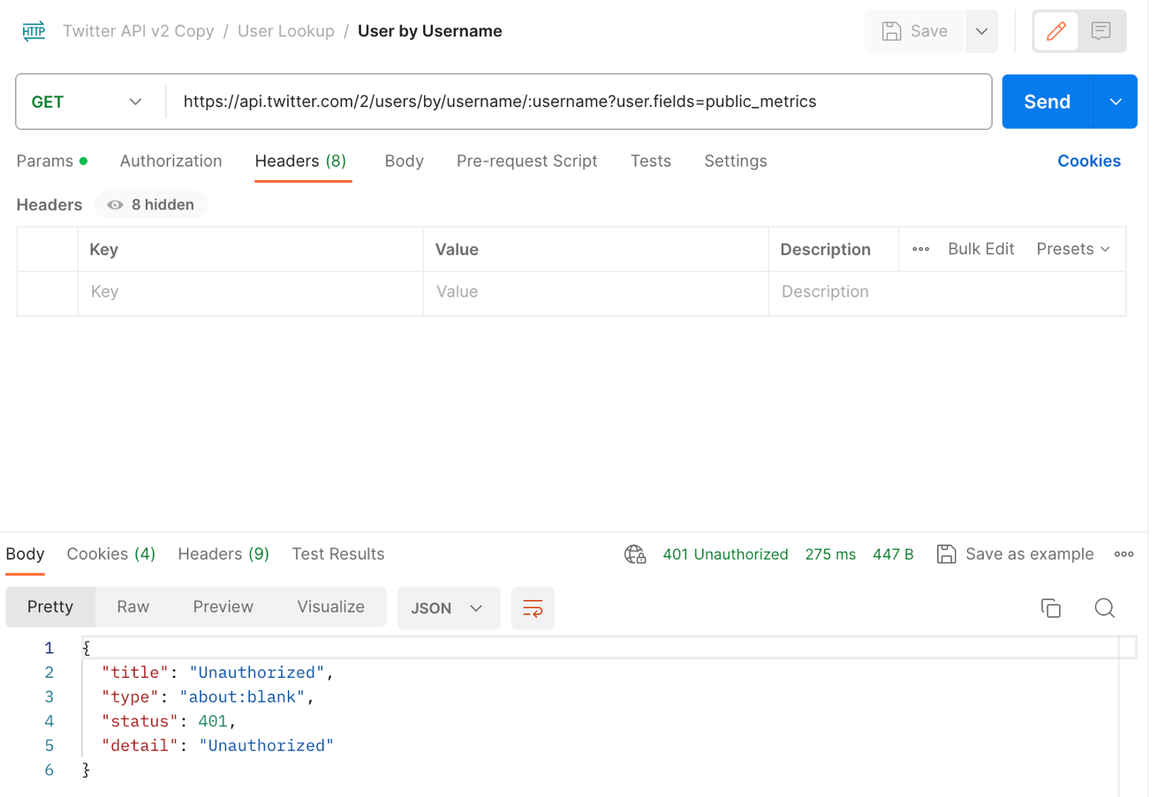

**Figure ‎5.1 Testing twitter API in Post Man**

* + - 1. **Scrapper API**

**Description:** It is use for web scrapping to get data

**Integration:** It is use to get the user data from social media through web.

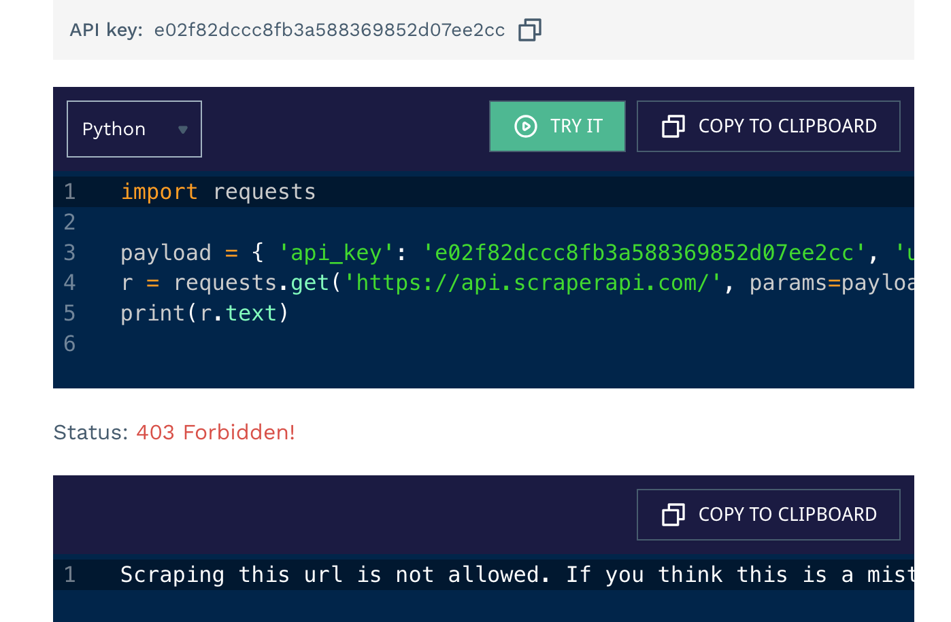

**Figure ‎5.2 shows that we are unable to enter twitter URL**

* + - 1. **Twitter API**

**Description**: For getting user data from in form of tweets

**Implementation**: implemented in Colab

* + - 1. **MongoDB Database**

**Description:** Storing user ID

**Integration:** Utilizes MongoDB.

* + 1. **Stubs**
       1. **Testing Stubs**

**Description:** Simulates external components for testing.

**Usage:** Validates component functionality.

* 1. **IDE, Tools and Technologies**
     1. **Optimized Technology Stack for Tomato Care Application**
     2. **Integrated Development Environment (IDE):**

**Backend:** Python (Specifically for Backend Development)

**Flutter**: Android studio Code

**Collaborative Model Training:** Google Colab

* + - 1. **Tools:**

**Version Control and Document Sharing**: GitHub

**Containerization:** Not Applicable (Omitted Docker for simplicity)

* + - 1. **Technologies:**

**Backend:** Python (Specifically for Backend Development)

**Framework:** Colab (Backend Web Framework)

**Machine Learning**: Transformers library, Auto Tokenizer

**Database**: MongoDB

**Flutter:** Dart

* 1. **Best Practices and Coding Standards**
     1. **Software Engineering Practices**

**Version Control:** GitHub

Continuous Integration and Deployment Practices

* + 1. **Development Practices and Standards**

**Python Coding Standards:** Adherence to PEP 8

**Flutter:** Followed Flutter's Coding Standards

* 1. **Deployment Environment for Body Boost** 
     1. **Deployment Environment:**
        1. **Operating System:** Not Specified (Omitted AWS EC2

Instances for simplicity)

* + - 1. **Server Configuration:**

Not Specified (Omitted specific server configuration for simplicity)

* + - 1. **Database:**

MongoDB

* 1. **Summary**

In this chapter, we outlined the composition of our project team, the detailed work breakdown structure for the implementation phase, and the methodologies and tools adopted for efficient collaboration. We addressed potential risks and mitigation strategies, presented flow control or pseudo codes, listed key components and technologies, and detailed the deployment environment. Our team adhered to best practices and coding standards throughout the implementation, ensuring a robust and effective solution.

# Bibliography

[1] Facebook AL. (2019). RoBERTa and BERT. English. 160GB of text. SQuAD 94.6/89.4, 88.5 on the GLUE benchmark

[2] Basarslan, M. S., & Kayaalp, F. (2020). Sentiment analysis with machine learning methods on social media

[3] Gandhi, A., Adhvaryu, K., Poria, S., Cambria, E., & Hussain, A. (2023). Multimodal sentiment analysis: A systematic review of history, datasets, multimodal fusion methods, applications, challenges and future directions. Information Fusion, 91, 424-444.