**Visual Programming**

**Lab 4**

**Submitted to**

Sir Mubashir

**Submitted By**

Ali Raza

Fa22-bse-118

## **Activity 3:**

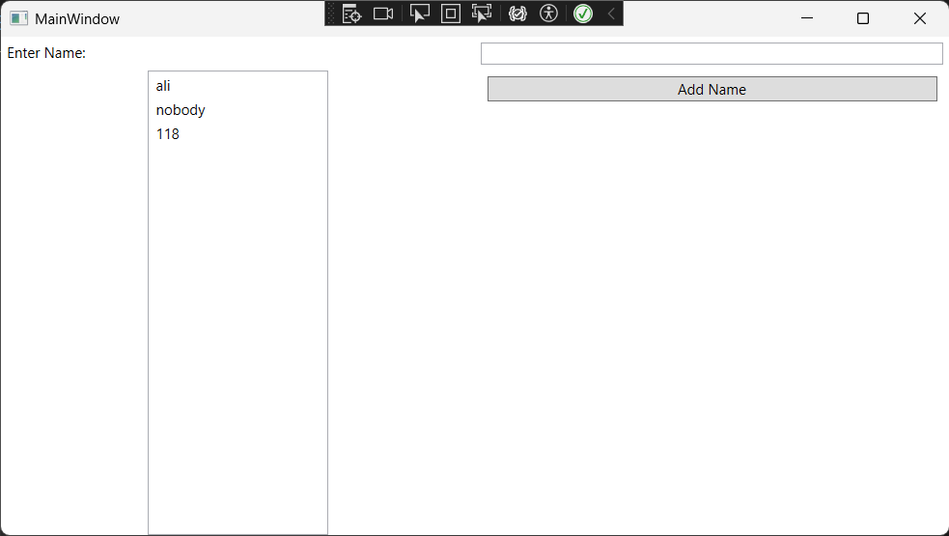

## **Activity 2:**

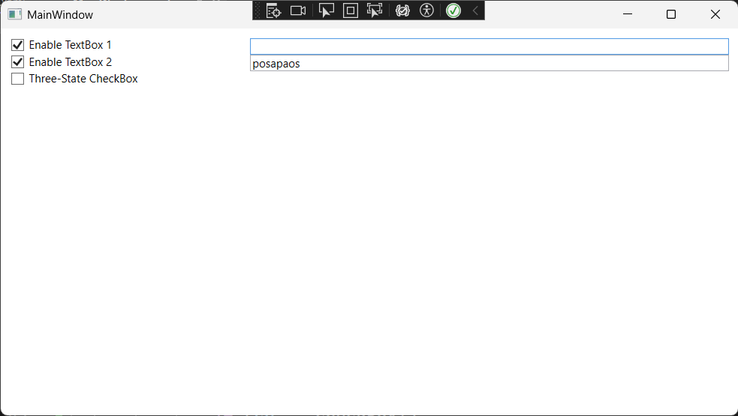

## **Task 1:**



