**Visual Programming**

**Assignment 1**

**Submitted to:** Sir Mubashir

**Submitted by:** Ali Raza

**Reg No:** FA22-BSE-118

**Question 1:**

**Event-driven Programming:**

It is a programming paradigm where the flow of program is determined by events. These events can be user actions, sensor outputs, or messages from other programs.

In EDP the program executes code in response to certain events. These events trigger functions or methods that handle actions required when an event occurs.

**Examples:**

* Mouse clicks
* Keyboard input
* Timers
* Sensor readings

**Characteristics**

* **Asynchronous**
  + The program typically waits for events to occur and does not execute in linear fashion.
* **Handlers**:
  + These are specific methods triggered by events.
* The program **reacts** to user input.

**Example:**

* GUI apps.
* Realtime systems

**Procedural Programming:**

It uses a sequence of step-by-step instructions or procedures to execute tasks. It focuses on the concept of functions or procedures and the data they operate on.

In this the program follows a top-to-bottom approach. The code is organized into functions that are called in a specific order to perform tasks.

**Characteristics:**

* **Synchronous:**
  + The program executes instructions in a linear, sequential order.
* **Modularity:**
  + The program is broken into smaller reusable functions or procedures.
* **State manipulations:**
  + The program operates on data structures and changes their state.

**Example:**

* Command line apps.
* Basic file-processing programs.
* Simple games and simulations.

**Question 2:**

**Pass by value:**

A copy of the variable is passed. Changes inside the method do not affect the original variable. Pass by value (default) works for value types but does not modify the original variable.

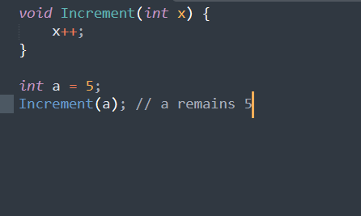

**Pass by Reference:**

A copy of the reference (memory address) is passed. The method can modify the object's state but cannot reassign the original reference.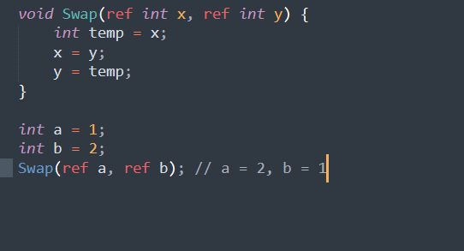

**Question 3:**

