**Visual Programing**

**Lab 3**

**Submitted to**

Mubashir Ubaidullah

**Submitted by**

Ali Raza

FA22-BSE-118

­­­

## **Activity 1:**

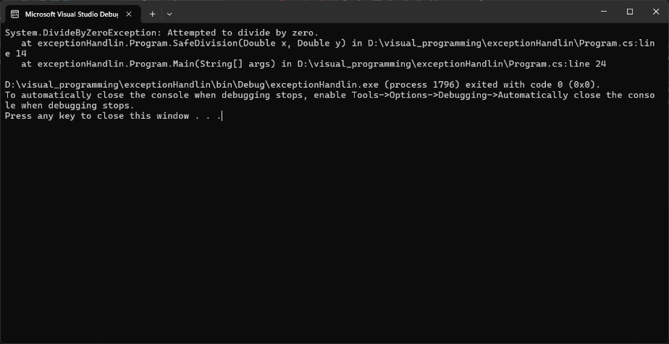

## **Activity 2:**

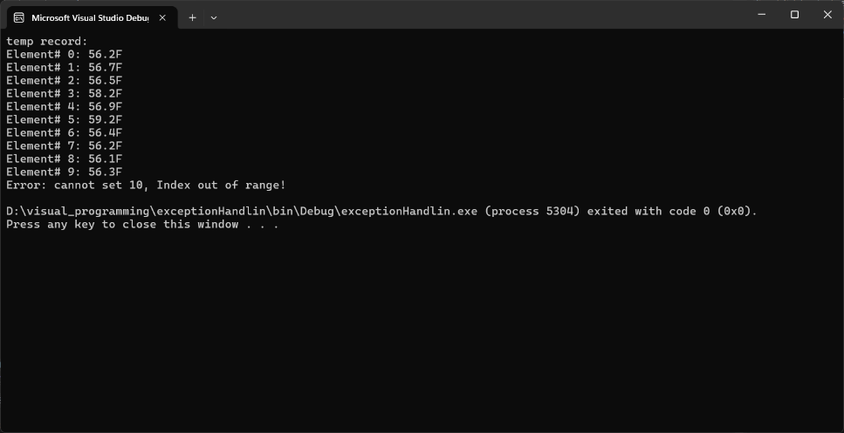

## **Activity 3:**

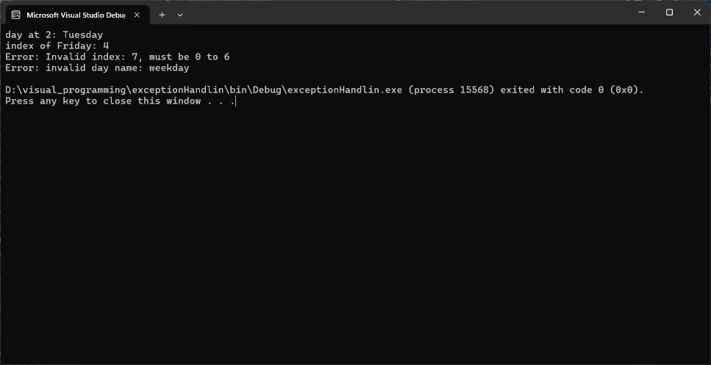

## **Activity 4:**

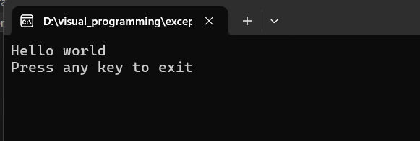

## **Task 1:**

