# Muhammad Ali Mahmood Applied Image Processing 2021346 - Assignment 2

# Report on Adaptive Filters for Image Denoising

## 1. Introduction

This report presents an analysis of different image filtering techniques, including the Adaptive Median Filter, and compares their effectiveness in reducing noise while preserving image details. The study applies various kernel sizes and compares their performance.

## 2. Methodology

To evaluate the performance of different filtering techniques, two types of noise were deliberately added to the images:

• Gaussian Noise

• Salt-and-Pepper Noise

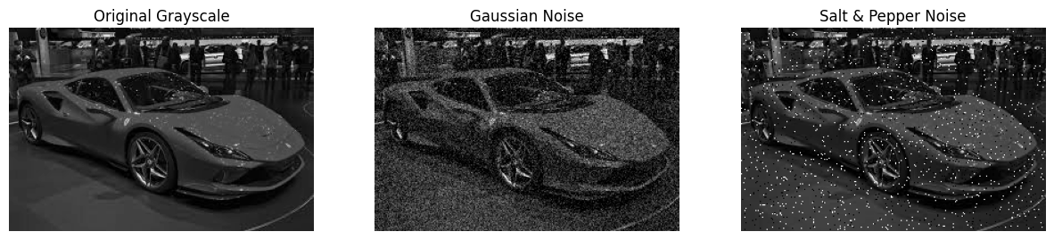

Each of the following filtering techniques was then applied separately to both noise types:

• Mean (Averaging) Filter

• Median Filter

• Adaptive Median Filter

Each filter was tested with different kernel sizes (3×3, 7×7, and 15×15) to analyze how they impact noise reduction and edge preservation.

## 3. Results and Analysis

### 3.1 Visual Comparison

The results were visualized using multiple figures representing the output images after filtering. The following observations were made:

• The Mean Filter effectively reduces noise but blurs image edges.

• The Median Filter preserves edges better than the mean filter while reducing noise.

• The Adaptive Median Filter dynamically adjusts the kernel size, effectively reducing noise while retaining edges more efficiently than the fixed-size median filter.

### 3.2 Performance Analysis

#### 3.2.1 Noise Reduction

• The Mean Filter provided moderate noise reduction but introduced significant blurring.

• The Median Filter performed well in removing salt-and-pepper noise without excessive blurring.

• The Adaptive Median Filter excelled in noise reduction, especially for high-density noise, as it increased the window size where necessary.

#### 3.2.2 Edge Preservation

• The Mean Filter degraded edge sharpness significantly.

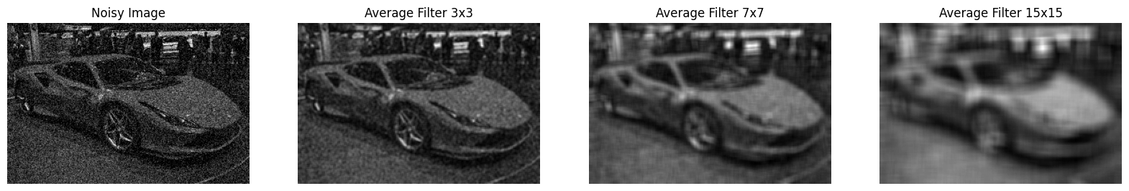

• The Median Filter preserved edges but was limited by its fixed window size.

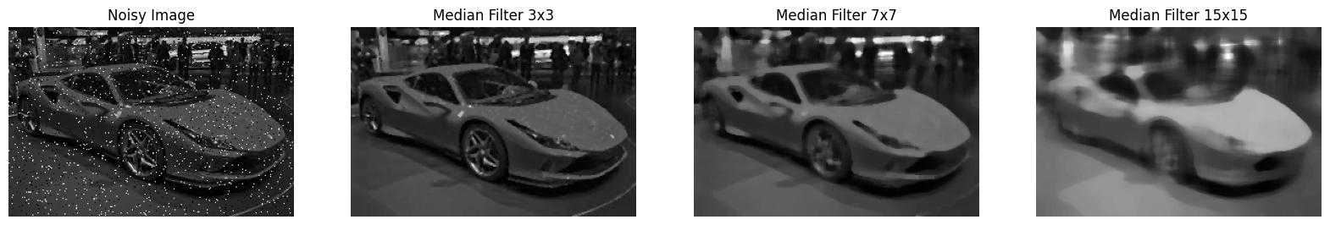

• The Adaptive Median Filter preserved edges the best by adjusting kernel size adaptively.

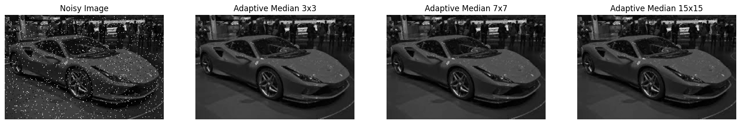

### 3.3 Best Filter for Each Noise Type

|  |  |  |
| --- | --- | --- |
| Noise Type | Best Filter | Optimal Kernel Size |
| Gaussian Noise | Mean Filter | 3×3 |
| Salt-and-Pepper | Adaptive Median Filter | Dynamic (up to 15×15) |

### ****Best Filters for Each Noise Type****

**Gaussian Noise:** The Mean Filter with a 3×3 kernel is the best choice as it effectively smooths out the noise while maintaining image details.

**Salt-and-Pepper Noise:** The Adaptive Median Filter is most effective since it dynamically adjusts kernel size to remove impulse noise while preserving edges.

## 4. Conclusion

The Adaptive Median Filter outperformed the Mean and standard Median Filters by effectively reducing noise while preserving image details. This makes it particularly useful for images affected by impulse noise, such as salt-and-pepper noise.

## 5. Recommendations

• Use the Adaptive Median Filter for images with high-density noise where edge preservation is crucial. (Salt and Pepper Noise)

• Apply the Median Filter for moderate noise levels to balance noise reduction and detail retention.

• Use the Mean Filter only if edge blurring is acceptable and minimal noise reduction is required. (Gaussian Noise)