


Health, Safety and Environment (HSE) Guide

HSE Operational Controls
Operational controls are methods, systems, processes and equipment that safeguard the health and safety of the workers and protection of environment. These can be safety signs, fire alarm system, warning signs, work instructions, trainings, safety drills, procedure related to HSE risk analysis, HSE monitoring, system audits, and emergency response preparedness.
For performing critical and complex operation, process personnel are instructed in the form of work instructions or notices. Work instructions explain how to operate process equipment and machines, define what steps are required to perform certain operations and inspections, warn against safety hazards etc. Work instructions are established for all operations where it is deemed that absence of such instructions would have health and safety concerns.
HSE operational control required and the need for the work instructions is decided by the IMS team member in consultation with compliance team and the concerned HOD. When deciding whether work instructions are needed for a specific operation that may have effect on health, safety and environment the following steps are considered:
- Importance of operation and its potential impact on health, safety and environment
- Complexity of operation
- History of problems associated with the operations
- General level of qualification and experience of operators
- Identified risk to health and safety of the worker/operator
- Legal and regulatory requirements
Internal audits and analysis of non-conformity reports are used to determine whether additional and/or more detailed instructions are required.
Work instructions or safety signs or other physical operational controls like safety equipment are displayed or installed at appropriate locations and workers/operators are instructed to act upon or use these instructions or equipment. Maintenance / inspection of this firefighting equipment are regularly carried out and record is maintained.

COMPLIANCE TEAM IS THE RESPONSIBLE AUTHORITY AT THE SITE TO ENSURE COMPLIANCE & AWARENESS AT ALL LEVELS.

COMPLIANCE TEAM IS ALSO RESPONSIBLE FOR EXECUTION & IMPLEMENTATION OF ALL HSE RELATED FUNCTION.

Fire and Types of Fire

What is Fire?
Fire comes from a chemical reaction between oxygen in the atmosphere and some sort of fuel (wood or gasoline, for example). For the combustion reaction to happen, you have to heat the fuel to its ignition temperature.
There are three fundamental and essential ingredients necessary to produce the chemical reaction that is called fire;
    - Oxygen - The catalyst
    - Heat - The ignition source
    - Fuel - Solid, liquid or gas that burns

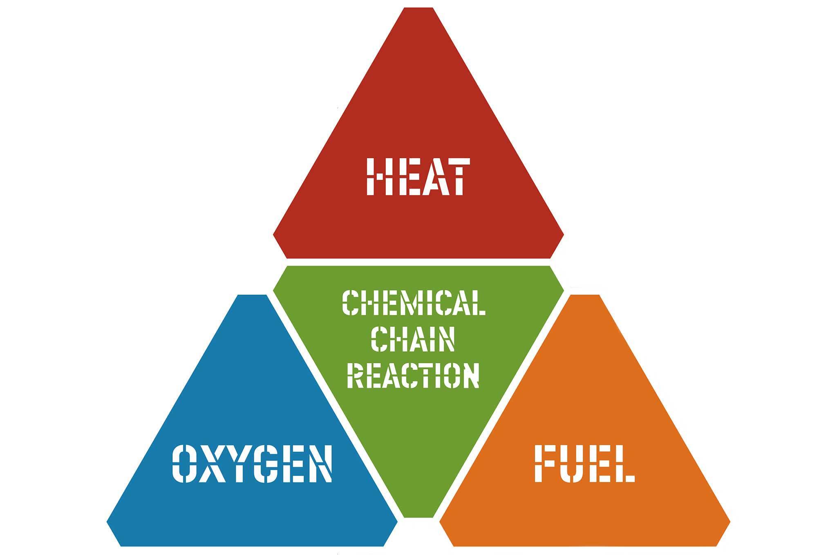

Types of Fire
Fire can be classified based on the source of fuel used in the combustion process. Following are the classifications of fire based on the nature of fuel.

Class A – Solids –This could be wood, plastic, paper, fabrics, soft furnishings, fixtures, or fittings.
Class B – Flammable liquids – There is a whole range of items that fit within this category, including solvents, paints, cleaning fluids, and fuels.
Class C – Gases – Flammable gasses include butane, propane, methane, LPG.
Class D – Metals – Although you might not consider metal as a fire risk, some are surprisingly combustible (sodium, for instance). Most metals also make very good conductors.
Class E – Because electrical fires can easily fall within many of the other classes, they don’t really get their own full class. But electrical fires usually refer to wiring and equipment such as computers, televisions, and routers.
Class F – Cooking fats and oils – This is fairly self-explanatory and relates to things like chip pan fires.

Types of Fire Extinguisher:
A fire extinguisher, flame extinguisher, or simply an extinguisher, is an active fire protection device used to extinguish or control small fires, often in emergency situations. Internationally there are several accepted classification methods for hand-held fire extinguisher. Each classification is useful in fighting fires with a particular group of fuel.
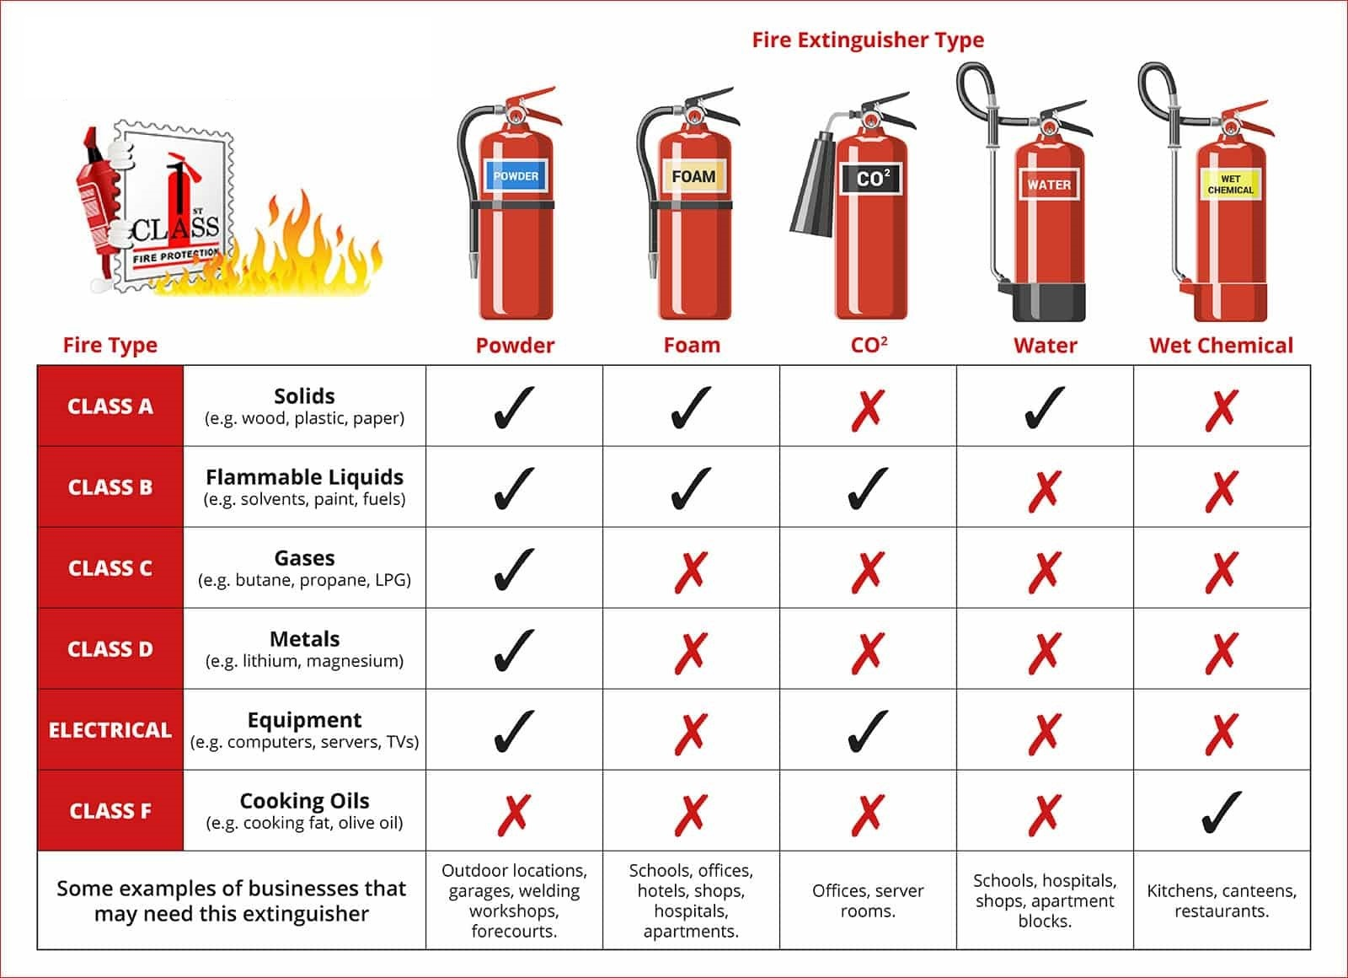

Use of Fire Extinguisher:
There are different types of fire extinguisher. Look closely at the extinguishers around where you work and identify what type they are.
There are four (4) basic steps for using modern portable fire extinguishers.
The acronym PASS is used to describe these four basic steps.

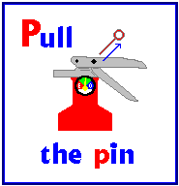 | Pull Pin:  Pull pin at the top of the extinguisher, breaking the seal. When in place, the pin keeps the handle from being pressed and accidentally operating the extinguisher.
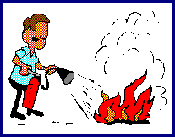 | Aim:  Approach the fire standing at a safe distance. Aim the nozzle or outlet towards the base of the fire.
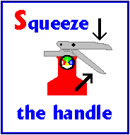 | Squeeze:  Squeeze the handles together to discharge the extinguishing agent inside. To stop discharge, release the handles.
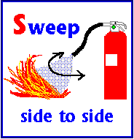 | Sweep:  Sweep the nozzle from side to side as you approach the fire, directing the extinguishing agent at the base of the flames.

Inspection and Maintenance Program
Inspection and maintenance programs define the frequency and scope of the planned inspections or service. Where equipment manuals specify maintenance requirements, the manuals in themselves may be sufficient to define the maintenance program; but they must be reference in appropriate procedures or work instructions.
Fire extinguishers need to be regularly checked to ensure that:
- The extinguisher is not blocked by furniture, doorways, or anything that might limit access in an emergency.
- The pressure is at the recommended level. Some extinguishers have gauges that indicate when the pressure is too high or too low.
- All parts are operable and not damaged or restricted in any way. Make sure hoses and nozzles are free of insects or debris. There should not be any signs of damage or abuse, such as dents or rust, on the extinguisher.
- The outside of the extinguisher is clean. Remove any oil or grease that might accumulate on the exterior.
- The nozzle or other parts are not hindered in any way.
- The pin and tamper seal (if it has one) are intact.
- There are no dents, leaks, rust, chemical deposits and/or other signs of abuse/wear. Wipe off any corrosive chemicals, oil, gunk etc. that may have deposited on the extinguisher
Inspection and testing of firefighting equipment is carried out on regular basis. Checklists have been prepared for this purpose.

SOP for Use of Dry Chemical Powder (DCP) Fire Extinguisher Trolly:
- Check the class of fire for which it is recommended.
- Check the DCP fire extinguisher trolley gauge.
- Dry Chemical Powder (DCP) extinguisher is used for all classes of fire.
- Move the trolley towards the fire at a safe distance from fire.
- Unroll the hose from the trolley.
- Remove the safety pin from the cylinder valve then open the cylinder valve and direct the nozzle at the base of fire.
- Operate from a distance of 8 to 10 feet from the fire standing against the
wind direction Escape route must be decided first while operating the fire
extinguisher.
- In case the fire is extinguished, cool down the area and do not walk on the
area where fire is extinguished.
- If the fire is not extinguished, retreat back so That flame may not hurt you.
- Use appropriate PPEs.

SOP for Use of Dry Chemical Powder (DCP) portable Fire Extinguisher:

- Check the class of fire for which it is recommended.
- Check the fire extinguisher gauge.
- Move towards fire point.
- Dry Chemical Powder (DCP) extinguisher is used for all classes of fire.
- Remove the safety pin from the cylinder then squeeze the lever and direct the nozzle at the base of fire.
- Operate from a distance of 8 to 10 feet from the fire standing against the wind direction Escape route must be decided first while operating the fire extinguisher.
- In case the fire is extinguished, cool down the area and do not walk on the
area where fire is extinguished.
- If the fire is not extinguished, retreat back so That flame may not hurt you.
- Use appropriate PPEs.

SOP for Use of carbon dioxide (CO2) portable Fire Extinguisher:

- Check the class of fire for which it is recommended.
- Check the carbon dioxide (CO2) Fire Extinguisher physically.
- Carbon dioxide (CO2) fire extinguisher is used for E & B fire and isolates the circuit while extinguishing the electrical fire.
- Move towards fire point.
- Remove the safety pin from the cylinder then squeeze the lever and direct the nozzle at the base of fire.
- Operate from a distance of 3 to 5 feet from the fire standing against the
wind direction Escape route must be decided first while operating the fire
extinguisher.
- In case the fire is extinguished, cool down the area and do not walk on the
area where fire is extinguished.

SOP for Use of Carbon dioxide (CO₂) Fire Extinguisher trolley:
- Check the class of fire for which it is recommended.
- Check the (CO2) Fire Extinguisher physically.
- Carbon dioxide CO2 fire extinguisher is used for E & B fire and isolates the circuit while extinguishing the electrical fire.
- Move the trolley towards the fire at a safe distance from fire.
- Unroll the hose from the trolley.
- Remove the safety pin from the cylinder valve and direct the nozzle on the base of fire and hold the discharge hose firmly at the upstream of horn then open the cylinder valve.
- Operate from a distance of 3 to 5 feet from the fire standing against the wind
direction.
- Stop entrance of any person in the area where CO2 fire extinguisher has been operated.
- Escape route must be decided while operating fire extinguisher inside the room.
- Use appropriate PPEs.

SOP for Use of Aqueous Film-Forming Foam (AFFF) Fire Extinguisher trolley:

- Check the class of fire for which it is recommended.
- Check the Aqueous Film-Forming Foam (AFFF) fire extinguisher trolley gauge.
- Aqueous Film-Forming Foam (AFFF) fire extinguisher is used for A&B class fire.
- Move the trolley towards the fire at a safe distance from fire.
- Unroll the hose from the trolley.
- Remove the safety pin from the cylinder valve then open the cylinder valve and direct the nozzle at the base of fire.
- Operate from a distance of 8 to 10 feet from the fire standing against the
wind direction Escape route must be decided first while operating the fire
extinguisher.
- In case the fire is extinguished, cool down the area and do not walk on the
area where fire is extinguished.
- If the fire is not extinguished, retreat back so That flame may not hurt you.
- Use appropriate PPEs.

SOP for Use of Aqueous Film-Forming Foam (AFFF) portable Fire Extinguisher:

- Check the class of fire for which it is recommended.
- Check the Aqueous Film-Forming Foam (AFFF) fire extinguisher gauge.
- Move towards fire point.
- Aqueous Film-Forming Foam (AFFF) fire extinguisher is used for A&B class fire.
- Remove the safety pin from the cylinder then squeeze the lever and direct the nozzle at the base of fire.
- Operate from a distance of 8 to 10 feet from the fire standing against the
wind direction Escape route must be decided first while operating the fire
extinguisher.
- In case the fire is extinguished, cool down the area and do not walk on the
area where fire is extinguished.
- If the fire is not extinguished, retreat back so That flame may not hurt you.
- Use appropriate PPEs.

SOP for Refilling / Inspection of Fire Extinguishers:
- All fire extinguishers will be inspected on monthly basis and refilled after a year or as recommended.
- QHSE officers of the respective area are responsible to manage this job. Security in-charge will supervise the refilling activity & firefighting suppliers will perform it.
- Unscrew the cap of fire extinguisher safely (Shell contains pressure, take care).
- Examine the inlet, outlet tubes, cartridge, powder and threads of cap.
- Try to find any abnormality in inner structure of fire extinguisher.
- Check powder, it must be in powder form. Powder in lump form must be replaced.
- After inspection, refilling; screw the cap and tight it firmly.
- Write the inspection date on the card after properly sealing it

Safety Signs:
Some of the common safety signs used in the industry are following.
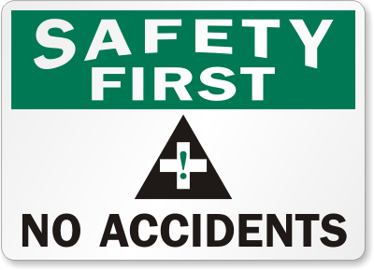 | 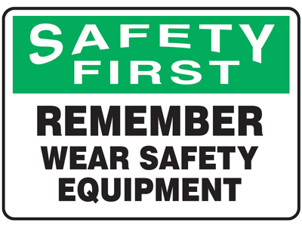
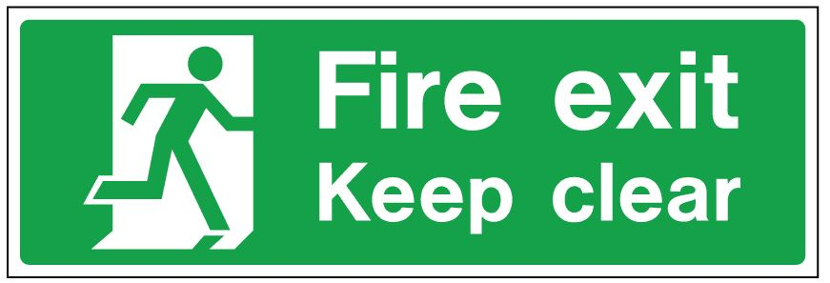 | 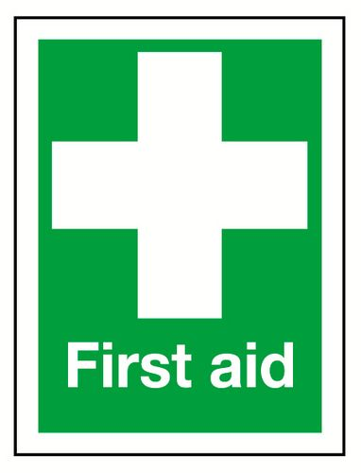
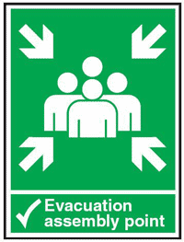 | 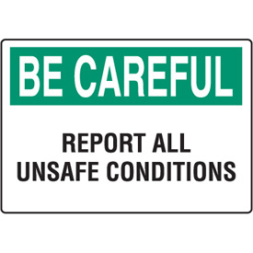
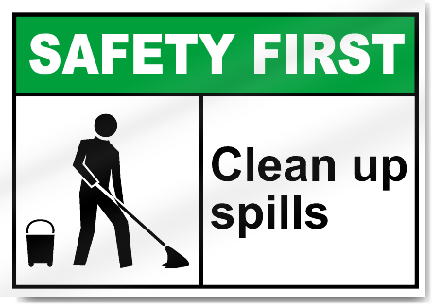 | 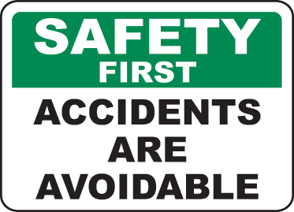
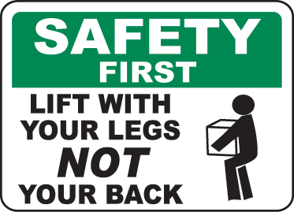 | 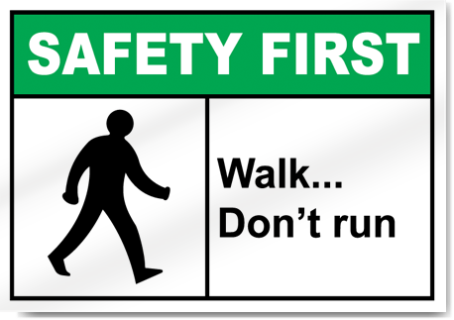
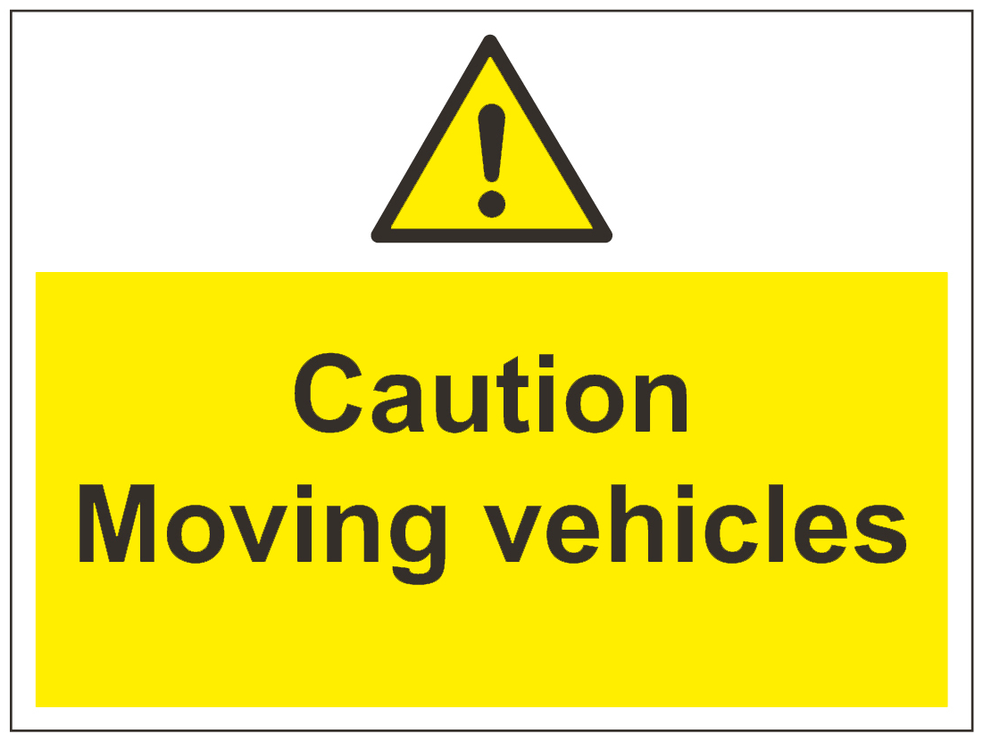 | 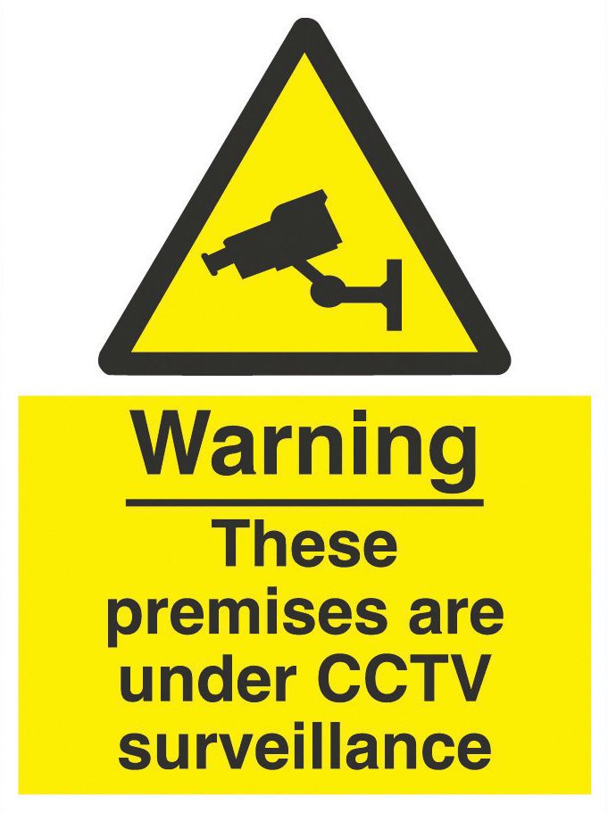
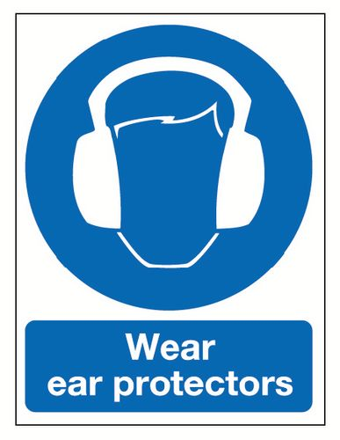 | 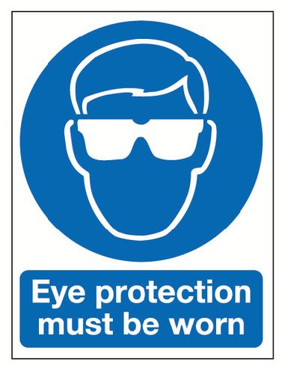
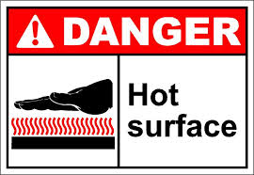 | 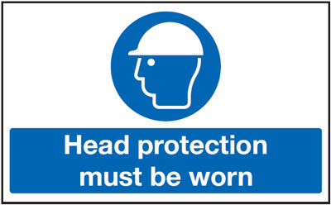
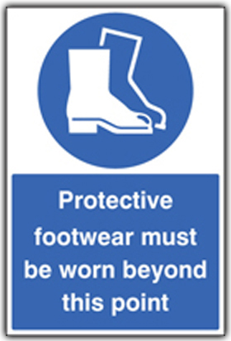 | 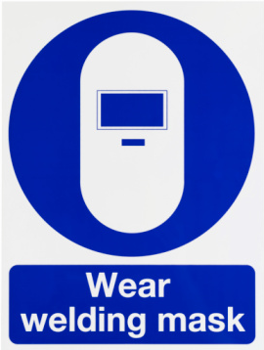
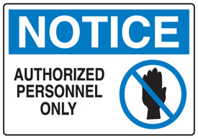 | 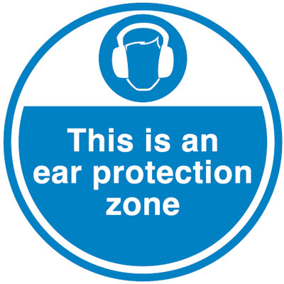
 | 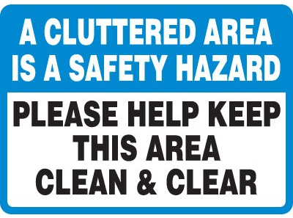
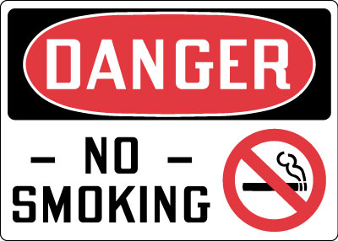 | 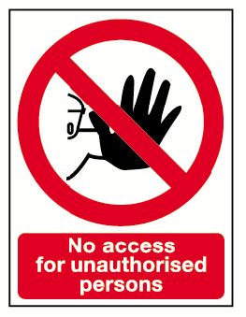
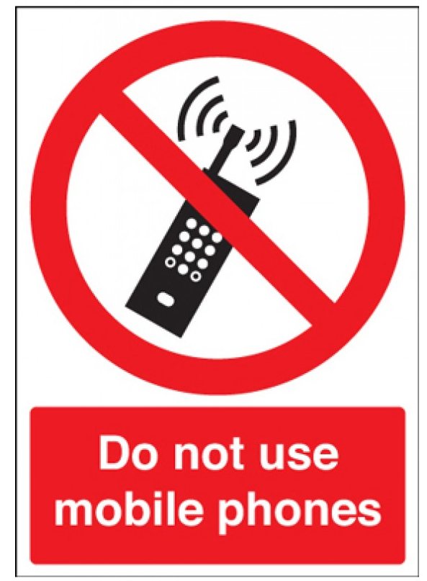 | 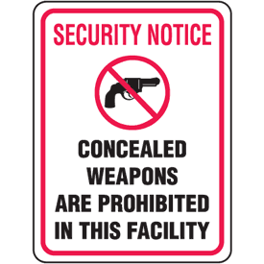
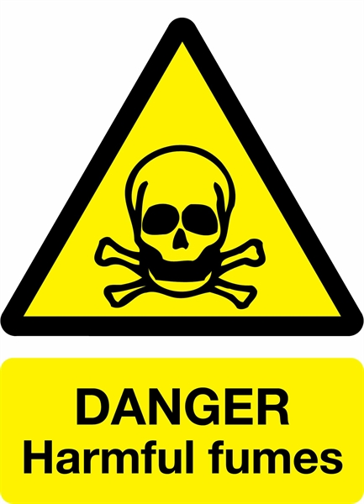 | 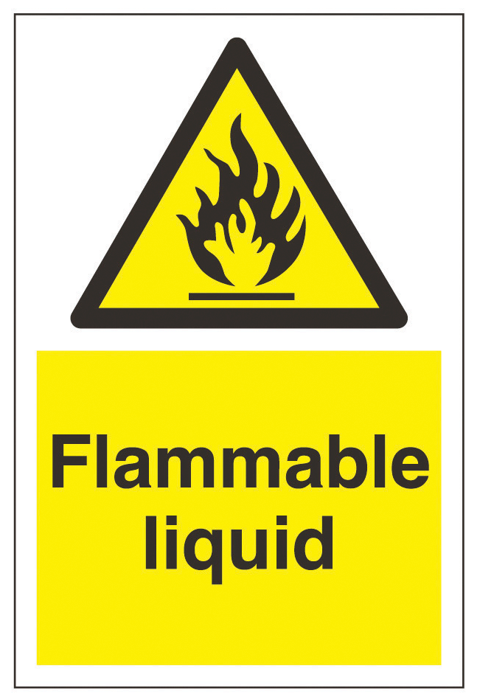

4. Emergency Preparedness
4.1 Emergency evacuation plan
Emergency evacuation plans including the information of exit points, detail of fire extinguishers and potential hazards and aspects are displayed in all the sections and appropriate places, so that employees know which way to go in case of any emergency.
4.2 Emergency Exit Points
All exit and emergency exits points are marked and emergency lights are provided at each exit to avoid the confusion in case of any emergency when there is an electricity shutdown.
4.3 Emergency Contact Numbers
Emergency numbers are displayed at appropriate locations in order to provide awareness to all the personnel so that they know whom to contact in case of emergency. Emergency contact numbers includes Fire Brigade, Rescue, Ambulance/first aid, Bomb Disposal, nearest Hospital, nearest Police Station, WAPDA etc.
4.4 Water Hydrants
BRCC-Unit 1 has installed a proper water hydrants system to deal with the fire emergencies at appropriate location throughout the organization and all the fire hydrants are marked in the maps displayed in each section.
4.5 Fire Extinguishers
Fire extinguishers are installed at appropriate locations inside the departments and office areas as well. All these fire extinguishers are also marked in the displayed maps. Fire extinguishers are periodically inspected and record of inspection is maintained by Compliance Team.
4.6 First Aid Boxes
To deal with the medical emergencies and personal injuries, first aid kits/boxes are placed in different departments/sections. Compliance Team is responsible to maintain the first aid kits/boxes. Concerned ERT member will ensure that first aid items are not misused.
4.7 Trainings & Awareness
Trainings of the employees are conducted on planed basis related to each type of emergency situation. Trainings provided include but not limited to the following;
- Firefighting training will be given to factory personnel as a part of the regular training program.
- First Aid training is provided to the members of Emergency Response Team related to the medical emergencies and personal injuries like electric shock, cuts, unconsciousness etc.
- Spill control training is also provided to the personnel where there is a chance of oil, chemical or dye spill.
- Waste Management awareness is also provided to the personnel by senior person of section on how to handle each type of waste.
The ERT may co-ordinate with the suitable department and shall arrange for joint firefighting training at the site.
4.8 Emergency Drills
ERT makes proper arrangements for emergency drills at least once in a year to reinforce training and get feedback efficiently.
4.9 Fire detectors and fire alarm system
Compliance Team with electrical supervisor will inspect the fire alarm system on quarterly bases. After approval of GM, Compliance Team will inform all departments regarding day and time of inspection so that employees should not evacuate on fire alarm bell. No unauthorized personnel will approach to fire alarm control panel except Compliance Team/ERT leader, security chief, electrical supervisor or concern external service provider with prior approval of concern GM.

Smoke detectors will be cleaned and maintain by electrical department on quarterly basis.

For Unit 2, Security chief will be responsible to allow authorized personnel (as mentioned before) on approval of GM for maintenance or inspection of fire alarm control panel.

For Unit 1, after approval of GM, authorized personnel (as mentioned before) will take electrical in-charge/Supervisor with his self to approach the fire control panel.

5. Emergency Response Plans
Emergency response plans have been developed to cater different emergency situations.
Potential Emergency Situation | Fire
Actions to be Taken
- The person who sees the fire is required to shout “fire, fire, fire” loudly or sound the alarm.
- Fire alarm is raised by the person working near to alarm so that alarm is raised in minimum possible time.
- Put off electrical main switch of the premises
- Use the fire extinguisher and fire buckets to put off the fire if it is in a smaller area
- If the fire is out of control then immediately Move to assembly point

Potential Emergency Situation | Chemical Spillage
Actions to be Taken
- In case of spilling of acidic chemicals, immediately wash the affected area with a dilute solution of Soda Ash or any other basic solution to neutralize the effects of acidic chemical otherwise wash the area with diluted oxalic acid in case of basic chemical. The affected area is thoroughly flushed with tap water.
- In case of swallowing, rinse the mouth with cold water. If the victim is conscious, have them drink lots of water to dilute the acid followed by a glass of milk or milk of magnesia in case of acid. Induce vomiting any other common chemical is swallowed. Call 1122 for immediate medical assistance.
- In case of skin exposure, move the victim immediately under water source and flush the affected area with large amounts of cool running water. Immediately washing off the chemical is of primary importance. Remove all contaminated clothing while flushing with water. While the victim is being rinsed with water, someone shall notify for arrangement of emergency medical assistance. Immediately after flushing with water begin massaging the recommended gel into the burn site. Apply the gel every 15 minutes and massage until pain/redness resolve or until medical care is available. Wear gloves when applying the gel to prevent transfer of acid or base.
Potential Emergency Situation | Air Emissions
Actions to be Taken
In case of any excessive emissions which are hazardous to health, safety or environment, the related process is immediately shutdown to avoid the impacts of emissions. The IMS team member of the area reviews the situation and decides whether to continue the process or not. If the situation is severe the process is kept halted and immediately reported to GM, who take further appropriate actions to resolve the issue.
Potential Emergency Situation | Earthquake
Actions to be Taken
If inside the building, get under a desk or table or stand in a doorway or corner. Stay clear of windows, file cabinets, mirrors, and fireplaces. If possible, extinguish open flames/ignition sources. Do not use elevator.
If outside the building, stay in an open area away from trees, buildings, walls, and power lines.
If driving, pull over and stop. Avoid overpasses and power lines. Stay inside the vehicle until shaking stops. If the earthquake was severe, do not attempt to cross damaged walls or buildings.

6. Consultation & Participation:
Our organization will make sure that mechanisms, time, training and resources necessary for consultation and participation are defined and provided. Organization will provide timely access to clear, understandable and relevant information about the OH&S management system. Organization will determine and remove obstacles or barriers to participation and minimize those that cannot be removed.
Consultation of non-managerial workers will be done on the following:
- Determining the needs and expectations of interested parties
- Establishing the OH&S policy
- Assigning organizational roles, responsibilities and authorities, as applicable
- Determining how to fulfill legal requirements and other requirements
- Establishing OH&S objectives and planning to achieve them
- Determining applicable controls for outsourcing, procurement and contractors
- Determining what needs to be monitored, measured and evaluated
- Planning, establishing, implementing and maintaining an audit program (s)
- Ensuring continual improvement
Participation of non-managerial workers will be done in the following:
- Determining the mechanisms for their consultation and participation.
- Identifying hazards and assessing risks and opportunities
- Determining actions to eliminate hazards and reduce OH&S risks
- Determining competence requirements, training needs, training and evaluating training
- Determining what needs to be communicated and how this will be done
- Determining control measures and their effective implementation and use
- Investigating incidents and nonconformities and determining corrective actions.

Mechanism of consultation and participation:

Develop the safety committee involving at least one non-managerial and one managerial employee from each section/department of organization.

Conduct safety committee meetings on quarterly basis and circulate minutes of each meeting to all committee members.

Conduct safety talk (Toolbox talk) on each section/department on weekly/bi-monthly basis in which discuss safety relevant issue and provide awareness regarding health and safety.

Amendment History Record
Revision Number | Section | Amended Text
1 | 7 | Added consultation and participation mechanism
2 | 2 | Updated fire diagram, types of fire and Fire extuinguisher procedures

