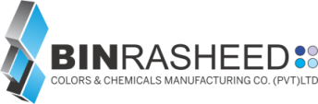COLOR ANALYSIS REPORT

|  |  |  |  |  |  |  |  |  |  |  |  |  |  |  |  |  |  |
| --- | --- | --- | --- | --- | --- | --- | --- | --- | --- | --- | --- | --- | --- | --- | --- | --- | --- |
|  |  |  |  |  |  |  |  |  |  |  |  |  |  |  |  |  |  |

Issue Date: 22 Feb, 2022

Customer Name: **SYNTRONICS LIMITED**

Product Name: **ARISTOTM White BR-W 60**

Product Type: White Master Batch

**Blown Film Testing Detail:**

Testing Detail: ○ Calendaring Chip ○ Injection Chip ● Blown Film

Shade Detail: ● Direct Shade ○ Tint Shade

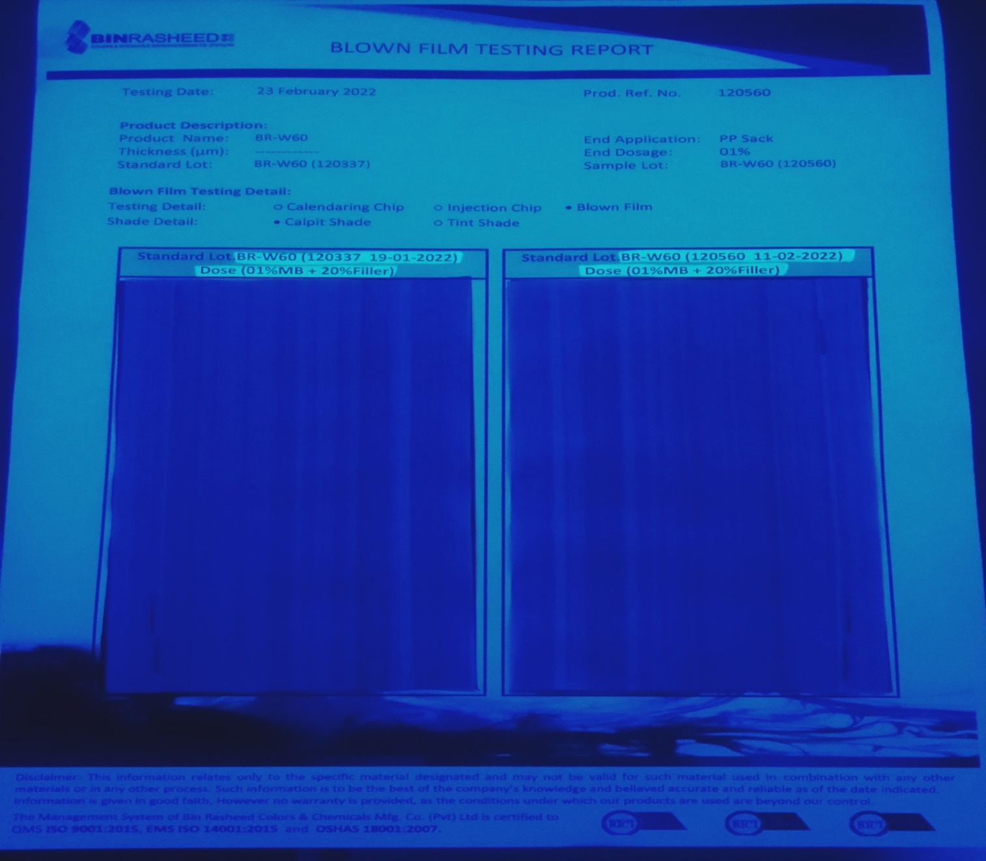

**Remarks:**

The customer said lot analyses in our lab scale blown film and check in the UV light there is no difference in the shade as seen above blown film the results as per standard.