Date: 08/02/2020 Unit #: 02

**Part A – General**

|  |  |  |
| --- | --- | --- |
| **Incident Reference Number**  ***(Compliance Team Only)*** |  | |
| Department/Area: Waste Yard (Admin) | | Date & Time of Incident: 06/02/20 , 10:30 AM |
| **Type of Incident** | | **Estimated Cost of Incident** |
| * Fatality * Major Injury (Hospitalisation, Major Disability, more than 1 day bed rest) * Minor Injury (First Aid) * Serious Ill health (Occupational Disease) * Major Chemical Spillage * Fire * Property Damage * Passage of arms or serious misbehave * Serious Near Miss * Other:_________________________ | | **Indirect Cost:**  1. Employees morale down and felt difficulty in movement which caused low productivity, quality of work & efficiency. |

**Part B – Investigation Team**

|  |  |  |  |
| --- | --- | --- | --- |
| Name | Designation | Department | Signature |
| Ali Raza Gohar | QHSE Team Lead | Compliance (CIC) |  |
| Syed Yasir Hussain | HOD | Admin |  |

**Part C - Information Gathering**

|  |  |  |  |
| --- | --- | --- | --- |
| 1. Witness Detail: (Attach witness statement) | | | |
| Name | Designation | Department/Section | Signature |
| Ashiq Maseeh | Sweeper Incharge | Store |  |
| 2. Affected Person or Material Detail: | | | |
| Name/Title/Reference:  *Babar Maseeh* | | | |
| Designation/Type/Purpose:  *Sweeper (Admin)* | | | |
| Other Detail:  *Working from last two years in this company.* | | | |
| 3. Where did the incident happen? Attach Pictures (If necessary) | | | |
| Drum Yard (Picture Attached Below) | | | |
| 3. How incident happened? | | | |
| While unloading pallets from hand lifter, a plastic pallet thrown from a distance to pallet storing area (in waste yard) and rope (attached with this pallet) entangled in neck resulting pallet hit back to legs of sweeper. | | | |
| 4. What impacts were caused? Attach Pictures (If necessary) | | | |
| Both legs under knee lower front side injured (skin punctured) with little bleeding.  (Pictures Attached) | | | |
| 5. What activities/tasks were being carried out at the time of the incident? (Attach SOP,WI or checklist of activity, if available) | | | |
| Handling of Waste (Plastic Pallets) from store to waste yard | | | |
| 6. Was there a risk assessment covering the activities/tasks being undertaken? (Attach risk assessment, if available) | | | |
| * Yes * No | | | |
| 7. In relation to the working environment and/or equipment involved, was maintained and cleaning up to date? (Attach monitoring/maintenance record, if available) | | | |
| Equipment not involved in this accident. | | | |

**Part D - Analysis and Further Action**

|  |
| --- |
| 8. What were the immediate and root causes of the incident? |
| a) Immediate causes:  1. Entanglement of attached rope with neck  b) Root causes:  1. Improper unloading and material handling technique  2. Carelessness |

|  |  |  |  |  |
| --- | --- | --- | --- | --- |
| 9. What additional risk control measures are required to prevent recurrence? | | | | |
| Action | | Target | Responsible | Signature |
| Provision of on field awareness and monitoring by sweeper supervisor. | |  | Ashiq Maseeh |  |
| Update Hazard Analysis report accordingly | | 08/02/20 | Ali Raza Gohar |  |
| 12. Do similar risks exist elsewhere? | | | | |
| **Not** | | | | |
| Name of Lead investigator: Ali Raza Gohar | | | | |
| Signature: | Date: 08/02/20 | | | |

|  |  |  |  |  |
| --- | --- | --- | --- | --- |
| Reviewed by: |  |  | Approved by: |  |

(Compliance Department) (GM/MD/CEO)

Comments, If Any:

Attachments:

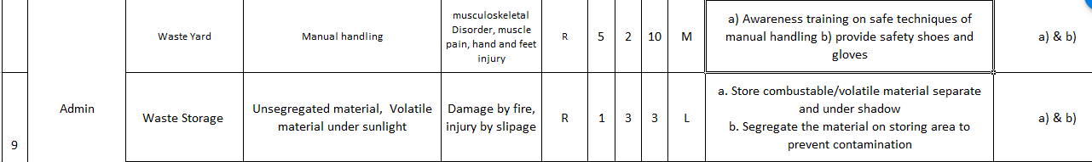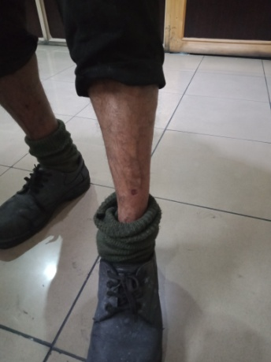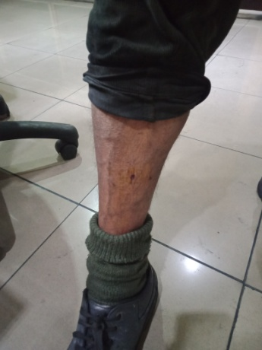

Hazard Analysis Updated