1. **Purpose**

This purpose of this document is to verify the effectiveness of the organization’s management system and complying with the legal and other applicable requirements. To identify the gaps and areas those required improvements. It also identifies the associated inputs, outputs and respective process steps of auditing process and post activities of the internal audit in the Bin Rasheed Colors and Chemicals (BRCC) & Pakistan Coating Chemicals (PCC) .

1. **Scope**

This procedure is applicable and implemented throughout the Bin Rasheed Colors and Chemicals & Pakistan Coating Chemicals to meet the requirements of the Integrated Management System (ISO 9001, 14001 & OHSMS and PS-3733)

1. **Responsibility**
   1. Compliance team are responsible for planning and scheduling internal audits
   2. CEO/GM or his deputed representative approves the audit plan
   3. Auditor prepares the audit report after the completion of audit
   4. Concerned departmental heads are responsible for taking corrective actions on non-conformities identified in audit
   5. Compliance team is responsible for the follow up of the corrective actions
2. **Procedure**
   1. **Audit Team**

BRCC has developed an **Internal Audit Team** for conducting internal audits on regular basis and Compliance team maintains the list of internal auditors. Internal Auditors are selected from different functions within the company based on their experience and professional skills. They are then trained on auditing skills by sending them to seminars and/or conducting internal training sessions. Training record/certificate copies of the auditors is maintained.

* 1. **Audit Frequency and Planning**

Compliance team is responsible for planning and scheduling the internal audits after coordination with Internal Audit team. Internal audit plan should be made keeping the surveillance audit calendar in view. Internal audit should be completed at least 1 month before surveillance audit.

Before the proposed audit date, Compliance team prepares the **Audit Plan**. The audit plan lists all the activities corresponding to the Integrated Management System, identifies locations where these activities are taking place, and time of audit for each activity. The audit plan is approved by the CEO/GM and is then distributed to all the concerned departments / sections by the Compliance team.

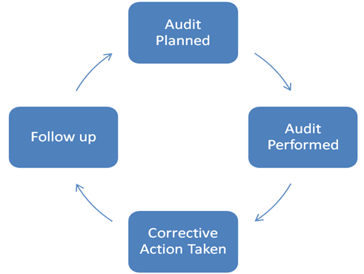

If the activities i.e. **Audit Planning**, **Audit Performance**, **Corrective Actions** and **Follow Up** of the corrective action taken, is complete for all departments, it completes one audit cycle. It is compulsory to complete one audit cycles each year.

* 1. **Audit Execution**
     1. Before starting an audit, the auditors ensure the possession of;

1. Audit Plan
2. Last Internal Audit Report
   * 1. The audit begins with a briefing to the management on the methodology of the audit, its scope and any administrative arrangements required.
     2. While conducting the audit, the auditors seek to:
3. Determine whether documented information and instructions meet the requirements of the standards
4. Verify whether procedures and instructions are being implemented. For this, the data is generated as evidence of activities is examined for compliance with specified procedures. In addition, the auditors make it a point to talk to personnel performing various tasks to ascertain whether they understand the procedures and instructions and are following these.
5. When an auditor observes non-conformity in the system, all relevant information is examined carefully and full details of nonconformance are recorded so that corrective action can be taken.
6. On completion of the audit, a closing meeting is arranged with the management to review findings and to obtain clarifications if required. Appropriate corrective measures are also discussed
   * 1. After the completion of audit, auditors compile all these findings and prepare **Audit Report**. It includes the summary of the audit and audit non-conformities and observations observed. Audit report normally contains the following information;
     2. Report title, number and the relevant information
     3. scope
     4. Summary of findings and observations
   1. **Corrective Action and Follow up**
      1. Compliance team initiates the Corrective Plan & Action Requests (CPARs) on the non-conformities observed in the audit and gives it to the concerned departmental / section heads. The concerned departmental / section head investigates the cause of the problem, proposes a corrective action to be taken and indicates the date by which the corrective action will be fully implemented.
      2. On, or immediately after, the due date for implementation of the corrective action, the auditors/Compliance team follows up with an audit to determine if the corrective action has been implemented and if it is effective. When there is objective evidence that the corrective action is effective, the audit non-compliance report is closed out. If more work is needed to fully implement the corrective action, a new follow-up date is agreed upon.
   2. **Input to Management Review Meetings**

Results of internal audit are submitted in Management Review Meeting by Compliance team as input.

1. **Associated Documented information**
   1. List of Approved Internal Auditors
   2. Internal Audit Plan
   3. Internal Audit Report

**Amendment History Record**

| **Revision Number** | **Section** | **Amended Text** |
| --- | --- | --- |
| 1 | 2 | PS-3733 added in scope |
| 4.2 | ~~In this program, each cell, against the each year and department, is split in to four (4) cells. Each cell representing a step of audit cycle as explained below.~~ **~~Box 1~~** ~~represents planning, when the BRCC & PCC have to start the planning of the audit of any concerned department/section.~~ **~~Box 2~~** ~~is for planned audit execution when audit actually is to be performed.~~ **~~Box 3~~** ~~represents that when the BRCC & PCC have to take the corrective actions against the nonconformities found during the audit. And~~ **~~Box 4~~** ~~represents that when the follow up of the corrective actions that are to be taken as a result of non-conformance, is required to check the compliance level.~~ |