**Department:** Maintenance **Date:** 16-11-2020

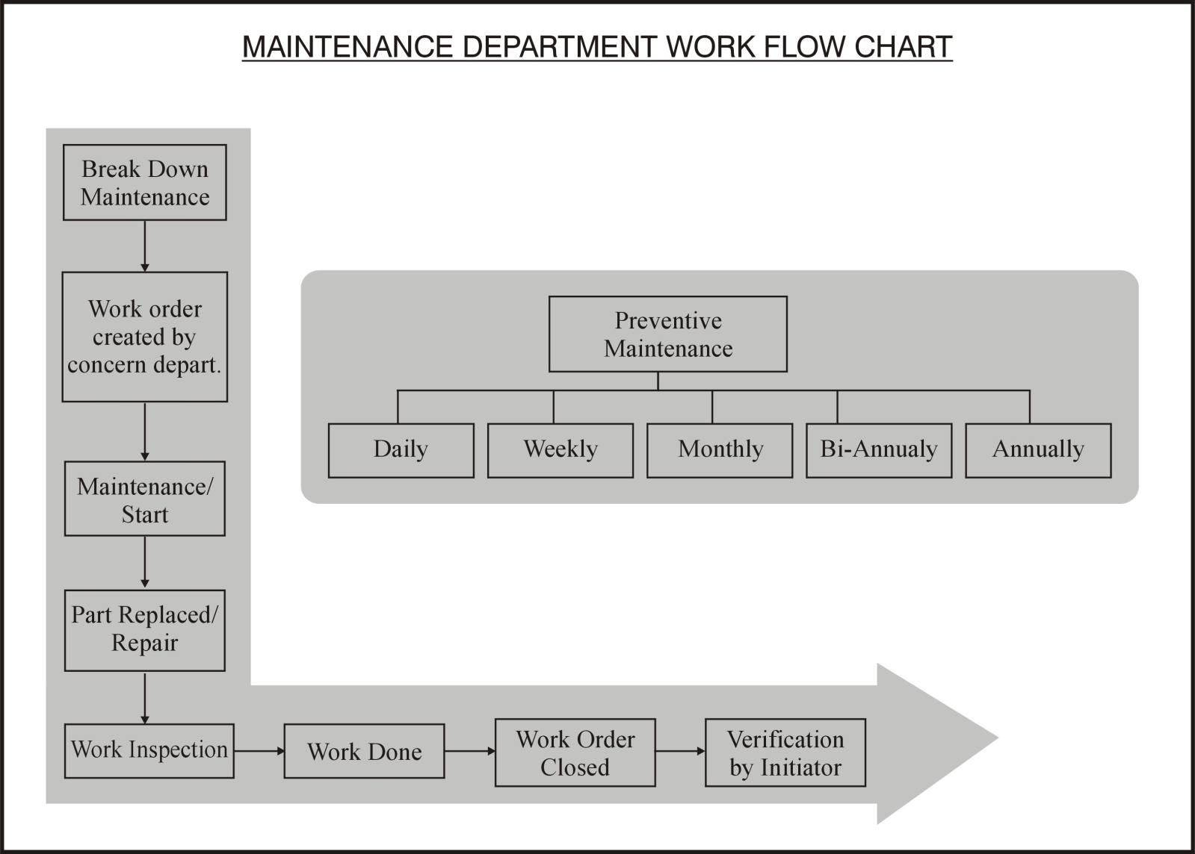

Checked By (HOD): ___________________ Approved by (QHSE TL): _____________________