Department: EMD Date: 13-08-21

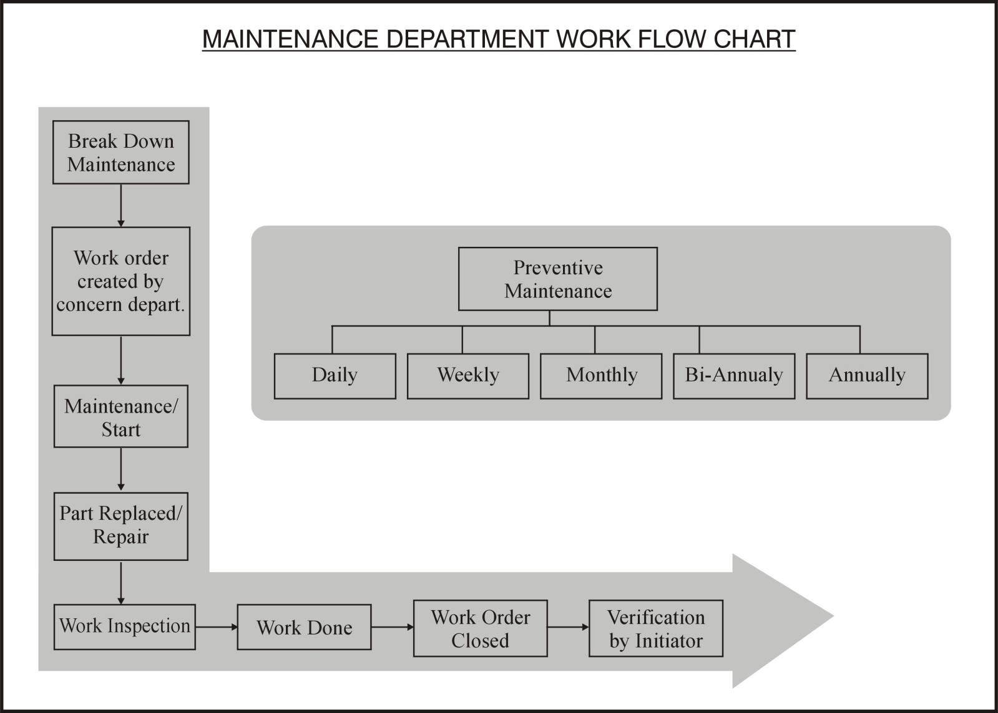

Checked By (HOD): ___________________ Approved by (GM): _____________________