## Purpose

The purpose of this documented procedure if to timely delivered materials on production floor for production process according to their demand and requirement

1. **Scope**

The main and basic scope of store issue process is to deliver material on all production lines/Labs, when QC/Production departments raise demand through SAP to store department. The relevant person of QC/Production department will mention and raise a query & requisite for material according to their job card on SAP/store issue requisite form and will handover it to store department. Store in-charge is responsible to deliver exact material as per the store issue document

## Responsibilities

* **Production in charge**

To prepare accurate and correct store issue requisite according their sheet formulation for production process

* **QC In charge**

To prepare accurate and correct store issue requisite according their sheet formulation for trial or testing process

* **Store In charge**

To make sure the deliverance and issuance of required material with mentioned quantities with minimum lead time 30 minutes approx and issue the component from SAP after material issuance and getting receiving from concerned department/person

* **Store workers**

To issue and deliver required and mentioned material to concerned places, halls with proper care and according to the instructions

* **Store management**

To look after the whole process with further and continual improvement

## Procedure

* Issuance/preparation of Production order, store issue requisite
* Checking availability of concerned raw material
* Issuance of concerned raw material
* To update issue components

1. **Operational steps**

* Concerned person from production/ Lab department will prepare and compile production order (job card) according to their recipe formulation with lot of care and responsibility and will handed over to store department in store office
* Store in-charge will check and verify the current status and quantity of different ingredients in store before giving instructions for issuance
* Store workers will issue and deliver mentioned and required material to different concerned halls and will take the receiving from concerned department/person
* Store In charge/ store supervisor/ data entry operator will update issue components of concerned materials/items after taking material issuance receiving on same or maximum by next working day.

1. **Precautions**

* Any person is not allowed to release or issue any material without written requisite
* Signatures of concerned authorities are required for any material movement from store to production/ Labs
* Store department will ensure to avoid any material mix up during weighing and issuance procedure
* Material name must be mentioned and highlighted clearly and properly in case of any loose/open bag/material issuance
* Store workers will make sure to avoid any kind of leakage and other material wastages during issuance or delivery process
* Weighing instruments and other helping tools must be kept neat and clean to avoid any kind of inconvenience during material issue process

## Associated Documents and Records

* **Raw Material Issuance Request**

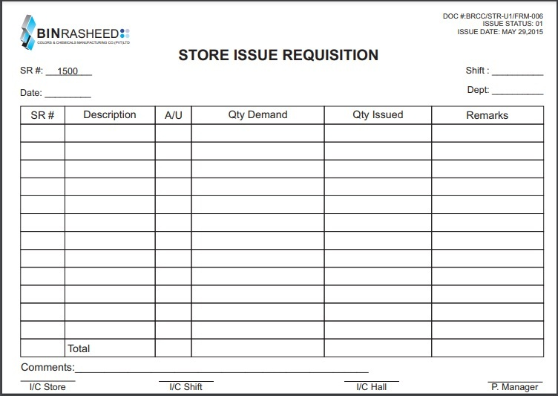

* **Production order**

