**Department: Sales & Marketing**

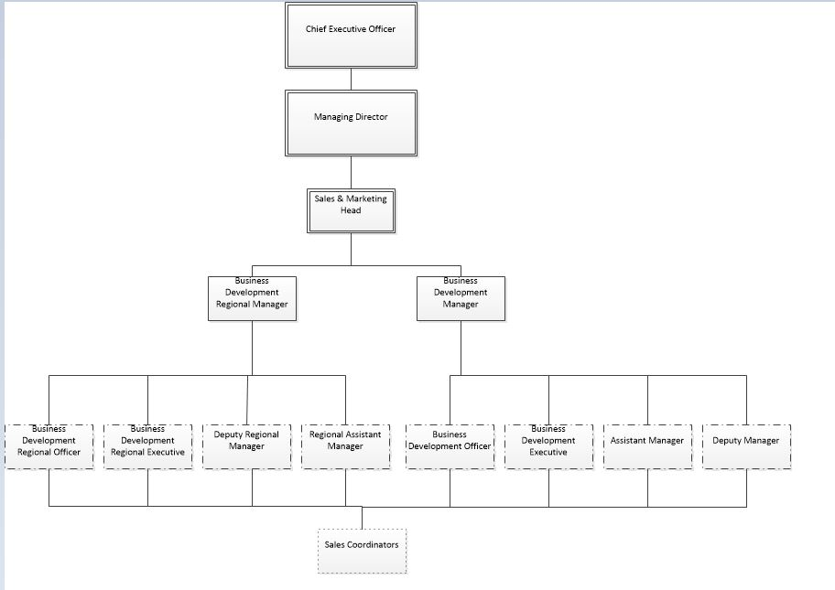

|  |  |  |
| --- | --- | --- |
| **Prepared By:** | **Reviewed By:** | **Approved By:** |
| **HOD** | **GM** | **MD/CEO** |
|  |  |  |
| Date: | Date: | Date: |