|  |
| --- |
| **STANDARD OPERATING PROCEDURE**  PURCHASES |

|  |  |  |
| --- | --- | --- |
| **Author** | | |
| Name | M Shaheed Ullah | **Signature** |
| Designation | Admin Department |
| Date | 11-11-2020 |
| **Review** | | |
| Name |  | **Signature** |
| Designation |  |
| Date |  |
| **Approval** | | |
| Name | Mr. Ahsan Abid | **Signature** |
| Designation | GM Factory |
| Date |  |

## Purpose

The main purpose is to make timely purchases on demand of different departments of working in unit.

## Scope

To make the purchases in most economical rates and to make sure that goods are purchased according to requirement of respective department.

## Responsibilities

* Respective department
* Purchase department
* Security department
* Store department

## Procedure

* Demand note will be prepared by respective department HOD according to their requirements
* Factory management (GM factory) will approve the demand
* For local purchase demand will handover to purchaser for purchase process
* If the purchase is for new project and item’s worth is more than 5K the purchaser will go for 3 minimum numbers of quotations to select the best one.
* For Lahore Purchase PR generated from SAP
* PO will be generated with vender/purchaser’s name after approval of purchase
* Purchase will be made 72 hours after approval in case of routine purchase
* Urgent purchase will made in same day after approval
* Purchased item is entered in register at gate
* Gate inward pass will be made
* GRN will be prepared through SAP
* Computer entry will be done by store in charge in concerned ledger or head

## Associated Documents and Records

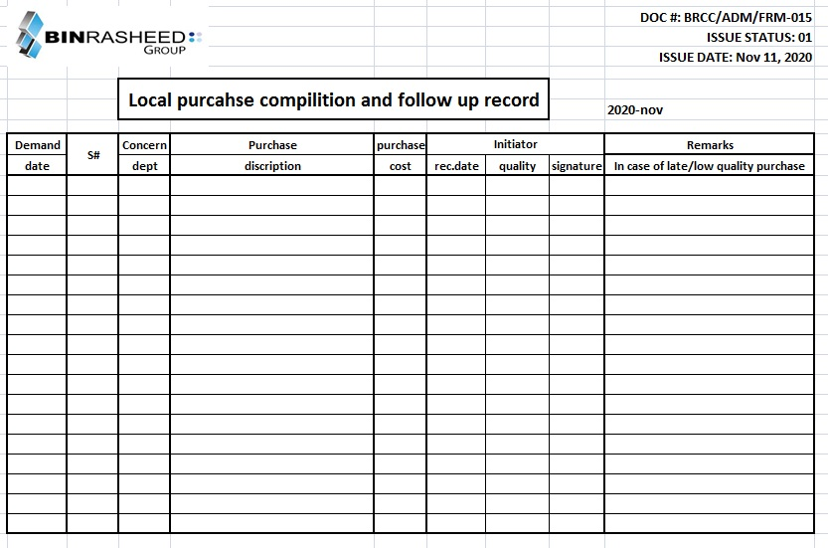

|  |
| --- |
|  |

**AMENDMENT HISTORY**

|  |  |  |  |
| --- | --- | --- | --- |
| **REV. #** | **DCR#** | **SECTION** | **AMENDED TEXT** |
| 1st | N/A | All | A complete revision done with addition of operational steps and precautionary matters |
|  |  |  |  |
|  |  |  |  |

* All changes made in the document are notified in the Amendment History Table.