|  |
| --- |
| **STANDARD OPERATING PROCEDURE**  HIRING LABOR STAFF |

|  |  |  |
| --- | --- | --- |
| **Author** | | |
| Name | M Shaheed Ullah | **Signature** |
| Designation | Admin Department |
| Date | 11-11/2020 |
| **Review** | | |
| Name |  | **Signature** |
| Designation |  |
| Date |  |
| **Approval** | | |
| Name | Mr. Ahsan Abid | **Signature** |
| Designation | GM Factory |
| Date |  |

## Purpose

To fulfilled the requirement of shortage of labor on line

## Scope

Shortage of labor demand must be raised by the relevant department HOD in case of:-

* According to strength of department respective department have to maintain strength in case of leaving and termination of any person
* If any HOD need extra labor so he must raise the demand for labor after approval from top management hiring process will start

## Responsibilities

* Admin Manager
* Senior Admin Officer

## Procedure

* Rise of demand from concerned HOD
* Worker arrangement through administration, other internal or external sources
* Technical Labor is interviewed before hiring firstly concerned Head of department and then by Admin manager
* Filling of recruitment form in case of selection
* Gm Factory will make final signature
* Accommodation process (in case of residential worker)

## Associated Documents and Records

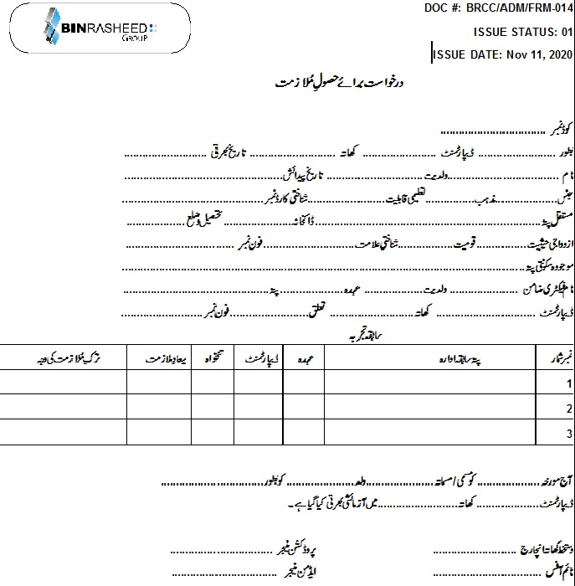

All Education Documentations along with two photo copies of CNIC and four Pictures are required

**AMENDMENT HISTORY**

|  |  |  |  |
| --- | --- | --- | --- |
| **REV. #** | **DCR#** | **SECTION** | **AMENDED TEXT** |
| 1 | N/A | all | A complete revision done with addition of operational steps and precautions |
|  |  |  |  |
|  |  |  |  |

* All changes made in the document are notified in the Amendment History Table.