|  |
| --- |
| **STANDARD OPERATING PROCEDURE**  VISITOR |

|  |  |  |
| --- | --- | --- |
| **Author** | | |
| Name | M Shaheed Ullah | **Signature** |
| Designation | Admin department |
| Date |  |
| **Review** | | |
| Name |  | **Signature** |
| Designation |  |
| Date |  |
| **Approval** | | |
| Name | Mr. Ahsan Abid | **Signature** |
| Designation | GM |
| Date |  |

## Purpose

To keep record of visitors visiting concerned individuals in factory and sharing essential instructions to visitors

## Scope

It is applicable for all contractors, customers, external vehicle drivers, guests, external auditors, government officials and other visitors on entrance in factory premises

## Responsibilities

* Security guards
* Admin department
* Concerned person visited by visitor

## Procedure

* When an individual wants to visit someone in factory premises he/she have to submit any proof of identification before entering into any part of factory. Security guards make proper inquiry and if satisfied then allow person to meet concerned person, if he/she fails to provide valid identification then guard is not allowed to enter visitor inside factory
* If visitor is on car or bike, security guards do entry on register; the entry time and exit time along with car/bike registration number as a proof.
* Security guard will provide visitor card (for hiring persons only) to visitor and also share necessary instructions regarding visitor safety and company’s protocols.
* Security guard will provide visitor slip (visiting persons only) to visitor and also share necessary instructions regarding visitor safety and company’s protocols. The slip will consist of the information about visitor, to whom he is visiting, entrance time.
* After all necessary inquiry and clearance regarding identification guard along with visitor guide him to concerned person or department.
* After the meeting when visitor is about to leave he/she will return colored card (for hiring persons) at gate and guards will give him/her back the identity proof they have detained for security purposes
* After the meeting when visitor is about to leave he/she will return visitors slip (for visiting persons) at gate but not without host signatures and guards will give him/her back the identity proof they have detained for security purposes

## Associated Documents and Records

1. Visitor Register
2. Visitor slip

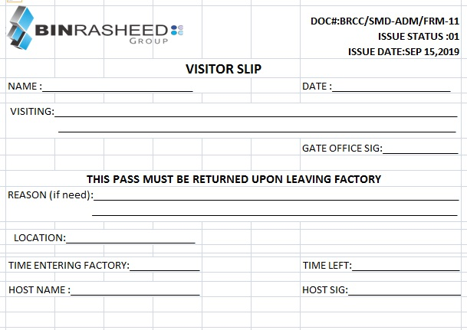

**AMENDMENT HISTORY**

|  |  |  |  |
| --- | --- | --- | --- |
| **REV. #** | **DCR#** | **SECTION** | **AMENDED TEXT** |
| 1 | N/A | all | Total protocols and SOPs revised with running requirements |
|  |  |  |  |

* All changes made in the document are notified in the Amendment History Table.