|  |
| --- |
| **STANDARD OPERATING PROCEDURE**  MESS |

|  |  |  |
| --- | --- | --- |
| **Author** | | |
| Name | M Shaheed Ullah | **Signature** |
| Designation | Admin Department |
| Date | 11-11-2020 |
| **Review** | | |
| Name |  | **Signature** |
| Designation |  |
| Date |  |
| **Approval** | | |
| Name | Mr. Ahsan Abid | **Signature** |
| Designation | GM Factory |
| Date |  |

## Purpose

To provide hygienic and clean food to both labor and executive employees of factory

## Scope

To provide clean place for labor and executive to have 3 time meal in factory, they provide food and water on decided time to ensure that everyone working in factory get quality and hygienic food on time.

Bin Rasheed (U#01) management facilitates his workers in mentioned way:-

* Colony residential workers both, executives and labor staff will be facilitated with 3 times meals for 24/7
* Only breakfast or lunch will be offer to morning shift workers subject of shift timing
* One time meal (lunch) will be offered to general shift workers and staff
* Dinner will be provided to evening shift workers and staff
* Night shift will be entertained with late night tea
* In case of overtime food will be provided to outside workers in working shift

## Responsibilities

* Admin department
* Mess committee
* Mess In charge
* Kitchen Staff

## Procedure/ operational steps

* Mess committee will decide the menu in their meeting and after approval from higher management
* Demand will be raised from mess staff regarding routine menu
* Mess In charge will be aware of available items either it’s available on stock or not.
* Purchase will be made by purchaser against the raised demand 1 day before the day’s menu (chicken, yogurt will be purchased in same day but well before cooking time)
* Items will be handed over to mess in charge/ head cook after being verified and entered in main gate
* Head cook/mess in charge has the responsibility to maintain and locate the purchased item in dry, clean and safe place
* Mess In charge will make sure to update the ledger on consistent basis

**5. Precautions**

* Mess in charge will make sure to avoid extra material storage and other mess wastages
* Purchaser ensures on time deliverance of raised and require purchase
* Food items will be kept in safe and dry place to avoid wastage
* Mess committee will be responsible for quality of the meal
* Mess In Charge will make sure the following of mess menu, any he has the authority to change the day’s menu in case of swear shortage of material or other cooking accessories
* Cleaning of mess is mandatory and head cook is responsible to maintain neat and clean environment in mess area with the help of housekeeping staff

## Associated Documents and Records

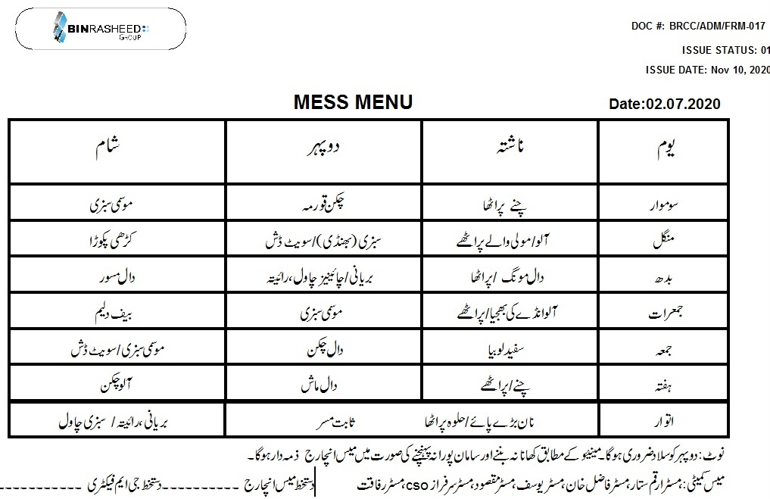

**AMENDMENT HISTORY**

|  |  |  |  |
| --- | --- | --- | --- |
| **REV. #** | **DCR#** | **SECTION** | **AMENDED TEXT** |
| 01 | N/A | All | Document revised completely and amendments been done after adding |
|  |  |  |  |
|  |  |  |  |

* All changes made in the document are notified in the Amendment History Table.