|  |
| --- |
| **STANDARD OPERATING PROCEDURE**  CLEANING |

|  |  |  |
| --- | --- | --- |
| **Author** | | |
| Name | M Shaheed Ullah | **Signature** |
| Designation | Admin Department |
| Date |  |
| **Review** | | |
| Name | Ali Raza Gohar | **Signature** |
| Designation | Compliance department |
| Date |  |
| **Approval** | | |
| Name | Mr. Ahsan abid | **Signature** |
| Designation | GM Factory |
| Date |  |

## Purpose

To maintain cleanliness in factory premises and dispose waste through proper wastage system

## Scope

Entire factory area including production halls, admin block, all offices, stores, factory main road, waste yard and residential block, both workers and executive mess.

## Responsibilities

* Admin department
* Hall In charges
* Sweepers
* Gardeners

## Procedure

* Cleaning of prod halls, residential areas twice in morning shift
* Cleaning of main entrance to colony, waste yard daily in morning shift
* To pick waste from different plants and mess and put them in designated places in waste yard
* Complete washing of masjid once in a week mostly before jumma prayer (by guardeners)
* Complete cleaning of main drain will high flow water once in a week
* Cooling towers pits cleaning as per requirement by production department
* Daily toilets and washroom cleaning in main gate, office washrooms and in residential area located
* Other time to time assigned administrative tasks and instructions

**5. Operational Steps**

* Sweepers are responsible for cleaning of offices and other designated areas
* Production, lab and store management is responsible to maintain their premises neat and clean by taking proper workings from designated sweepers
* Administration department is responsible for daily and standard cleaning of admin block, factory open areas and residential sectors.
* They ensure that waste should be properly dealt and disposed off or put in waste yard through proper wastage accumulation system
* Admin department discharge their duties and also they handle all sweepers related issue

**6. Precautions**

* Sweepers should avoid damage and breakage of office goods
* They should work on time to avoid any inconvenience
* They are not allowed to make any decision without the permission of concerned management

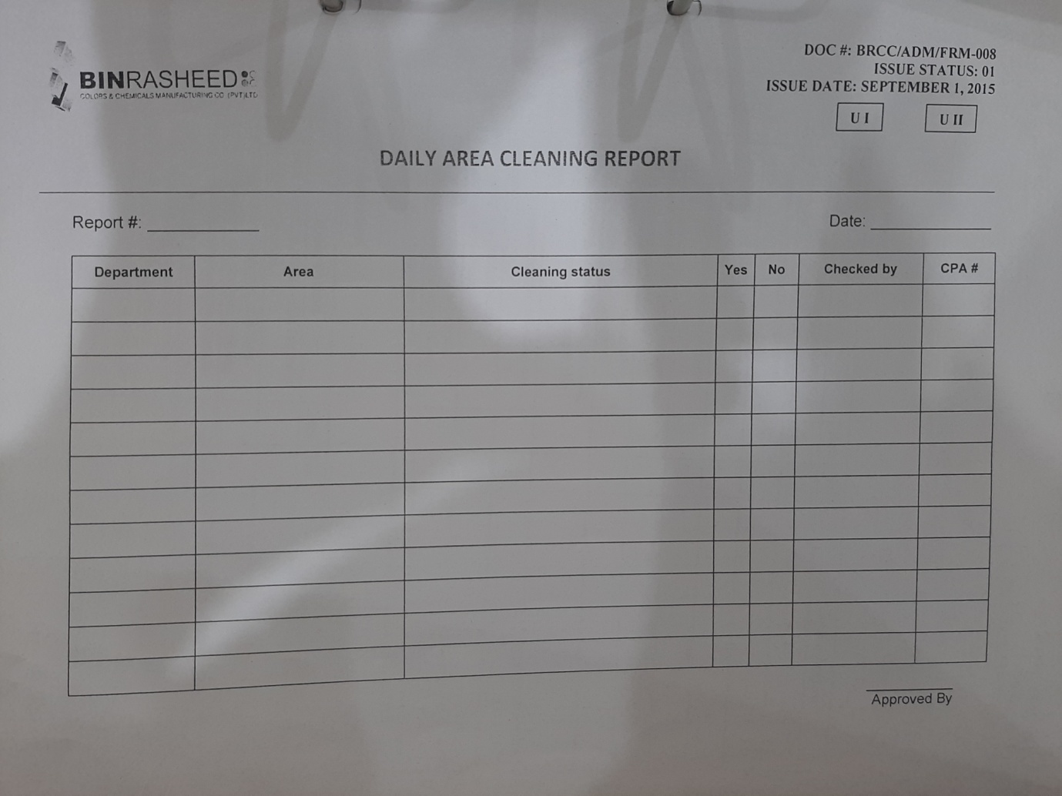

**AMENDMENT HISTORY**

|  |  |  |  |
| --- | --- | --- | --- |
| **REV. #** | **DCR#** | **SECTION** | **AMENDED TEXT** |
| 1 | N/A | all | Entire document revised and operational steps, precautions and other necessary additions were made in SOP |
|  |  |  |  |
|  |  |  |  |

* All changes made in the document are notified in the Amendment History Table.