|  |
| --- |
| **STANDARD OPERATING PROCEDURE**  EXECUTIVE / LABOR COLONY |

|  |  |  |
| --- | --- | --- |
| **Author** | | |
| Name | M Shaheed ullah | **Signature** |
| Designation | Admin Department |
| Date |  |
| **Review** | | |
| Name |  | **Signature** |
| Designation |  |
| Date |  |
| **Approval** | | |
| Name | Mr. Ahsan Abid | **Signature** |
| Designation | GM Factory |
| Date |  |

## Purpose

To outline general rules and regulation governing factory residency administration are outlined and discussed in this SOP is for uniform and transparent handling of the various issues related with the residency sector.

## Scope

It applies to all those executives & labors enrolled on company pay roll and they belong to out station areas and availing residency facility.

## Responsibilities

* Admin Department
* GM factory

## Procedure

* Acquire about residency of employee
* Allotment of residency within factory
* Communications of rules and regulations
* Employee follow code of conduct

1. **Operational Steps**

* Whenever a new employee will be hired, the concerned Manager and managemen twill know the status of employee in the interview for his residence in Colony.
* Admin officer will arrange for his accommodation after his recruitment in concerned residential colony
* Within the same day Admin officer will communicate all rules & regulation.
* Employees availing company accommodation shall adhere to company’s code of conduct for all necessary disciplinary actions.

1. **Description of General Rules:**
   1. **Accommodation:**

1. The Factory administration will generally provide the following facility to labor &executives;

* 3 times discounted food facility (Breakfast, Lunch, & Dinners)
* Carpet, bed, Cupboards, Curtains (for executives only)
* Laundry (washing machine), air conditioner (for executives only)
* PVC sheets/cots (for workers colony)
* Fresh and warm water (according to seasons)

2. The Factory administration will notprovide the following facility to labor & executives;

* Blankets/quilts
* Tooth pastes & brushes
* Combs
* Towels & Soap
* Laundry (for workers)

**6.2 Code of Conduct and precautions:-**

**1.** All residents are required to maintain standards of behavior courteously and fairly with every one

**2.** The residential rooms of the hostel should be kept clean

**3.** Notices shall not be pasted on walls only administration department has the authority

**4.** If any maintenance work is to be carried out when the residence is under occupation, it is the occupant’s responsibility to make the residence available for the maintenance work.

**5.** The residents are responsible for any damage to the property in the residence during their occupancy of that residence and will be required to replace/repair at their own cost the damage, if any occurs due to the negligence.

**6**. The residents should not carry unauthorized/illegal items in the residency area. Any violation will be dealt severely.

**7**. In the residence premises following are strictly prohibited;

* Consumption of alcoholic drinks/drugs
* Gambling
* Intimidation or violence
* Willful damage to property
* Entering the premises in drunk state
* Shouting and using abusive language in their resident area.
* Employing unauthorized persons for personal work such as washing clothes etc

**8**. Residents should not participate in any anti-national, antisocial or undesirable activity inside the residential premises that may damage the name of country, religion and organization. If found doing so strict action would be taken against concern/s.

**9**. The use of electrical appliances such as immersion heaters, electric stove / heaters are not allowed in the residence without factory administration permission. Such appliances, if found will be confiscated and disciplinary action will be taken.

**10**. The uses of audio systems which may cause inconvenience to other residents are not allowed in any part of the premises.

**11**. When the residents go out of the residence they should switch off all the electrical /electronic appliances, and keep it locked.

**12**. Resting in the premises during official timings would be eligible for disciplinary actions else in case of illness and approval from HOD/Line supervisors.

**13**. Non-resident employees are not allowed to enter residency area without prior permission of factory administration/ Head of departments

**14**. In case any factory resident has to stay out of factory for a day or more for any reason, he has to inform the factory administration, mess & security guards.

**15**. Residents will be responsible for protecting their valuables

## Associated Documents and Records

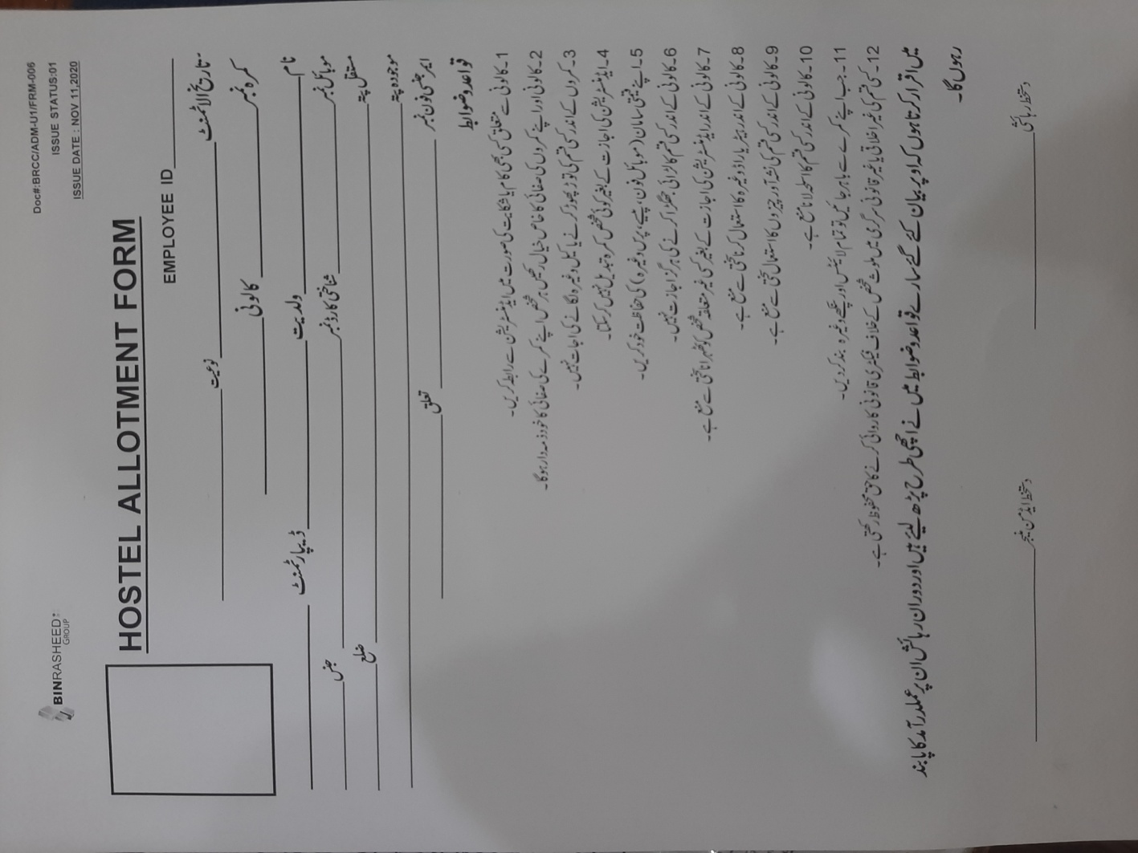

**AMENDMENT HISTORY**

|  |  |  |  |
| --- | --- | --- | --- |
| **REV. #** | **DCR#** | **SECTION** | **AMENDED TEXT** |
| 1 | N/A | all | Complete and entire document revised with concerns additions |
|  |  |  |  |
|  |  |  |  |

* All changes made in the document are notified in the Amendment History Table.