|  |
| --- |
| **STANDARD OPERATING PROCEDURE**  **COLOR TESTING** |

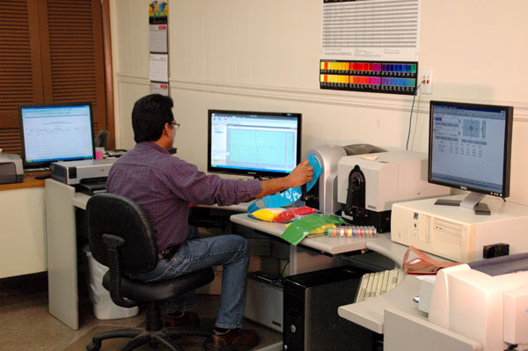

|  |  |  |
| --- | --- | --- |
| **Author** | | |
| Name : | Arif Kamal | **Signature** |
| Designation: | Shift Engineer |
| Date: | October 10,2018 |
| **Review** | | |
| Name: | Israr Hussain | **Signature** |
| Designation: | Quality Control Manager |
| Date: | October 10,2018 |
| **Approval** | | |
| Name: | Ahsan Abid | **Signature** |
| Designation: | GM Operations |
| Date: | October 10,2018 |

## Purpose

This procedure describes the identification of color undertone through CIE L*, a*, b* values and inspecting variation from the specified Standard color using color data software through various instruments like Spectrophotometer, Data color and Color Light Box.

## Scope

This procedure shall apply to any Master Batch grade that is being produced in Bin Rasheed Colors and Chemicals Mfg. Co. (Pvt) Ltd via Quality Control Lab. The grade may be Prime / Cheap Color, Filler, Additive, White and other Master Batch Grades including Black and R & D Trials on larger lines.

## Responsibilities

* 1. The following trained Quality Control Shift In-charges and Shift Managers of the QC department will perform the assay. The results will be reviewed by QC management or designee.

## Procedure

Calendaring Chips, Injection Chips, Blown Films, thin Films of color and filler master batch are made and its color/ undertone variation and saturation is checked on Spectrophotometer, Colorimeter or Data Color. The Standard Target of each grade is saved in SpectraMagix Software. The batch of each production is tested and compared with the standard being saved earlier.

* 1. **Calendaring Chips**

As per end application calendaring or injection chips are made of different ratios.

1. Direct Chips

We make direct chips of master batches whose end application is in injection molding or in Blown Film applications. In direct chip we use 1 or 5 grams master batch and 49 or 45 grams polymer (LLDPE 500026) respectively. The direct chips of the master batch are checked for color strength and undertone.

1. Tint Chips

Tinting strength describes the ability of a color master batch to efficiently render color to the resin and to check the strength of our color master batch to be used in applications where our master batch has to go through stretching and elongation as in PP woven bags. We actually dilute the master batch to see what end result it give after being stretched. In tint chips we use 1 gram master batch, 5 grams of titanium dioxide and 44 grams of polymer (LLDPE 500026).

1. Mixing Chips

Direct or tint chips are made of mixing for grades in which Polypropylene or High Density Polyethylene is used in granular form. The mixing is weighed after separating the granules of PP or HDPE.

1. Tint of White Master Batch (Mixing)

The undertone, whiteness, opacity and strength of white color master batch are checked in either blue or black (grey) shade/background. 0.2 to 0.5 grams of black pigment (4330) or ultra Marine Blue pigment (GP-58) respectively is used in 5 grams of white master batch mixing and 44.8 grams of Polymer (LLDPE 500026).

* 1. **Injection Chips**

For grades having end application in injection molding or profile extrusion, we make injection chips of the master batch and check the chip for undertone variation and pigment dispersion.

Injections chips are made at 2 % dosage with 2 grams of Master Batch and 98 grams of polymer. Usually PPRC RA-130 is used for PP Profile extrusion and PP HY001P is used for normal injection molding applications.

* 1. **Blown Film/ Thin Film** 
     1. Blown Film

For grades having end application in blow molding and blown film making, we make blown film of the master batch and check the film for undertone variation and saturation. We usually check the blown film of filler grades for fish eye formation and pigment dispersion while the blown film of White grades are checked for undertone, dispersion and whiteness.

Blown film is made with polymer ratio 550 gram LDPE, 250 gram LLDPE & different %age of Master Batch. The percentage of dosage is as mentioned below.

* 5 % (45 Grams) for prime color blown film grades
* 10 % (90 Grams) for White blown film and filler color grades
* 40 % (520 Grams) for White filler blown film grades
  + 1. Thin Film

We make thin film of direct chips of master batches whose end application is in Blown Film applications of PP Woven Sacks.

* 1. **Light Box**

Colors appear differently under different lighting conditions. Light booth is used to simulate different lighting situations for different color samples. Six different controlled light sources i.e. D65, F, CWF, TL83, TL84, & UV are used to achieve objective color assessment of different samples. Test article is viewed within the full illumination of the light box.

## Associated Documents and Records

1. Batch Wise Testing Report
2. Backup of testing on Testing Instrument Library

**AMENDMENT HISTORY**

|  |  |  |  |
| --- | --- | --- | --- |
| **REV. #** | **DCR #** | **SECTION** | **AMENDED TEXT** |
|  |  |  |  |
|  |  |  |  |
|  |  |  |  |