|  |
| --- |
| **STANDARD OPERATING PROCEDURE**  **MOISTURE TESTING** |

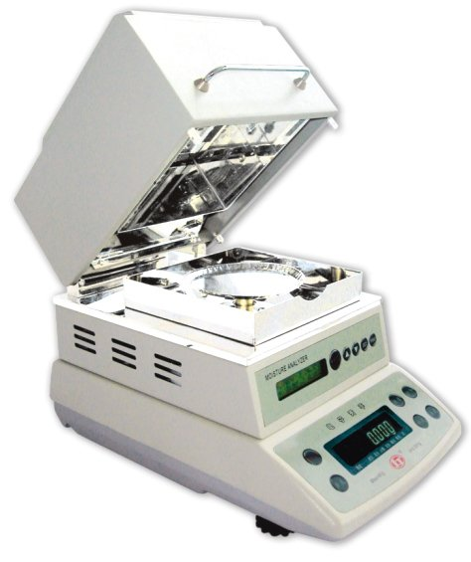

|  |  |  |
| --- | --- | --- |
| **Author** | | |
| Name : | Arif Kamal | **Signature** |
| Designation: | Shift Engineer |
| Date: | October 10,2018 |
| **Review** | | |
| Name: | Israr Hussain | **Signature** |
| Designation: | Quality Control Manager |
| Date: | October 10,2018 |
| **Approval** | | |
| Name: | Ahsan Abid | **Signature** |
| Designation: | GM Operations |
| Date: | October 10,2018 |

## Purpose

The purpose of this procedure is to determine quantitatively the moisture present in master batch by means of loss in weight technology.

## Scope

This test method covers the quantitative determination of moisture by means of loss in weight technology following the ASTM D 6980.

This procedure shall apply to any Master Batch grade that is being produced in Bin Rasheed Colors and Chemicals Mfg. Co. (Pvt) Ltd via Quality Control Lab. The grade may be Prime / Cheap Color, Filler, Additive, White and other Master Batch Grades including Black and R & D Trials on larger lines. This test procedure is adapted for use as a control, acceptance and assessment test.

## Responsibilities

* 1. The following trained Quality Control Shift In-charges and Shift Managers of the QC department will perform the assay. The results will be reviewed by QC management or designee.

## Procedure

Approximately 30 grams of the sample material is spread onto a sample pan that is supported on a balance in a heating chamber. It is then heated to vaporize the moisture. The analysis is completed when the indicated weight loss falls below a rate specified. The total loss of weight is integrated and displayed as the percent of moisture.

## Associated Documents and Records

1. Moisture Detail Log Book

**AMENDMENT HISTORY**

|  |  |  |  |
| --- | --- | --- | --- |
| **REV. #** | **DCR #** | **SECTION** | **AMENDED TEXT** |
|  |  |  |  |
|  |  |  |  |
|  |  |  |  |