Department: Quality Control Date: 05-02-2018

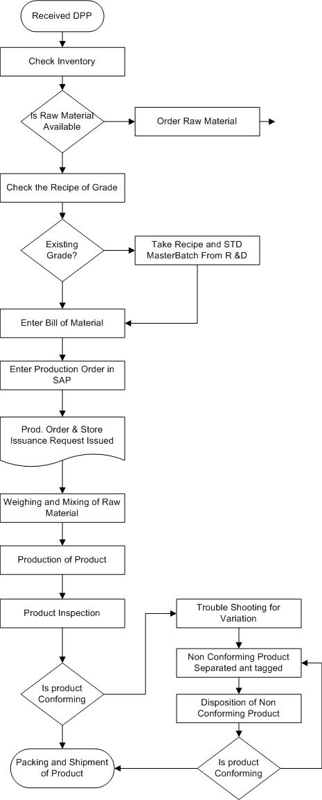

NO

YES

NO

YES

NO

YES

NO

YES

Checked By (HOD): ___________________ Approved by (QHSE TL): _____________________