|  |
| --- |
| **STANDARD OPERATING PROCEDURE**  **MELT FLOW TESTING** |

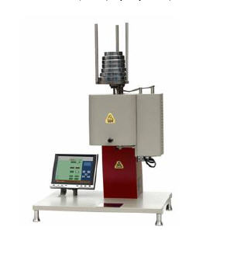

|  |  |  |
| --- | --- | --- |
| **Author** | | |
| Name : | Arif Kamal | **Signature** |
| Designation: | Shift Engineer |
| Date: | October 10,2018 |
| **Review** | | |
| Name: | Israr Hussain | **Signature** |
| Designation: | Quality Control Manager |
| Date: | October 10,2018 |
| **Approval** | | |
| Name: | Ahsan Abid | **Signature** |
| Designation: | GM Operations |
| Date: | October 10,2018 |

## Purpose

The purpose of this procedure is to study the rheological behavior/ flow characteristics of Master Batch. Melt Flow rate of each critical and other grades of master batches are calculated and checked to ensure consistency in each batch and each lot.

## Scope

This test procedure covers measurement of the rate of extrusion of molten master batch/ polymer resin through a die of a specified length and diameter under prescribed conditions of temperature, load and piston position in the barrel as the timed measurement is being made.

ASTM D 1238 is followed to determine the melt flow rate of different polymer resins and master batch.

This procedure shall apply to any Master Batch grade that is being produced in Bin Rasheed Colors and Chemicals Mfg. Co. (Pvt) Ltd via Quality Control Lab. The grade may be Prime / Cheap Color, Filler, Additive, White and other Master Batch Grades including Black and R & D Trials on larger lines.

## Responsibilities

## . The following trained Quality Control Lab Operator of the QC department will perform the assay. The results will be reviewed by Quality Control Shift In-charge or/and Shift Manager.

## Procedure

Approximately 8 grams of the material is loaded into the barrel of the melt flow apparatus, which has been heated to a temperature specified for the material. Just before pre heat cycle reaches its completion, a weight specified for the material is applied to a plunger and the molten material is forced through the die. A timed extrudate is collected and weighed. Melt flow rate values are calculated in g/10 min.

## Associated Documents and Records

1. MFI Detail Log Book
2. Quality Control History Report

**AMENDMENT HISTORY**

|  |  |  |  |
| --- | --- | --- | --- |
| **REV. #** | **DCR #** | **SECTION** | **AMENDED TEXT** |
|  |  |  |  |
|  |  |  |  |
|  |  |  |  |