|  |
| --- |
| **WORK INSTRUCTIONS**  **INJECTION MOLDING** |

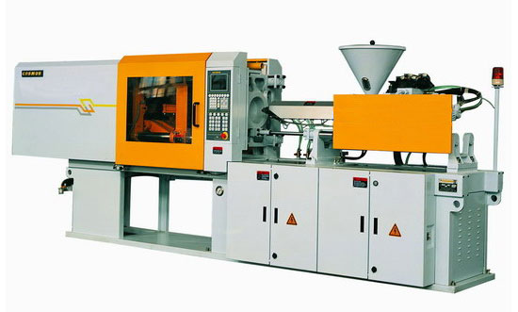

|  |  |  |
| --- | --- | --- |
| **Author** | | |
| Name : | Arif Kamal | **Signature** |
| Designation: | Shift Engineer |
| Date: | October 10,2018 |
| **Review** | | |
| Name: | Israr Hussain | **Signature** |
| Designation: | Quality Control Manager |
| Date: | October 10,2018 |
| **Approval** | | |
| Name: | Ahsan Abid | **Signature** |
| Designation: | GM Operations |
| Date: | October 10,2018 |

**Operational Steps**

1. First of all clean the apparatus properly before use.
2. Check the hopper and hopper magnet properly and remove any foreign material present in the hopper.
3. Turn on the power to the injection Molding Machine by pushing up the power switch.
4. Check the heating parameters and adjust the barrel temperature according to the raw material used.
5. Make sure that the barrel temperature and drying temperature are according to the below mentioned temperatures.

|  |  |  |  |
| --- | --- | --- | --- |
| Material Name | Drying Temperature (0C) | Drying time  (Minutes) | Barrel Temperature |
| **ABS** | 80-85 0C | 20. | 190-250 0C |
| **PC** | 120 0C | 30 | 230-250 0C |
| **PET** | 100-110 0C | 45 | 240-280 0C |
| **HIPS** | Not required | Not required | 180-220 0C |
| **PS** | Not required | Not required | 180-220 0C |

If moisture is present in PET, HIPS and PP, preheat it at 40 0C.

1. Give proper time for the heaters to reach the set values of barrel temperature.
2. Manually purge the line using the appropriate polymer (Like PP HY-001P for regular injection Chips) after desired temperatures are reached.
3. Clean the line properly using transparent polymer and make sure that no shade of the previous grade appears in the purged polymer.
4. Clean both mold halves, mold cavity and air vent properly.
5. Set the barrel temperature, injection pressure, screw speed and shot weight.
6. Set the injection time, cooling time etc.
7. Securely close both the halves of the mold prior to injection of the material into the mold using the clamping unit.
8. Weigh the material according to the dosage and recipe.
9. Pour the polymer and the weighed sample master batch to the hopper and open the gate at the bottom of the hopper.
10. Select operation mode to semi auto mode.
11. Turn on the oil pump by pushing the ON button.
12. Close the mold using the switch and feed the barrel by injecting the material.
13. Move the injector unit forward using the injection switch knob.
14. Inject the material and by adjusting the back pressure and speed, fill the mold.
15. Open the mold and Press the ejector switch and eject the injected part.
16. Close the mold and make another injection by repeating the procedure.
17. **Precautions**
18. Do not operate the machine until the barrel temperature reaches the adjusted temperature.
19. Check the oil gauge before operation.
20. Make sure that the material is free of iron particles.
21. Clean the moving parts of the machine and lubricate properly as per requirement.

|  |  |  |
| --- | --- | --- |
| **Author** | **Review** | **Approval** |
| **Signature** | **Signature** | **Signature** |
| Arif Kamal | Israr Hussain | Ahsan Abid |
| Shift Engineer | Quality Control Manager | GM Operations |