|  |
| --- |
| **WORK INSTRUCTIONS**  **MELT FLOW INDEXER** |

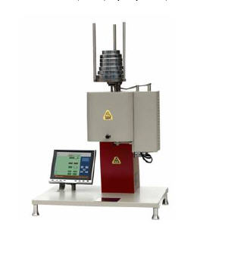

|  |  |  |
| --- | --- | --- |
| **Author** | | |
| Name : | Arif Kamal | **Signature** |
| Designation: | Shift Engineer |
| Date: | October 10,2018 |
| **Review** | | |
| Name: | Israr Hussain | **Signature** |
| Designation: | Quality Control Manager |
| Date: | October 10,2018 |
| **Approval** | | |
| Name: | Ahsan Abid | **Signature** |
| Designation: | GM Operations |
| Date: | October 10,2018 |

1. **Operational Steps**
2. First of all clean the apparatus properly before use.
3. Select the temperature and load in accordance with the material specification.

|  |  |  |
| --- | --- | --- |
| Material Name | Temperature (0C) | Load (Kgs) |
| **PE** | 190 0C | 2.16 Kg |
| **PS** | 200 0C | 5 Kgs |
| **PP** | 230 0C | 2.16 Kgs |
| **ABS** | 220 0C | 10 Kgs |
| **PC** | 300 0C | 1.2 Kgs |

1. Weigh the master batch sample 8 grams using small digital weighing scale.
2. Put material into the barrel with the help of charging tool and insert piston into the barrel.
3. Press the piston until the barrel is well filled by the master batch so that no air packets remain between the materials. Start the timer and give 7 minutes pre heat time.
4. Just before pre heat cycle reaches its completion, place the weights according to the standard onto the piston.
5. When the lower of the scribed line reach the top of the barrel, cut off the extrudate and reset the timer.
6. Cut the extrudate as the upper scribed line reaches the top of the barrel.
7. Weigh the extrudate and note down the time on timer.
8. Calculate the MFI in gms/10 minute using the formula below.
$$MFR \left({gms}/{10}Minute\right)=\frac{Extrudate Weight \left(gms\right)}{Time \left(Seconds\right)}x 600$$

9. **Precautions**
10. Inspect the apparatus and die properly for cleanliness.
11. Carefully put weights on the piston.

|  |  |  |
| --- | --- | --- |
| **Author** | **Review** | **Approval** |
| **Signature** | **Signature** | **Signature** |
| Arif Kamal | Israr Hussain | Ahsan Abid |
| Shift Engineer | Quality Control Manager | GM Operations |