|  |
| --- |
| **WORK INSTRUCTIONS**  **BLOWN FILM** |

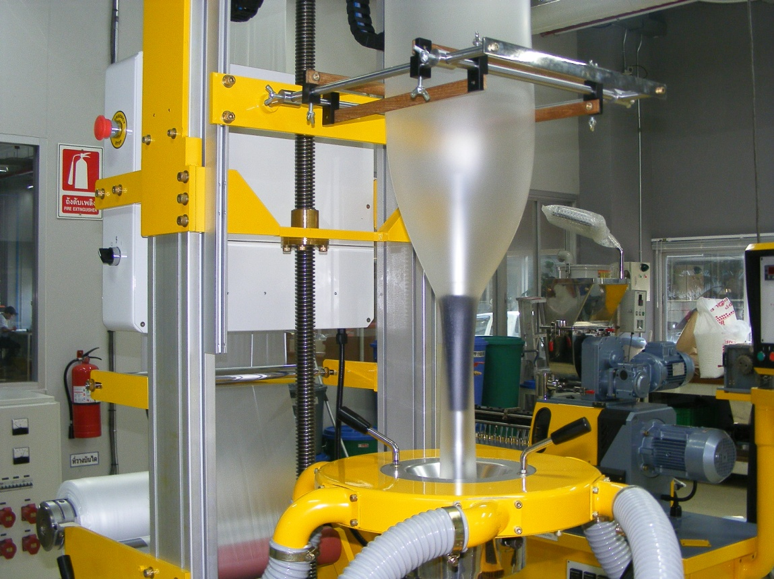

|  |  |  |
| --- | --- | --- |
| **Author** | | |
| Name : | Arif Kamal | **Signature** |
| Designation: | Shift Engineer |
| Date: | October 10,2018 |
| **Review** | | |
| Name: | Israr Hussain | **Signature** |
| Designation: | Quality Control Manager |
| Date: | October 10,2018 |
| **Approval** | | |
| Name: | Ahsan Abid | **Signature** |
| Designation: | GM Operations |
| Date: | October 10,2018 |

1. **Operational Steps**
2. First of all clean the apparatus properly before use.
3. Check the hopper properly and remove any foreign material present in the hopper.
4. Check the heating parameters and adjust the barrel temperature according to the polymer used.
5. Give proper time for the heaters to reach the set values of barrel temperature.
6. Take sample of the Blown film grade from the line.
7. Take either dried sample from packing area or dry it using lab scale drier or oven.
8. Check moisture of the dried sample.
9. If the moisture content of the dried sample is above 0.01 %, kindly re-dry it and repeat steps 6 and 7.
10. Weigh the sample according to the dosage in the blown film as mentioned below.

|  |  |  |  |  |
| --- | --- | --- | --- | --- |
| Grades | Sample Dosage  (percentage) | Sample Dosage  (Grams) | LDPE 374  (Grams) | LLDPE 118W  (Grams) |
| Color Grades | 3 % | 25 Grams | 250 Grams | 550 Grams |
| White Grades | 10 % | 90 Grams | 250 Grams | 550 Grams |
| Filler Grades ( Color) | 5 % | 45 Grams | 250 Grams | 550 Grams |
| Filler Grades ( White) | 40 % | 520 Grams | 250 Grams | 550 Grams |
| PP Woven Grades | 2.7% (Color) | 25 Grams | 250 Grams | 550 Grams |
| 8.3% (Filler) | 75 Grams |

1. Take 550 grams of LLDPE (118 W, 1210P, Q1018) and 250 grams of LDPE 374, 4023, 2023. Mix the polymers thoroughly with the weighed sample of the blown film grade.
2. Purge the line with transparent polymer (or filler if required) and clean the line properly and remove any remaining strains of the previously run grade.
3. Feed the weighed material into the hopper.
4. Turn on the blower and nip roller motor and run the extruder.
5. Handle the material coming out of the die with care and manually pass it through the nip rollers to winder.
6. Blow appropriate air manually into the blown by the air pipe unit.
7. Wind the film at the winder or wind manually and adjust the thickness of film using the nip roller speed.
8. Make blown film at 50 RPM of Nip Rollers and adjust width according to the standard.
9. **Precautions**
10. Do not operate the machine until the barrel temperature reaches the adjusted temperature.
11. Purge the line with transparent polymer to ensure proper cleaning.
12. Check the Air ring pipes and all the auxiliaries of the blown film attached and make sure that the blown film is in working condition.
13. Use heat-proof safety gloves while operating the machine.
14. Keep the machine dust free.
15. Make sure that the material is free of iron particles.

|  |  |  |
| --- | --- | --- |
| **Author** | **Review** | **Approval** |
| **Signature** | **Signature** | **Signature** |
| Arif Kamal | Israr Hussain | Ahsan Abid |
| Shift Engineer | Quality Control Manager | GM Operations |