|  |
| --- |
| **WORK INSTRUCTIONS**  **LIGHT BOX** |

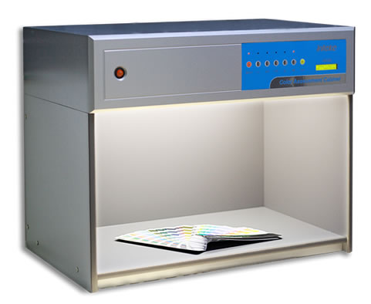

|  |  |  |
| --- | --- | --- |
| **Author** | | |
| Name : | Arif Kamal | **Signature** |
| Designation: | Shift Engineer |
| Date: | October 10,2018 |
| **Review** | | |
| Name: | Israr Hussain | **Signature** |
| Designation: | Quality Control Manager |
| Date: | October 10,2018 |
| **Approval** | | |
| Name: | Ahsan Abid | **Signature** |
| Designation: | GM Operations |
| Date: | October 10,2018 |

1. **Operational Steps**
2. Connect the power cable to the switch and turn the Light Box on.
3. Place the sample into the Light Booth.
4. Press the button and turn on the required light.
5. Six different controlled light sources i.e. D65, F, CWF, TL83, TL84, & UV are present.
6. Press the required of respective light source button ON.
7. View the test article within the full illumination of the light box.
8. **Precautions**
9. View the sample in full illumination of the light box only.
10. Keep the lights clean to ensure full illumination.

|  |  |  |
| --- | --- | --- |
| **Author** | **Review** | **Approval** |
| **Signature** | **Signature** | **Signature** |
| Arif Kamal | Israr Hussain | Ahsan Abid |
| Shift Engineer | Quality Control Manager | GM Operations |