|  |
| --- |
| **WORK INSTRUCTIONS**  **MOISTURE ANALYZER** |

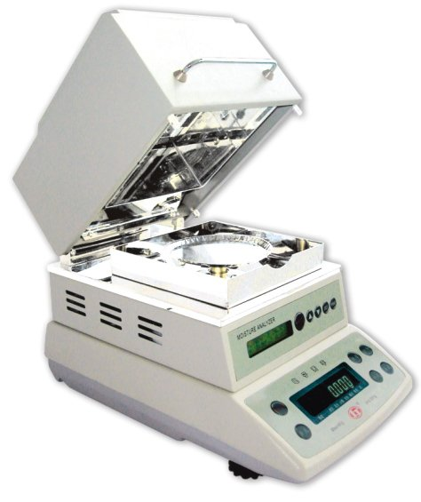

|  |  |  |
| --- | --- | --- |
| **Author** | | |
| Name : | Arif Kamal | **Signature** |
| Designation: | Shift Engineer |
| Date: | October 10,2018 |
| **Review** | | |
| Name: | Israr Hussain | **Signature** |
| Designation: | Quality Control Manager |
| Date: | October 10,2018 |
| **Approval** | | |
| Name: | Ahsan Abid | **Signature** |
| Designation: | GM Operations |
| Date: | October 10,2018 |

1. **Operational Steps**
2. Place the analyzer on a flat level surface.
3. Connect the power cable to the switch and turn the analyzer on, program the analyzer with the suggested test conditions.
4. Weigh the master batch sample 30 grams using small digital weighing scale.
5. Spread the weighed test specimen (30 Grams) onto the sample pan that is supported on a balance.
6. Press the START/STOP button and turn on the heater.
7. The sample is heated to vaporize the moisture
8. Wait until the beep sound is heard.
9. Record the result as displayed in percent moisture. The total loss of weight is integrated and displayed as the percent of moisture.
10. Repeat the process thrice and take the average value of percentage moisture.
11. At the end of the test allow the analyzer to cool and remove the sample pan.
12. **Precautions**
13. Do not place flammable objects near the analyzer.
14. Use sample pan handler while removing the pan.
15. Use only Aluminum 3003 pans or pans made of other nonreactive material.

|  |  |  |
| --- | --- | --- |
| **Author** | **Review** | **Approval** |
| **Signature** | **Signature** | **Signature** |
| Arif Kamal | Israr Hussain | Ahsan Abid |
| Shift Engineer | Quality Control Manager | GM Operations |