|  |
| --- |
| **WORK INSTRUCTIONS**  **TWO ROLL MILL** |

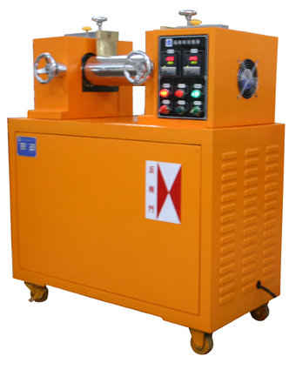

|  |  |  |
| --- | --- | --- |
| **Author** | | |
| Name : | Arif Kamal | **Signature** |
| Designation: | Shift Engineer |
| Date: | October 10,2018 |
| **Review** | | |
| Name: | Israr Hussain | **Signature** |
| Designation: | Quality Control Manager |
| Date: | October 10,2018 |
| **Approval** | | |
| Name: | Ahsan Abid | **Signature** |
| Designation: | GM Operations |
| Date: | October 10,2018 |

1. **Operational Steps**
2. First of all clean the apparatus properly before use.
3. Inspect the rollers making sure that there is nothing stuck in them and they are in good condition.
4. Check the heating parameters and adjust the Roller temperature according to the raw material used.
5. Press the Red Heat Button to turn on the Roller heaters.
6. Give proper time for the heaters to reach the set values of Barrel temperature.
7. Check to see which way the rollers are turning by looking at the rolls.
8. Adjust the hand wheel screw clockwise to close the rollers together and counterclockwise to separate the rollers.
9. Turn the Green Power Button On and engage the motor by pressing the Green start button.
10. Adjust the speed of the front and rear roller accordingly.
11. Clean the rollers properly by using transparent polymer and if still any color remains on the rollers, clean it with Stearic Acid.
12. Take the required quantity of Polymer and the sample Master Batch as per requirement.
13. First take the Polymer LLDPE 500026 on the rollers and make thin sheet using blade after the polymer is melted on the rollers.
14. Put the weighed sample of the Master Batch and mix it homogeneously in the melted polymer by tightening the rollers together.
15. Make the required calendaring Tint, Direct and calpit chip of the set thickness.
16. When rolling is complete and the calendaring chip is ready, turn off Two Roll Mill by pressing the RED push button.
17. Unwind the Calendaring chip from the roller and let it cool down on a flat and clean surface or table.
18. **Precautions**
19. Do not operate the machine until the Roller temperature reaches the adjusted temperature.
20. Before operating the two roll mill; familiarize yourself with the controls (note which button stops the rollers in case of an emergency, you don’t want to press the wrong button in a panic).
21. The two roll operator must be well trained prior to starting work with the Two Roll Mill.
22. No loose pieces of clothing should be worn by the operator.
23. Long sleeve shirts and Kurtas need to have the arms rolled up.
24. Do not leave the Two Roll Mill unattended during working.

|  |  |  |
| --- | --- | --- |
| **Author** | **Review** | **Approval** |
| **Signature** | **Signature** | **Signature** |
| Arif Kamal | Israr Hussain | Ahsan Abid |
| Shift Engineer | Quality Control Manager | GM Operations |