|  |
| --- |
| **STANDARD OPERATING PROCEDURE**  **TESTING OF CRITICAL GRADES** |

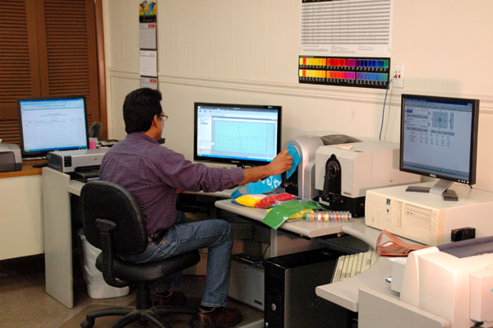



|  |  |  |
| --- | --- | --- |
| **Author** | | |
| Name : | Arif Kamal | **Signature** |
| Designation: | Shift Engineer |
| Date: |  |
| **Review** | | |
| Name: | Murtaza Grewal | **Signature** |
| Designation: | Lab Manager |
| Date: |  |
| **Approval** | | |
| Name: | Ahsan Abid | **Signature** |
| Designation: | GM Operations |
| Date: |  |

## Purpose

This procedure describes the testing method for the testing of critical grades according to end application and sensitivity.

1. **Terminology**
   1. *Definitions:*
      1. *Critical Grades, n—*the product grade will be considered critical if the end application is other than PP Mat, Black Cheap Master batch and cheap caplet master batches. In critical grades even minor variation or deviation from Standard is not acceptable as per customer criteria.

## Scope

This procedure shall apply to only specific critical Master Batch grades that are being produced in Bin Rasheed Colors and Chemicals Mfg. Co. (Pvt) Ltd via Quality Control Lab. The grade may be Prime / Cheap Color, Filler, Additive, White and other Master Batch Grades including Black and R & D Trials on larger lines.

## Responsibilities

* 1. The following trained Quality Control Shift In-charges and Shift Managers of the QC department will perform the assay. The results will be reviewed by QC management or designee.

## Procedure

Calendaring Chips after heat and before heat, Injection Chips, Blown Films, thin Films of color and filler master batch are made and its color/ undertone variation and saturation is checked on Spectrophotometer, Colorimeter or Data Color. MFI, Blown Film, Line Heating parameters, dispersion in blown film and thin film and smoothness of strands and Master batch is cheched microscopically. The Standard Target of each grade is saved in SpectraMagix Software.

* 1. **Testing of PP Woven Sack Grades**
     1. Calendaring Chip Testing

The color strength, heat stability and undertone of Masterbatch grades having end application in PP Woven Sacks (both low and heavy denier), where our master batch undergoes very high stretching and heating at elevated temperature above 220 0C during the production of tapes, is tested after passing through the weighed sample of Master batch through the MFR orifice at temperature 250 0C after giving a residence time of 30 seconds. Tint chip of the extrudate is made. Tinting strength describes the ability of a color master batch to efficiently render color to the resin and to check the strength of our color master batch to be used in applications where our master batch has to go through stretching and elongation as in PP woven bags. We actually dilute the master batch to see what end result it give after being stretched. In tint chips we use 1 gram master batch, 5 grams of titanium dioxide and 44 grams of polymer (LLDPE 500026).

After heat tint chip of every batch is made and if the results are according to the standard that batch is packed and if the results out of range, the material is separated and is not sent to the customer.

* + 1. Blown Film Testing

We usually check the blown film of master batch at dosage of 2-5 % to check the pigment dispersion.

* 1. **Testing of Blown film Prime Grades having high pigment dose**
     1. Blown Film Testing

For grades having end application in blown film, we make blown film of the master batch and check the film for pigment dispersion, spotting and also undertone variation. The grades with high pigmentation are run at specific production parameters to ensure high dispersion.

Blown film of Standard and Production is made on same dosage and is compared for dispersion and undertone. Blown Film is viewed on light box to compare and check dispersion and dispersion issues.

To ensure proper dispersion of pigment, rework is also added in specific percentage (10-30 %) or the whole lot is recycled and then checked. The blown film then is compared with the STD or approved lot of the grade.

Blown film is made of Master batch using the following carrier resin:

* 70% LLDPE with MFI 1 Gram/10 min (e.g. 118 W, 1210 P)
* 30% LDPE with MFI 3-4 Gram/10 min (374, 474)

Dosage of Master Batch in blown film depends on the master batch grade and end application. Following dosage is used to check the blown film.

* White Master Batch 10%
* Prime Master Batch 03%
* Filler (Caplet) Master Batch 20%
* Filler (Color) Master Batch 10 %
  + 1. Thin Film Checking

We make thin film of direct chips of master batches is also checked microscopically to determine any un-dispersed or burnt particles.

* + 1. Checking of strand

Strands of the extrudate are taken and are checked microscopically to determine any un-dispersed or burnt particles on the surface of strands. Strand smoothness is also checked physically and compared with the previous approved lot STD.

* 1. **Testing of White Critical grades**
     1. Calendaring Chip Testing

The undertone, whiteness, opacity and strength of white color master batch are checked in either blue or black (grey) shade/background. 5 gram mixing of white master batch is taken. 0.2 to 0.5 grams of black pigment (4330) or ultra Marine Blue pigment (GP-58) respectively is used in 5 grams of white master batch mixing and 44.8 grams of Polymer (LLDPE 500026). The calendaring chip is compared with the standard to determine whiteness and undertone.

* + 1. Blown Film Testing

Blown film of the grade is made at 10 % and is checked for undertone, dispersion and whiteness. The l, a, b values are compared with STD. Blown Film is also viewed under light Box to check optical brightness if necessary.

* 1. **General Testing for all Critical grades**
     1. Melt Flow Index Testing

Melt Flow rate of each critical and other grades of master batches are calculated and checked to ensure consistency in each batch and each lot.

* + 1. Ash Testing

Ash Content of critical grades is determined (on customer demand / raw material change) to evaluate the inorganic content (ash) in Master Batch by destructive testing technique.

* + 1. Bulk Density Testing

Bulk Density of critical grades is determined of each lot.

* + 1. Moisture Testing

Moisture content of critical grades is determined by means of loss in weight technology using moisture analyzer.

* + 1. Any other testing specified by customer

## Frequency for Testing

Testing Frequency for critical grades depends on the grade nature, requirement of the test in specific end application and quantity of the lot. Testing frequency for different critical grades is as following.

|  |  |  |  |
| --- | --- | --- | --- |
| S# | Testing Detail | Testing Methods | Frequency |
| 1 | Color Testing | BRCC/SMD-QC/SOP-001 | Every 2nd Batch and batch to batch for critical |
| 2 | Melt Flow Rate | ASTM D1238 | Each lot Once (depending on prod. Plan) |
| 3 | Bulk Density | BRCC/SMD-QC/SOP-007 | Each lot Once (Mix Lot) |
| 4 | Ash Content | BRCC/SMD-QC/SOP-004 | As per customer Requirement |
| 5 | Pellet Count | BRCC/SMD-QC/SOP-008 | Tested each Lot once (Mix Lot) |
| 6 | Moisture Content | ASTM-6980 | Tested each Lot once (Mix Lots) |
| 7 | Blown Film | ----- | First batch mandatory (Each lot Once) |
| 8 | Filter Pressure Value |  | First batch every lot (depending on Grade) |

## Associated Documents and Records

1. Batch to Batch Testing Report
2. Backup of testing on Testing Instrument Library

**AMENDMENT HISTORY**

|  |  |  |  |
| --- | --- | --- | --- |
| **REV. #** | **DCR #** | **SECTION** | **AMENDED TEXT** |
|  |  |  |  |
|  |  |  |  |
|  |  |  |  |